CfE Higher Chemistry

Unit 3:
Chemistry in Society

Exam Questions

Name:
Class:

3.1 Getting the Most from Reactants

1. How many moles of oxygen atoms are in 0.5 mol of carbon dioxide?
A 0.25
B 0.5
C 1
D 2

2. A fullerene molecule consists of 60 carbon atoms.
Approximately how many such molecules are present in 12 g of this type of carbon?
A 1.0 × 10²²
B 1.2 × 10²³
C 6.0 × 10²³
D 3.6 × 10²⁵

3. Which of the following gases would contain the greatest number of molecules in a 100 g
sample, at room temperature?
A Fluorine
B Hydrogen
C Nitrogen
D Oxygen

4. A mixture of potassium chloride and potassium carbonate is known to contain
0·1 mol of chloride ions and 0·1 mol of carbonate ions. How many moles of potassium ions are present?
A 0·15
B 0·20
C 0·25
D 0·30

5. The mass of 1 mol of sodium is 23 g. What is the approximate mass of one sodium
atom?
A 6 × 10²³ g
B 6 × 10^{–23} g
C 3.8 × 10^{–23} g
D 3.8 × 10^{–24} g

6. Which of the following gas samples has the same volume as 7 g of carbon monoxide?
(All volumes are measured at the same temperature and pressure.)
A 1 g of hydrogen
B 3.5 g of nitrogen
C 10 g of argon
D 35 . 5 g of chlorine

7. In which of the following pairs do the gases contain the same number of oxygen atoms?
A 1 mol of oxygen and 1 mol of carbon monoxide
B 1 mol of oxygen and 0.5 mol of carbon dioxide
C 0.5 mol of oxygen and 1 mol of carbon dioxide
D 1 mol of oxygen and 1 mol of carbon dioxide

8. The Avogadro Constant is the same as the number of
A molecules in 16 g of oxygen
B ions in 1 litre of sodium chloride solution, concentration 1 mol l–1
C atoms in 24 g of carbon
D molecules in 2 g of hydrogen.

9. Which of the following contains one mole of neutrons?
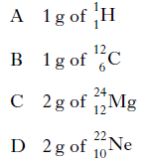

10. The Avogadro Constant is the same as the number of
A ions in 1 mol of NaCl
B atoms in 1 mol of hydrogen gas
C electrons in 1 mol of helium gas
D molecules in 1 mol of oxygen gas.

11. The Avogadro Constant is the same as the number of
A molecules in 16 g of oxygen
B electrons in 1 g of hydrogen
C atoms in 24 g of carbon
D ions in 1 litre of sodium chloride solution, concentration 1 mol l^{–1}.

12. Avogadro’s Constant is the same as the number of
A molecules in 16.0 g of oxygen
B atoms in 20.2 g of neon
C formula units in 20.0 g of sodium hydroxide
D ions in 58.5 g of sodium chloride.

13. Which of the following has the largest volume under the same conditions of temperature and pressure?
A 1 g hydrogen
B 14 g nitrogen
C 20·2 g neon
D 35·5 g chlorine

14. The equation for the complete combustion of propane is:
C₃H_{8(g)} + 5O_{2(g)} → 3CO_{2(g)} + 4H₂O_{(l)}
30cm³ of propane is mixed with 200cm³ of oxygen and the mixture is ignited. What is the volume of the resulting gas mixture? (All volumes are measured at the same temperature and pressure.)
A 90cm³
B 120cm³
C 140cm³
D 210cm³

15. 20cm³ of butane is burned in 150 cm³ of oxygen.
C₄H_{10(g)} + 6O_{2(g)} → 4CO2_{(g)} + 5H₂O_{(g)}
What is the total volume of gas present after complete combustion of the butane?
A 80cm³
B 100cm³
C 180cm³
D 200cm³

16. 2NO_{(g)} + O_{2(g)} → 2NO_{2(g)}
How many litres of nitrogen dioxide gas could theoretically be obtained in the reaction of 1 litre of nitrogen monoxide gas with 2 litres of oxygen gas? (All volumes are measured under the same conditions of temperature and pressure.)
A 1
B 2
C 3
D 4

17. 2NO_{(g)} + O_{2(g)} → 2NO_{2(g)}
How many litres of nitrogen dioxide gas would be produced in a reaction, starting with
a mixture of 5 litres of nitrogen monoxide gas and 2 litres of oxygen gas? (All volumes are measured under the same conditions of temperature and pressure.)
A 2
B 3
C 4
D 5

18. What volume of oxygen (in litres) would be required for the complete combustion of a
gaseous mixture containing 1 litre of carbon monoxide and 3 litres of hydrogen?
(All volumes are measured at the same temperature and pressure.)
A 1
B 2
C 3
D 4

19. 2C₂H_{2(g)} + 5O_{2(g)} → 4CO_{2(g)} + 2H₂O_{(l)}
ethyne
What volume of gas would be produced by the complete combustion of 100 cm3 of ethyne gas? All volumes were measured at atmospheric pressure and room temperature.
A 200 cm³
B 300 cm³
C 400 cm³
D 800 cm³

20. 20cm3 of ammonia gas reacted with an excess of heated copper(II) oxide.
3CuO + 2NH₃ → 3Cu + 3H₂O + N₂
Assuming all measurements were made at 200 °C, what would be the volume of gaseous
products?
A 10cm³
B 20cm³
C 30cm³
D 40cm³

21. Calcium carbonate reacts with nitric acid as follows.
CaCO_{3(s)} + 2HNO_{3(aq)} → Ca(NO₃)_{2(aq)} + H₂O_{(l)} + CO_{2(g)}
0·05 mol of calcium carbonate was added to a solution containing 0·08 mol of nitric acid. Which of the following statements is true?
A 0·05 mol of carbon dioxide is produced.
B 0·08 mol of calcium nitrate is produced.
C Calcium carbonate is in excess by 0·01 mol.
D Nitric acid is in excess by 0·03 mol.

22. A mixture of magnesium bromide and magnesium sulfate is known to contain 3 mol
of magnesium and 4 mol of bromide ions. How many moles of sulfate ions are present?
A 1
B 2
C 3
D 4

23. 5 g of copper is added to excess silver nitrate solution. The equation for the reaction that takes place is:
After some time, the solid present is filtered off from the solution, washed with water,
dried and weighed. The final mass of the solid will be
A less than 5 g
B 5g
C 10g
D more than 10 g.

24. A pupil added 0·1 mol of zinc to a solution containing 0·05 mol of silver(I) nitrate.
Zn_{(s)} + 2AgNO_{3(aq)} → Zn(NO₃)_{2(aq)} + 2Ag_{(s)}
Which of the following statements about the experiment is correct?
A 0·05 mol of zinc reacts.
B 0·05 mol of silver is displaced.
C Silver nitrate is in excess.
D All of the zinc reacts.

25. 0·5 mol of copper(II) chloride and 0·5 mol of copper(II) sulphate are dissolved together in water and made up to 500 cm3 of solution. What is the concentration of Cu²⁺_{(aq)} ions in the solution in mol l^{–1}?
A 0·5
B 1·0
C 2·0
D 4·0

26. 10 g of magnesium is added to 1 litre of 1 mol l^{–1} copper(II) sulphate solution and the
mixture stirred until the reaction is complete. Which of these is a result of this reaction?
A All the magnesium reacts.
B 63 . 5 g of copper is displaced.
C 2 mol of copper is displaced.
D The resulting solution is colourless.

27. Ammonia is manufactured from hydrogen and nitrogen by the Haber Process.
3H_{2(g)} + N_{2(g)} 2NH_{3(g)}
If 80 kg of ammonia is produced from 60 kg of hydrogen, what is the percentage yield?
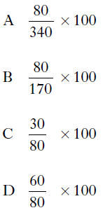

28. Two identical samples of copper(II) carbonate were added to an excess of 1 mol l^{–1}
hydrochloric acid and 1 mol l^{–1} sulphuric acid respectively.
Which of the following would have been different for the two reactions?
A The pH of the final solution
B The volume of gas produced
C The mass of water formed
D The mass of copper(II) carbonate dissolved

29. Which of the following is the best description of a feedstock?
A A consumer product such as a textile, plastic or detergent.
B A complex chemical that has been synthesised from small molecules.
C A mixture of chemicals formed by the cracking of the naphtha fraction from oil.
D A chemical from which other chemicals can be extracted or synthesised.
30. Which of the following compounds is a raw material in the chemical industry?
A Ammonia
B Calcium carbonate
C Hexane
D Nitric acid

31. The mean bond enthalpy of the N−H bond is equal to one third of the value of ΔH for
which change?
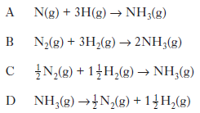

32. Ammonia is made by the Haber Process.
N_{2(g)} + 3H_{2(g)} 2NH_{3(g)}
The equilibrium position lies to the left. Which line in the table is correct?
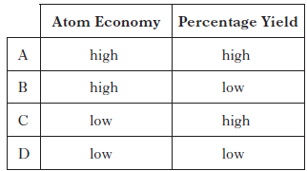

33. The flow chart summarises some industrial processes involving ethene.
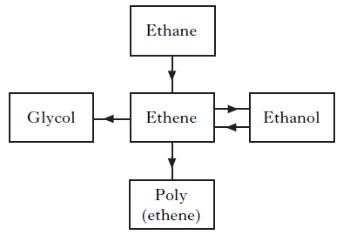

The feedstocks for ethene in these processes are
A ethane and glycol
B ethane and ethanol
C glycol and poly(ethene)
D glycol, poly(ethene) and ethanol.

34. Polylactic acid is used to make a biodegradable polymer. Polylactic acid can be manufactured by either a batch or a continuous process. What is meant by a batch process? (1)

35. Magnesium metal can be extracted from sea water.
An outline of the reactions involved is shown in the flow diagram.

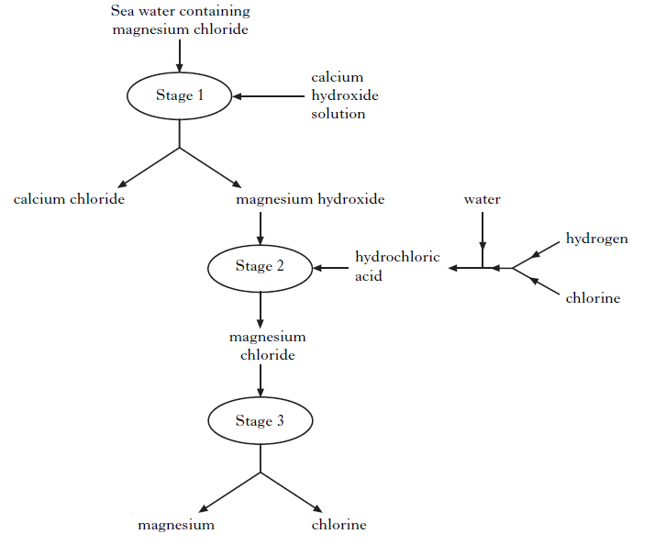

(a) Why can the magnesium hydroxide be easily separated from the calcium chloride at Stage 1? (1)

(b) Name the type of chemical reaction taking place at Stage 2. (1)

(c) Give two different features of this process that make it economical. (2)

36. Cerium metal is extracted from the mineral monazite.
The flow diagram for the extraction of cerium from the mineral is shown below.

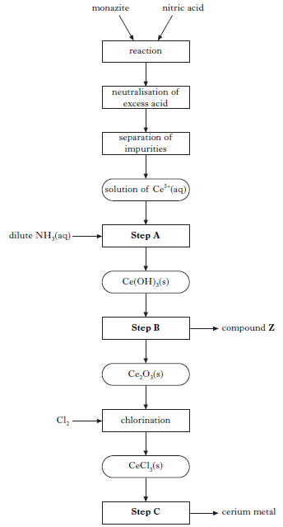

(a) Name the type of chemical reaction taking place in Step A. (1)

(b) In Step B, cerium hydroxide is heated to form cerium oxide, Ce₂O₃, and compound Z. Name compound Z. (1)

(c) In Step C, cerium metal is obtained by electrolysis. What feature of the electrolysis can be used to reduce the cost of cerium production? (1)

37. Ozone can be produced in the laboratory by electrical discharge.
3O_{2(g)} → 2O_{3(g)}
Calculate the approximate number of O_{3(g)} molecules produced from one mole of O_{2(g)} molecules. (1)

38. Chlorine gas can be produced by heating calcium hypochlorite, Ca(OCl)2, in dilute
hydrochloric acid.
Ca(OCl)_{2(s)} + 2HCl_{(aq)} → Ca(OH)_{2(aq)} + 2Cl_{2(g)}
Calculate the mass of calcium hypochlorite that would be needed to produce 0·096 litres of chlorine gas. (Take the molar volume of chlorine gas to be 24 litres mol^{–1}.)
Show your working clearly. (2)

39. A student bubbled 240 cm³ of carbon dioxide into 400cm³ of 0.10 mol l^{–1} lithium hydroxide solution.
The equation for the reaction is:
2LiOH_{(aq)} + CO_{2(g)} → Li₂CO_{3(aq)} + H₂O_{(l)}
Calculate the number of moles of lithium hydroxide that would not have reacted.
(Take the molar volume of carbon dioxide to be 24 litres mol^{–1}.)
Show your working clearly. (2)

40. (a) In the lab, nitrogen dioxide gas can be prepared by heating copper(II) nitrate.
Cu(NO₃)_{2(s)} → CuO_{(s)} + 2NO_{2(g)} + ½ O_{2(g)}
Calculate the volume of nitrogen dioxide gas produced when 2.0g of copper(II) nitrate is completely decomposed on heating. (Take the molar volume of nitrogen dioxide to be 24 litres mol^{–1}.) Show your working clearly. (2)

(b) Nitrogen dioxide has a boiling point of 22 °C. Complete the diagram to show how nitrogen dioxide can be separated and collected. (1)

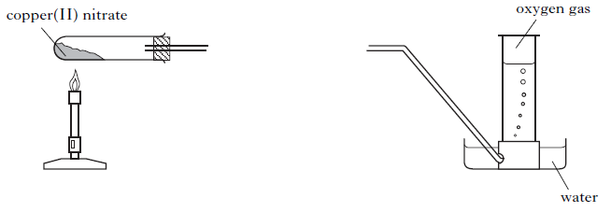

41. Sherbet contains a mixture of sodium hydrogencarbonate and tartaric acid. The
fizzing sensation in the mouth is due to the carbon dioxide produced in the
following reaction.
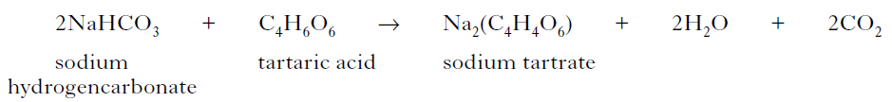
In an experiment, a student found that adding water to 20 sherbet sweets produced
105 cm³ of carbon dioxide. Assuming that sodium hydrogencarbonate is in excess, calculate the average mass of tartaric acid, in grams, in one sweet.
(Take the molar volume of carbon dioxide to be 24 litre mol^{–1}.)
Show your working clearly. (2)

42. The nutritional information states that 100 g of margarine contains 0.70 g of sodium. The sodium is present as sodium chloride (NaCl). Calculate the mass of sodium chloride, in g, present in every 100 g of margarine. (1)

43. Hydrogen fluoride gas is manufactured by reacting calcium fluoride with concentrated sulphuric acid.
CaF₂ + H₂SO₄ CaSO₄ + 2HF
What volume of hydrogen fluoride gas is produced when 1.0 kg of calcium fluoride reacts completely with concentrated sulphuric acid?
(Take the molar volume of hydrogen fluoride gas to be 24 litres mol–1.)
Show your working clearly. (2)

44. Methanamide, HCONH2, is widely used in industry to make nitrogen compounds.
It is also used as a solvent as it can dissolve ionic compounds.
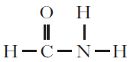

(a) Why is methanamide a suitable solvent for ionic compounds? (1)

(b) In industry, methanamide is produced by the reaction of an ester with ammonia.

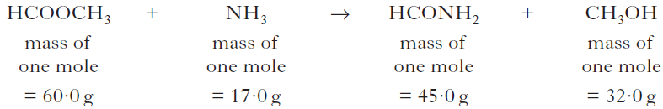

(i) Name the ester used in the industrial manufacture of methanamide. (1)

(ii) Calculate the atom economy for the production of methanamide. (1)

(c) In the lab, methanamide can be prepared by the reaction of methanoic acid
with ammonia.
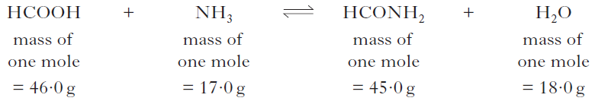

When 1·38 g of methanoic acid was reacted with excess ammonia, 0·945 g of methanamide was produced. Calculate the percentage yield of methanamide. Show your working clearly. (2)

45. Aspirin, a common pain-killer, can be made by the reaction of salicylic acid with
ethanoic anhydride.
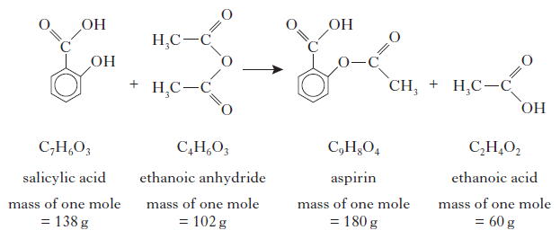
(a) Calculate the atom economy for the formation of aspirin using this method.
Show your working clearly. (2)

(b) In a laboratory preparation of aspirin, 5·02 g of salicylic acid produced 2·62 g
of aspirin. Calculate the percentage yield of aspirin. Show your working clearly. (2)

46. From the 1990s, ibuprofen has been synthesised by a three step process. The equation below shows the final step of the synthesis.

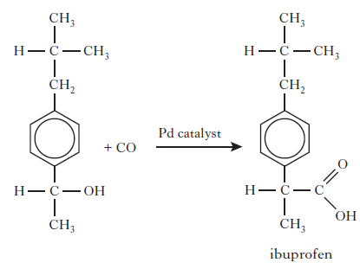
What is the atom economy of this step? (1)

47. One of the chemicals released in a bee sting is an ester that has the structure shown.
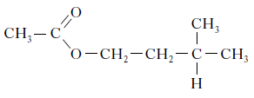
This ester can be produced by the reaction of 2-methylbutan-1-ol with ethanoic acid.
If there is a 65% yield, calculate the mass of ester produced, in grams, when 4.0 g of the alcohol reacts with a slight excess of the acid.
(Mass of one mole of the alcohol = 88 g; mass of one mole of the ester = 130 g)
Show your working clearly. (2)

48. Ammonia is produced in industry by the Haber Process.
N_{2(g)} + 3H_{2(g)} 2NH_{3(g)}
Under certain conditions, 500 kg of nitrogen reacts with excess hydrogen to produce
405 kg of ammonia. Calculate the percentage yield of ammonia under these conditions. Show your working clearly. (2)

49. Ethane-1,2-diol is produced in industry by reacting glycerol with hydrogen.
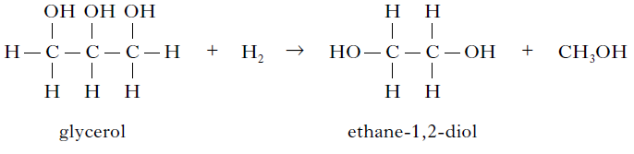
Excess hydrogen reacts with 27·6 kg of glycerol to produce 13·4 kg of ethane-1,2-diol.
Calculate the percentage yield of ethane-1,2-diol. Show your working clearly. (2)

50. Sulphur trioxide can be prepared in the laboratory by the reaction of sulphur dioxide
with oxygen.
2SO_{2(g)} + O_{2(g)} 2SO_{3(g)}
The sulphur dioxide and oxygen gases are dried by bubbling them through concentrated
sulphuric acid. The reaction mixture is passed over heated vanadium(V) oxide.
Sulphur trioxide has a melting point of 17 °C. It is collected as a white crystalline solid.

(a) Complete the diagram to show how the reactant gases are dried and the product is collected. (2)
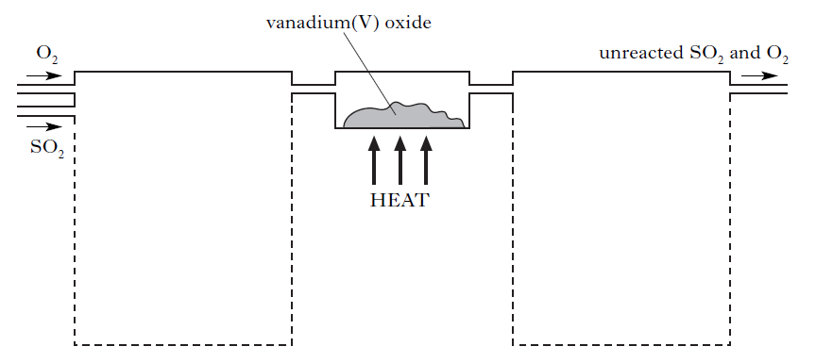
(b) Under certain conditions, 43·2 tonnes of sulphur trioxide are produced in the reaction of 51·2 tonnes of sulphur dioxide with excess oxygen. Calculate the percentage yield of sulphur trioxide. Show your working clearly. (2)

3.2 Equilibria

1. A catalyst is used in the Haber Process.
N_{2(g)} + 3H_{2(g)} 2NH_{3(g)}
Which of the following best describes the action of the catalyst?
A Increases the rate of the forward reaction only
B Increases the rate of the reverse reaction only
C Increases the rate of both the forward and reverse reactions
D Changes the position of the equilibrium of the reaction

2. In which of the following systems will the equilibrium be unaffected by a change in
pressure?
A 2NO_{2(g)} N₂O_{4(g)}
B H_{2(g)} + I_{2(g)} 2HI_{(g)}
C N_{2(g)} + 3H_{2(g)} 2NH_{3(g)}
D 2NO_{(g)} + O_{2(g)} 2NO_{2(g)}

3. A few drops of concentrated sulphuric acid were added to a mixture of 0·1 mol of
methanol and 0·2 mol of ethanoic acid. Even after a considerable time, the reaction mixture was found to contain some of each reactant. Which of the following is the best explanation for the incomplete reaction?
A The temperature was too low.
B An equilibrium mixture was formed.
C Insufficient methanol was used.
D Insufficient ethanoic acid was used.

4. Which line in the table shows the effect of a catalyst on the reaction rates and position of equilibrium in a reversible reaction?
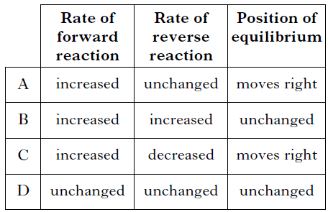

5. The following equilibrium exists in bromine water.
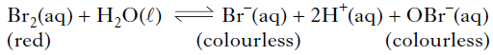
The red colour of bromine water would fade on adding a few drops of a concentrated
solution of
A HCl
B KBr
C AgNO3
D NaOBr.

6. A catalyst is added to a reaction at equilibrium. Which of the following does not apply?
A The rate of the forward reaction increases.
B The rate of the reverse reaction increases.
C The position of equilibrium remains unchanged.
D The position of equilibrium shifts to the right.

7. In which of the following reactions woulD an increase in pressure cause the equilibrium position to move to the left?
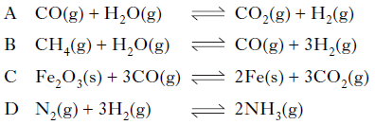

8. If ammonia is added to a solution containing copper(II) ions an equilibrium is set up.
Cu²⁺_{(aq)} + 2OH–_{(aq)} + 4NH_{3(aq)} Cu(NH₃)₄(OH)_{2(aq)}
(deep blue)
If acid is added to this equilibrium system
A the intensity of the deep blue colour will increase
B the equilibrium position will move to the right
C the concentration of Cu2+(aq) ions will increase
D the equilibrium position will not be affected.

9. Steam and carbon monoxide react to form an equilibrium mixture.
CO_{(g)} + H₂O_{(g)} H_{2(g)} + CO_{2(g)}
Which of the following graphs shows how the rates of the forward and reverse reactions
change when carbon monoxide and steam are mixed?
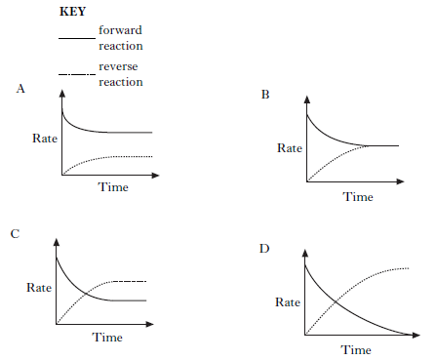

10. 2SO_{2(g)} + O2_{(g)} 2SO_{3(g)}
The equation represents a mixture at equilibrium. Which line in the table is true for the mixture after a further 2 hours of reaction?
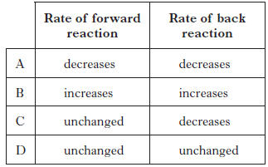

11. In which of the following would an increase in pressure result in the equilibrium position
being moved to the left?
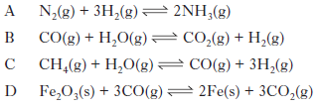

12. Nitrogen dioxide gas can be prepared in different ways. It is manufactured industrially as part of the Ostwald process. In the first stage of the process, nitrogen monoxide is produced by passing ammonia and oxygen over a platinum catalyst.
NH_{3(g)} + O_{2(g)} NO_{(g)} + H₂O_{(g)}

(a) Balance the above equation. (1)

(b) Platinum metal is a heterogeneous catalyst for this reaction. What is meant by a heterogeneous catalyst? (1)

(c) The nitrogen monoxide then combines with oxygen in an exothermic reaction to form nitrogen dioxide.
2NO_{(g)} + O_{2(g)} 2NO_{2(g)}
What happens to the yield of nitrogen dioxide gas if the reaction mixture is cooled? (1)

13. Atmospheric oxygen, O_{2(g),} dissolves in the Earth’s oceans forming dissolved oxygen, O_{2(aq)}, which is essential for aquatic life. An equilibrium is established.
O_{2(g)} + (aq) O_{2(aq)} ΔH = –12·1 kJ mol–1

(a) (i) What is meant by a reaction at “equilibrium”?

(ii) What would happen to the concentration of dissolved oxygen if the temperature of the Earth’s oceans increased?

(b) A sample of oceanic water was found to contain 0·010 g of dissolved oxygen.
Calculate the number of moles of dissolved oxygen present in the sample. (1)

14. When cyclopropane gas is heated over a catalyst, it isomerises to form propene gas and an equilibrium is obtained.

The graph shows the concentrations of cyclopropane and propene as equilibrium is established in the reaction.
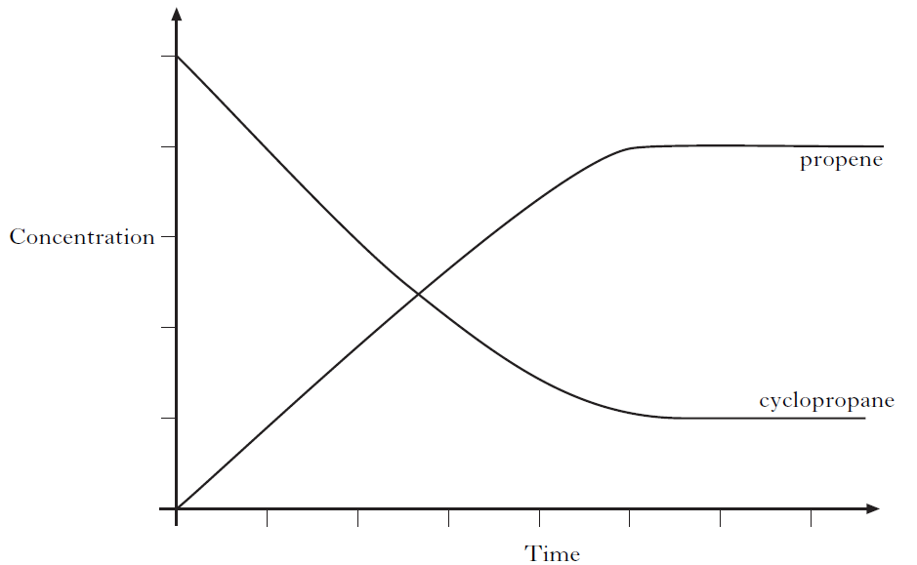
(a) Mark clearly on the graph the point at which equilibrium has just been reached. (1)

(b) Why does increasing the pressure have no effect on the position of this equilibrium? (1)
(c) The equilibrium can also be achieved by starting with propene.
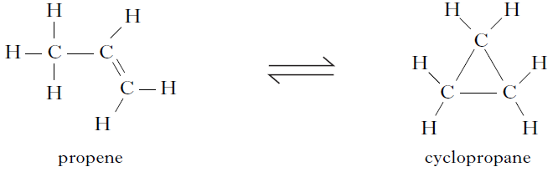
Using the initial concentrations shown, sketch a graph to show how the concentrations of propene and cyclopropane change as equilibrium is reached for the reverse reaction (1)
15. Tetrafluoroethene, C₂F₄, is produced in industry by a series of reactions. The final reaction in its manufacture is shown below.
2CHClF_{2(g)} C₂F_{4(g)} + 2HCl_{(g)}
The graph shows the variation in concentration of C₂F₄ formed as temperature is increased.
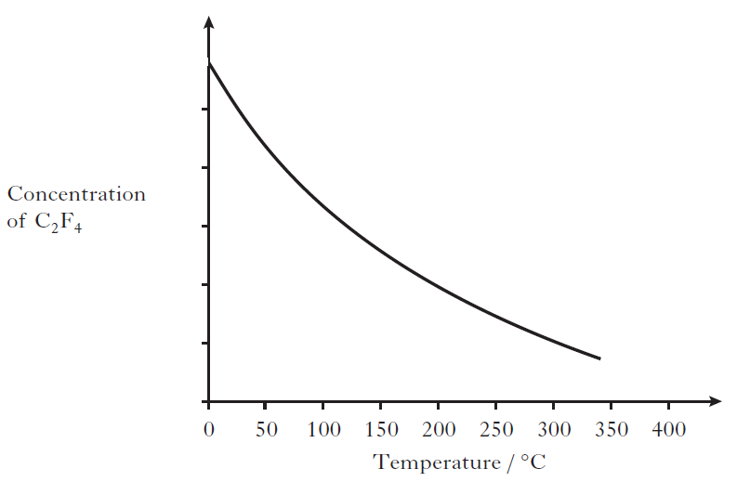
(a) What conclusion can be drawn about the enthalpy change for the formation of tetrafluoroethene? (1)

(b) Sketch a graph to show how the concentration of tetrafluoroethene formed would vary with increasing pressure. (1)

16. Ammonia is produced in industry by the Haber Process.
N_{2(g)} + 3H_{2(g)} 2NH_{3(g)}

(a) State whether the industrial manufacture of ammonia is likely to be a batch or a continuous process. (1)

(b) The graph shows how the percentage yield of ammonia changes with temperature at a pressure of 100 atmospheres.
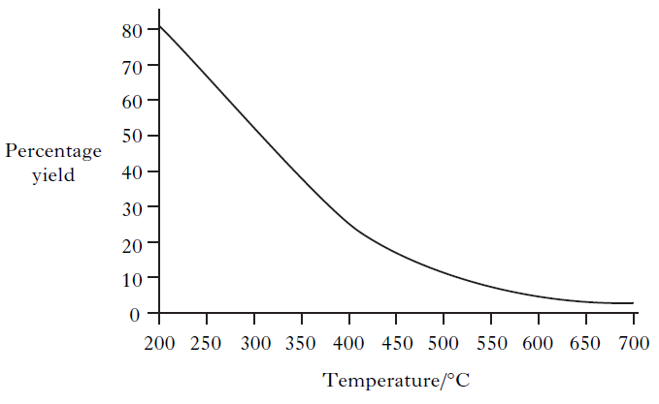
(i) A student correctly concludes from the graph that the production of ammonia is an exothermic process. What is the reasoning that leads to this conclusion? (1)

(ii) Explain clearly why the industrial manufacture of ammonia is carried out at a pressure greater than 100 atmospheres. (2)

17. Rivers and drains are carefully monitored to ensure that they remain uncontaminated by potentially harmful substances from nearby industries. Chromate ions, CrO42–, are particularly hazardous.
When chromate ions dissolve in water the following equilibrium is established.
2CrO4^{2–}_{(aq)} + 2H⁺(aq) Cr₂O₇ 2–_{(aq)} + H₂O_{(l)}
yellow orange
Explain fully the colour change that would be observed when solid sodium hydroxide is added to the solution. (2)

3.3 Chemical Energy

1. Which of the following represents an exothermic process?
A Cl_{2(g)} → 2Cl_{(g)}
B Na_{(s)} → Na_{(g)}
C Na_{(g)} → Na⁺_{(g)} + e–
D Na⁺_{(g)} + Cl–_{(g)} → Na⁺Cl–_{(s)}

2. Which of the following equations represents an enthalpy of combustion?
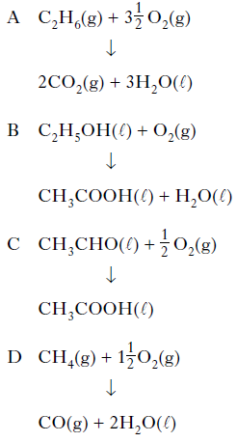

3. The enthalpy of combustion of methanol is –727 kJ mol^{–1}. What mass of methanol has to be burned to produce 72·7 kJ?
A 3·2 g
B 32·0 g
C 72·7 g
D 727·0 g

4. 5N₂O_{4(l)} + 4CH₃NHNH_{2(l)} → 4CO_{2(g)} + 12H₂O_{(l)} + 9N_{2(g)} ΔH = −5116 kJ
The energy released when 2 moles of each reactant are mixed and ignited is
A 2046 kJ
B 2558 kJ
C 4093 kJ
D 5116 kJ.

5. Aluminium reacts with oxygen to form aluminium oxide.
2Al_{(s)} + 1½O_{2(g)} → Al₂O_{3(s)} ΔH = −1670 kJ mol−1
What is the enthalpy of combustion of aluminium in kJ mol⁻¹?
A −835
B −1113
C −1670
D +1670
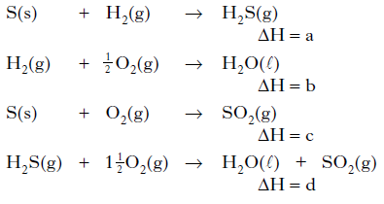
6.

What is the relationship between a, b, c and d?
A a = b + c – d
B a = d – b – c
C a = b – c – d
D a = d + c – b

7. Given the equations
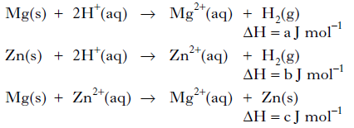
then, according to Hess’s Law
A c = a – b
B c = a + b
C c = b – a
D c = – b – a.

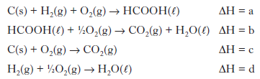
8.

What is the relationship between a, b, c and d?
A a = c + d − b
B a = b − c − d
C a = −b − c − d
D a = c + b + d

9. In the presence of bright light, hydrogen and chlorine react explosively. One step in the reaction is shown below.
H_{2(g)} + Cl_{(g)} → HCl_{(g)} + H_{(g)}
The enthalpy change for this step can be represented as
A (H-H bond enthalpy) + (Cl-Cl bond enthalpy)
B (H-H bond enthalpy) − (Cl-Cl bond enthalpy)
C (H-H bond enthalpy) + (H-Cl bond enthalpy)
D (H-H bond enthalpy) − (H-Cl bond enthalpy).

10. The energy changes taking place during chemical reactions have many everyday uses.
(a) Some portable cold packs make use of the temperature drop that takes place when the chemicals in the pack dissolve in water.
Name the type of reaction that results in a fall in temperature. (1)

(b) Flameless heaters are used by mountain climbers to heat food and drinks. The chemical reaction in a flameless heater releases 45 kJ of energy. If 200 g of water is heated using this heater, calculate the rise in temperature of the water, in °C. (1)

11. The compound diborane (B₂H₆) is used as a rocket fuel.
(a) It can be prepared as shown.
BF₃ + NaBH₄ → B₂H₆ + NaBF₄
Balance this equation. (1)

(b) The equation for the combustion of diborane is shown below.
B₂H_{6(g)} + 3O_{2(g)} → B₂O_{3(s)} + 3H₂O_{(l)}
Calculate the enthalpy of combustion of diborane (B2H6) in kJ mol−1, using the following data. (2)
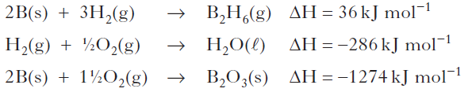

12. Hydrogen peroxide decomposes as shown:
H₂O_{2(aq)} → H₂O_{(l)} + ½ O_{2(g)}
The reaction can be catalysed by iron(III) nitrate solution.

(a) What type of catalyst is iron(III) nitrate solution in this reaction? (1)

(b) In order to calculate the enthalpy change for the decomposition of hydrogen peroxide, a student added iron(III) nitrate solution to hydrogen peroxide solution.
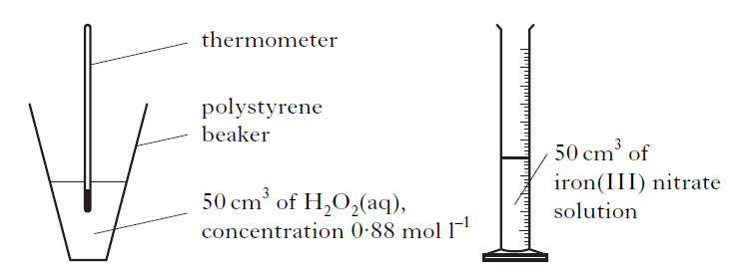
As a result of the reaction, the temperature of the solution in the polystyrene beaker
increased by 16 °C.
(i) What is the effect of the catalyst on the enthalpy change (ΔH) for the reaction? (1)

(ii) Use the experimental data to calculate the enthalpy change, in kJ mol–1, for the decomposition of hydrogen peroxide. Show your working clearly. (3)

13. A student used the simple laboratory apparatus shown to determine the enthalpy of combustion of methanol.
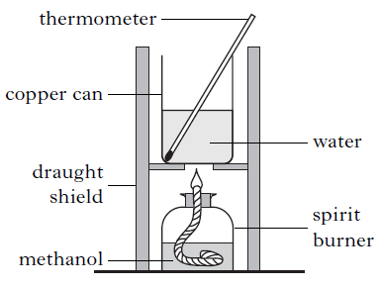
(a) (i) What measurements are needed to calculate the energy released by the burning methanol? (1)
(ii) The student found that burning 0.370 g of methanol produces 3.86 kJ of energy.
Use this result to calculate the enthalpy of combustion of methanol. (1)

(b) A more accurate value can be obtained using a bomb calorimeter.
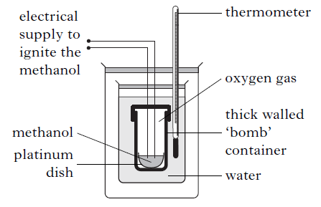
One reason for the more accurate value is that less heat is lost to the surroundings than in the simple laboratory method. Give one other reason for the value being more accurate in the bomb calorimeter method. (1)

14. Mobile phones are being developed that can be powered by methanol. Methanol can be made by a two-stage process.
In the first stage, methane is reacted with steam to produce a mixture of carbon monoxide and hydrogen.
CH_{4(g)} + H₂O_{(g)} CO_{(g)} + 3H_{2(g)}
Use the data below to calculate the enthalpy change, in kJ mol^{–1}, for the forward reaction.
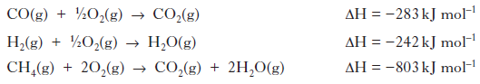
Show your working clearly. (2)

15. The enthalpies of combustion of some alcohols are shown in the table.
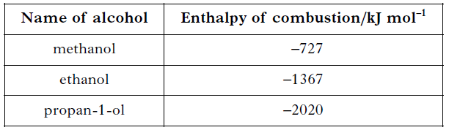

(a) Using this data, predict the enthalpy of combustion of butan-1-ol, in kJ mol–1. (1)

(b) A value for the enthalpy of combustion of butan-2-ol, C₄H₉OH, can be determined experimentally using the apparatus shown.

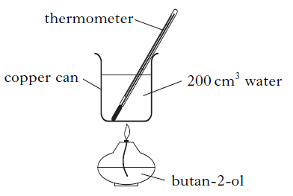
Mass of butan-2-ol burned = 1·0 g
Temperature rise of water = 40 °C
Use these results to calculate the enthalpy of combustion of butan-2-ol, in kJ mol^{–1}. (2)
(c) Enthalpy changes can also be calculated using Hess’s Law. The enthalpy of formation for pentan-1-ol is shown below.
5C_{(s)} + 6H_{2(g)} + ½ O_{2(g)} → C₅H₁₁OH_{(l)} ΔH = –354 kJ mol^{–1}
Using this value, and the enthalpies of combustion of carbon and hydrogen from the data booklet, calculate the enthalpy of combustion of pentan-1-ol, in kJ mol^{–1}. (2)

16. Different fuels are used for different purposes.
(a) Ethanol, C₂H₅OH, can be used as a fuel in some camping stoves.
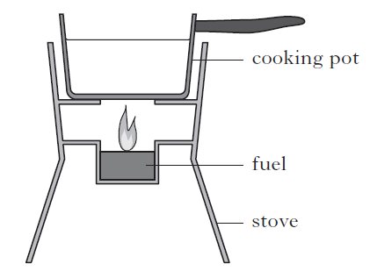
(i) The enthalpy of combustion of ethanol given in the data booklet is
−1367 kJ mol⁻¹. Using this value, calculate the mass of ethanol, in g, required to raise the temperature of 500 g of water from 18 °C to 100 °C. Show your working clearly. (3)

(ii) Suggest two reasons why less energy is obtained from burning ethanol in the camping stove than is predicted from its enthalpy of combustion. (2)

(b) Petrol is a fuel used in cars.
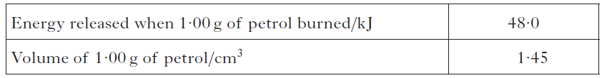
A car has a 50·0 litre petrol tank. Calculate the energy, in kJ, released by the complete combustion of one tank of petrol. (2)

17. Hydrogen has been named as a ‘fuel for the future’. In a recent article researchers
reported success in making hydrogen from glycerol:
C₃H₈O_{3(l)} → CO_{2(g)} + CH_{4(g)} + H_{2(g)}

(a) Balance this equation. (1)

(b) The enthalpy of formation of glycerol is the enthalpy change for the reaction:
3C_{(s)} + 4H_{2(g)} + 1½O_{2(g)} → C₃H₈O_{3(l)}
(graphite)

Calculate the enthalpy of formation of glycerol, in kJ mol^{–1}, using information from the data booklet and the following data.
C₃H₈O_{3(l)} + 3½O_{2(g)} → 3CO_{2(g)} + 4H₂O_{(l)} ΔH = –1654 kJ mol^{–1}
Show your working clearly. (2)

18. The equation for the enthalpy of formation of ethyne is:
2C_{(s)} + H_{2(g)} C₂H_{2(g)}
Use the enthalpies of combustion of carbon, hydrogen and ethyne given in the data booklet to calculate the enthalpy of formation of ethyne, in kJ mol–¹. Show your working clearly. (2)

19. Chloromethane can be produced by the reaction of methane with chlorine.
CH_{4(g)} + Cl_{2(g)} → CH₃Cl_{(g)} + HCl_{(g)}
Using bond enthalpies from the data booklet, calculate the enthalpy change, in
kJ mol⁻¹, for this reaction. (2)

20. The production of hydrogen chloride from hydrogen and chlorine is exothermic.
H_{2(g)} + Cl_{2(g)} → 2HCl_{(g)}
Using bond enthalpy values, calculate the enthalpy change, in kJ mol⁻¹, for this reaction. (2)

21. When in danger, bombardier beetles can fire a hot, toxic mixture of chemicals at the
attacker. This mixture contains quinone, C₆H₄O₂, a compound that is formed by the reaction of hydroquinone, C₆H₄(OH)₂, with hydrogen peroxide, H₂O₂. The reaction is catalysed by an enzyme called catalase.

(a) Most enzymes can catalyse only specific reactions, eg catalase cannot catalyse the hydrolysis of starch. Give a reason for this. (1)

(b) The equation for the overall reaction is:
C₆H₄(OH)_{2(aq)} + H₂O_{2(aq)} C₆H₄O_{2(aq)} + 2H₂O(l)
Use the following data to calculate the enthalpy change, in kJ mol^{–1}, for the above
reaction.
C₆H₄(OH)_{2(aq}) → C₆H₄O_{2(aq)} + H_{2(g)} ΔH = +177.4 kJ mol^{–1}
H_{2(g)} + O_{2(g)} → H₂O_{2(aq)} ΔH = –191.2 kJ mol^{–1}
H_{2(g)} + ½ O_{2(g)} → H₂O_{(g)} ΔH = –241.8 kJ mol^{–1}
H₂O_{(g)} → H₂O_{(l)} ΔH = –43.8 kJ mol^{–1}
Show your working clearly. (2)

22. (a) Methane is produced in the reaction of aluminium carbide with water.
Al₄C₃ + H₂O → Al(OH)₃ + CH₄
Balance the above equation. (1)

(b) Silane, silicon hydride, is formed in the reaction of silicon with hydrogen.
Si_{(s)} + 2H_{2(g)} → SiH_{4(g)}
silane

The enthalpy change for this reaction is called the enthalpy of formation of silane.
The combustion of silane gives silicon dioxide and water.
SiH_{4(g)} + 2O_{2(g)} → SiO_{2(s)} + 2H₂O_{(l)} ΔH = –1517 kJ mol^{–1}
The enthalpy of combustion of silicon is –911 kJ mol^{–1}.
Use this information and the enthalpy of combustion of hydrogen in the data booklet to calculate the enthalpy of formation of silane, in kJ mol–¹. Show your working clearly. (2)

23. (a) Hess’s Law can be verified using the reactions summarised below.
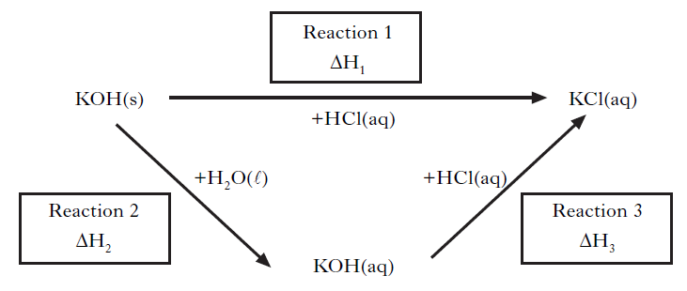
(i) Complete the list of measurements that would have to be carried out in order to determine the enthalpy change for Reaction 2. (1)

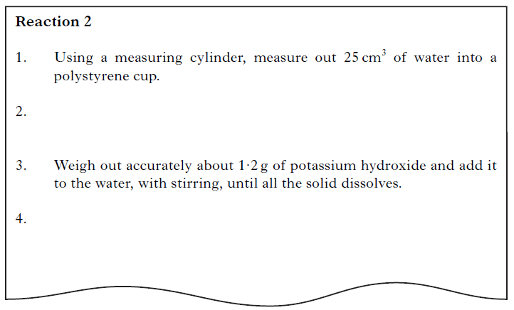
(ii) Why was the reaction carried out in a polystyrene cup? (1)

(iii) A student found that 1·08kJ of energy was released when 1·2 g of potassium hydroxide was dissolved completely in water. Calculate the enthalpy of solution of potassium hydroxide. (1)

(b) A student wrote the following incorrect statement.
The enthalpy of neutralisation for hydrochloric acid reacting with potassium hydroxide is less than that for sulphuric acid reacting with potassium hydroxide because fewer moles of water are formed as shown in these equations.
HCl + KOH → KCl + H₂O
H₂SO₄ + 2KOH → K₂SO₄ + 2H₂O
Explain the mistake in the student’s statement. (1)

3.4 Oxidising or Reducing Agents

1. The iodate ion, IO3–, can be converted to iodine.
Which is the correct ion-electron equation for the reaction?
A 2IO3–_{(aq)} + 12H⁺_{(aq)} + 12e– 2I–_{(aq)} + 6H₂O_{(l)}
B IO3–_{(aq)} + 6H⁺_{(aq)} + 7e– I–_{(aq)} + 3H₂O_{(l)}
C 2IO3–_{(aq)} + 12H⁺_{(aq)} + 11e– I_{2(aq)} + 6H₂O_{(l)}
D 2IO3–_{(aq)} + 12H⁺_{(aq)} + 10e– I_{2(aq)} + 6H₂O_{(l)}

2. Which of the following is a redox reaction?
A Mg + 2HCl MgCl₂ + H₂
B MgO + 2HCl MgC_{l2} + H₂O
C MgCO₃ + 2HCl MgCl₂ + H₂O + CO₂
D Mg(OH)₂ + 2HCl MgCl₂ + 2H₂O

3. The ion-electron equations for a redox reaction are:
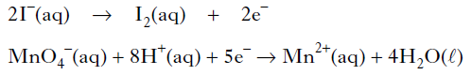
How many moles of iodide ions are oxidized by one mole of permanganate ions?
A 0.2
B 0.4
C 2
D 5

4. In which of the following reactions is the hydrogen ion acting as an oxidising agent?
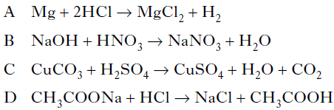

5. During a redox process in acid solution, iodate ions IO₃⁻_{(aq)} are converted into iodine I_{2(aq).}
IO₃⁻_{(aq)} → I_{2(aq)}
The numbers of H⁺(_{aq)} and H₂O_{(l)} required to balance the ion-electron equation for the
formation of 1 mol of I_{2(aq)} are, respectively
A 3 and 6
B 6 and 3
C 6 and 12
D 12 and 6.

6. In which of the following reactions is a positive ion reduced?
A Iodide iodine
B Nickel(II) nickel(III)
C Cobalt(III) cobalt(II)
D Sulphate sulphite

7. In which reaction is hydrogen gas acting as an oxidising agent?
A H₂ + CuO → H₂O + Cu
B H₂ + C₂H₄ → C₂H₆
C H₂ + Cl₂ → 2HCl
D H₂ + 2Na → 2NaH

8. Iodide ions can be oxidised using acidified potassium permanganate solution.
The equations are:
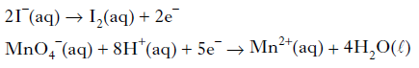
How many moles of iodide ions are oxidized by one mole of permanganate ions?
A 1.0
B 2.0
C 2.5
D 5.0

9. During a redox process in acid solution, iodate ions are converted into iodine.
2IO₃–_{(aq)} + 12H⁺_{(aq)} + xe– → I_{2(aq)} + 6H₂O_{(l)}
To balance the equation, what is the value of x?
A 2
B 6
C 10
D 12

10. The following reactions take place when nitric acid is added to zinc.
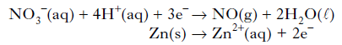
How many moles of NO3– _{(aq)} are reduced by one mole of zinc?
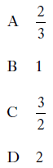

11. One of the reactions taking place within a carbon monoxide sensor is
2CO + 2H₂O → 2CO₂ + 4H⁺ + 4e⁻
This reaction is an example of
A reduction
B redox
C oxidation
D hydration.

12. The concentration of ethanol in a person’s breath can be determined by measuring the voltage produced in an electrochemical cell.
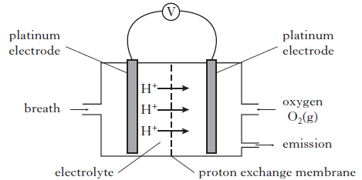
Different ethanol vapour concentrations produce different voltages as is shown in
the graph below.

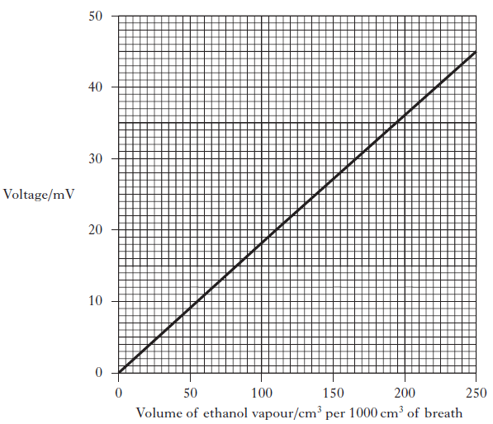

(a) Calculate the mass of ethanol, in g, in 1000 cm3 of breath when a voltage of 20 mV was recorded. (Take the molar volume of ethanol, C₂H₅OH, vapour to be
24 litres mol⁻¹.) Show your working clearly. (3)

(b) The ion-electron equations for the reduction and oxidation reactions occurring in the cell are shown below.
O₂ + 4H⁺ + 4e⁻ → 2H₂O
CH₃CH₂OH + H₂O → CH₃COOH + 4H⁺ + 4e⁻
Write the overall redox equation for the reaction taking place. (1)

13. Oxalic acid is found in rhubarb. The number of moles of oxalic acid in a carton of rhubarb juice can be found by titrating samples of the juice with a solution of potassium permanganate, a powerful oxidising agent.
The equation for the overall reaction is:
5(COOH)_{2(aq)} + 6H⁺_{(aq)} + 2MnO₄ –_{(aq)} → 2Mn²⁺ _{(aq)} + 10CO2(aq) + 8H₂O_{(l)}

(a) Write the ion-electron equation for the reduction reaction. (1)

(b) Why is an indicator not required to detect the end-point of the titration? (1)

3.5 Chemical Analysis

1. An organic chemist is attempting to synthesise a fragrance compound by the following chemical reaction.
compound X + compound Y → fragrance compound
After one hour, a sample is removed and compared with pure samples of compounds X and Y using thin-layer chromatography. Which of the following chromatograms shows that the reaction has produced a pure sample of the fragrance compound?
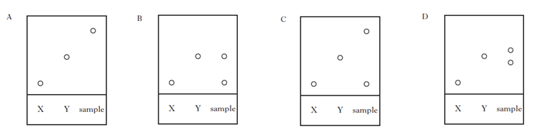

2. The alcohol content of wine was analysed by four students. Each student carried out the experiment three times.
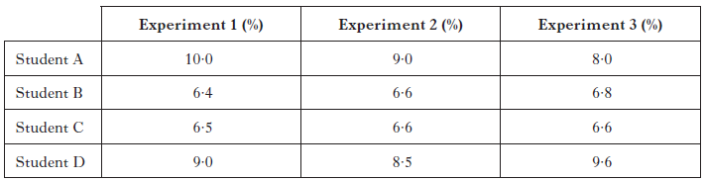

The most reproducible results were obtained by
A Student A
B Student B
C Student C
D Student D

3. 45 cm³ of a solution could be most accurately measured out using a
A 50 cm³ beaker
B 50 cm³ burette
C 50 cm³ pipette
D 50 cm³ measuring cylinder.

4. Aluminium carbonate can be produced by the following reaction.
2AlCl_{3(aq)} + 3K₂CO_{3(aq)} → Al₂(CO₃)_{3(s)} + 6KCl_{(aq)}
The most suitable method for obtaining a sample of the aluminium carbonate is
A collection over water
B distillation
C evaporation
D filtration.

5. Seaweeds are a rich source of iodine in the form of iodide ions. The mass of iodine in a seaweed can be found using the procedure outlined below.

(a) Step 1
The seaweed is dried in an oven and ground into a fine powder. Hydrogen peroxide solution is then added to oxidise the iodide ions to iodine molecules.
The ion-electron equation for the reduction reaction is shown.
H₂O_{2(aq)} + 2H⁺_{(aq)} + 2e– → 2H₂O_{(l)}
Write a balanced redox equation for the reaction of hydrogen peroxide with iodide ions. (1)

(b) Step 2
Using starch solution as an indicator, the iodine solution is then titrated with sodium thiosulphate solution to find the mass of iodine in the sample. The balanced equation for the reaction is shown.
2Na₂S₂O_{3(aq)} + I_{2(aq)} → 2NaI_{(aq)} + Na₂S₄O_{6(aq)}
In an analysis of seaweed, 14.9cm³ of 0.00500 mol l^{–1} sodium thiosulphate solution was required to reach the end-point. Calculate the mass of iodine present in the seaweed sample. Show your working clearly. (3)

6. Oxalic acid is found in rhubarb. The number of moles of oxalic acid in a carton of rhubarb juice can be found by titrating samples of the juice with a solution of potassium permanganate, a powerful oxidising agent.
The equation for the overall reaction is:
5(COOH)_{2(aq)} + 6H⁺_{(aq)} + 2MnO₄ –_{(aq)} → 2Mn²⁺ _{(aq)} + 10CO2(aq) + 8H₂O_{(l)}

(a) Write the ion-electron equation for the reduction reaction. (1)

(b) Why is an indicator not required to detect the end-point of the titration? (1)

(c) In an investigation using a 500 cm³ carton of rhubarb juice, separate 25.0cm³ samples were measured out. Three samples were then titrated with 0.040 mol l^{–1} potassium permanganate solution, giving the following results.
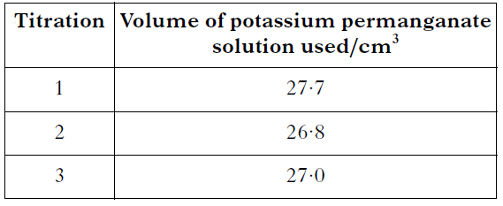

Average volume of potassium permanganate solution used = 26.9cm³.
(i) Why was the first titration result not included in calculating the average volume of potassium permanganate solution used? (1)

(ii) Calculate the number of moles of oxalic acid in the 500 cm³ carton of rhubarb juice.
Show your working clearly. (2)

7. The number of moles of carbon monoxide in a sample of air can be measured as follows.

Step 1 The carbon monoxide reacts with iodine(V) oxide, producing iodine.
5CO_{(g)} + I₂O_{5(s)} → I_{2(s)} + 5CO_{2(g)}

Step 2 The iodine is then dissolved in potassium iodide solution and titrated
against sodium thiosulphate solution.
I_{2(aq)} + 2S₂O₃^{2–}_{(aq)} → S₄O₆^{2–}_{(aq)} + 2I–_{(aq)}

(a) Write the ion-electron equation for the oxidation reaction in Step 2. (1)

(b) Name a chemical that can be used to indicate when all of the iodine has been
removed in the reaction taking place in Step 2. (1)

(c) If 50.4cm³ of 0.10 mol l^{–1} sodium thiosulphate solution was used in a titration,
calculate the number of moles of carbon monoxide in the sample of air.
Show your working clearly. (2)

8. A major problem for the developed world is the pollution of rivers and streams by nitrite and nitrate ions. The concentration of nitrite ions, NO₂ ^{–(}aq), in water can be determined by titrating samples against acidified permanganate solution.

(a) Suggest two points of good practice that should be followed to ensure that an accurate end-point is achieved in a titration.

(b) An average of 21·6cm³ of 0·0150 mol l^{–1} acidified permanganate solution was required to react completely with the nitrite ions in a 25·0 cm³ sample of river water. The equation for the reaction taking place is:
2MnO₄– _{(aq)} + 5NO₂–_{(aq)} + 6H⁺_{(aq)} → 2Mn²⁺_{(aq)} + 5NO₃–_{(aq)} + 3H₂O_{(l)}

(i) Calculate the nitrite ion concentration, in mol l^{–1}, in the river water. Show your working clearly. (2)

(ii) During the reaction the nitrite ion is oxidised to the nitrate ion. Complete the ion-electron equation for the oxidation of the nitrite ions.
NO₂–_{(aq)} → NO₃–_{(aq)} (1)

9. (a) The concentration of chromate ions in water can be measured by titrating with a solution of iron(II) sulphate solution. To prepare the iron(II) sulphate solution used in this titration, iron(II) sulphate crystals were weighed accurately into a dry beaker. Describe how these crystals should be dissolved and then transferred to a standard flask in order to produce a solution of accurately known concentration. (2)

(b) A 50·0cm³ sample of contaminated water containing chromate ions was titrated and found to require 27·4 cm³ of 0·0200 mol l^{–1} iron(II) sulphate solution to reach the end-point. The redox equation for the reaction is:
3Fe²⁺_{(aq)} + CrO₄^{2–}_{(aq)} + 8H⁺_{(aq)} → 3Fe³⁺_{(aq)} + Cr³⁺_{(aq)} + 4H₂O_{(l)}
Calculate the chromate ion concentration, in mol l^{–1}, present in the sample of water. Show your working clearly. (2)

10. Hydrogen sulfide, H₂S, can cause an unpleasant smell in water supplies. The concentration of hydrogen sulfide can be measured by titrating with a chlorine standard solution. The equation for the reaction taking place is
4Cl_{2(aq)} + H₂S_{(aq)} + 4H₂O_{(l)} → SO₄²⁻_{(aq)} + 10H⁺_{(aq)} + 8Cl⁻_{(aq)}
50·0 cm³ samples of water were titrated using a 0∙010 mol l⁻¹ chlorine solution.

(a) Name an appropriate piece of apparatus which could be used to measure out the water samples. (1)

(b) What is meant by the term standard solution? (1)

(c) An average of 29·4 cm³ of 0∙010 mol l⁻¹ chlorine solution was required to react completely with a 50·0 cm³ sample of water. Calculate the hydrogen sulfide concentration, in mol l⁻¹, present in the water sample. Show your working clearly. (3)

11. Zinc is an essential element for the body and is found in a variety of foods.
(a) The mass of zinc in four 100 g samples taken from a cheese spread was measured.
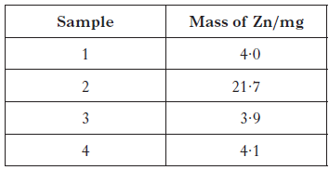

Calculate the average mass of Zn, in mg, in 100 g of this cheese spread. (1)

(b) The recommended daily allowance of zinc is 9·5 mg for an adult male. 100 g of peanuts contains 3·3 mg of zinc. Calculate the mass of peanuts which would provide the recommended daily allowance of zinc. (2)

12. Solutions containing iodine are used to treat foot rot in sheep. The concentration of iodine in a solution can be determined by titrating with a solution of thiosulfate ions.
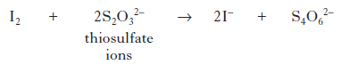
(a) Write an ion-electron equation for the reaction of the oxidising agent in the titration. (1)

(b) Three 20·0 cm³ samples of a sheep treatment solution were titrated with 0·10 mol l^{–1} thiosulfate solution. The results are shown below.

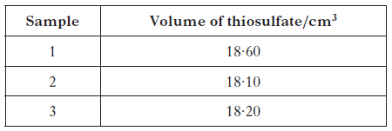

(i) Why is the volume of sodium thiosulfate used in the calculation taken to be
18·15 cm³, although this is not the average of the three titres in the table? (1)

(ii) Calculate the concentration of iodine, in mol l^{–1}, in the foot rot treatment solution. Show your working clearly. (3)

(iii) Describe how to prepare 250 cm³ of a 0·10 mol l⁻¹ standard solution of sodium thiosulfate, Na₂S₂O₃. Your answer should include the mass, in g, of sodium thiosulfate required. (3)

13. A student carried out an investigation to measure the nitrite level in the school water supply. A compound, which reacts with the nitrite ions to form a product that absorbs light, is added to water samples. The higher the concentration of nitrite ions present in a water sample, the greater the amount of light absorbed.

(a) The student prepared potassium nitrite solutions of known concentration by diluting samples from a stock solution.

(i) Calculate the mass, in mg, of potassium nitrite, KNO₂, needed to make 1 litre of stock solution with a nitrite ion concentration of 250 mg l^{–1}. (2)

(ii) Describe how the weighed potassium nitrate is dissolved to prepare the stock solution to ensure that its concentration is accurately known. (2)

(iii) Why should the student use distilled or deionised water rather than tap water when dissolving the potassium nitrite? (1)

(iv) To prepare a solution with a nitrite ion concentration of 0·05 mg l^{–1} the student dilutes the stock solution. Why is this method more accurate than preparing a solution by weighing out potassium nitrite? (1)

(b) The graph below shows results for five solutions of potassium nitrite and a sample of distilled water.
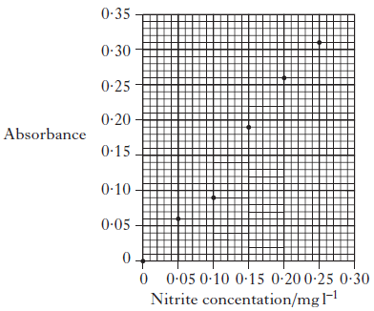

The results for four tap water samples are shown below.
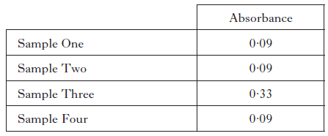

What is the concentration of nitrite ions, in mg l^{–1}, in the tap water? (2)
14. Soft drinks contain many ingredients. Caffeine is added to some soft drinks. The concentration of caffeine can be found using chromatography. A chromatogram for a standard solution containing 50 mg l⁻¹ of caffeine is shown below.

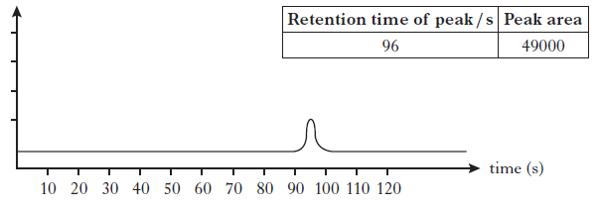

Results from four caffeine standard solutions were used to produce the calibration graph below.
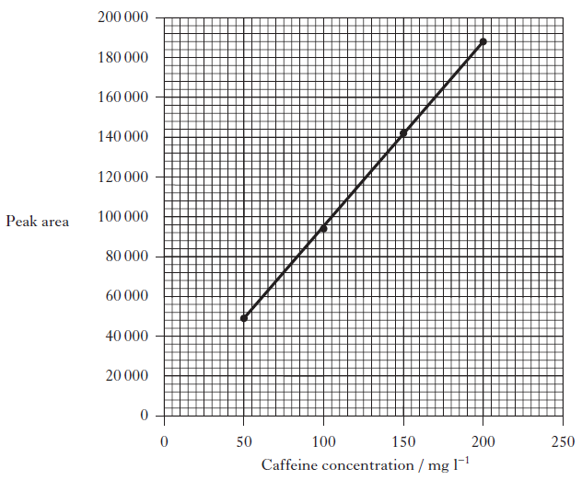

Chromatograms for two soft drinks are shown below.

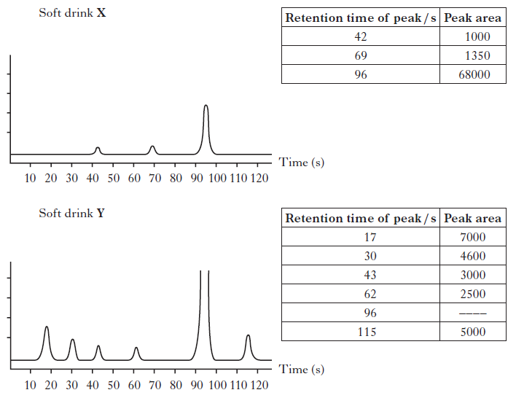

(a) What is the caffeine content, in mg l−1 of soft drink X? (1)

(b) The caffeine content of the soft drink Y cannot be determined from its chromatogram. What should be done to the sample of soft drink Y so that the caffeine content could be reliably calculated? (1)

15. When forensic scientists analyse illegal drugs, anaesthetics such as lidocaine, benzocaine and tetracaine are sometimes found to be present. The gas chromatogram below is from an illegal drug.
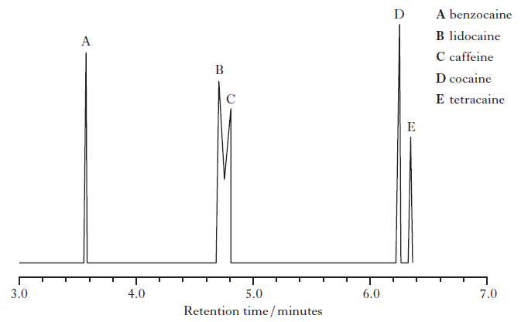
(a) The structures of lidocaine, benzocaine and tetracaine are shown below.
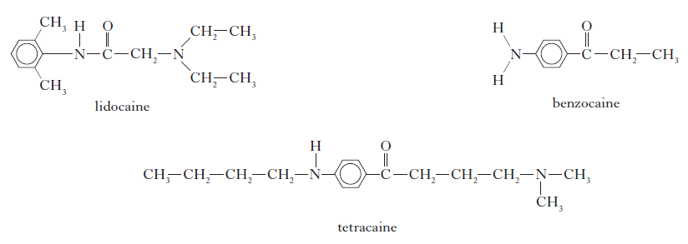
Suggest why benzocaine has a shorter retention time than tetracaine. (1)

(b) Why is it difficult to obtain accurate values for the amount of lidocaine present in a sample containing large amounts of caffeine? (1)

(c) Add a peak to the diagram below to complete the chromatogram for a second sample that only contains half the amount of tetracaine compared to the first. (1)
