St Andrews Academy

National 5 Chemistry

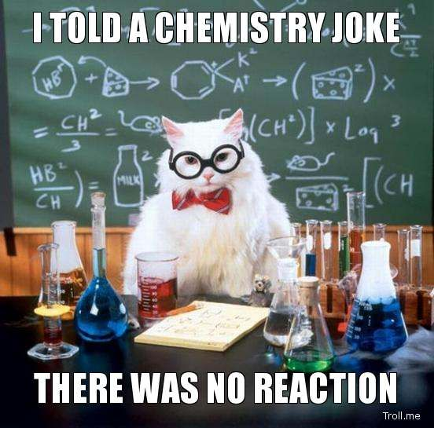

Unit 2 Homework

Natures Chemistry

Homework 1 – Fuels

1. Carbon burns in an exothermic reaction to form carbon dioxide.
2. Explain what is meant by an exothermic reaction.
3. Write an equation, using symbols and formulae, for the combustion of carbon.
4. What is the test for oxygen?
5. What is the test for carbon dioxide?
6. Wood is a solid fuel.
7. What is meant by the word fuel?
8. What gas is used up when coal burns?
9. Name the three things needed for burning to happen.
10. Carbon is an important fuel. Depending on the conditions of combustion it may burn to produce carbon monoxide or carbon dioxide.
11. Give the formulae for (i) oxygen (ii) carbon monoxide (iii) carbon dioxide
12. Under what conditions will carbon burn to make carbon monoxide?
13. Write an equation for the reaction in which carbon burns to form carbon monoxide.
14. Write a balanced equation for the reaction in which carbon burns to form carbon dioxide.
15. Hydrogen is a useful fuel. It is often used to power rockets.
16. What is the test for hydrogen gas?
17. What is the formula of hydrogen?
18. Write a balanced equation for hydrogen burning.
19. Read the following passage and use the information to answer the questions.

Biomass fuel is the name given to renewable fuels obtained from living things. The most commonly used biomass fuel is wood. In many parts of the world, wood is the main fuel used for domestic heating and cooking. Charcoal and wood-alcohol are biomass fuels made from wood. Charcoal can be used in solid fuel heaters, while wood-alcohol is used as a liquid fuel. Charcoal is produced by heating wood in the absence of air. This process is called destructive distillation. The process also produces a mixture of gases which can be condensed to form an oily liquid. Wood-alcohol is obtained from this liquid. Sugar cane can be used to produce another liquid biomass fuel called ethanol. Sugar, which is extracted from sugar cane plants, is converted to ethanol by the process of fermentation. Ethanol can be burned to produce heat energy or used in a fuel cell to produce electrical energy.

1. What is the most commonly used biomass fuel?
2. Describe how charcoal is produced.
3. What happens during the process of fermentation?
4. Name two liquid biomass fuels.

Homework 2 – Combustion

1. A pupil tries to identify the products of combustion of various gases. To do this she sets up the experiment shown below.

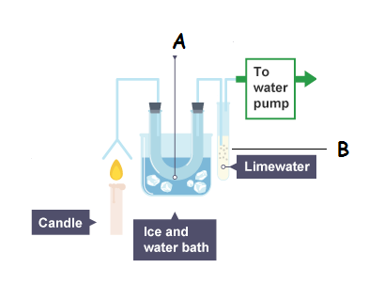

1. What could be trapped in beaker A. How would you test for this substance?
2. What is the purpose of the container with lime water?
3. What would you see at A and B if the following gases were burned at X?
4. Hydrogen
5. Carbon monoxide
6. a hydrocarbon
7. Petrol is a mixture of hydrocarbons. Inside the car's engine the petrol is mixed with oxygen and burned. The exhaust fumes from a car are a complex mixture of chemicals including un-burnt petrol, nitrogen dioxide, nitrogen monoxide, water, carbon dioxide, carbon monoxide and soot. All modern cars now come equipped with catalytic converters.
8. Explain why nitrogen dioxide is dangerous.
9. Explain why the following gases are present in car exhausts:
10. Carbon monoxide
11. Oxides of nitrogen.
12. Why do cars have catalytic converters fitted?
13. Different types of coal have different moisture content (%). The heat output (kW/kg) depends on the type of coal. Anthracite coal has a moisture content of 15%. The heat output of anthracite is 9 kW/kg. Bituminous coal has a higher moisture content of 20% and gives out 7·5 kW/kg. The heat output of lignite coal is 6 kW/kg and it has a moisture content of 30%. Brown coal has the lowest heat output, 5 kW/kg, and at 45%, it has the highest moisture content.

Show this information in a table with three suitable headings.

1. The table below shows the amount of sulphur dioxide emitted by the European Union in 1992.

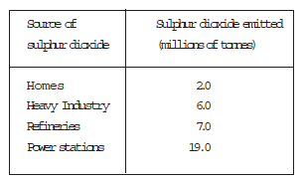

Present this information in a bar chart.

Homework 3 – Alkanes

1. Give the molecular formula, extended structural formula, and formula mass of the following hydrocarbons.
2. Propane.
3. Pentane.
4. Heptane
5. Name the following hydrocarbons. Give the molecular formula and formula mass of each.
6. 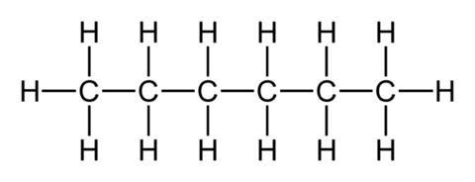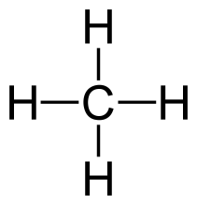 (b)
7. From the shortened structural formulae below, draw the extended structural formulae and name the molecules.
8. CH3CH2CH2CH3 (b) CH3CH2CH2CH2CH2CH2CH2CH3
9. Alkanes can be prepared by the Kolbé synthesis. For example ethane can be prepared in the Kolbe synthesis reaction between two ethanoate ions.



Draw a structural formula for and give the name of the alkane made when propanoate ions are used instead of ethanoate ions.



1. The table gives information about some members of the alkane family.



1. Predict the boiling point of dodecane.
2. What term is used to describe any family of compounds, like the alkanes, which have the same general formula and similar chemical properties?
3. Some famous diamonds have been found in different countries. Each diamond has a different weight measured in carats. The Kohinoor diamond, from India, has a weight of 105.60 carats. The Millenium Star diamond has a weight of 203.04 carats and was found in Congo. The Centenary diamond weighs 273.85 carats and the Cullinan diamond, the largest ever found, weighs 530.20 carats. Both the Centenary and Cullinan diamonds were found in South Africa.

Present this information in a table with three suitable headings.

1. The lowest temperature at which a hydrocarbon ignites is called its flash point.

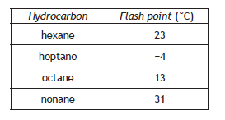

1. Using the information in the table make a general statement linking the flash point to the number of carbon atoms.
2. Predict the flash point, in ˚C, of decane, C10H22.

Homework 4 – Branched Alkanes

1. Draw the extended and shortened structural formulae of the following hydrocarbons:
2. 2-methyl propane.
3. 2-methyl pentane.
4. For each of the hydrocarbons below give:
5. the shortened structural formula
6. the systematic name
7. 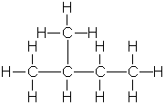

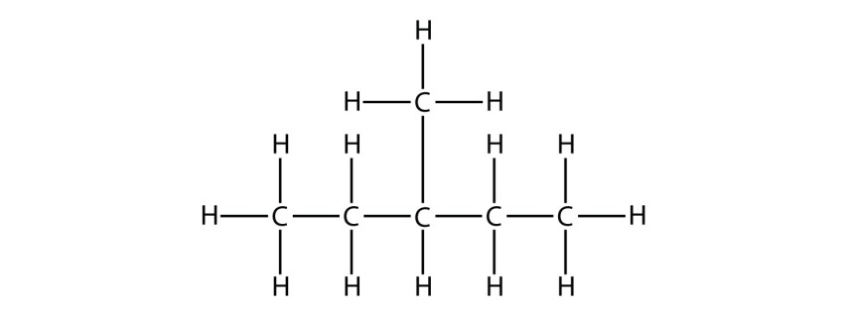

1. Give the extended structural formula and systematic name of each of the compounds below.
2. CH3CH(CH3)CH2CH2CH3
3. CH3CH(CH3)CH3
4. Silicon combines with hydrogen to form a series of compounds called the Silanes.

The formula of the first four silanes is shown below.

SiH4 Si2H6 Si3H8 Si4H10

(a ) What is the general formula of the silanes?

1. Draw the structural formula of Si3H8.
2. The compound Si3H8 reacts with oxygen to form silicon dioxide and one other substance. Suggest what this substance might be.

Homework 5 – Alkenes and Cycloalkanes

1. Give the extended and shortened structural formulae, molecular formulae and formula mass of the following hydrocarbons.
2. Ethene
3. Hex-1-ene.
4. Name the following hydrocarbons and give their molecular formula, shortened structural formulae, and formula mass.

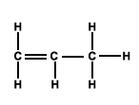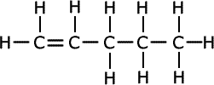

1. Draw the extended structural formula and give the name of each of the following hydrocarbons

(a) CH2CHCH2CH3

(b) CH2CHCH2CH2CH3

1. Give the structural and molecular formulae of the following hydrocarbons.

(a) Cyclobutane

(b) Cyclopentane

1. What is the general formula of the Cycloalkanes.
2. Draw the full structural formula for two hydrocarbons with molecular formula C4H8
3. Essential oils can be extracted from plants and used in perfumes and food flavourings.
4. Essential oils contain compounds called terpenes.

A Terpene is a chemical made up of a number of isoprene molecules joined together.

The shortened structural formula of isoprene is CH2C(CH3)CHCH2

Draw the full structural formula for isoprene

1. 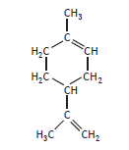Limonene, C10H16, is an essential oil which is added to some cleaning products to give them a lemon scent.

The concentration of limonene present in a cleaning product can be determined by titrating with bromine solution.

1. Name the type of chemical reaction taking place when limonene reacts with bromine solution.
2. Write the molecular formula for the product formed when limonene, C10H16, reacts completely with bromine solution.

Homework 6 – Isomers

1. C5H12 can exist as three isomers.
2. Define isomers.
3. Draw the extended structural formula of each isomer.
4. C4 H8 can exist as isomers.
5. Give the name and extended structural formula of two unsaturated isomers whose molecular formula is C4H8.
6. Give the name and extended structural formula of a saturated isomer whose molecular formula is C4H8.
7. A mixture of gas hydrocarbons can be separated by a method called gas chromatography.

The gas mixture is passed through a special column packed with a powder.

Different hydrocarbons move through the column at different speeds.

The following result was obtained from a mixture of hydrocarbons.

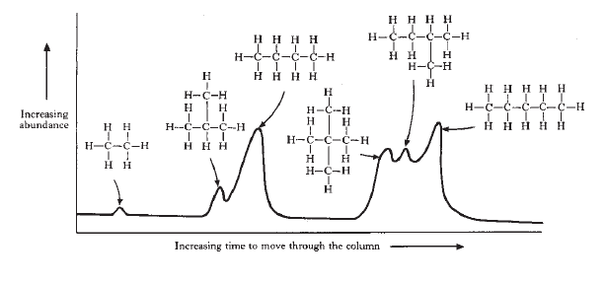

Make two general statements linking the structure of a hydrocarbon with the length of time taken to pass through the column.

1. The structural formulae of two hydrocarbons are shown.

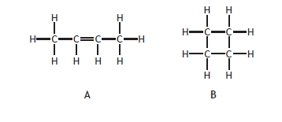

1. Name Hydrocarbon A
2. Hydrocarbons A and B can be described as isomers.

State what is meant by the term isomer.

Homework 7 – Crude oil and Cracking

1. A sample of crude oil is fractionally distilled into a series of fractions.

|  |  |
| --- | --- |
| **Fraction number** | **Number of C atoms in chain** |
| 1 | 1-4 |
| 2 | 5-6 |
| 3 | 7-8 |
| 4 | 9-15 |
| 5 | 15-25 |
| 6 | More than 25 |

1. Why can the fractions in crude oil be separated by fractional distillation?
2. Which fraction contains the highest boiling point molecules?
3. Which fraction is made up exclusively of gases?
4. Which of the fractions 2, 3 or 4 is easiest to ignite?
5. Which of the fractions 2, 3 or 4 is the most viscous?
6. Which of the fractions 2, 3 or 4 contains the largest molecules?
7. When a sample of a hydrocarbon is heated it breaks down as follows

C8H18  🡪 C6H14 + X

1. What is the molecular formula of the hydrocarbon X?
2. Name the hydrocarbons with molecular formula C8H18 and C6H14.
3. The alkynes are a family of hydrocarbons which contain a carbon to carbon triple bond.

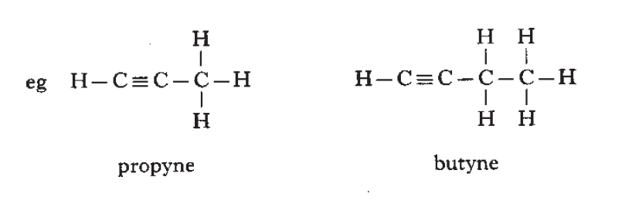

1. Suggest a general formula for the alkynes.
2. Draw the structural formula of pentyne.

Homework 8 – Alcohols

1. In Brazil sugar is changed into ethanol to produce a renewable fuel for cars. The sugar is dissolved in water and yeast added. After a few days the solution will contain about 12% ethanol. Pure ethanol can then be obtained from this solution.
2. What name is given to process which produces alcohol from sugar and yeast?
3. Explain why the maximum concentration of ethanol which can be made from sugar and yeast is about 12 to 15%.
4. What name is given to the process which produces pure ethanol from the ethanol/water mix?
5. Why can ethanol and water be separated?
6. What two substances are made when ethanol is burned?
7. Explain why ethanol produced from carbohydrates is a renewable fuel.
8. Name the alcohols shown below:

(b)

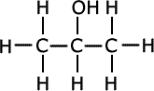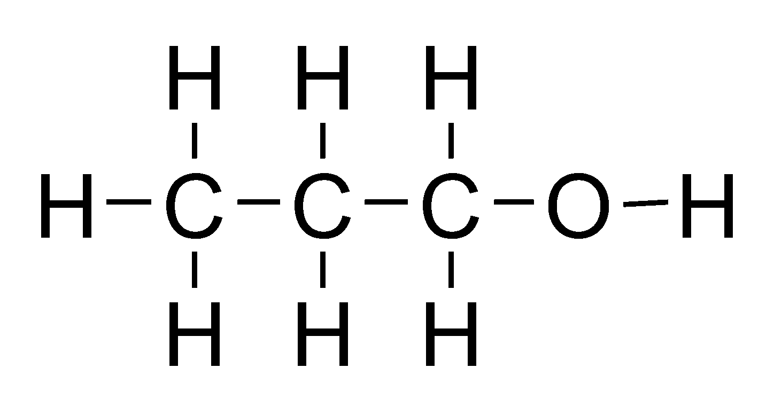

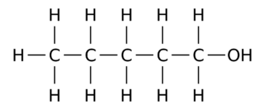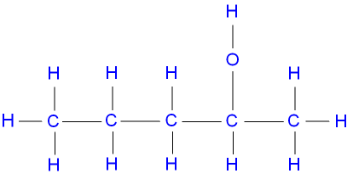

(d)

(c)

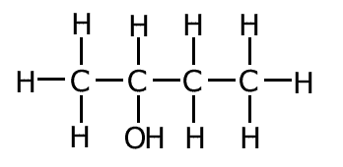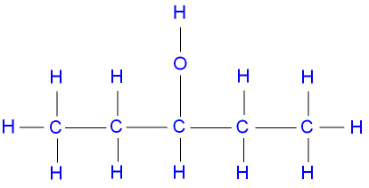

(f)

(e)

1. The bar chart shows the percentage of alcohol in different drinks.

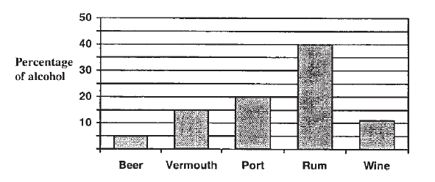

1. Which drink contains the least alcohol?
2. Which drink contains 20% alcohol?
3. What is the percentage of alcohol in vermouth?
4. “Burning ethanol as a fuel is better for the environment than burning petrol”.

**Using your knowledge of chemistry;** comment on the accuracy of this statement.

Homework 9 – Carboxylic Acids

1. For each of the carboxylic acids shown below give

(i) the name of the acid (ii) its shortened structural formula

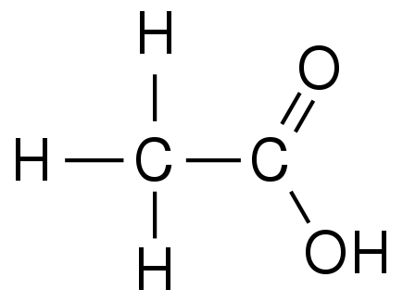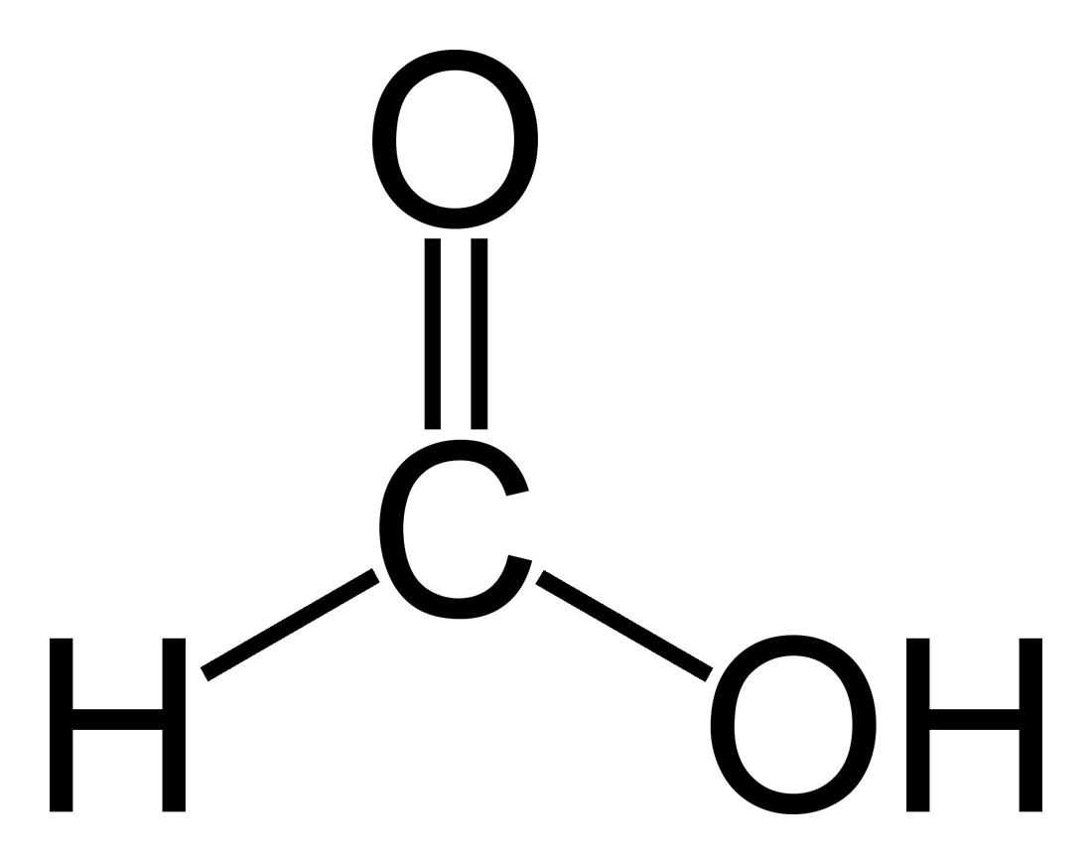(a)

(b)

(c)

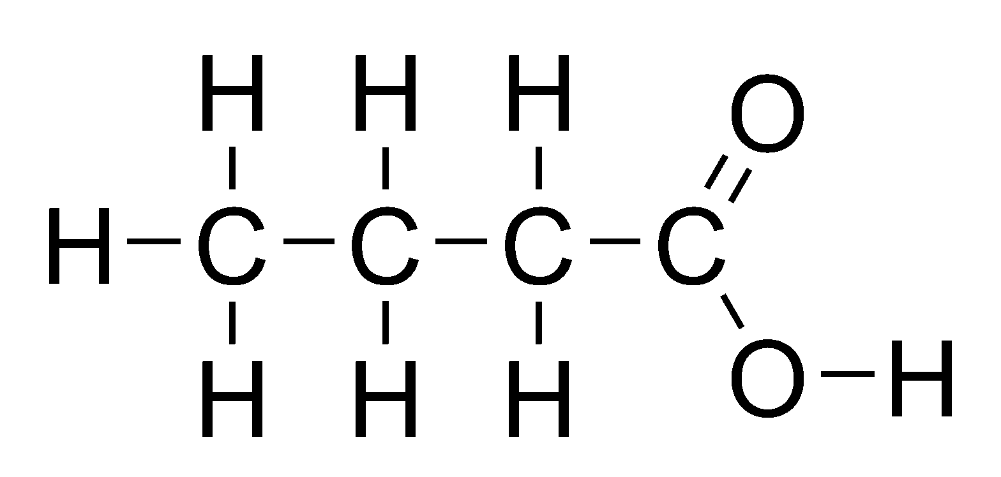

1. For each of the carboxylic acids below give:

(i) the name of the acid (ii) its extended structural formula

1. CH3CH2CH2CO2H
2. CH3CH2CH2CH2CO2H
3. Butter contains different triglyceride molecules.
4. A triglyceride molecule is made when the alcohol glycerol reacts with carboxylic acids.

Name the functional group in glycerol.

1. 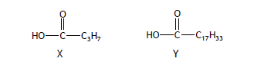When butter goes off, a triglyceride molecule is broken down, producing compounds X and Y
2. Name compound X
3. Describe the chemical test, including the result, to show that compound Y is unsaturated.

Homework 11- Energy from Fuels

1. A student calculated the energy absorbed by water when ethanol is burned using two different methods.

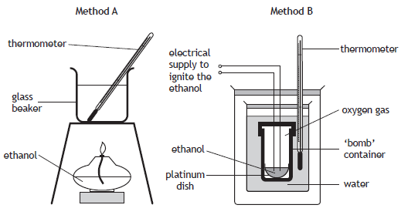

The student recorded the following data.

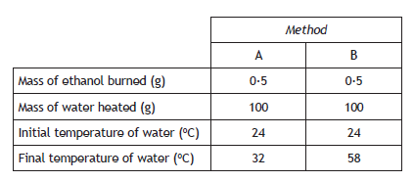

1. The final temperature of the water in experiment B is higher than in method A. Suggest why there is a difference in the energy absorbed by the water.
2. Calculate the energy, in KJ, absorbed by the water in method B. You may wish to use the data booklet to help you.
3. Nonane burns to produce carbon dioxide and water.

C9H20 + 14O2 9CO2 + 10H2O

Calculate the mass, in grams, of carbon dioxide produced when 32g of nonane is burned.

Show your working clearly.

1. Liquefied petroleum gas (LPG), which can be used as a fuel for heating, is a mixture of propane and butane.
2. Propane and butane are members of the homologous series of alkanes. Tick the two boxes that correctly describe members of the same homologous series.

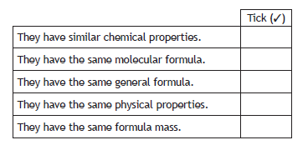

1. The table gives some information about propane and butane.

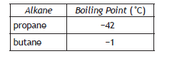

Explain why butane has a higher boiling point than propane.

1. 25KG of water at 10˚C is heated by burning some LPG.

Calculate the energy, in KJ, required to increase the temperature of the water to 30˚C.

You may wish to use the data booklet to help you.

1. LPG is odourless. In order to detect gas leaks, ethyl mercaptan, C2H6S, a smelly gas, is added in small quantities to the LPG mixture.

Suggest one disadvantage of adding sulphur compounds, such as ethyl mercaptan, to fuels such as LPG.

1. Calculate the quantity of heat energy in kilojoules required to:
2. Raise the temperature of 0.2 kg of water by 5oC.
3. Raise the temperature of 0.2 kg of water by 30oC
4. Calculate the quantity of heat energy in kilojoules required to:
5. Raise the temperature of 200g of water by 20oC.
6. Raise the temperature of 25 g of water by 50oC.
7. Methane burns in excess oxygen according to the equation

CH4 + 2O2 ------------> CO2 + 2H2O

What mass of oxygen will be needed to react with 12 g of methane?

1. Propane burns in excess oxygen according to the equation

C3H8 + 5O2 ------------> 3CO2 + 4H2O

What mass of oxygen will be needed to react with 11 g of propane?

1. Ethanol burns in oxygen according to the equation.

C2H6O + 3O2 ------------> 2CO2 + 3H2O

What mass of carbon dioxide will be produced from 13.8g of ethanol?