St Andrew’s Academy
Chemistry Homework

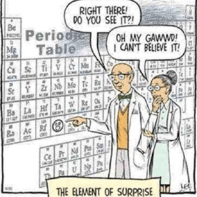

Book 1
Chemical Changes and Structure

HW 1 – Rates of Reaction
- Hydrogen gas can be produced in the laboratory by adding a metal to dilute acid. Heat energy is also produced in the reaction.

- State the term used to describe all chemical reactions that release heat energy.

- A student measured the volume of hydrogen gas produced when zinc lumps were added to dilute hydrochloric acid.
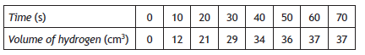

- Plot these results as a line graph
- Calculate the average rate of reaction, in cm3 s−1, between 10 and 30 seconds.
Show your working clearly.
- Estimate the time taken, in seconds, for the reaction to finish.
- The student repeated the experiment using the same mass of zinc. Plot a dotted line on your graph showing how the rate of the reaction would change if zinc powder was used instead of lumps.
- Ethyne is the first member of the alkyne family. It can be produced by the reaction of calcium carbide with water.
The equation for this reaction is

CaC₂(s) + 2H₂O(ℓ) C₂H₂(g) + Ca(OH)₂(aq)

- The table shows the results obtained in an experiment carried out to measure the volume of ethyne gas produced.
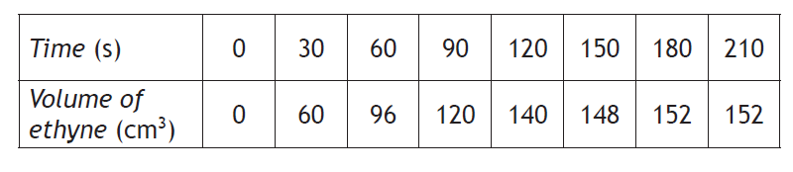

Calculate the average rate of reaction between 60 and 90 seconds. Your answer must include the appropriate units.
- Draw a line graph of the results. Use appropriate scales to fill most of the graph paper.
- A student reacted acidified potassium permanganate solution with oxalic acid, C₂H₂O₄.
2MnO₄–(aq) + 5C₂H₂O₄(aq) + 6H⁺(aq) 2Mn²⁺(aq) + 10CO₂(g) + 8H₂O(ℓ)

Using your knowledge of chemistry, comment on how the student could have determined the rate of the reaction.
HW 2 – The Periodic Table
- (a) Name three metal elements
- Name three elements which are gases.
- What are the only two liquid elements?
- Which is the only non-metal that will conduct electricity?
- What is the chemical test for Oxygen gas?
- Which gas would burn with a “POP” and is explosive?
- Name 3 elements that belong to the alkali metal family.
- Name 2 noble gases
- What is the family name given to group 7 of the periodic table?
- Name an element that has similar chemical properties to Nitrogen.
- Name the seven diatomic elements.

- Use the information in the passage below to answer the questions.
Polymers are materials made of giant molecules. Polymer molecules can be linear, branched or crosslinked. Linear and branched molecules form thermoplastic polymers such as polythene, polystyrene and nylon. Thermoplastic polymers soften when heated. Cross-linked molecules form thermosetting polymers. These polymers do not soften when heated. Urea-formaldehyde is a thermosetting polymer used to make electrical plugs and sockets. Bakelite, the
first commercially produced man-made polymer, is also thermosetting.
Polymers have a wide range of applications due to their useful properties, including strength, good electrical and thermal insulation and resistance to attack by corrosive chemicals. Low density polythene or LDPE is widely used in the packaging industry as a tough, transparent film. High density polythene or HDPE is used where greater strength is required. HDPE is used to make heavy
duty bottles and traffic cones. HDPE is also used in the construction industry to make pipes and gutters.
Polymer properties can be changed by using additives, such as plasticisers, lubricants, pigments and anti-oxidants. Plasticisers give the polymer more flexibility and lubricants reduce friction. Pigments are used to make final products of different colours. To protect polymers against attack by oxidising agents, anti-oxidants are added.

- What happens to nylon when it is heated?

- Why are traffic cones made from HDPE and not LDPE?

- What type of additive can be used to make HDPE bright orange in colour?

HW 3 – The Atom
- Copy and complete the following table:
Particle | Mass | Charge | Location
Proton
Electron
Neutron

- A) Calculate the number of protons, electrons and neutrons AND the electron arrangements for the following atoms

$a) {}_{20}^{40}{Ca}$ b) ${}_{12}^{24}{Mg}$ c) ${}_{26}^{56}{Fe}$ d) ${}_{3}^{7}{Li}$ e) ${}_{17}^{35}{Cl}$

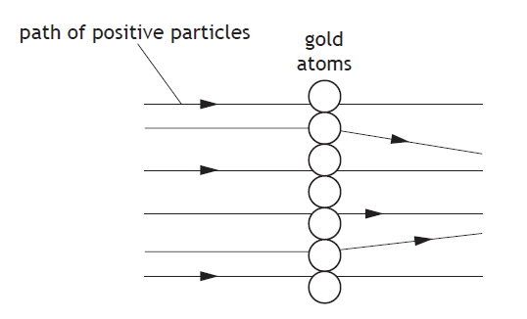
- In 1911, Ernest Rutherford carried out an experiment to confirm the structure of the atom. In this experiment, he fired positive particles at a very thin layer of gold foil. Most of the particles passed straight through but a small number of the positively charged particles were deflected.

What caused some of the positive particles to be deflected in this experiment?

- The element strontium was discovered in 1790 in the village of Strontian in Scotland.
Using your knowledge of chemistry, comment on the chemistry of strontium.

HW 4 – Ions and Isotopes
- Calculate the number of protons, electrons and neutrons AND the electron arrangements for the following ions:

$a) {}_{20}^{40}{Ca}$²⁺ b) ${}_{12}^{24}{Mg}$²⁺ c) ${}_{26}^{56}{Fe}$³⁺ d) ${}_{3}^{7}{Li}$⁺ e) ${}_{17}^{35}{Cl}$⁻

- Fluoride ions are effective in preventing tooth decay. A fluoride ion contains 9 protons, 10 neutrons, and 10 electrons. The symbol for a fluoride ion is ${}_{9}^{19}F$⁻ Write the symbols for the following ions.

- A chloride ion which contains 17 protons, 20 neutrons, and 18 electrons.
- A calcium ion which contains 20 protons, 20 neutrons, and 18 electrons.
- A potassium ion which contains 19 protons, 20 neutrons, and 18 electrons.
- A beryllium ion which contains4 protons, 5 neutrons and 2 electrons.

- Atom A has an atomic number of 93 and a mass number of 239. Atom B has an atomic number of 94 and a mass number of 239. Are A and B isotopes? Explain your answer.

- Two types of neon atom exist, one has a mass number of 20, and the other has a mass number of 22.

- W rite the symbol for each atom showing the atomic and mass numbers.
- Calculate the number of protons, neutrons, and electrons for the neon atom with a mass of 22.
- Give the electron arrangement of a neon atom.
- What name is given to atoms like the neon atoms described above?
- Explain why you cannot calculate the relative atomic mass of neon from the above information?

- A sample of nitrogen was found to contain equal amounts of two isotopes. One isotope has mass number 14 and the other has mass number 15.

What is the relative atomic mass of this sample of nitrogen?

Q6 on next page

- Electrons can be removed from all atoms. The energy required to do this is called the ionisation energy.
The first ionisation energy for an element is defined as the energy required to remove one mole of electrons from one mole of atoms, in the gaseous state.
The equation for the first ionisation energy of chlorine is:

Cl(g) Cl⁺(g) + e−

- State the electron arrangement for the Cl⁺ ion.
You may wish to use the data booklet to help you.

- Write the equation for the first ionisation energy of magnesium.

- Information on the first ionisation energy of some elements is given in the table.
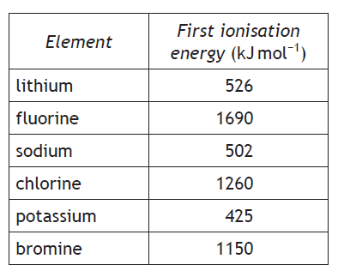

Describe the trend in the first ionisation energy going down a group in the Periodic Table.

HW 5 – Covalent Bonding
- Hydrogen gas exists as molecules which contain two hydrogen atoms. The diagram below shows a molecule of hydrogen.
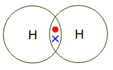

- What name is given to a molecule which contains two atoms?
- Name three other elements which are made up from molecules which contain only two atoms.
- What is the molecular formula for hydrogen?
- Why do the hydrogen atoms share electrons?
- What charge do the nucleii have?
- What charge do the electrons have?
- Explain how the shared pair of electrons helps to hold the molecule together.

- Look at the compounds below:
hydrogen chloride iron (II) oxide sodium carbonate
hydrogen oxide silicon oxide magnesium oxide

Which of the compounds above are covalent compounds?

- Each pair of elements below can form a compound. For each of the compounds:

(i) Draw a diagram showing the shape of the molecule and state the name of the molecules
shape.

(a) nitrogen and fluorine (b) hydrogen and sulphur
(c) hydrogen and chlorine (d) hydrogen and carbon

(ii)Draw diagrams to show how the outer electrons form covalent bonds in each of the following molecules
- Water H₂O (b) Phosphorus hydride PH₃ (c) methane CH₄

Q4 on next page.

- The diagram below shows the structures of water and of silicon dioxide.
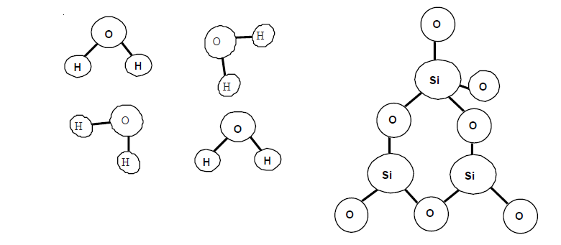
- What is the molecular formula of water?

- If water is boiled it turns into steam. How will the molecules in steam be different from the molecules of water?

- Although the covalent bonds in water are strong, water has a low boiling point. Explain this apparent contradiction.

- Use your data booklet to find the melting point of silicon dioxide.

- Use the diagram to explain why silicon dioxide has a high melting point.

- A student is given three different compounds each containing carbon.
Using your knowledge of chemistry, describe how the student could identify the compounds.

HW 6 – Ionic Bonding
- Sodium forms the sodium ion, the symbol for the sodium ion is Na+. The symbol for the copper (II) ion is Cu²⁺. What are the symbols for the following ions:

(a) calcium ion (b) chloride ion (c) oxide ion (d) copper(II) ion
(e) potassium ion (f) aluminium ion (g) magnesium ion (h) bromide ion

- When sodium is burned in oxygen it forms the ionic compound sodium oxide.

- Give the electron arrangements of sodium and oxygen atoms respectively.

- Explain, using electron arrangements, what happens to the sodium atom when it reacts.

- When oxygen reacts with sodium the oxygen atom forms an oxide ion.
- What is the electron arrangement of the oxide ion?
- Which noble gas has the same electron arrangement as the oxide ion?

- Polymers are materials made of giant molecules. Polymer molecules can be linear, branched or crosslinked. Linear and branched molecules form thermoplastic polymers such as polythene, polystyrene and nylon. Thermoplastic polymers soften when heated. Cross-linked molecules form thermosetting polymers. These polymers do not soften when heated. Urea-formaldehyde is a thermosetting polymer used to make electrical plugs and sockets. Bakelite, the first commercially produced man-made polymer, is also thermosetting. Polymers have a wide range of applications due to their useful properties, including strength, good electrical and thermal insulation and resistance to attack by corrosive chemicals. Low density polythene or LDPE is widely used in the packaging industry as a tough, transparent film. High density polythene or HDPE is used where greater strength is required. HDPE is used to make heavy duty bottles and traffic cones. HDPE is also used in the construction industry to make pipes and gutters. Polymer properties can be changed by using additives, such as plasticisers, lubricants, pigments and antioxidants. Plasticisers give the polymer more flexibility and lubricants reduce friction. Pigments are used to make final products of different colours. To protect polymers against attack by oxidising agents, antioxidants are added.

- What happens to nylon when it is heated?

- Why are traffic cones made from HDPE and not LDPE?

- What type of additive can be used to make HDPE bright orange in colour?

HW 7 – Properties of Covalent and Ionic Compounds
- State whether the bonding in the following compounds is ionic or covalent.

(a) sodium chloride (b) copper (II) oxide (c) sulphur dioxide
(d) hydrogen oxide (e) nitrogen chloride (f) magnesium nitrate

- Which of the following will conduct electricity?

(a) Solid copper (II) chloride (b) solid sodium (c) liquid bromine
(d) liquid hydrogen oxide (e) solid iodine (f) liquid mercury
(g) sucrose (C₁₂H₁₁O₂₂) solution (h) molten sodium chloride (i) liquid sodium
(j) iron(II) chloride solution (k) solid hydrogen oxide (l) liquid iron

- Identify which letter in the table represents:

- An ionic compound
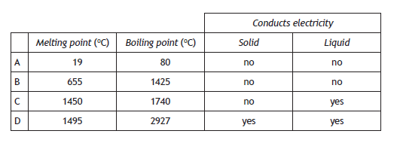
- A covalent molecular compound
- A covalent network

- Two bottles, containing white powder, have lost their labels.
One bottle contains potassium chloride the other contains glucose.
Using your knowledge of chemistry, describe how you would decide which bottle is which.

- Hydrogen iodide exists as molecules whilst sodium iodide exists as a lattice of oppositely charged ions.

- Which substance, HI or NaI, has the highest melting point?

- Solid sodium iodide does not conduct, whilst an aqueous solution does. Explain why this is so.

HW 8 – Electrolysis
- The following substances are melted and an electric current is passed through them. Name the products obtained at the positive and negative electrodes.

(a) potassium bromide (b) aluminium oxide (c) magnesium iodide
(d) lead bromide (e) calcium fluoride (f) lithium oxide

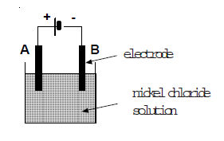
- The apparatus on the right is used to pass electricity through a solution of nickel (II) chloride. A grey solid is produced at one electrode and a gas at the other.

- What name is given to the process which occurs when electricity is passed through a solution of nickel(II) chloride?

- For the grey solid which is produced :
- Name the solid.
- Which electrode is the solid produced at, explain your answer.

- Some pupils used the apparatus below to electrolyse molten lithium bromide.

- Explain why the lithium bromide cannot be electrolysed when it is solid.
- Bromine is produced at the positive electrode. Explain why this is so.
- Give an ion electron equation for the production of bromine from bromide ions.
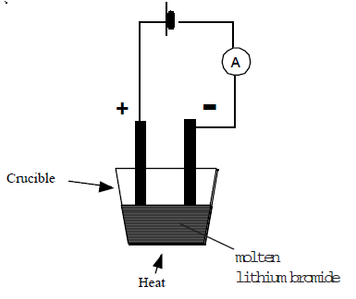

HW 9 – Formulae
- What are the chemical formulae of the following compounds?

(a) hydrogen chloride (b) lithium oxide
(c) sodium oxide (d) sodium chloride
(e) potassium sulphide (f) calcium chloride
(g) calcium oxide (h) potassium bromide
(i) sodium bromide (j) hydrogen oxide

- Calculate the chemical formulae of the following compounds:

(a) silver(I) oxide (b) iron(III) chloride
(c) iron(II) oxide (d) zinc(II) bromide
(e) copper(II) oxide (f) copper(I) chloride
(g) zinc(II) sulphide (h) iron(III) bromide
(i) iron(II) chloride (j) copper(I) oxide

- What is the formula of the following compounds?

(a) carbon monoxide (b) dintrogen monoxide
(c) nitrogen monoxide (d) carbon tetrachloride
(e) phosphorus pentachloride (f) nitrogen monoxide
(g) nitrogen dioxide (h) phosphorus trichloride

4. Calculate the chemical formulae of the following compounds. You may wish to use pg 8 of the data book to help you.

(a) potassium carbonate (b) copper(II) hydroxide
(c) sodium nitrate (d) copper (II) carbonate
(e) magnesium sulphate (f) magnesium nitrate
(g) sodium hydroxide (h) calcium hydroxide
(i) aluminium sulphate (j) iron (II) nitrate

5.The ionic formula of magnesium chloride is Mg²⁺( Cl⁻ )₂. What are the ionic formulae of the following compounds?

(a) sodium chloride (b) copper (II) chloride (c) calcium oxide (d) iron (II) chloride (e) calcium nitrate (f) sodium carbonate

- Balance these formulae equations
a) | Li | + | Br₂ |  | LiBr
b) | Al | + | Cl₂ |  | AlCl₃
c) | H₂ | + | O₂ |  | H₂O
d) | Na | + | H₂O |  | NaOH | + | H₂
e) | P | + | O₂ |  | P₂O₅
f) | Zn | + | AgNO₃ |  | Zn(NO₃)₂ | + | Ag
g) | Fe₂O₃ | + | CO |  | Fe | + | CO₂

HW 10 – Formula Mass and Moles
- Calculate the formula mass of each of the following compounds.

(a) NaF (b) Cl₂O
(c) CaO (d) P₂O₃
(e) Na₂O (f) MgSO₄
(g) CCL₄ (h) NaNO₃
(i) K₂O (j) NF₃
(k) Al(NO₃)₃ (l) K₂SO₄
(m) Al₂(SO₄)₃ (n) MgCO₃
(o) Cu(NO₃)₂ (p) Na₂CO₃
(q) Fe₂(SO₄)₂ (r) AgNO₃

- During a reaction 4·9 g of magnesium reacted with oxygen to form 8·1 g of magnesium oxide.

- How many moles of magnesium were used in the reaction?
- What is the formula of magnesium oxide?
- What is the mass of 1 mole of magnesium oxide?
- How many moles of magnesium oxide were made in the reaction?

- A beaker contains 200cm3 of water. 1 cm3 of water has a mass of 1g.

- What is the formula and mass of 1 mole of water?
- What mass of water was in the beaker?
- How many moles of water were in the beaker?

- Blackboard chalk is mainly calcium sulphate. A stick of chalk has a mass of 12g.

- Give the formula and mass of 1 mole of calcium sulphate.

- How many moles of chalk are present in 1 stick of chalk?

HW 11 – Acids and Alkalis
- (a) Describe how the pH of a solution can be measured.
(b)What colours do acids turn pH paper?
- What colours do Alkalis turn pH paper?

- From the following list:

potassium oxide phosphorous oxide iron(II) oxide,
lithium oxide sulphur dioxide lead(II) oxide
- Name two oxides which dissolve in water to produce acidic solutions.

- Name two metal oxides which are insoluble in water.

- Name two oxides which dissolve in water to produce an alkaline solution.

- When sodium oxide is added to water the pH of the water rises.

- What new substance is produced when sodium oxide dissolves in water?

- Give an equation for the reaction which occurs when sodium oxide reacts with water.

- Excess iron(II) oxide is added to hydrochloric acid. A reaction occurs in which one of the products is iron(II) chloride.
- Write an equation for the reaction.

- Write an ionic equation for the reaction.

- Identify the two spectator ions in the reaction.

- What name is given to substances like iron(II) oxide which can neutralise acids?

- Jim decided to make magnesium sulphate by reacting magnesium oxide with an acid.

- Which acid did Jim use in the reaction?

- Write a balanced equation for the above reaction.

- Write an ionic equation for the above reaction.

- Identify the two spectator ions in the above reaction.

Q6 on next page.

- Fiona decided to make sodium chloride by reacting sodium hydroxide with an acid. She added sodium hydroxide to the acid until the reaction mixture was neutral.
- Which acid did Fiona use in the reaction?

- Write an equation for the above reaction.

- Write an ionic equation for the above reaction.

- Identify the two spectator ions in the above reaction.

- How could Fiona have obtained a sample of the calcium chloride from the reaction mixture?

- How would Fiona have known when the sodium hydroxide had exactly neutralised the acid?

- Potassium hydroxide is added to nitric acid. The temperature of the solution is found to rise.

- Give two words could be used to describe the reaction which had occurred.

- Write an equation for the reaction.

- Write an ionic equation for the reaction.

- Identify the spectator ion in the reaction.

- Chalk is calcium carbonate. Excess chalk is added to an acid. A reaction occurs in which one of the products is calcium nitrate.
- Name the acid used in the reaction.

- Write a balanced equation for the reaction.

- Write an ionic equation for the reaction

- Identify the two spectator ions in the reaction.

- Crystals of sodium sulphate can be made by reacting an acid with a carbonate.

- Name the type of reaction which occurs between a carbonate and an acid.

- Name the acid used in the above reaction.

- Name the carbonate used in the above reaction.

- Write an equation for the above reaction.

- Write a balanced equation for the above reaction.

HW 12 Mole Calculations
- Calculate the mass of the following (show all your working)

- 0·1 moles of potassium oxide (b) 0·25 moles of water
(c) 0·5 moles of sulphuric acid (d) 0·2 moles of sodium hydroxide
(e) 0·75 moles of calcium hydroxide (f) 0·1 moles of sodium chloride

- How many moles of substance are present in the following (show all your working)

(a) 10g of sodium hydroxide (b) 14·8g of calcium hydroxide
(c) 36g of iron (II) oxide (d) 90g of water
(e) 2g of methane (CH₄) (f) 8·8g of carbon dioxide

- What is the concentration of the following solutions?

- 0.1 moles of substance dissolved in 250 cm³ of solution

- 0.02 moles of substance dissolved in 20 cm³ of solution

- 0.14 moles of substance dissolved in 70 cm³ of solution

- 0.05 mole of substance dissolved in 25 cm³ of solution

- How many moles of substance are dissolved in the following solutions?

(a) 1000 cm³ of 2 mol l⁻¹ (b) 250 cm³ of 0.5 mol l⁻¹
(c) 50 cm³ of 0.5 mol l⁻¹ (d) 40 cm³ of 2 mol l⁻¹
(e) 60 cm³ of 0.1 mol l⁻¹ (f) 50 cm³ of 4 mol l⁻¹

- Calculate the mass of solute in each of the following solutions:

- 25 cm³ of sodium hydroxide (NaOH), concentration 4 mol l⁻¹

- 10 cm³ of sulphuric acid (H₂SO₄), concentration 5 mol l⁻¹

- 0.1 litre of hydochloric acid, (HCl), concentration 0.4 mol l⁻¹

- Calculate the concentration of the following solutions:

- 5.85g of sodium chloride (NaCl) dissolved in 0.2 litre of solution

- 0.25 g of calcium carbonate (CaCO₃) dissolved in 25 cm³ of solution

- 1g of sodium hydroxide (NaOH) dissolved in 50 cm³ of solution

HW 13 More Mole Calculations
- A solution contains 2 g of sodium hydroxide in 100 cm³ of solution.

- What is the formula and mass of 1 mole of sodium hydroxide?
- How many moles of substance are present in 2g of sodium hydroxide?
- What is the concentration of the sodium hydroxide solution?

- 30.4g of iron(II) sulphate (FeSO₄)is used to make a 0.5 mol l⁻¹ solution.

- What is the mass of 1 mole of iron(II) sulphate?
- How many moles of substance are present in 30.4g of iron(II) sulphate?
- What volume of a 0.5 mol l-1 solution can be made from 30.4g of iron(II) sulphate?

- Calum prepares 250 cm³ of an 0·2 mol l⁻¹ solution of calcium hydroxide [ Ca(OH)₂ ].

- What is the mass of 1 mole of calcium hydroxide?
- How many moles of calcium hydroxide are present in the solution?
- What mass of calcium hydroxide is present in the solution?

- Kirsty added magnesium to hydrochloric acid. She found that 0.245g of magnesium reacted with 25 cm³ of 4 mol l⁻¹ acid.
- How many moles of hydrochloric acid did she use?

- How many moles of magnesium did she use?

- A beaker contains 50 cm³ of a 0·6 mol l⁻¹ solution of sodium carbonate.

- What is the formula and mass of one mole of sodium carbonate?

- How many moles of sodium carbonate is present in the solution?

- What mass of sodium carbonate is present in the solution?

- A bottle of sodium hydroxide solution is found in a lab. The bottle is labelled as "sodium hydroxide; 8 grams per litre solution"

- What is the formula and mass of 1 mole of sodium hydroxide?

- How many moles of substance are present in 8 grams of sodium hydroxide?

- What is the concentration in moles per litre of a 8 grams per litre solution of sodium hydroxide?

HW 14 Titration Calculations
- Nitric acid reacts with potassium hydroxide according to the equation:

HNO₃ + KOH ---> KNO₃ + H₂O

12·5 cm³ of nitric acid is neutralised by 20 cm³ of a 0·1 mol l⁻¹ solution of potassium hydroxide.
What was the concentration of the nitric acid?

- Sodium hydroxide reacts with hydrochloric acid according to the equation:

NaOH + HCl ---> NaCl + 2H₂O

40 cm³ of a solution of sodium hydroxide was neutralised by 100 cm³ of a 0·5 mol l⁻¹
solution of hydrochloric acid.
What was the concentration of the sodium hydroxide?

- Calcium hydroxide reacts with sulphuric acid according to the equation:

Ca(OH)₂ + H₂SO₄ ---> CaSO₄ + 2H₂O

20 cm³ of a solution of sulphuric acid is neutralised by 25 cm³ of a 0·5 mol l⁻¹ solution of
calcium hydroxide.
What was the concentration of the sulphuric acid?

- 1mole of oxalic acid neutralises 2 moles of sodium hydroxide.
What volume of a 0·5 mol l⁻¹ solution of oxalic acid neutralises 100 cm³ of a 2 mol l⁻¹
solution of sodium hydroxide?

