The Software Development Process

ANALYSIS & DESIGN

1. | List the stages of the software development process in order.
2. | Describe the term iterative.
3. | List three tasks carried out at the analysis stage.
4. | Name the document that is produced at the analysis stage that contains details of exactly what the software must do, the timescale and the budget.
5. | Describe the term ‘functional requirements’.
6. | Describe the term ‘user requirements’.
7. | State two tasks carried out at the design stage.
8. | Describe what is meant by ‘user interface’.
9.. | Name the design notation used to design the user interface.
10. | List three design notations that can be used to design the structure of the code.
11. | Give two examples of assumptions that developers may need to make at the design stage.
12. | Identify which design notation has been used in each example below.
 | Example 1
- RECEIVE name FROM KEYBOARD
- RECEIVE mark FROM KEYBOARD
- IF mark > 50 then
- SEND (“You have passed”) TO DISPLAY
- ELSE
- SEND (“You have failed”) TO DISPLAY
- END IF

 | Example 2
 | 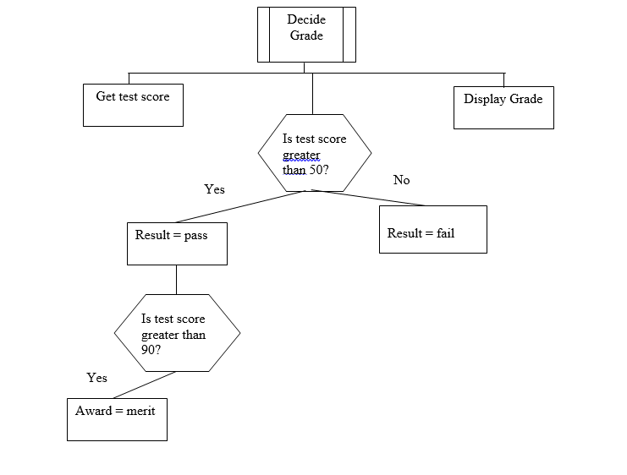
 | Example 3
13. | Design a solution the problem below using each design notation.
A program is required to process ticket purchases for a concert. Customers can buy between 1 and 10 tickets. A discount of 5% is given for purchases of more than 5 tickets.
Tickets for the concert are priced at £25.

