National 4/5 Music

Understanding Music
Scottish Music

Name:
Scottish Music

Make a list/mind map of everything you already know about Scottish music:

Instruments

There are a number of instruments which are common in Scottish Music. You should aim to identify them by sound, as well as learning about the features of each instrument.

Bagpipes
The bagpipes are most likely to be associated with Scotland because of the unique and sound that it can produce.
It is a wind instrument that consists of a chanter, which is used play the melody, 3 drones that play constantly fixed harmonies, and an air bag.
The bagpipes are usually played either solo, or because of its piercing sound, for military or marching purposes in pipe bands.
A pibroch is a piece of music for solo bagpipes consisting of a theme and variation and features many .

In the box below, draw and label your best attempt at the bagpipes!

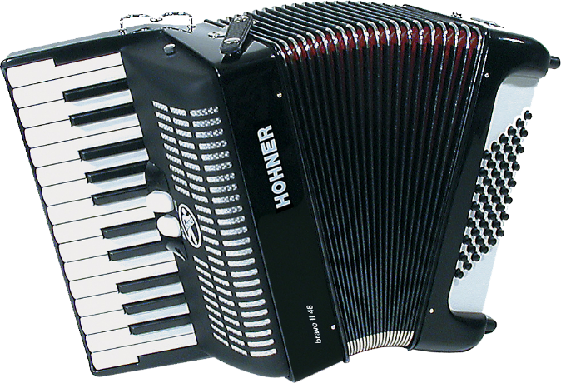
Accordion
The accordion is usually associated with Scottish dance bands.
The notes are produced by air that is pumped through a set of . The player’s right hand plays the melody on either a button or piano fingerboard, while the left hand operates the bellows and plays a bass-chord pattern called a vamp.
Modern accordions can now be fitted with an electronic midi controller to add the effect of a piano and bass being played through the accordion. This helps give the effect of being part of a larger band without additional musicians.
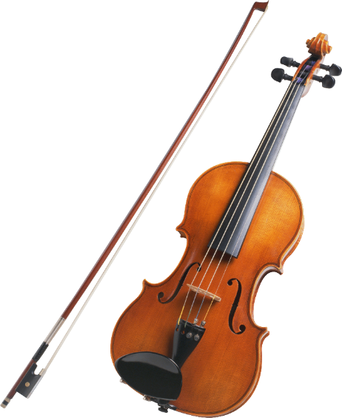
Fiddle
This is the Scottish term for a violin, however fiddles are made from a less sophisticated wood, which tends to give them a ‘rougher’ sound.
The fiddle tends to copy the intricate ornaments of the bagpipes, i.e. drones and grace notes.
The fiddle can either be found in or .

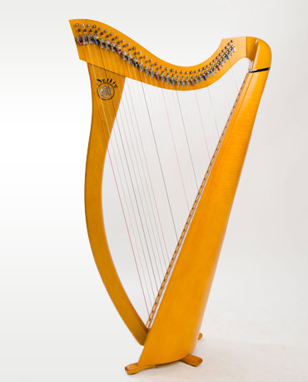
Clarsach
The clarsach is a small Celtic harp. It is very similar to the orchestral harp, however a clarsach is smaller and is only tuned to one scale.
It makes a beautiful accompaniment for singers and players, and is also used as a solo instrument or in a folk group.

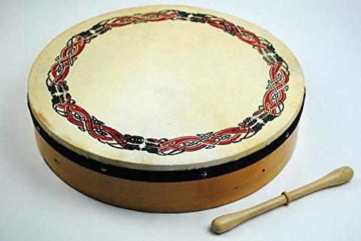
Bodhrán
The bodhrán is a drum used in Celtic music, held in the left hand and played with a beater in the right hand.

Flute
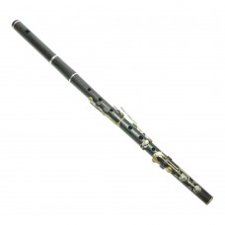
Traditional Scottish musicians tend to use the traditional flute rather than the orchestral flute. The traditional flute is most often made out of (African blackwood) and only have 3 to 9 keys – though some can be made without any keys at all!
The flute is held horizontally and the sound is produced by blowing across a hole in the .

Tin whistle/low whistle
While the flute is held horizontally, the tin whistle is held vertically and the sound is made by blowing into the mouthpiece or . Tin whistles are built with no keys, only open holes, and has a high piercing sound which can be heard above other instruments.
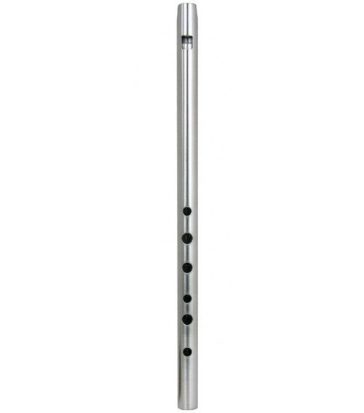
The low whistle is built and played in the same way, but is an octave lower and makes a sweeter, more gentle sound.
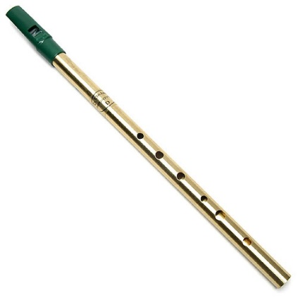

Scottish Dance Band
A Scottish Dance Band is a group of instruments which plays traditional dance music for ceilidhs, etc. It traditionally uses the following instruments:

Less traditionally, it can also include guitar, bass guitar, or tin whistle/flute. It doesn’t include a singer, but may have someone ‘calling’ the dances.

Folk Group
A folk group also plays traditional music, but includes a singer and a wider range of instruments. This music isn’t typically for dancing to. Expect to see some of the following:

Celtic Rock
A Celtic Rock band play rock music that incorporates traditional Scottish or Irish instruments. In the following example, Wolfstone perform their track ‘Time for Walking’ and includes bagpipes and fiddle.

Now listen to each piece of music and list all the instruments that you hear:

1.

2.

3.

4.

5.

Dances
Scottish music is often used to accompany dancing.
At ceilidhs, the music is often performed by a Scottish country dance band or ceilidh band, usually featuring accordion, fiddles, bass, piano and drums).
Before we look at each dance, there are a few features that you should be ready to listen out for…

*****
The music used for each style of dance can be recognised by its tempo, the number of beats in the bar, and whether it is in simple time or compound time.
Simple time is when each beat can be divided into halves
(e.g. ‘cof-fee, cof-fee, etc).
Compound time is when each beat is divided into threes.
(e.g. ‘straw-ber-ry, straw-ber-ry’)

*****
A scotch snap is a rhythm often used in Scottish music and especially in one particular type of dance.
It is a semiquaver followed by a dotted quaver and is written as:

Look at the song ‘Brochan Lom’ on the next page and highlight all the scotch snap rhythms you can see/hear.

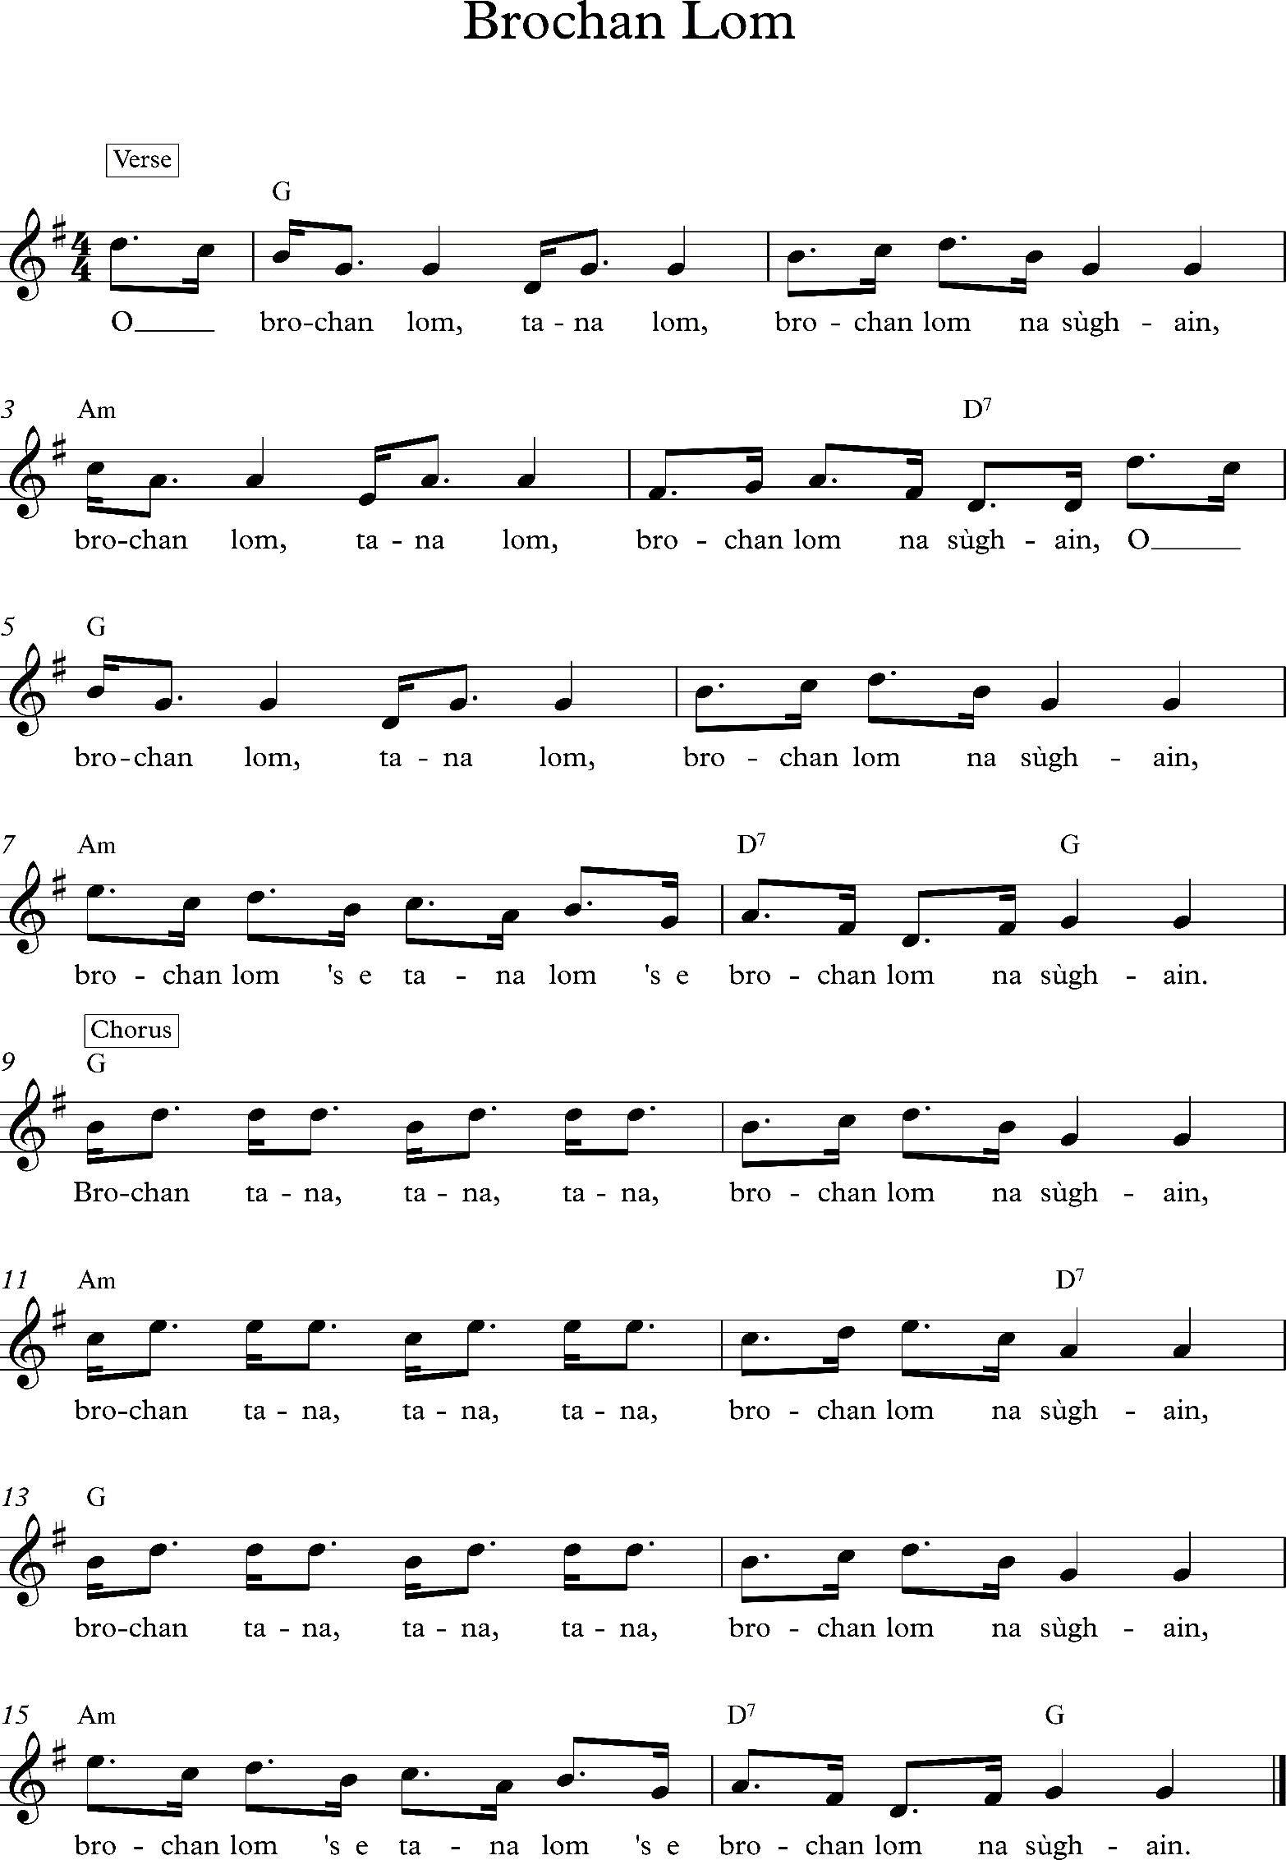

March

- tempo
- time
- Time signature or

Marches were originally used to accompany soldiers when marching. Though not strictly a ‘dance’, marches are now used for dances such as:

Strathspey

- tempo
- time
- Time signature or
- Features ‘scotch snaps’

The Strathspey is one of the most distinctive Scottish dances due to its use of dotted rhythms and Scotch snaps. You can play this music along with dances such as:

Waltz

- tempo
- time
- Time signature

This dance originated in the 19th century and is usually the slower dance at a ceilidh. You might dance the following dances to this music:

Reel

- tempo
- time
- Time signature or

These tunes are also popular in Irish music and have a lot of quaver and semiquaver movement. Quick dances which can be danced to this music include:

Jig

- tempo
- time
- Time signature or

The jig is a fast and lively dance, shared by Irish and Scottish traditions. The following dances can be danced to this music:

Complete the table below with the features of each dance:

Dance | Tempo | Simple/compound  time | Time signature | Any other features

Now listen to each piece of music and write down which of the 5 dances you hear:

1. 5.

2. 6.

3. 7.

4. 8.

Scottish Songs

Scottish folk songs often relate to tragic events, for example, the loss of a fishing boat, or a battle, or about the events in the workplace.
They are often very simple songs, like a lullaby, a love song, or a song about the Scottish landscape e.g. mountains or seas.
Most Scottish songs are sung in Scots or Gaelic.

Scots Ballad

- Sung in

- tempo

A Scots Ballad usually tells the story of either a historical event, a disaster, or a supernatural happening. They are often very long and require concentrated listening. Usually the writers of the songs are unknown, with the words being written down but the tunes passed on orally through friends and family.
On the next page are the lyrics for the song ‘The King’s Shilling’.

The King’s Shilling

Oh my love has left me with bairnies twa
And that's the last of him I ever saw
He joined the cavalry and marched to war
He took the shilling, he took the shilling and he's off to war

Chorus:
Come, laddies, come, hear the cannon roar
Take the king's shilling and you're off to war

Well, did he look as he marched along
With his kilt and sporran and his musket gun?
The ladies tipped him as he marched along
He sailed out by, he sailed out by the Broomielaw

Well the pipes did play as he marched along
And the soldiers sang out a battle song
"March on, march on," cried the captain gay
For king and country, for king and country we will fight today

Repeat Chorus

Well the battle rattled to the sound of guns
And the bayonets flashed in the morning sun
The drums did beat and the cannons roared
And the shilling didn't seem, oh the shilling didn't seem much worth the war

Well, the men they fought and the men did fall
Cut down by bayonet and musket ball
Many of these brave young men
Would never fight for, would never fight for their king again

Repeat Chorus 3x

Bothy Ballad

- Sung in

- tempo

- Traditionally sung by

- Traditionally unaccompanied

Bothy Ballads are songs written and sung by the male farm workers who lived together in small ‘bothies’ on the farm. These songs were mainly humorous, often about their work, their poor living conditions and about the farmer, their employer. Bothy Ballads, although humorous, were a good way for other workers to find out where the best jobs were, and where the worst employers were.
Listen to the song ‘The Hash o’ Benagoak’, following the lyrics, and see if you can summarise what each verse is telling us about this particular bothy.

The Hash o’ Benagoak

Sax month come Martinmas, I feed in Turra toon
They said I wis the brawest chiel in a the country roon.
Chorus:
Wi a ring-dum-day, a ring-dum-day
Ring-dum- a-diddle, come a dandy-o.
Aul WuIlie feed me, an Robbie niver spoke,
Tae come an ca the second pair at the Hash a Bennygoak.
Oor foreman’s like a constable, he niver fa’s asleep,
It’s up an doon the lang rigs, he niver slacks a theet.
The second billie, that’s masel, I ca’ a pair a broons,
Raisin ragnails on the foreman’s heels, I fairly keep my roons.
The third he comes fae Foggieloan, noo he’s a pintit chiel,
His horse an his harness they’re aye lookin weel.
Syne wi hiv an orraman, he seldom ca’s the ploo,
There’s aye plenty orra jobs, an fyles some neeps tae poo.
Sharny is the baillie, he’s a sturdy chiel,
It’s roon aboot the kittly nouks he gars the barra reel.
‘It’s a you jolly horsemen, ye’ll gang tae the ploo,
The orra man tae ca the neeps, an Sharny full an ploo.’
We hiv a gallant kitchie deem, her name is Bessie Broon,
Twid fairly tak a saiddle girth her middle tae gang roon.
The author a this canty lay, ye’ll wint it the be known,
Jist spier ye at the herrin boats at the Pier o Foggieloan.
Waulking Songs

- Sung in

- Always sung by

- Unaccompanied, except for a steady beat

- Call and response/question and answer

Waulking Songs are working songs sung by women in Gaelic. They were usually sung by women as they worked, thumping the damp tweed down onto the tables to shrink it. You can hear the thumping of the tweed in the background as they sing, which gives a very strong continuous beat to the song.

Mouth Music

- Sung in

- Traditionally unaccompanied, but can be accompanied nowadays

- Tempo

Mouth music is often known by its Gaelic name, port a beul (say ‘porsht a bay-ul’). This style of singing was used in place of instruments when they were not available. In fact, around 1745, the bagpipes were practically banned and so people tried to imitate the sound of the pipes with their voices as a way of accompanying their dancing of Strathspeys and Reels. The words were often humorous and would be improvised (made up on the spot), imitating the ornaments and grace notes usually played by the pipes.

‘Seallaibh Curaigh Eoghainn’ is a children’s song about a man called Owen with a small boat (‘curaigh’). These small boats would only have two oars and would only carry two people, but in this song, Owen’s boat has 25 oars working hard to keep the boat going.

Seallaibh curaigh Eoghainn
S’ coig ramh fichead oirre,
Seallaibh curaigh Eoghainn
Seachad air a Rùbha Bhàn

Seallaibh curaigh Eoghainn
S’ coig ramh fichead oirre,
Seallaibh curaigh Eoghainn
Seachad air a Rùbha Bhàn

Bi Eoghainn, bi Eoghainn,
Bi Eoghainn na sgiobair oirr’,
Bi Eoghainn, bi Eoghainn,
Seachad air a Rùbha Bhàn

Bi Eoghainn, bi Eoghainn,
Bi Eoghainn na sgiobair oirr’,
Bi Eoghainn, bi Eoghainn,
Seachad air a Rùbha Bhàn
Shal-iv coo-rie Ow-en
Z coig rav feek-it eu-ruh
Shal-iv coo-rie Ow-en
Shack-it air a Roo-ah Van

Shal-iv coo-rie Ow-en
Z coig rav feek-it eu-ruh
Shal-iv coo-rie Ow-en
Shack-it air a Roo-ah Van

Bee Ow-en, bee Ow-en,
Bee Ow-en na skip-per ur
Bee Ow-en, bee Ow-en,
Shack-it air a Roo-ah Van

Bee Ow-en, bee Ow-en,
Bee Ow-en na skip-per ur
Bee Ow-en, bee Ow-en,
Shack-it air a Roo-ah Van
Look at Owen’s boat
And five and twenty oars on it
Look at Owen’s boat
Going past the White Point

Look at Owen’s boat
And five and twenty oars on it
Look at Owen’s boat
Going past the White Point

Owen will be, Owen will be,
Owen will be the skipper on it
Owen will be, Owen will be,
Going past the White Point

Owen will be, Owen will be,
Owen will be the skipper on it
Owen will be, Owen will be,
Going past the White Point

Gaelic Psalms

- Sung in

- Unaccompanied

- No beat/pulse

Gaelic psalms are unaccompanied hymns (psalms) sung in churches, mostly in the Western Isles. Each line of the psalm is 'put out' by the ‘precentor’ or leader. The congregation then joins in gradually. The congregation often sounds out of time. This is due to the slow tempo and the different ways in which individuals sing the melody, often ‘improvising’ or adding ‘ornaments’.
*****
Now listen to each piece of music and write down which type of song you hear:

1.

2.

3.

4.

5.

6.

7.

8.
Pentatonic Scale

Scottish music is known for using a set of notes called a pentatonic scale. This means only 5 notes are used. An example of this is in the song ‘Auld Lang Syne’ which uses G, A, B, D, and E.

