

**Administration & IT**

Assignment Tasks

Internet Research



**ELYSIUM SPA AND HEALTH CLUB**

Elysium Spa and Health Club has recently opened in premises at Portland Street, Troon, KA10 6AA. Facilities will include a gym, spa, swimming pool, studios and personal trainers, with timetabled classes available to all members. A Launch Evening will take place on the third Thursday of next month from 6-9 pm.

You have just started your new job as an Admin Assistant reporting to Ms Audrey Lauder, the General Manager of Elysium Spa and Health Club.

Audrey would like you to do some research using the internet. She has provided a copy of her diary showing existing appointments. You will need this information when carrying out your research.

**Extract from E-diary:**

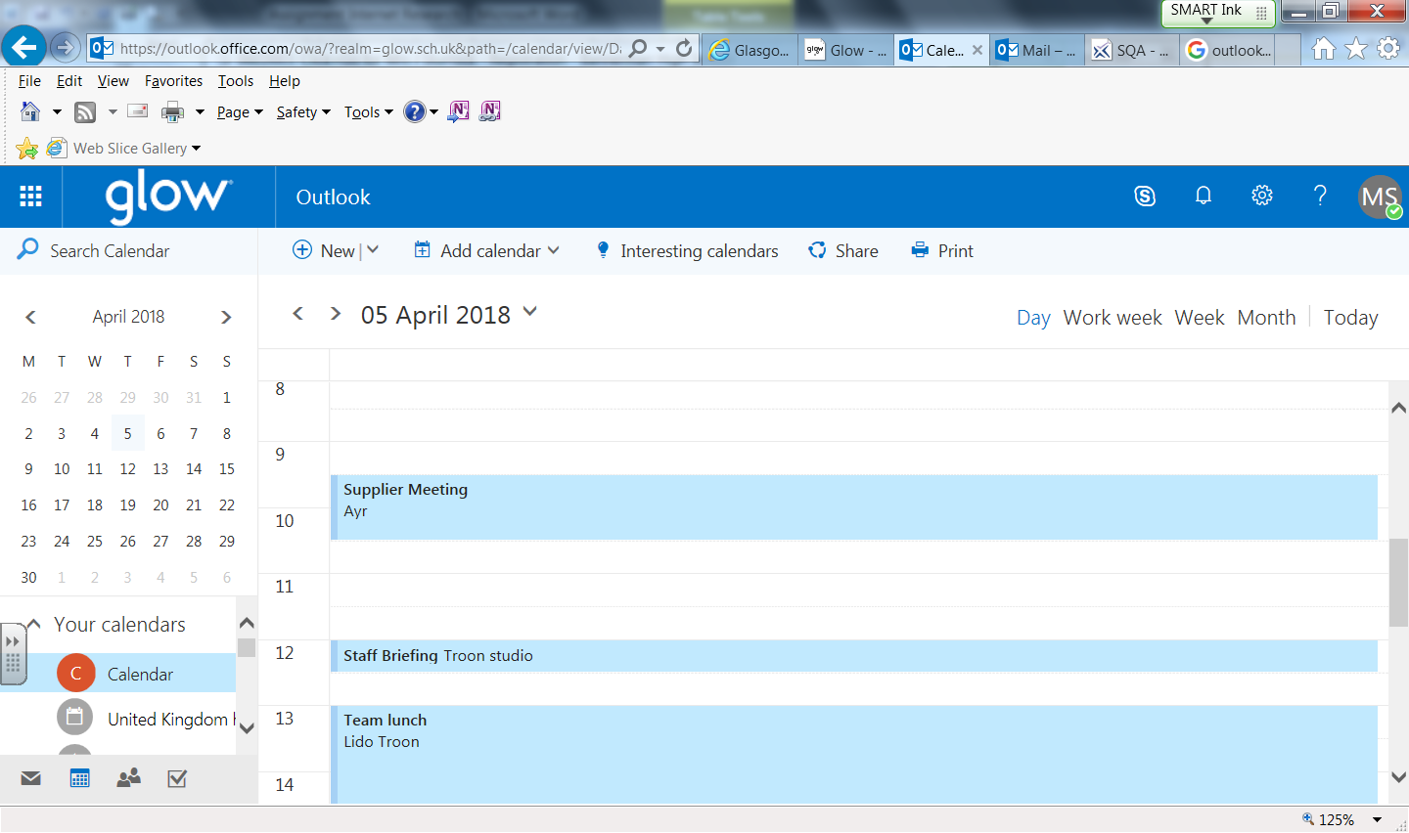

**Calendar**

|  |
| --- |
| **◼** 9:30 to 10:30 Supplier Meeting  **Location**: Ayr |
| **◼** 12:00 to 12:30 Staff Briefing  **Location**: Troon studio |
| **◼** 13:00 to 14:30 Team lunch  **Location**: Lido Troon |
| **◼** 18:00 to 21:00 Launch Evening  **Location**: Elysium Spa and Health Club, Troon |

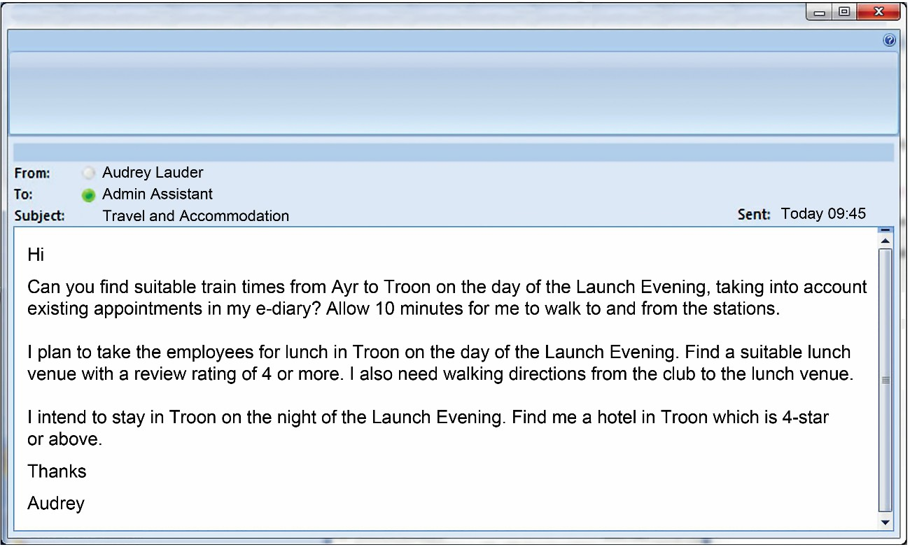

Access the internet to find the following information. Print evidence from websites showing train details, lunch venue, walking directions and a suitable hotel.

**SCOTLAND CARES**

You work as an Admin Assistant at Scotland Cares, a charity raising funds for the young people of Scotland. You work with Mr George Sullivan, the Head Office Manager. He has asked you to complete the following task.

You have received the following e-mail about a volunteer who will be attending the walk-a-thon meeting which is taking place next Thursday from 1 pm to 4 pm. Print a copy of the results.

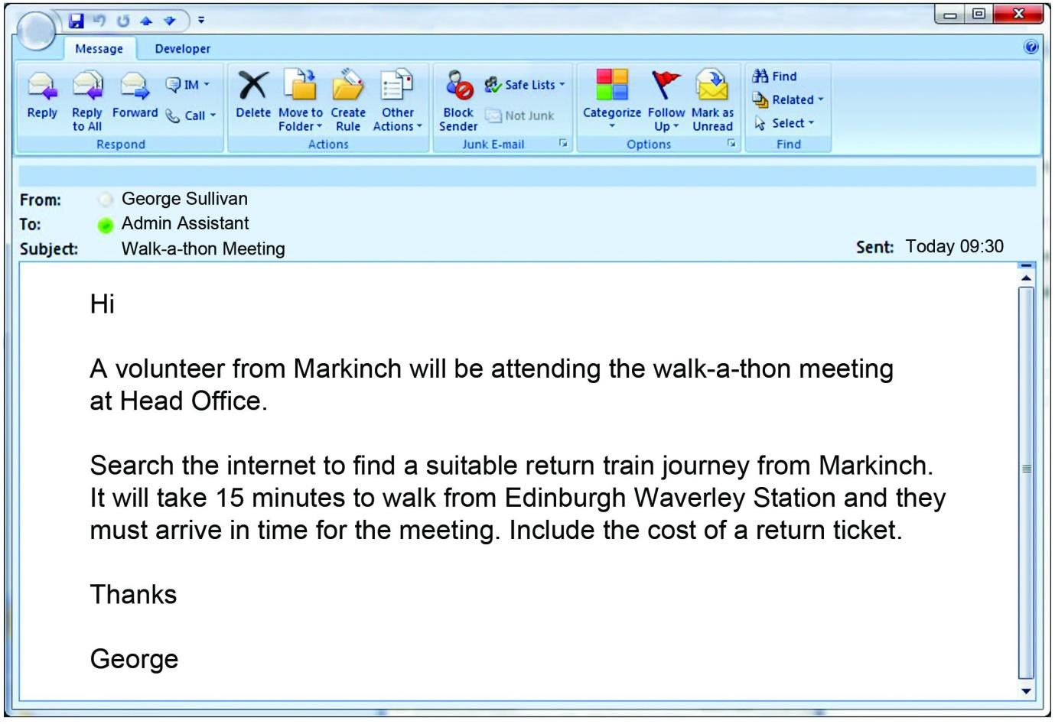

**SOUNDS ON THE SHORE**

Your company, Sounds on the Shore**,** is organising a music festival which is taking place on the South Beach, Aberdeen, for the first time on the last Friday and Saturday of July.

You work as an Admin Assistant with Mitch Goodwin, the Festival Organiser, and he has asked you to organise and support this event.

Access the internet to find the following information for Mr Goldie, one of the music promoters, who is coming to look around Aberdeen and the festival site next weekend. Print evidence from websites showing a suitable hotel and flight details.

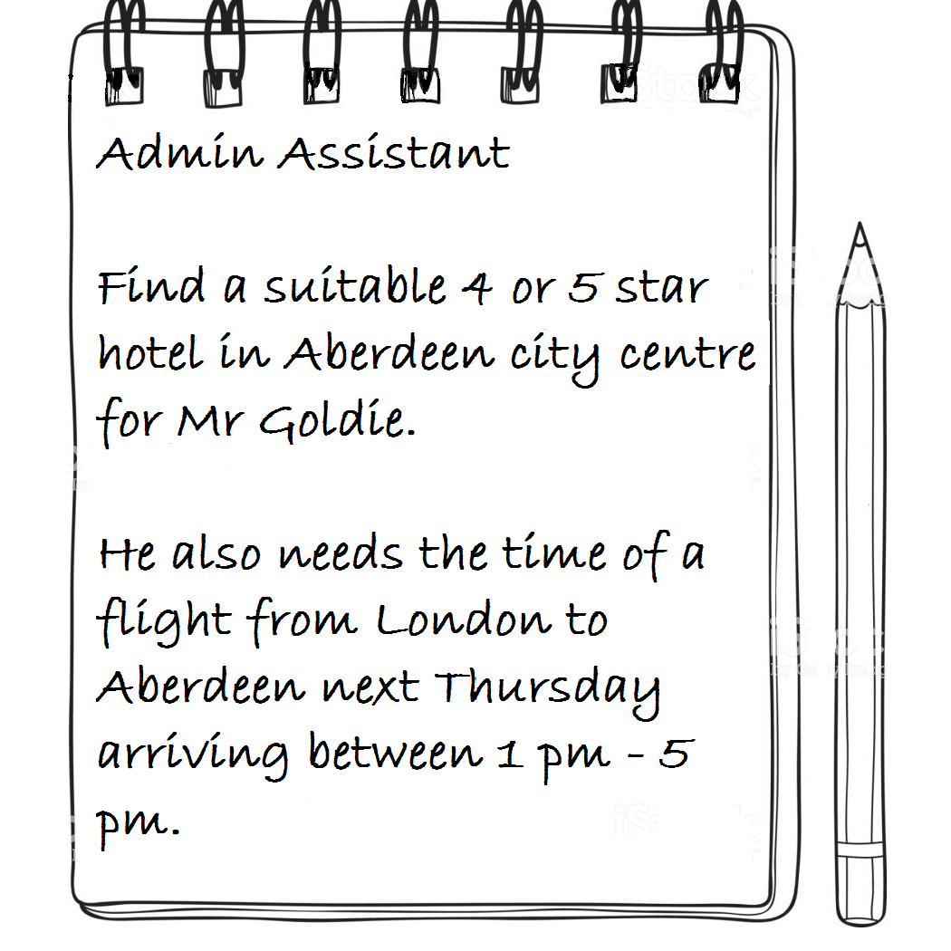

**SCHOOL TRIP TO PARIS, FRANCE**

You work as an Admin Assistant at Park View High School. Ms Susan MacFarlane, the teacher in charge of organising this year’s school trip to Paris, France during the mid-term October break, has asked you to complete the following task.

Pupils who do not have a valid European Health Insurance Card (EHIC) must apply for one.

Find the NHS website where the form can be found.

Copy this link and include it in an e-mail to the office and copy the Head Teacher into it.

Ask the office to put this link on the school website under the details for the Paris Trip.

**MORVEN’S CAKE PLACE**

Morven Adams is the owner of Morven’s Cake Place, a small cake and coffee shop based at 122 Cathedral Street, Glasgow, G1 2TG. She is keen to expand her business into catering for various functions and is taking a stand to promote her business at the Good Food Exhibition taking place at the SECC next month.

You work as an Admin Assistant with Morven and she has asked you to complete the following task:

Access the internet to find the following information. Print a copy of the sent email.

