**St Andrew’s Academy**

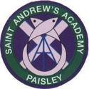

**Faculty of Business Education & Computing Science**

**Departmental Handbook**

Staff

|  |  |  |
| --- | --- | --- |
| Name | Position | Subject |
| Patrick McFadden | **Depute Head** | **Computing Science** |
| Lynsey Melrose | **Depute Head (SMT Link)** | **Computing Science** |
| Corrinne Squires | **Faculty Head** | **Business Education** |
| Stephanie Little | **Teacher** | **Business Education** |
| Hollie Dowds | **Principal Teacher of Pastoral Care** | **Business Education** |
| Raymond Kane | **Teacher** | **Business Education** |
| Clare Glen | **Teacher**  **Acting Principal Teacher of Pastoral Care (0.4)** | **Business Education** |
| Domenico D’Annunzio | **Teacher** | **Computing Science** |
| Deborah Blackburn | **Teacher** | **Computing Science** |
| Cara McClymont | **Teacher (NQT)** | **Business Education** |
|  |  |  |

ROOM ALLOCATION & EQUIPMENT

The department has 7 ICT suites each with 20 PC’s. Rooms S005 & S008 have 21 PC’s. Rooms are used regularly by subjects from across the school therefore a clean desk policy is in operation. The department operates a monthly booking system that allows staff from across the school to book out and use ICT suites when required, staff can book rooms by writing their initials on the room allocation timetable that is pinned on the wall in the staff base or by e-mailing Stephanie Little.

The department also has 3 laptops for staff & pupil use. Priority use of these laptops is for Business Management classes with more than 20 pupils in them.

ICT TECHNICIAN

The department is supported for ICT by David Falconer who is based in the school. Jobs can be raised by logging in to the service desk portal with your supplied username and password. <https://ictservicedesk.renfrewshire.gov.uk/sw/selfservice/#/loginmanual>

Job details should include room number, PC number, details of issues and screenshots of any error message or additional information.

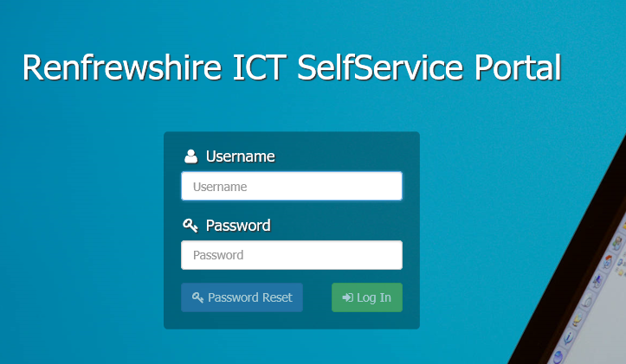

CLASSROOM ASSISTANT

The department has allocated hours of classroom assistant time to assist with supporting pupils and staff. Staff who require support from classroom assistants should raise this through the faculty head.

PHOTOCOPYING

There are two separate codes for photocopying, one for Business Education & one for Computing Science, codes can be obtained from any member of the faculty. There is a photocopier in the departmental store that can be used for small jobs. Any photocopying that is more than 100 sheets should be saved as a PDF file and e-mailed to Documents Solutions via the office with clear instructions of the requirements.

COMMUNICATION

A monthly newsletter is issued highlighting key events for the month as well as any quality assurance activities that will take place and also details of any SQA updates.

The department have a GLOW group that is used for day-to-day communication between staff.

FACULTY MEETINGS

Staff meet as a faculty once per calendar month. Subject specific meetings take place once per calendar month.

Agenda items can be added by all staff by e-mailing or speaking to the faculty head.

Minutes of meetings can be found in

**X:\** **X:\ict\DEPARTMENTAL ADMIN\DM Agenda&Minutes**

THE SCHOOL DAY

**Monday/Tuesday/Thursday Wednesday/Friday**

|  |  |  |  |  |
| --- | --- | --- | --- | --- |
| 8.50 – 9.40 | Period 1 |  | 8.50 – 9.40 | Period 1 |
| 9.40 – 10.30 | Period 2 |  | 9.40 – 10.30 | Period 2 |
|  |  |  |  |  |
| 10.30 – 10.45 | Interval (S1-3)* |  | 10.30 – 10.45 | Interval (S4-6)* |
|  |  |  |  |  |
| 10.45 – 11.35 | Period 3 |  | 10.45 – 11.35 | Period 3 |
| 11.35 – 12.25 | Period 4 |  | 11.35 – 12.25 | Period 4 |
| 12.25 – 1.15 | Period 5 |  |  |  |
|  |  |  |  |  |
| 1.15 – 2.00 | Lunch |  | 12.25 – 1.10 | Lunch |
|  |  |  |  |  |
| 2.00 – 2.50 | Period 6 |  | 1.10 – 2.00 | Period 5 |
| 2.50 – 3.40 | Period 7 |  | 2.00 – 2.50 | Period 6 |

*Please see Staggered Interval and Lunch arrangements below – these were introduced as a measure during the Covid pandemic, however will be remaining as a permanent feature based on feedback from pupils, staff and parents.

STAGGERED LUNCHES

|  |  |  |  |  |
| --- | --- | --- | --- | --- |
| **S1, 2 & 3 Pupils** | |  | **S4, 5 and 6 pupils** | |
| Mon, Tues & Thurs | Wed & Fri |  | Mon, Tues & Thurs | Wed & Fri |
| Period 1 8.50am-9.40am | Period 1 8.50am-9.40am |  | Period 1 8.50am-9.40am | Period 1 8.50am-9.40am |
| Period 2 9.40am – 10.30am | Period 2 9.40am – 10.30am |  | Period 2 9.40am – 10.30am | Period 2 9.40am – 10.30am |
| Interval 10.30am – 10.45am | Period 3 10.30am – 11.20am |  | Period 3 10.30am – 11.20am | Interval 10.30am -10.45am |
| Period 3 10.45am – 11.35am | Interval 11.20am – 11.35am |  | Interval 11.20am – 11.35am | Period 3 10.45am – 11.35am |
| Period 4 11.35am – 12.25pm | Period 4 11.35am – 12.25pm |  | Period 4 11.35am – 12.25pm | Period 4 11.35am – 12.25pm |
| Lunch 12.25pm – 1.15pm | Period 5 12.25-1.15pm |  | Period 5 12.25pm – 1.15pm | Lunch 12.25pm – 1.15pm |
| Period 5 1.15pm – 2.00pm | Lunch 1.15pm-2.00pm |  | Lunch 1.15pm – 2.00pm | Period 5 1.15pm – 2.00pm |
| Period 6 2.00pm – 2.50pm | Period 6 2.00pm – 2.50pm |  | Period 6 2.00pm – 2.50pm | Period 6 2.00pm - 2.50pm |
| Period 7 2.50pm – 3.40pm |  |  | Period 7 2.50pm – 3.40pm |  |

ABSENCES

In the event of absence due to illness staff should:

1. Inform the school as soon as possible or at least by 8.00am on the first day of illness. You can contact the Business Support Manager (Lynne Bain) on the mobile number 07534 154261.
2. Indicate the length of absence.
3. Reason for absence

In addition to the formal procedure detailed above, it is helpful if Lynsey is notified of a potential incidence of staff absence at the earliest opportunity in order that teaching resources can be prepared for classes. Please phone or text Lynsey (07940587928) at the earliest opportunity if you have been unwell and anticipate that you will be absent.

Any member of staff who wishes to be absent from school – even when the absence is for a Staff Development course – must confirm with this with Kevin Henry (HT), on the day prior to the absence. Attendance at a course/meeting may be cancelled by the HT/DHT if cover situation merits such action. A member of staff who has been given permission by the HT to be absent from the school must ensure that the details (date and periods requiring cover, i.e. P1-4) are entered in the school diary, held in the BSM’s office, so that the appropriate cover can be arranged.

No entry should be made in the diary without prior permission from the HT / DHT (timetable).

SECURITY

On arrival you will be asked to sign into the building at the janitor’s office at the front door. This also allows you to sign out a key to open your class room. All keys for the ICT classrooms work for every classroom in the faculty. Keys should be returned to the box outside the janitor’s office at the end of the day. Janitorial staff also requests that you inform them if you are intending on staying beyond 5.00 pm.

There is a disabled toilet in the ICT corridor, the key for this is kept on a pink keyring in filing cabinet in the staff base. Only pupils with disabilities and staff are permitted to use this toilet.

Staff should wear ID badges at all times. These can be obtained from Lynne Bain (ESM).

PHONE CALLS

The school’s phone number is: **0300 300 1440** - Main office

Internal Calls: A list of departmental numbers is on display in the science staff base.

If you require to make a call for school business: Dial 9 for an outside line before you dial your required number.

DEPARTMENTAL IMPROVEMENT PLAN

The departmental and school improvement plans are stored centrally for all staff on the ICT faculty shared area. This is a collegiate agreement and working document which is revisited throughout the year. Staff can print off their own copy to monitor the planned improvements throughout the academic year.

**X:\** **X:\ict\DEPARTMENTAL ADMIN\IMPROVEMENT PLAN**

RESOURCES

An extensive variety of high quality teaching resources can be found in the staff resources folder on the server.

TEACH ICT

The department has a subscription to TEACH ICT

|  |  |  |
| --- | --- | --- |
|  | Username | Password |
| Teacher | PA2 7LG | Standrews8 |
| Pupil | PA2 7LG | memory1 |

GLOW

All pupils are issued with login details to GLOW in S1. Staff should set up GLOW groups for each class and upload teaching resources for pupils to access at home.

TEACHER TOOLKIT

Resources to support teaching & learning can be found in

**X:\ict\LEARNING & TEACHING\Teachers Toolkit**

Resources include timers, random name generators, starter/plenary activity templates and ideas.

REGISTRATION

Registration is completed using Seemis. Login details for Seemis can be obtained from Lynne Bain. Registers should be completed within the first 10 minutes of the period. In the case of covering classes for an absent teacher, the register can be completed using the “registration by staff” facility.

Class registers contain confidential pupil data such as medical conditions and additional support needs therefore it is important that registers are not displayed via the projector to pupils.

Seating plans can be created and stored on Seemis using the option shown below.

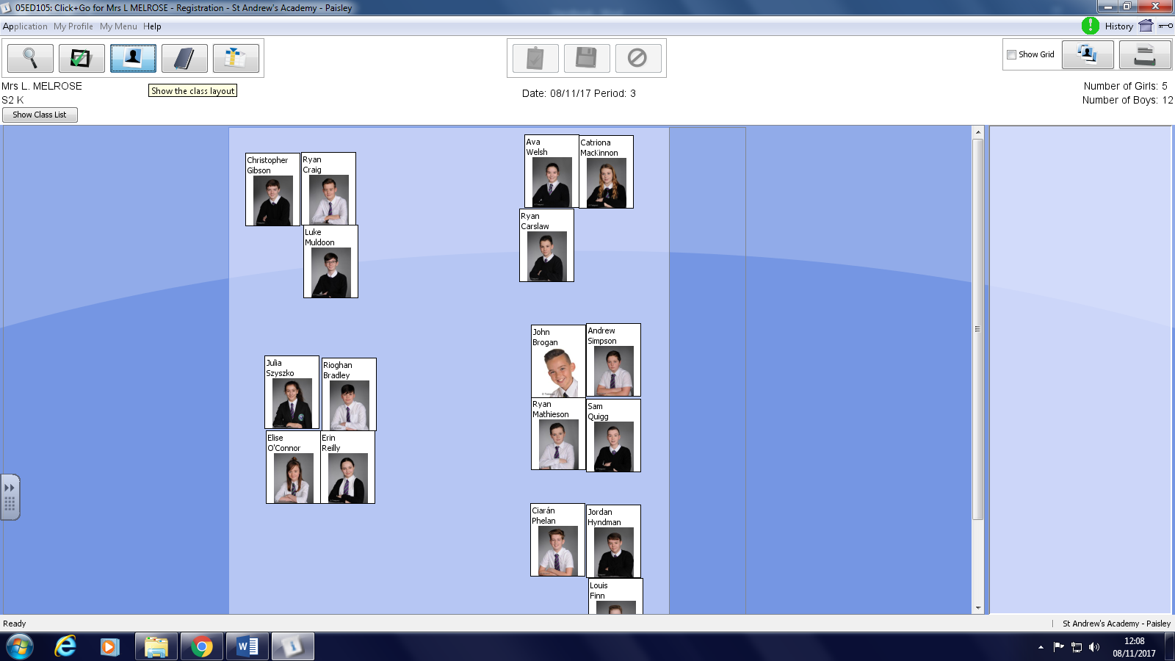

RECORD OF WORK

Staff are asked to complete their planners as a record of planned and completed work. Course plans should also be in staff planners showing course coverage.

PUPIL TRACKING

The department uses electronic assessment files to record pupil progress and results. These assessment files can be found in

**X:\ict\PUPIL TRACKING**

Staff are asked to record all assessment marks, results of unit assessments and coursework in this file.

Any parental correspondence such as Appendix 8’s or Early Warnings should also be recorded in this file.

PUPIL EVIDENCE

Pupils in S3 and above have a pupil file in the filing cabinet in the staff base. Class tests, unit assessments and final pieces of work should be filed here.

S1 & S2 pupils have evidence folders in the store. Assessments, final pieces of work and projects should be filed in these. Details of evidence to be filed for S1/2 courses can be found on the course plans.

SQA COURSE ASSESSMENTS

If a pupil fails an SQA Course Assessment then a letter should be sent home to parents informing them of this. Staff are then asked to work with the individual pupil concerned to identify revision strategies and agree a re-sit date to ensure they have the best possible chance of passing their re-sit. The appendix 8 letter for ICT has a sentence to inform parents of this (sentence h). A copy of the letter can be found here:

**X:\ict\PUPIL TRACKING (OLD MARKS FOLDER)\Appendix 8's\2017.18**

HOMEWORK

Homework for all subjects in the Faculty should be challenging, meaningful and given on a regular basis.

Homework can be issued and returned via GLOW or by the traditional method and can be teacher, peer or self-marked as appropriate. Should any teacher have a concern regarding homework, an Appendix 8 letter can be sent home to alert parents.

FIRE EVACUATION PROCEDURES

In the event of a fire evacuation, all personnel should leave the building to the appropriate muster point as denoted by the fire evacuation posters in each classroom. Staff with an allocated register class should go to that class’ meeting point. Any member of staff without a register class should help out with supervision.

Classroom doors should be left unlocked.

Pupils with physical disabilities will be evacuated by the fire warden using the EVAC chair. The designated fire warden for ICT is L Melrose, however D D’Annunzio is also trained in using the EVAC chair.

COURSES OFFERED

S1 ICT

This is a common course offered to all S1 pupils. The course focusses on developing pupil skills in computer applications and using ICT to enhance learning.

**S2**

The department has recently changed the structure of its S2 course by moving from a common course to two single periods, one for Business & ICT to enhance learning and the other for Computing Science. Updated course plans have been produced to ensure that the new E’s &O’s for technologies are being covered, these will be evaluated at the end of each session and updated as required.

**S2 BUSINESS**

This course is designed to cover the Business experiences & outcomes and ICT to enhance learning whilst also preparing pupils for embarking on subject choices at the end of S2.

**S2 COMPUTING SCIENCE**

This course is designed to cover the Computing Science experiences & outcomes.

S3 BGE

In S3 pupils can choose one or a combination of subjects from Administration & IT, Management and Computing Science for further study up to level 4 as specified in the guidelines for A Curriculum for Excellence.

The ICT faculty offer a selection of courses from S4-S6 designed to meet the needs of all young people within the faculty.

|  |  |  |
| --- | --- | --- |
| Year Group | Subjects Offered | Level |
| S3/4 | Administration & IT  Business Management  Computing Science | National 3 – National 5 |
| S5/6 | Administration & IT  Business Management  Computing Science | National 4 – Higher |
| NPA Games Design | Level 4 – Level 6 |

The range of courses in S5/6 varies from year to year and may include Advanced Higher Computing Science, PC Passport & Personal Finance and NPA Business & IT.

COURSE PLANS

Course plans can be found in the shared area. With all the new courses currently being implemented these can still be works in progress. Regular discussions with colleagues about progress of work is encouraged and is discussed and recorded in minutes at DM’s.

S1 & S2 pupils are issued with Personal Learning Plans each year. This allows them to see their progression through the course and record their successes and next steps. These should be stored in pupil folders and updated regularly.

PUPIL SUPPORT

St Andrew’s Academy has a vertical pupil support system where all pupils are assigned the support of one of the PT’s of Pupil Support. Pupil support assignment groups are placed in a house system and are listed below:

|  |  |  |  |  |  |
| --- | --- | --- | --- | --- | --- |
| Mrs Holgan | Ms Devine | Mrs Buchanan | Mr Fulton | Ms Dowds | Mrs Wilson |
| **St Mirin** | **St Margaret** | **St James** | **St Columba** | **Our Lady** | **St Rose** |
| 1.1 | 1.2 | 1.3 | 1.4 | 1.5 | 1.6 |
| 2.1 | 2.2 | 2.3 | 2.4 | 1.7 | 1.8 |
| 3.1 | 2.8 | 2.6 | 3.4 | 2.5 | 2.7 |
| 4.1 | 3.2 | 3.3 | 3.6 | 3.5 | 3.8 |
| 5.7 | 4.2 | 3.7 | 4.4 | 4.5 | 4.6 |
| 6.1 | 5.2 | 4.3 | 4.7 | 5.5 | 4.8 |
| 6.6 | 6.2 | 5.3 | 5.1 | 5.6 | 5.8 |
|  |  | 6.7 | 5.4 | 6.5 | 6.3 |
|  |  |  | 6.4 |  |  |
|  |  |  |  |  |  |

REFERRALS

Referrals can be made in reference to any point of concern for a pupil whether discipline or pastoral.

Class teachers should complete the relevant referral form and send this to Raymond. Referrals are completed on SEEMiS and can be accessed as shown below:

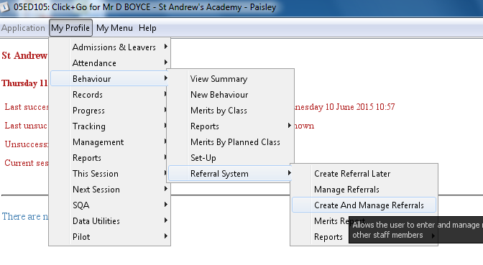

On discussion with the class teacher, Lynsey will take appropriate action on the referral and pass on the information to either the Pupil Support department and/or the Year Head. It is important that all referrals are passed to Lynsey in the first instance. Lynsey should take action on the referral within the timeframe of 1 week.

All staff should be familiar with the referral structure. There is a copy of the referral structure in the ICT shared area here:

**X:\ict\DEPARTMENTAL ADMIN\REFERRAL STRUCTURE**

DISCIPLINE

The ICT faculty prides itself in maintaining a high standard of discipline. It is the responsibility of every member of staff to promote positive behaviour by making use of praise along with a stimulating and challenging learning environment. If a member of staff feels a pupil has displayed unacceptable behaviour they should deal with it appropriately. If this continues they can refer the pupil to Lynsey. Staff should try and avoid removing pupils to stand in the corridor for any significant length of time as this is a form of exclusion. Pupils sent out to the corridor should be followed by staff straight away to deal with indiscipline. The whole school policy on discipline and school rules can be accessed here.

**X:\Staff\Staff Handbook\10 Discipline and School Rules**

SUPPORT FOR LEARNING

The Support for Learning department is lead by Mr John Mullen. Information on pupils with additional support needs are listed in the link below. Information about suggested teaching strategies along with reader and scribe information can be found in this document. It is vital that teachers are familiar with the any additional needs for pupils in their classes.

**X:\Staff\ASN Confidential Info**

All PC’s in the department have Ivona text reading software installed, pupils with additional support needs should be encouraged to use this software when completing classwork and assessments.

ASSESMENT SUPPORT

Readers and scribes can be booked by e-mailing John Mullen with a week’s notice. Assessments should also be e-mail to SFL prior to the assessment date.

The ICT department is in the process of updating assessments for all courses to ensure that digital assessments are available to pupils with ASN to complete online. Staff involved in the development of any future assessments should also ensure a digital version is also created. Lynsey can provide guidance as to how to do this.

BEHAVIOUR SUPPORT

The Don Bosco Base in the school is set up to help with behaviour support. The Don Bosco team can give excellent advice and support on teaching and learning strategies for many pupils. It is vital that teachers are familiar with any behavioural support needs for pupils in their classes. If teachers are concerned with the behaviour of any pupils in their class they can discuss the possibility of a referral to Don Bosco with Lynsey.

EXTRA CURRICULAR (not currently running in 2020-21)

|  |  |  |  |
| --- | --- | --- | --- |
| Activity | Year Group | Day | Staff |
| Homework Club | S1-S6 | Wednesday | S Little |
| Chill Zone | S1/S2 | Thursday | C McClymont |
| Robotics | S1-S3 | Friday | D D’Annunzio |
| Enterprise |  |  |  |

PUPIL EXCURSIONS

Opportunities for appropriate trips are considered each year and represented in the improvement plans. Any staff member wishing to offer a trip should see Corrinne to discuss cost, risk assessments, staffing and transport.

PARTNERSHIPS

The department works in partnership with West College Scotland to facilitate the completion of distance learning courses. S5/6 pupils attending college in column D or E complete these online courses during periods 1 & 2 on Monday/Tuesday. Any administration issues with regards to pupil logins or enrolment keys should be e-mailed to Corrinne.