Software Development
Design Notations

Design a solution for each problem description below using
- A structured diagram
- A flowchart
- Pseudocode

1. | A program is being designed for a coffee shop that will allow customers to transfer money to their coffee shop account to pay for purchases.  The customer enters their coffee shop account number and password, then a 16-character bank card number, a 4-character card expiry date and the amount of money to transfer to the account. A button is clicked to submit this information.  These details (without the password) are then displayed, and the customer clicks "confirm" to complete the process. Once completed, the total money available on the card with the account number is displayed.  Using a design technique of your choice, design an efficient solution to ensure that a card number of only 16 characters can be entered.  An error message should be displayed if the incorrect number of characters is entered, and the customer asked to re-enter the card number.
2. | The farmer plans to hire out quad bikes and allow customers to ride them across a route on his land. Customers will pay £40 for the experience. Concession tickets at £27·50 are available for people under 18 years old and people over 60 years old. Tickets must be purchased as a group booking. The minimum number of people in a group is 2 and the maximum number of people in a group is 10.  The program requires the following inputs:  - The name of the group making the booking  - The number of people in each group  - The age of each person in the group  The output from the program should display:  - The name of each group  - The number of people in each group  - The total cost of the group booking (all totals should be displayed to two decimal places)  An example of the output is provided below:  Your task is to write a program that will enable the farmer to calculate the total cost of a single group booking.

3. | Pupils attending the dance must book a table as part of a group. Groups can have a minimum of 4 and a maximum of 10 pupils. Pupils can buy either an entrance ticket (£3·00) or a ticket that allows entrance and a photo (£4·99).  The program requires the following inputs:  - The name of the group  - A valid number of pupils in the group  - The name of each pupil in the group  - Yes or No to ordering a photo  The output from the program should display:  - The name of the group  - The number of pupils in the group  - The name of each pupil in the group  - The total cost of the ticket per pupil (all totals should be displayed to two decimal places).
4. | A design is created for a simple program to sell tickets for theatre show. The design is shown below.  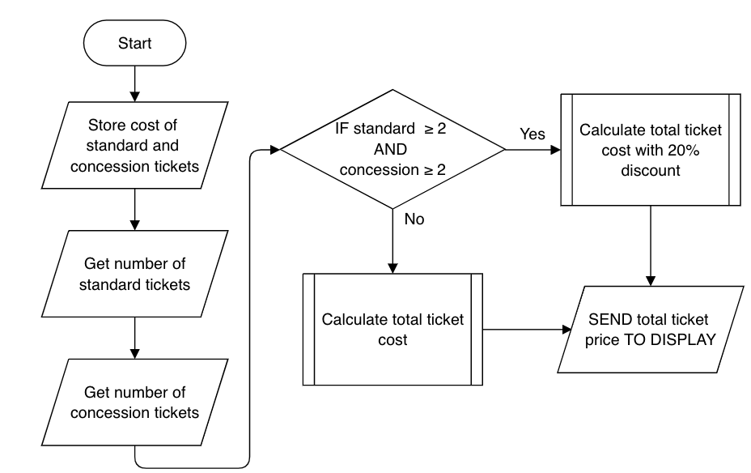  It is decided to limit ticket purchases to 10 tickets. These can be made up of any combination of standard or concession tickets. Where a user tries to purchase too many tickets, a suitable error message will be displayed.  Using a design technique of your choice, create a design for the input of the number of standard and concession tickets.

5. | A program is being designed that will allow pupils to add money to their lunch money account. The user enters their name, an 8 character password and the amount of money they want to add. A button is then clicked and the updated balance of the account is displayed.  Using a design technique of your choice, design an efficient solution to ensure that a password of only 8 characters can be entered. An error message should be displayed if the incorrect number of characters is entered, and the user asked to re-enter the password.
6. | An online pet supply retailer is offering a special deal to customers buying at least two, but not more than six, bags of pet food. If customers try to buy any other quantity, a message is displayed.  Design an efficient solution to the problem, how input validation could be used to ensure an acceptable number of bags is entered.
7. | A software development company decides to review staff knowledge of computer related legislation. Mikal is asked to create an app covering a range of legal issues. Mikal develops an interactive quiz for the app to test the staff’s knowledge of legislation.  Mikal uses the graphics to create question 3 for the app.  Design a solution that will show how the total score is calculated when the user answers question 3 correctly.
8. | Scott is developing an online quiz with ten true or false questions. At the end of the quiz, the user’s final score will be calculated.  The user interface is shown.  For each correct response, 5 points are added to the user’s score. Design efficient code to calculate the user’s final score. Your code should use a running total within a loop.

9. | A program is used by “Easy Windows Cleaners” to calculate the cost of cleaning jobs and calculate the total income from jobs for that day.  A house with 6 or fewer windows costs £12 to clean, a house with 7 to 12 windows is £16 and more than 12 windows costs £20. If there are more than 16 windows then the job is costed at £1.50 per window. If the house pays in cash then there is a discount of £3.50.  The cost for each house is stored in a 1-D array and, at the end of the day, this 1-D array is used to calculate the total income for the company that day.  Algorithm  1. Setup array and jobCounter  2. Loop  3. Get the details of the job  4. Calculate the cost of the job  5. Store the cost in array  6. Get if there are any more jobs today  7. Until AnymoreJobsToday = False  8. Calculate and display total from array  Refinement  3.1 Get the number of windows  3.2 Get if house will pay cash  5.1 Set Jobs[jobCounter] to jobCost  5.2 Set jobCounter to jobCounter + 1
 | (a) | Using a design technique of your choice, refine step 4.
 | (b) | Using a design technique of your choice, refine step 8.

