St Andrew’s Academy

National 5 Chemistry

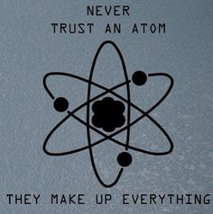

Unit 3 Homework

Chemistry in Society

Homework 1 – Reactions of Metals

1. Iron reacts with oxygen to form Iron(II) oxide.
2. What is the formula of iron (II) oxide?
3. Write a balanced equation for the reaction which occurs between the iron and the oxygen.
4. Magnesium reacts with oxygen to form magnesium oxide.
5. What is the electron arrangement of magnesium?
6. Explain, with reference to the electron arrangement, what happens to the magnesium when it forms magnesium oxide.
7. What is the ionic formula of magnesium oxide?
8. Write an equation for the reaction between magnesium and oxygen.
9. When sodium is added to cold water the reaction produces so much heat that the sodium melts. Hydrogen gas is produced and sodium hydroxide solution is formed.
10. What is the test for hydrogen?
11. What name is given to reactions which produce heat energy?
12. Suggest why the group 1 elements are called the alkali metals.
13. Write a balanced equation for the reaction between sodium and water.
14. Calcium metal reacts rapidly with water.
15. Write an equation for the reaction which occurs between calcium and water.
16. What is the ionic formula of calcium hydroxide?
17. Write an ionic equation for the reaction between calcium and water.
18. Write balanced chemical equations for the following reactions.
19. Calcium reacting with hydrochloric acid.
20. Calcium reacting with sulphuric acid.
21. Aluminium reacting with hydrochloric acid.

**Q6 on next page**

1. Write ionic equations for the following reactions:
2. Magnesium reacting with sulphuric acid.
3. Magnesium reacting with hydrochloric acid.
4. The yellow alloy called brass does not corrode easily. Brass is a mixture of the metals copper and zinc. The more zinc in the brass, the lighter the yellow colour becomes. More zinc in brass makes it hardwearing. The bigger the percentage of copper in brass, the easier the brass is to shape. More copper in brass makes the yellow colour darker.

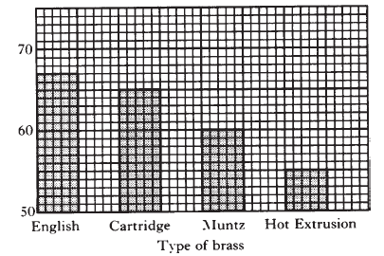The graph below shows the percentage of copper in different types of brass.

Use the information in the passage and the graph to answer the following questions.

1. Which type of brass would be lightest in colour?
2. Do you think hot extrusion brass would be easy to shape? Explain your answer.
3. Give two properties of English brass.

Homework 2 – Extraction of Metals

1. When heated gently silver(I) oxide decomposes to form silver and oxygen.
2. What is the formula for silver(I) oxide?
3. How would you show that oxygen had been produced in the above reaction?
4. Give a balanced equation for the reaction which occurs when silver(I) oxide is heated.
5. What would be left in the test tube when the reaction was complete?
6. Metals can be used as catalysts.

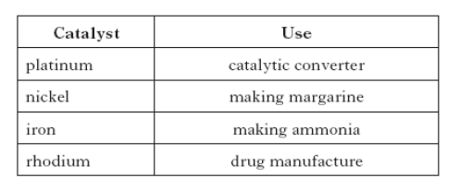

1. What is a catalyst?
2. Platinum is found uncombined in the Earth’s crust. What does this indicate about the reactivity of platinum?
3. Metals can also be used to make alloys. Explain what is meant by alloy.
4. Aluminium is extracted from aluminium oxide by electrolysis of molten aluminium oxide.

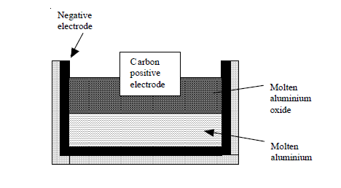

1. What electrode is the aluminium formed at? Explain your answer.
2. Why must the aluminium oxide be molten?
3. Suggest why the molten aluminium oxide floats on top of the molten aluminium.

**Q4 on next page.**

1. Metals such as tin, mercury and lead are often called “heavy metals”. They have many important uses. However, these metals can cause a lot of damage to the environment. Tin is used in paints for the hulls of ships. It is known to be very poisonous to marine life. There are no known effects of tin on humans. Mercury and lead are both found in some paints. Mercury is used in making alkaline batteries. Lead is used in making car batteries and solder. Mercury is dangerous to humans as it can cause nerve damage. Lead can cause fits and brain damage. Both of these metals build up in the body and can cause death.
2. What name is often used to describe metals such as tin, mercury and lead?
3. How can tin damage the environment?
4. Give one use for lead
5. 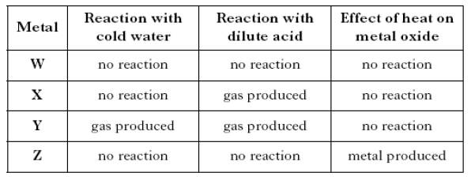A pupil carried out some experiments with four metals and their oxides. The results are shown in the table.
6. Place the four metals in order of reactivity (most reactive first).
7. Name the gas produced when metal Y reacts with cold water.
8. Suggest names for metals Y and Z.
9. Ores are naturally occurring compounds from which metals can be extracted.
10. When a metal is extracted from its ore, metal ions are changed to metal atoms. Name this type of chemical reaction.
11. Iron can be extracted from its ore haematite, Fe2O3, in a blast furnace.

Calculate the percentage by mass of iron in haematite.

**Show your working clearly.**

1. Magnesium cannot be extracted from its ore in a blast furnace.

Suggest a method that would be suitable for the extraction of magnesium from its ore.

Homework 3 – Displacement Reactions

1. When magnesium is added to copper (II) sulphate solution a displacement reaction occurs which forms magnesium sulphate solution and copper.
2. Why does the magnesium displace the copper from the solution of copper(II) sulphate?
3. What is the formula of copper (II) sulphate?
4. Write an equation for the reaction which occurs when magnesium is added to copper (II) sulphate solution.
5. Write an ionic equation for the reaction.
6. Give the ion electron equation for the change which happens to the magnesium, what name is given to this change?
7. For each of the displacement reactions below
8. Write an equation for the reaction.
9. Write an ionic equation for the reaction
10. Identify the spectator ion in the reaction.
11. Magnesium and copper (II) chloride
12. Zinc(II) and iron (II) sulphate
13. Titanium can be mixed with other metals to make a substance that is strong and lightweight.
14. What term is used to describe a mixture of metals?
15. Medical instruments can be made from a mixture of metals containing 76% titanium, 4% zirconium and the rest is other metals. Copy and label the pie chart to show the name and percentage for each part of the mixture.



Homework 4 – Voltaic cells

1. 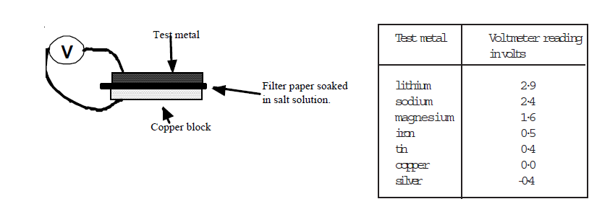Using the apparatus below the following results were obtained.
2. What name is given to this kind of series of metals arranged from voltmeter readings?
3. Which combination of metals would give the largest voltage in the above cell?
4. Why is the filter paper soaked in a salt solution?
5. Look at the diagram below:

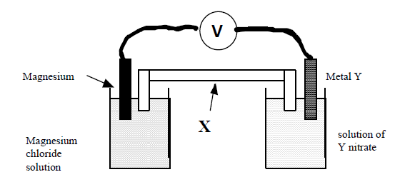

Oxidation takes place at the magnesium electrode

1. In which direction will electrons flow through the meter?
2. Write an ion electron equation for the reaction which occurs at the magnesium electrode.
3. What name is given to piece of apparatus marked X? What is its function?
4. Suggest the name of a metal which might be metal Y.
5. A battery is a number of cells joined together.
6. The diagram shows a simple battery made from copper and zinc discs separated by paper soaked in potassium nitrate solution.

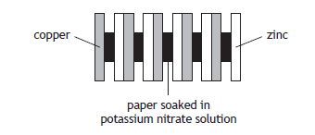

The purpose of the potassium nitrate solution is to complete the circuit.

State the **term** used to describe an ionic compound which is used for this purpose.

1. A student set up a cell using the same metals as those used in the battery.

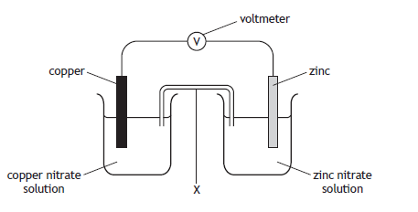

1. In which direction would the electrons flow? You may wish to use the data booklet to help you.
2. Name the piece of apparatus labelled **X**.

Homework 5 – Redox

1. 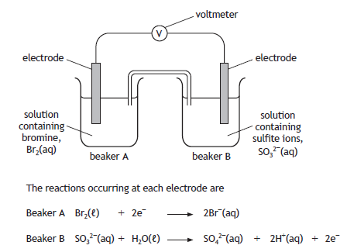Electricity can also be produced in a cell containing non-metals.
2. Name the type of chemical reaction taking place in beaker **B**.
3. Write the redox equation for the overall reaction.
4. Name a non-metal element which is suitable for use as the electrodes.
5. Aluminium can be extracted from naturally occurring metal compounds such as bauxite.
6. State the term used to describe naturally occurring metal compounds such as bauxite.
7. Bauxite is refined to produce aluminium oxide. Electrolysis of molten aluminium oxide produces aluminium and oxygen gas. The ion-electron equations taking place during the electrolysis of aluminium oxide are:

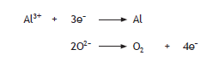

1. Write the redox equation for the overall reaction.
2. State why ionic compounds, like aluminium oxide, conduct electricity when molten.
3. Bauxite contains impurities such as silicon dioxide. Silicon can be extracted from silicon dioxide as shown.

SiO2 + 2Mg Si + 2MgO

Identify the reducing agent in this reaction.

1. Use the data booklet to
2. Find equations for each of the following changes
3. Identify the change as oxidation or reduction.
4. A calcium atom changing into a calcium ion
5. A copper atom changing into a copper(II) ion
6. An Iron(III) ion changing into an Iron(II) ion
7. Iodine changing into iodide ions
8. Chloride ions changing into chlorine
9. For each of the oxidation and reduction equations below combine the equations to give a balanced redox equation.
10. Cl2 + 2e– --> 2Cl–

Mg --> Mg2+ + 2e-

1. Ag --> Ag+ + e-

Cl2 + 2e– --> 2Cl–

1. Cl2 + 2e– --> 2Cl–

SO32- + H2O --> SO42- + 2H+ + 2e-

1. Fe2+ --> Fe3+ + e-

Br2 + 2e– --> 2Br–

1. A group of students were given strips of aluminium, iron, tin and zinc.

**Using your knowledge of chemistry**, suggest how the students could identify each of the four metals.

Homework 6– Polymers

1. Many modern articles are made from thermoplastic polymers . Examples of these are washing up basins, cups, and computer cases. Other objects such as pot handles are made from thermosetting polymers.
2. What is a polymer?
3. What is meant by the word thermoplastic?
4. Why are thermosetting polymers used on pot handles?
5. Most synthetic polymers are not biodegradeable. To dispose of plastics they are often burned, although this can produce toxic fumes.
6. Explain the meaning of the term "biodegradeable".
7. Name a toxic gas which can be produced from the burning of plastics.
8. Succinic acid is a natural antibiotic.

The structure of succinic acid is shown.

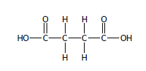

1. Name the functional group present in succinic acid.
2. Succinic acid can form a polymer with ethane-1,2-diol.
3. The structure of ethane-1,2-diol is shown.

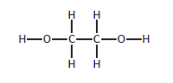

1. Name the type of polymerisation which would take place between succinic acid and ethane-1,2-diol.
2. Draw the repeating unit of the polymer formed between succinic acid and ethane-1,2-diol.

**Q4 on next page**

1. Poly(vinylcarbazole) is a plastic which conducts electricity when exposed to light. The structure of the monomer used to make poly(vinylcarbazole) is:

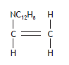

1. Draw a section of the polymer showing three monomer units joined together.
2. Name the type of polymerisation taking place when these monomers join together.
3. Polypropene is a thermoplastic polymer formed by polymerisation of ethene. It burns in an exothermic reaction.
4. What is meant by the word “exothermic”?
5. What will be produced when polypropene burns?
6. Give the structural and molecular formula of propene.
7. Draw three molecules of propene polymerising to polypropene.
8. The diagram below shows part of a polyester molecule.

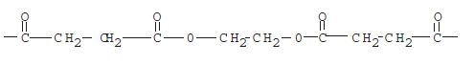

1. Draw the structural formula of the diol and diacid which combine to form this polyester.
2. What type of polymerisation occurs when a diol and diacid react to form a polyester?

The polyester formed in the above reaction can be reshaped when it is heated.

1. What name is given to polymers which can be reshaped when heated?
2. What name is given to small molecules like diols and diacids which can join together to form larger molecules?

Homework 7 – Haber and Ostwald process’

1. The manufacture of potassium nitrate, for use in fertilisers, can be split into three stages.
2. In stage **1**, ammonia is produced.
3. Name the industrial process used to manufacture ammonia.
4. Draw a diagram to show how **all** the outer electrons are arranged in a molecule of ammonia, NH3.

1. In stage **2**, ammonia is converted into nitric acid, HNO3, as shown in the flow diagram.

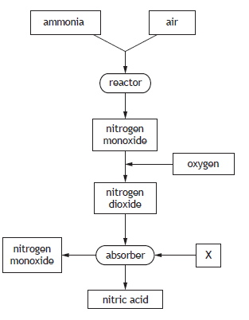

1. Name substance **X**.
2. How could the process can be made more economical.
3. In stage **3**, nitric acid is converted to potassium nitrate.

The equation for the reaction taking place is

HNO3(aq) + KOH(aq) KNO3(aq) + H2O(*ℓ*)

1. Name the type of chemical reaction taking place in stage **3**.
2. State how a sample of **solid** potassium nitrate could be obtained from the potassium nitrate solution.
3. Ammonia is made industrially by the direct combination of nitrogen and hydrogen in the Haber process. The process is shown in the flow diagram below.

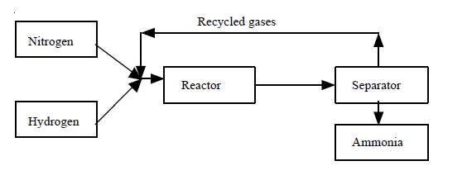

1. Where is the nitrogen obtained from for the Haber process?
2. What catalyst is used in the reactor?
3. How is the ammonia removed from the gas mixture in the separator?
4. What gases are recycled in the above process?
5. The hydrogen for the above process is produced by reacting together methane (CH4) with steam. The reaction produces carbon monoxide and hydrogen.

Write a balanced equation for the reaction which occurs between methane and steam.

**Q3 on next page**

1. The manufacture of nitric acid is an important chemical process.

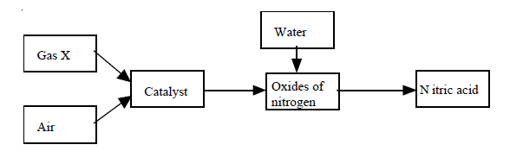

1. What is the name of the process which produces nitric acid?
2. What catalyst is used in this process?
3. What is gas X which is reacted with air?
4. What is the formula of nitric acid?
5. Nitric acid is produced by the reaction of nitrogen dioxide, water, and oxygen. Write an equation for this reaction.

Homework 8 – Radioactivity

1. Comparing alpha, beta, and gamma radiation.
2. Which has a positive electrical charge?
3. Which has the smallest mass?
4. Which has zero mass?
5. Which can pass through several centimetres of lead?
6. Which is stopped by a sheet of paper?
7. Different types of radiation have different penetrating properties.

An investigation was carried out using 3 radioactive sources.

Name the type of radiation emitted by source 2.

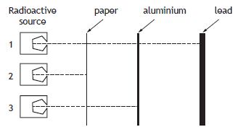

1. The average annual radiation dose absorbed by a person in the UK is 2·5 millisieverts (mSv). Most of this radiation is natural but some comes from man-made sources. Radon, a gas produced by rocks such as granite, is the biggest natural source of radiation. The pie chart shows the percentage of the annual radiation dose absorbed from different sources.

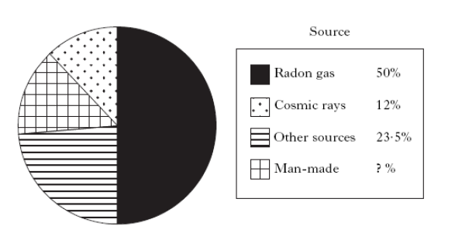

1. What percentage of the annual radiation dose comes from man-made sources of radiation?
2. What is the average annual radiation dose, in millisieverts, obtained from the biggest source of natural radiation?

Homework 9 – Nuclear Equations and Half life

1. Americium-241, a radioisotope used in smoke detectors, has a half-life of 432 years.
2. The equation for the decay of americium-241 is

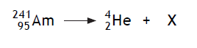

Name element **X**.

1. Name the **type** of radiation emitted by the americium-241 radioisotope.
2. Another radioisotope of americium exists which has an atomic mass of 242. Americium-242 has a half-life of 16 hours.
3. A sample of americium-242 has a mass of 8 g. Calculate the mass, in grams, of americium-242 that would be left after 48 hours.
4. Suggest why americium-241, and not americium-242, is the radioisotope used in smoke detectors.
5. Write nuclear equations for the following changes.
6. ${}_{6}^{14}C$ emits a beta particle
7. ${}_{94}^{238}{Pu}$ emits an alpha particle
8. ${}_{28}^{61}{Ni}$ emits a beta particle
9. ${}_{84}^{212}{Po}$ emits an alpha particle
10. What is formed when:
11. Cobalt 60 emits a beta particle
12. Uranium 230 emits an alpha particle
13. Thorium 232 emits a beta particle
14. Bismuth 210 emits a beta particle
15. A radioactive source has an activity of 400 cpm. The half-life of the source is 2 minutes. What would the activity of the source be after 8 minutes?
16. A radioactive isotope has a count rate of 80 c.p.m. at time zero. After 12 years the count rate is 20 c.p.m.
17. What is the half-life of the isotope?
18. What will the count rate be 24 years after time zero?