By Unit then Key Areas; Section A Questions followed by Section B (section B where covering multiple key areas are given when the last content in the question is covered – assuming order as key areas)

Organic Chemistry and Instrumental Analysis Unit 2
Molecular orbitals 2
Molecular structure 4
Stereochemistry 5
Synthesis 7
Experimental determination of structure 9
Pharmaceutical Chemistry 11

Organic Chemistry and Instrumental Analysis Unit

Molecular orbitals
Section A Answers
Q |  | Source | Answer
1 | 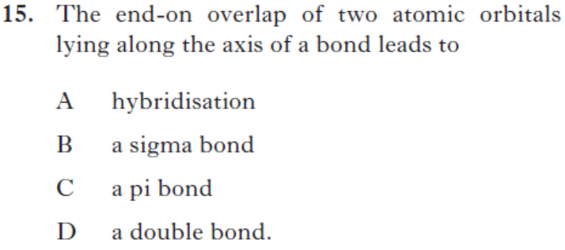 | 2014Rev/15 | B

Section B Answers
Q |  | Source | Answer (from SQA Mark Scheme)
1 | 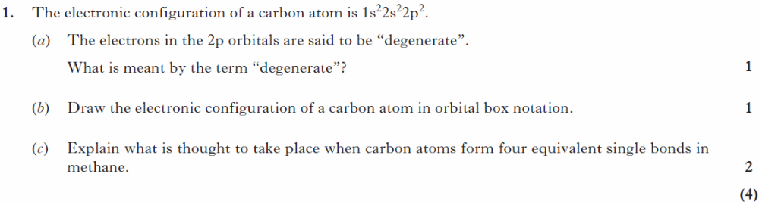 | 2013  Rev/1 | - Equal energy/ same energy  b)  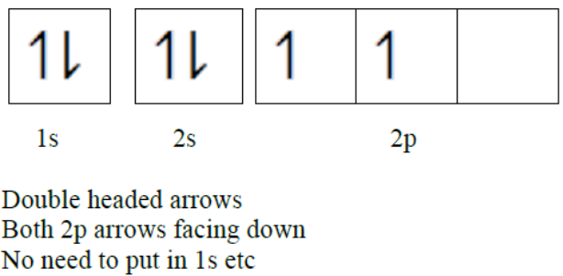  c)  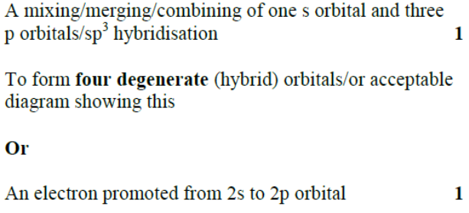

Molecular structure
Section A Answers
Q |  | Source | Answer
1 |  | SQP/23 | C

Stereochemistry
Section A Answers
Q |  | Source | Answer
1 |  | SQP/29 | B
2 | 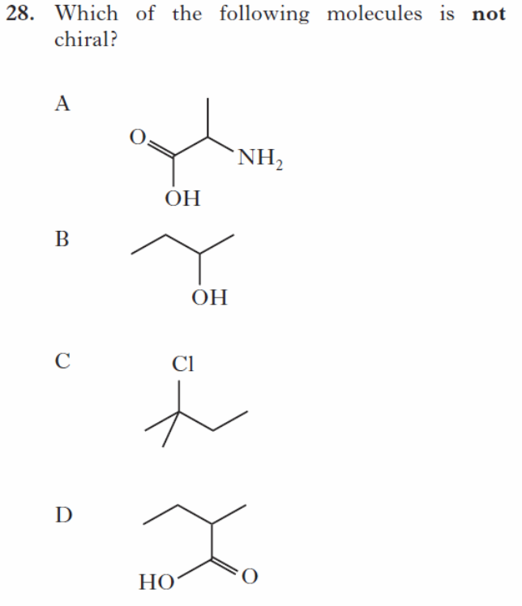 | SQP/28 | C
3 | 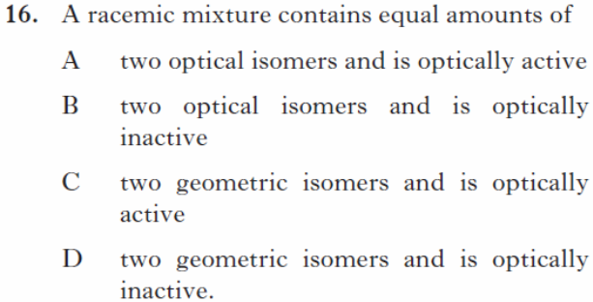 | SQP/16 | B
4 | 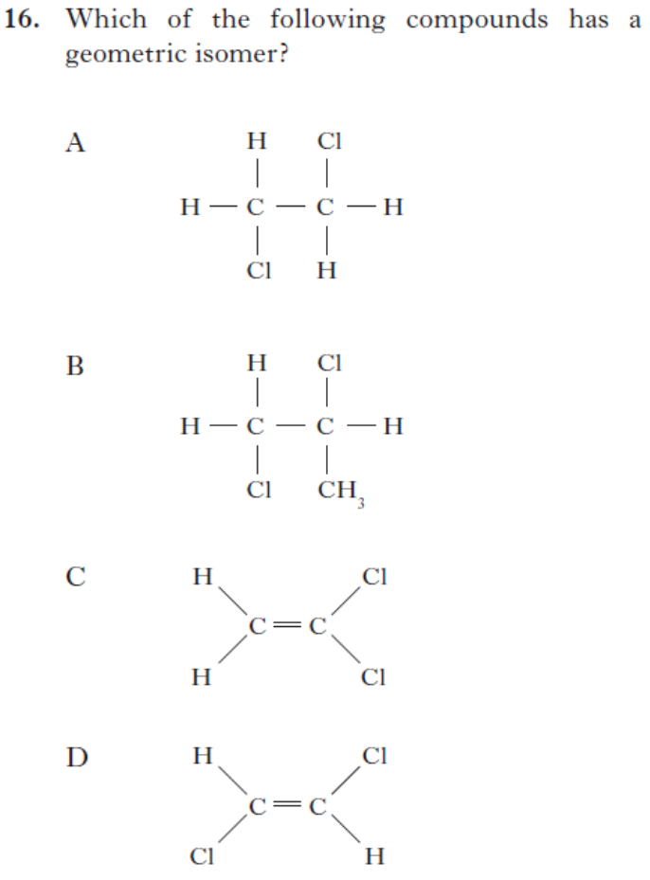 | 2014Rev/16 | D
5 | 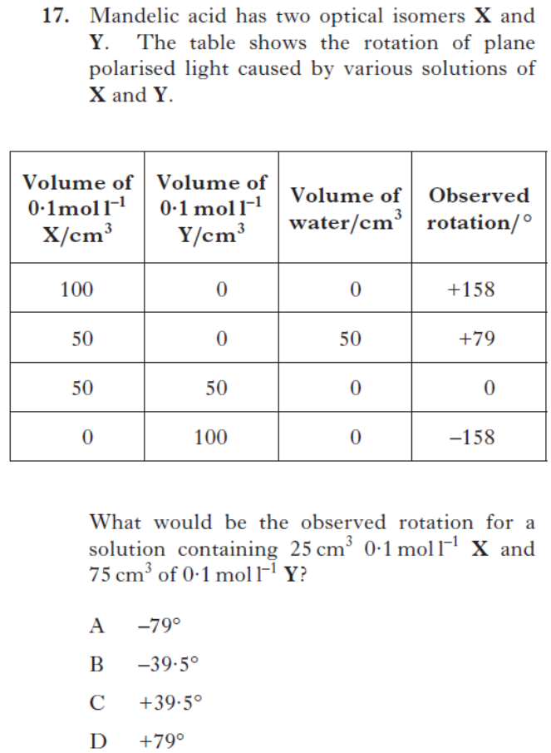 | 2014Rev/17 | A

Section B Answers
Q |  | Source | Answer (from SQA Mark Scheme)
1 | 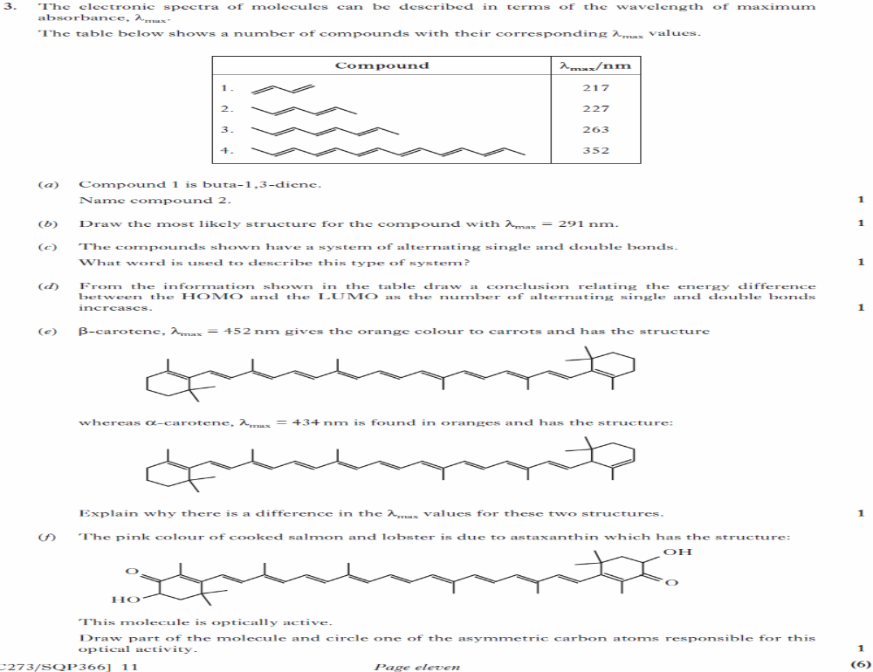 | SQP/3 | - Hexa-2,4-diene  - Any correct structure for deca-2,4,6,8-tetraene such as  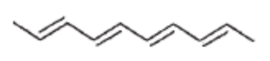  - Conjugated/conjugation  - As the number of alternating single and double bonds increases the energy difference between the HOMO and the LUMO decreases  - α-carotene has a shorter conjugated system or similar  - 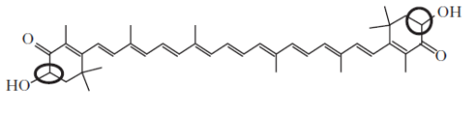  Either of the two carbons connected to an OH group  Or section with one of the asymmetric carbon atoms circled.

Synthesis
Section A Answers
Haloalkanes
Q |  | Source | Answer
1 | 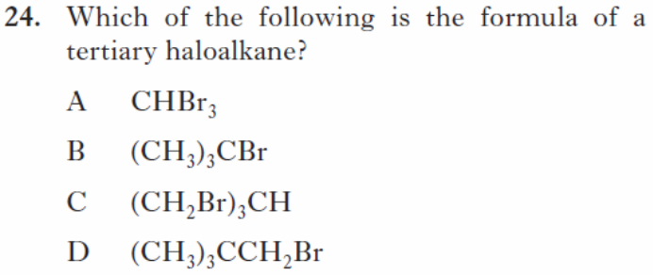 | SQP/24 | B
2 | 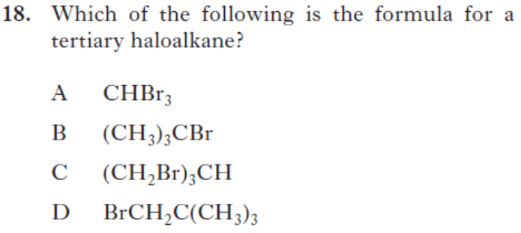 | 2014Rev/18 | B
3 | 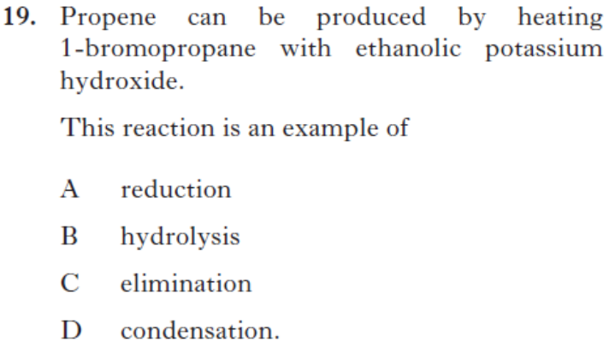 | 2014Rev/19 | C
4 | 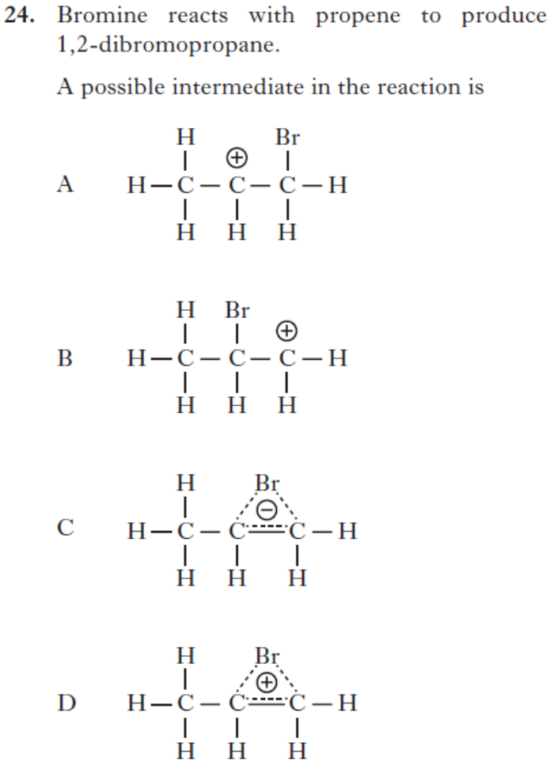 | 2013Rev/24 | A
Alcohols
Q |  | Source | Answer
5 | 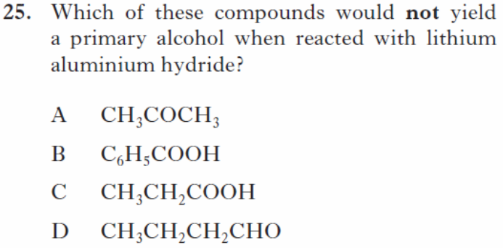 | SQP/25 | A
6 | 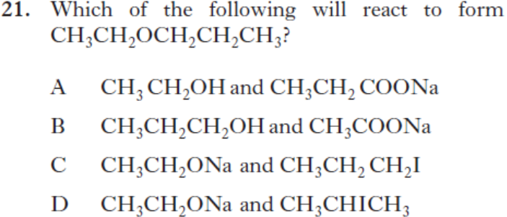 | 2014Rev/21 | C
7 | 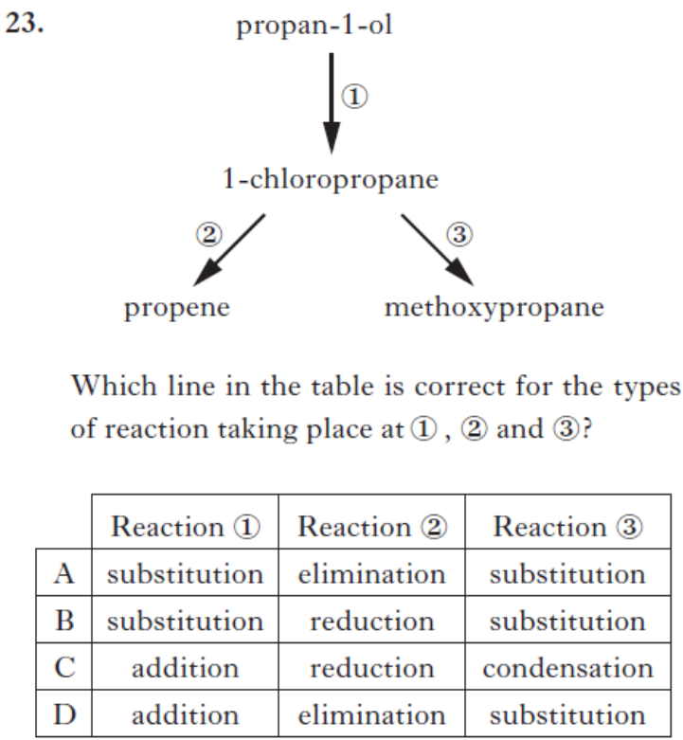 | 2013Rev/23 | A
8 | 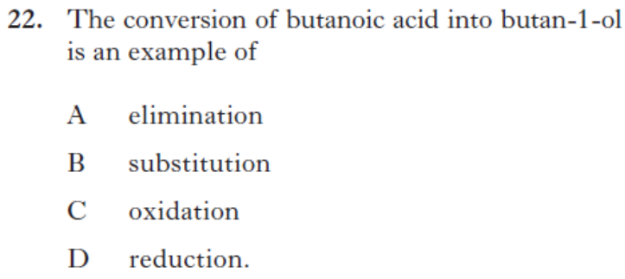 | 2013Rev/22 | D
Ethers
Q |  | Source | Answer
9 | 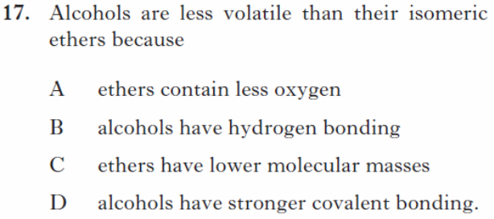 | SQP/17 | B
10 | 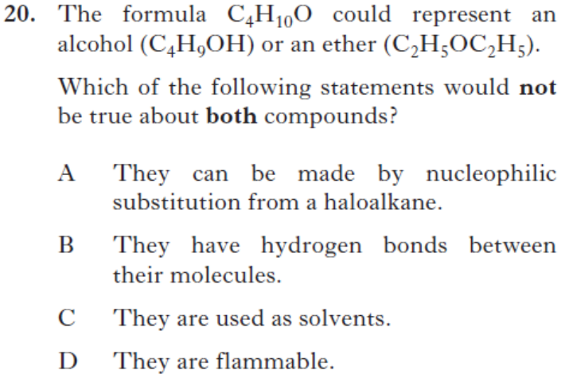 | 2014Rev/20 | B
11 | 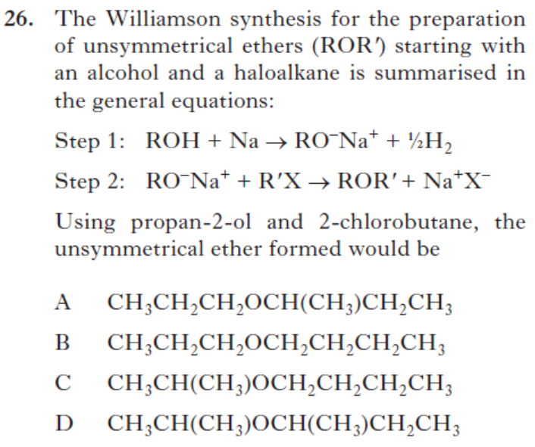 | 2013Rev/26 | D
Aldehydes and Ketones and carboxylic acids
Q |  | Source | Answer
12 | 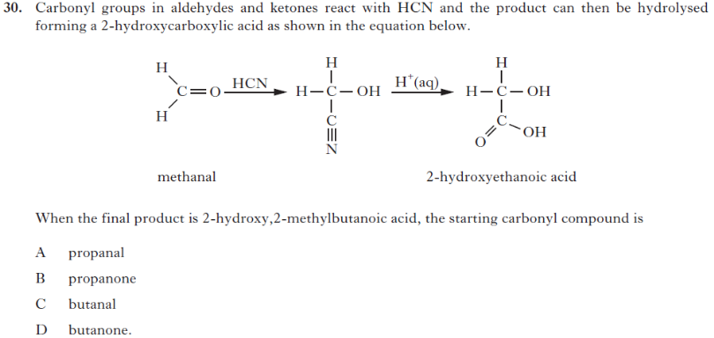 | 2013Rev/30 | D
13 | 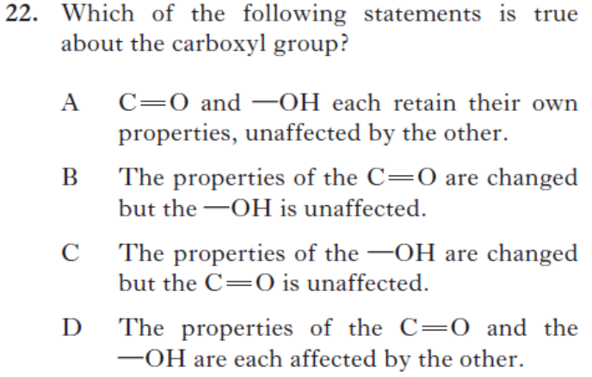 | 2014Rev/22 | D
Amines
Q |  | Source | Answer
14 | 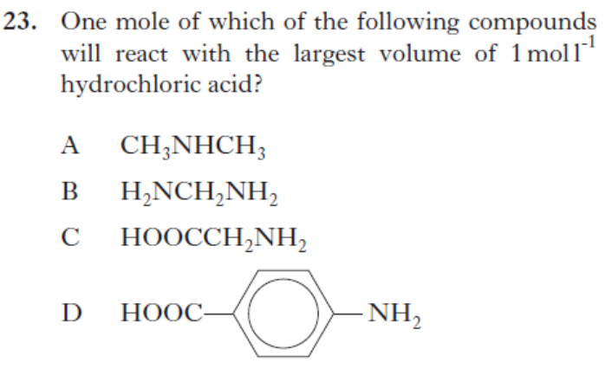 | 2014Rev/23 | B
15 | 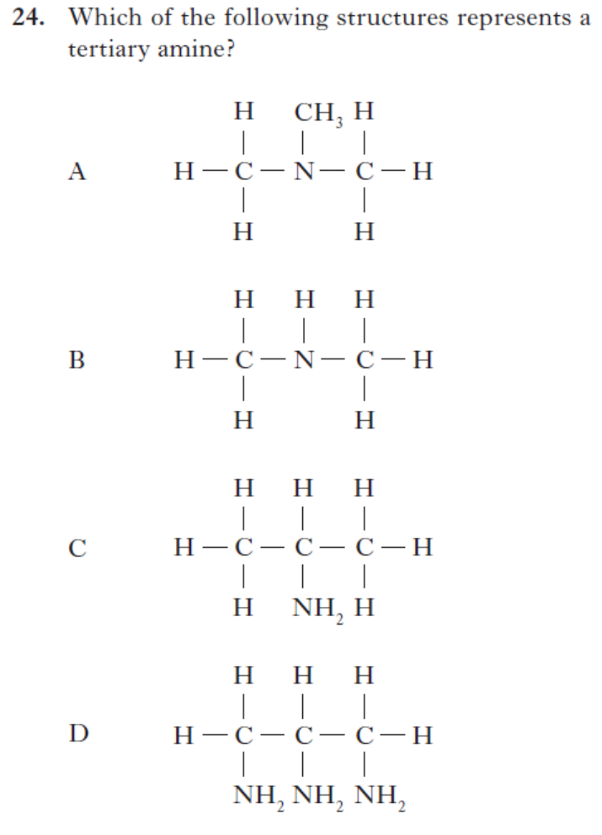 | 2014Rev/24 | A
Aromatics
Q |  | Source | Answer
16 | 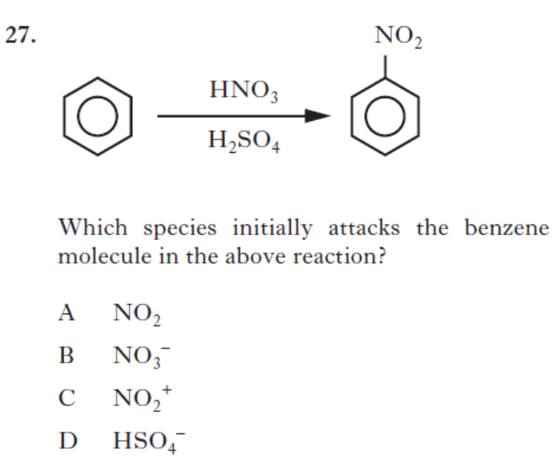 | 2013Rev/27 | C
Reactions Overall
Q |  | Source | Answer
17 | 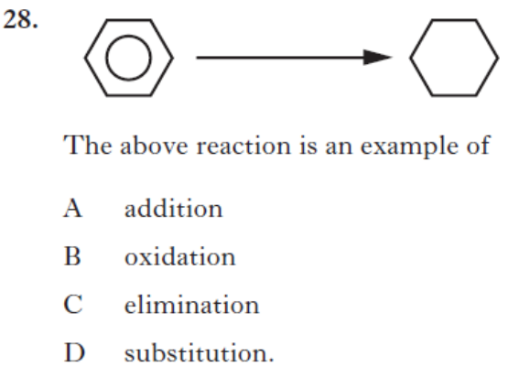 | 2013Rev/28 | A
18 | 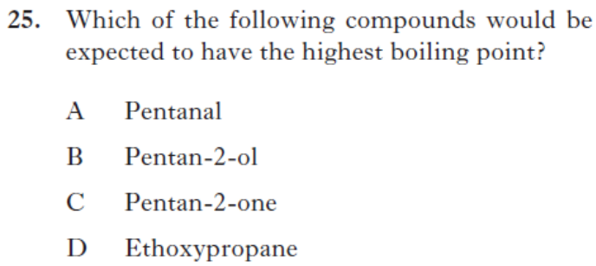 | 2013Rev/25 | B
19 | 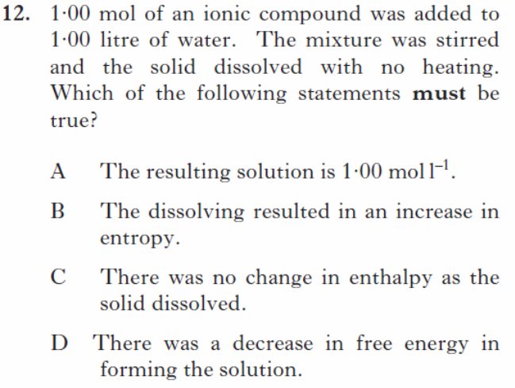 | SQP/12 | D
20 | 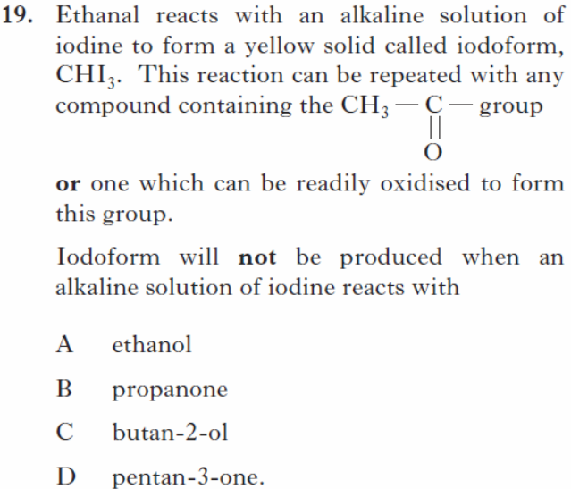 | SQP/19 | D
21 | 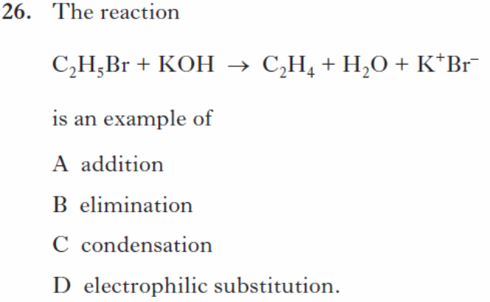 | SQP/26 | B
22 | 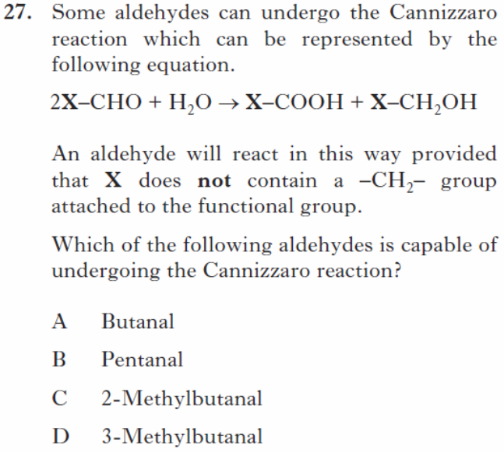 | SQP/27 | C
23 | 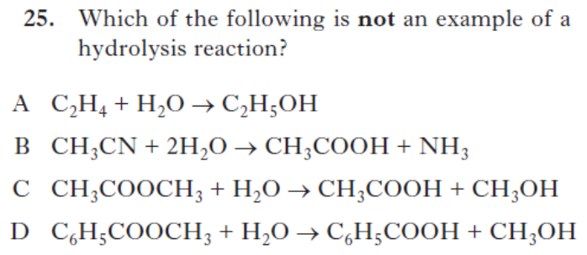 | 2014Rev/25 | A
24  25 | 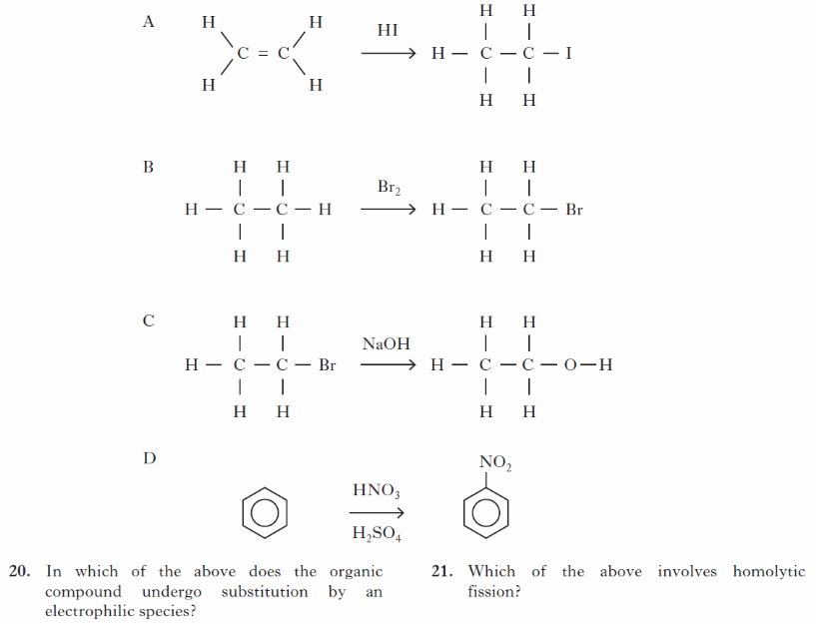 | SQP20  SQP21 | D  B

Section B Answers
Q |  | Source | Answer (from SQA Mark Scheme)
1 | 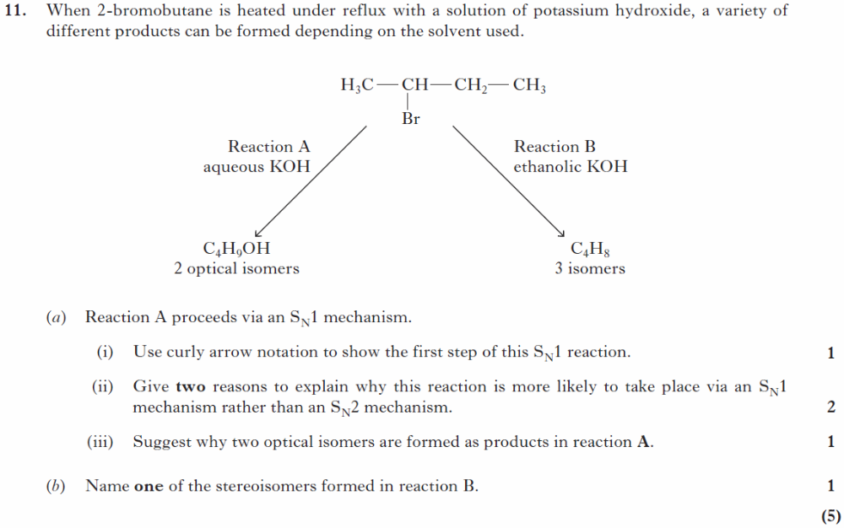 | SQP  /11 | a)i)  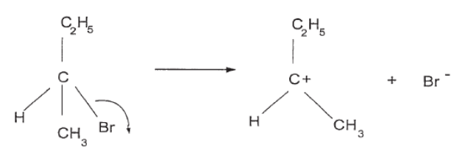  ii)  Steric hindrance from CH₃ and C₂H₅ group preventing 5 numbered intermediate forming in S_{N}2 mechanism (1)  The carbocation intermediate of S_{N}1 reaction is stabilised by the inductive effect from the two alkyl groups in the intermediate (1)  iii) the OH⁻ can attack from either side of carbocation making both of the optical isomers (of butan-2-ol)  b) cis but-2-ene or trans but-2-ene
2 | 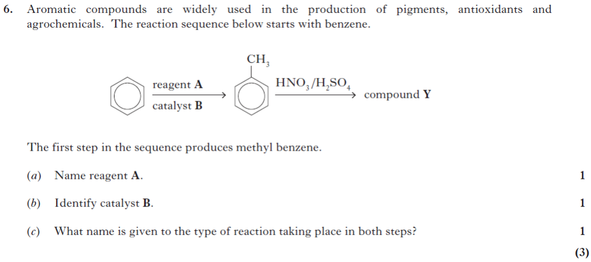 | 2014  Rev/6 | a)  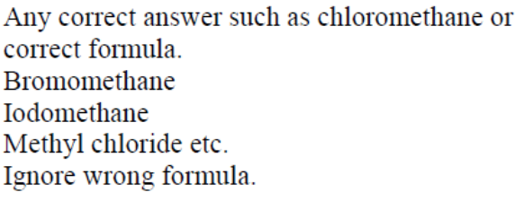  Unacceptable  Fluromethane / CH₃⁺/ wrong name with correct formula.  b)  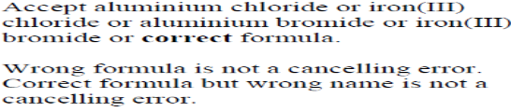  Unacceptable  Wrong formula / aluminium oxide  c) electrophilic substitution
3 | 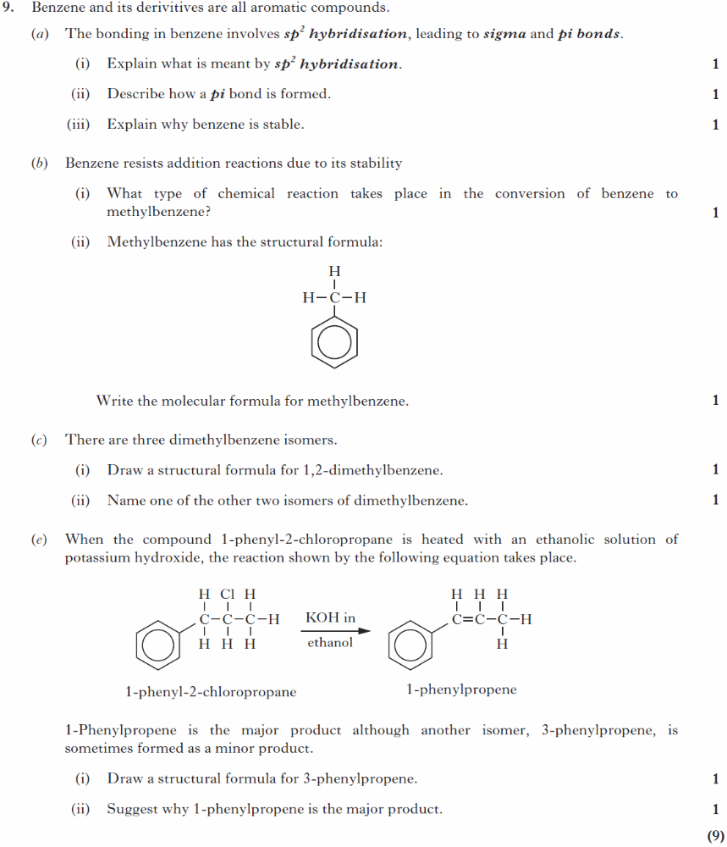 | SQP/9 | a)i) it is a mixing of combining of one s orbital and two p orbitals to form three molecular orbitals  ii) A pi bond is made by “sideways” overlap of orbitals  iii) The delocalisation of the electrons within the ring gives stability  b)i) electrophilic substitution/alkylation  (unacceptable – nucleophilic substitution)  ii) C₇H₈  c)i)  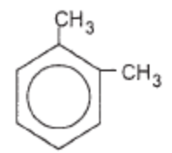  ii) 1,3-dimethylbenzene or 1,4-dimethylbenzene  d)i)  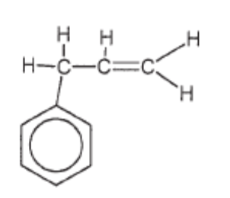  ii) conjugation of the C=C and benzene ring delocalised electrons gives much greater stability of 1-phenylpropene
4 | 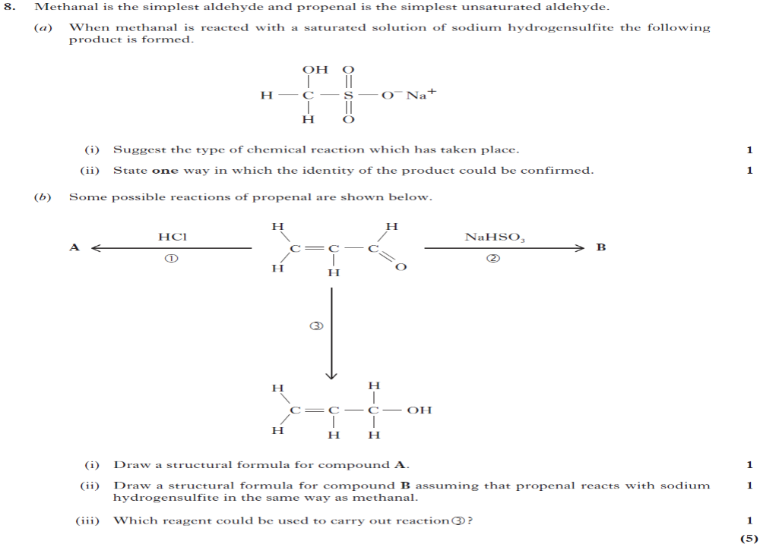 | 2014  Rev/8 | i)  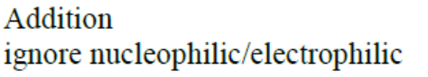  unacceptable  sulphonation  ii)  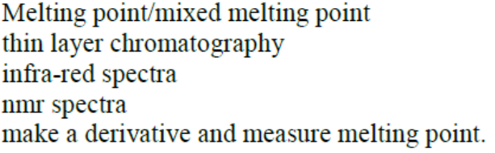  Unacceptable  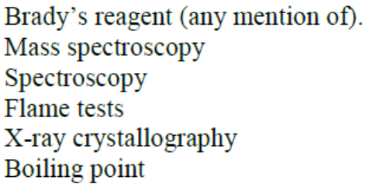
b)i)
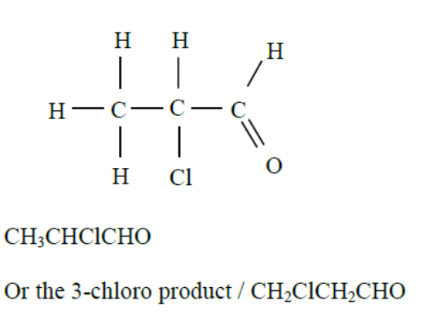
Unacceptable
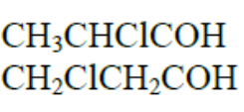
ii)
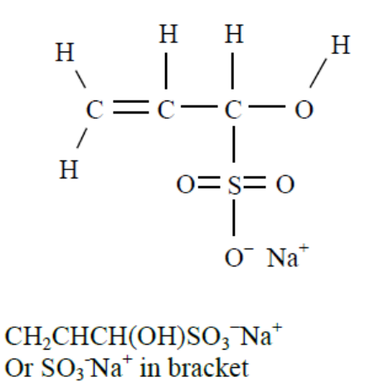
iii)
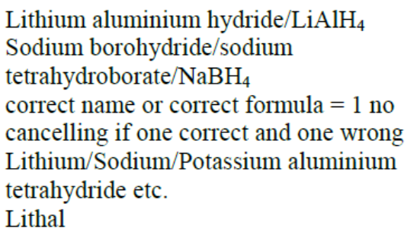
Unacceptable
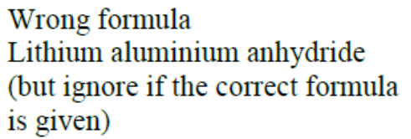
5 | 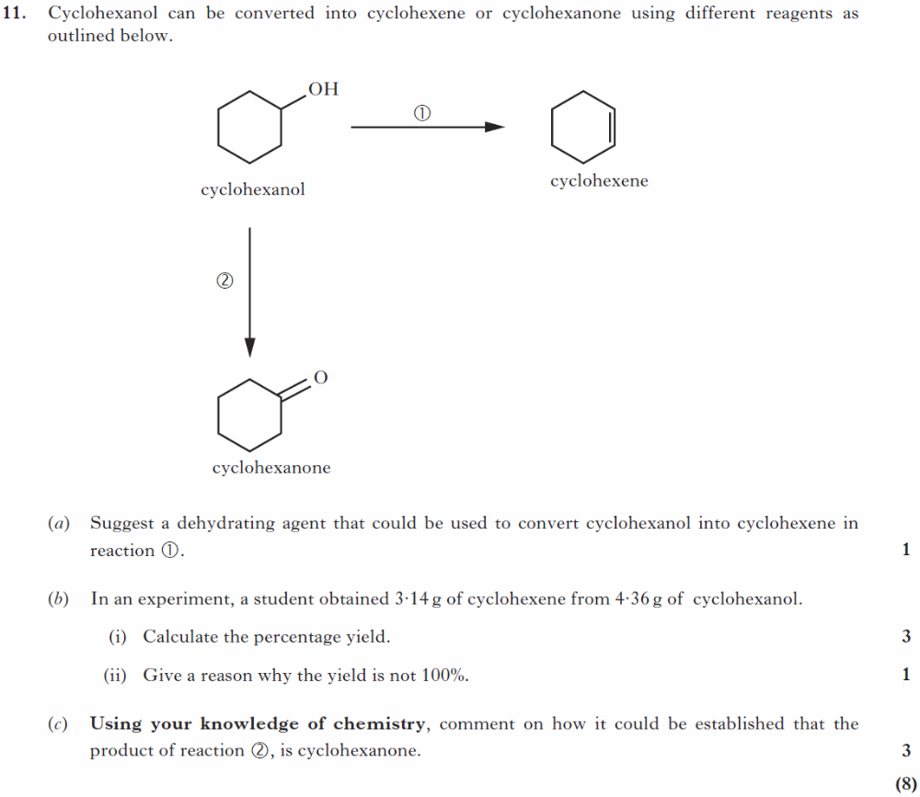 | 2013  Rev/11 | a)phosphoric acid  or/aluminium oxide  or (concentrated) sulphuric acid  not acceptable  Silica/anhydrous calcium chloride  b)  one mark for  One mole cyclohexanol gives one mole cyclohexene moles cyclohexanol = 4·36/100 = 0·0436 moles  One mark for  theoretical yield of cyclohexene = 0·0436 × 82 = 3·575 (g)  one mark for  % yield = 3·14 × 100/3·575 = 87·8 (%) 1  Using 0·44 mol, gives 3·608 g giving 87·029 or 87·03 (%) for 3 marks  1Deduct 1 mark per error  Accept any answer between 87 and 88 (%) for 3 marks  Award 1 mark for both formula masses correct  ii)  Impure starting materials/mechanical losses/mass transfer losses/reaction may not go to completion/side reactions/equilibrium reaction  c)  This is an open ended question  1 mark: The student has demonstrated a limited understanding of the chemistry involved. The student has made some statement(s) which is/are relevant, showing that at least a little of the relevant chemistry is understood.  2 marks: The student has demonstrated a reasonable understanding of the chemistry involved. The student makes some statements which are relevant showing understanding of the problem.  3 marks: The maximum available mark would be awarded to a student who has demonstrated a good understanding of the chemistry involved. The student has shown a good understanding of the chemistry involved and has provided a logically correct answer to the question asked. This type of response might include a statement of the principles involved, a relationship or an equation and an application of these to answer the question. This does not mean that the answer has to be what might be termed an ‘excellent’ or ‘complete’ answer.
6 | 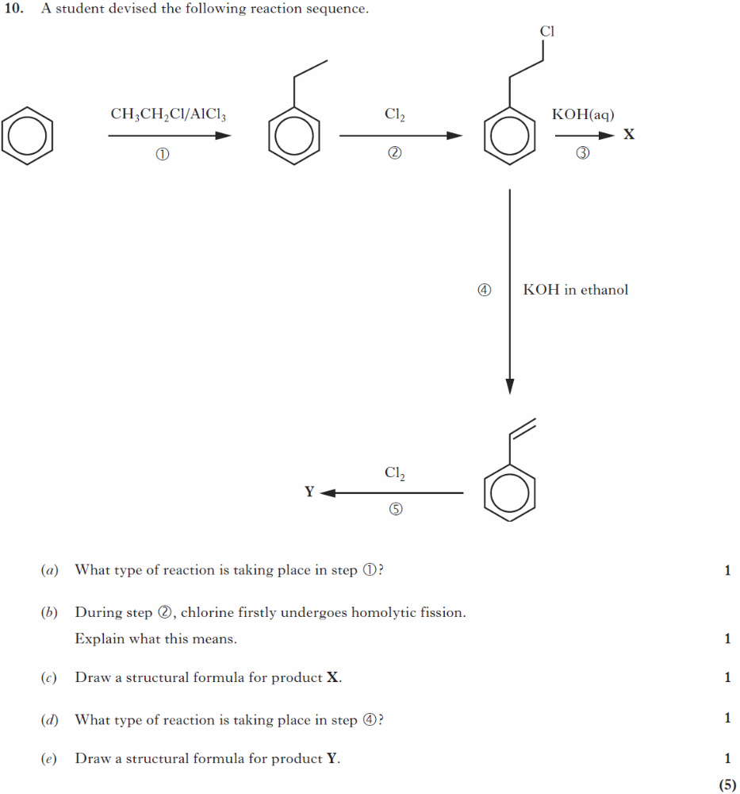 | 2013  Rev/10 | - Electrophilic substitution/alkylation  b)  Chlorine molecules have changed into chlorine radicals or chlorine atoms  or Chlorine has changed into chlorine radicals or chlorine atoms  or both atoms retain one electron from the covalent bond  or correct equation  c)  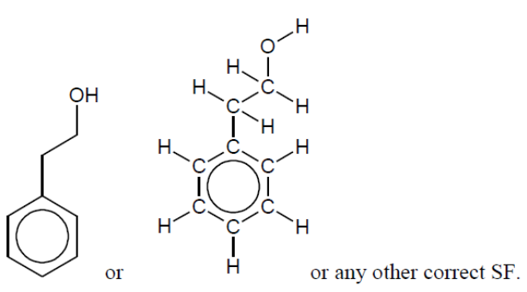  d)  (base induced) Elimination  e)  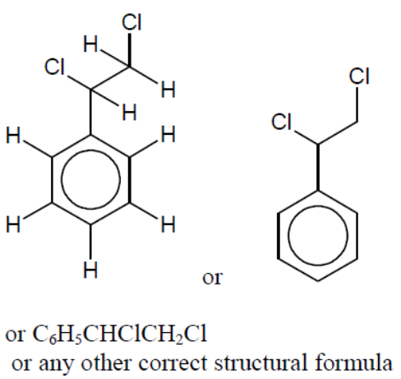
7 | 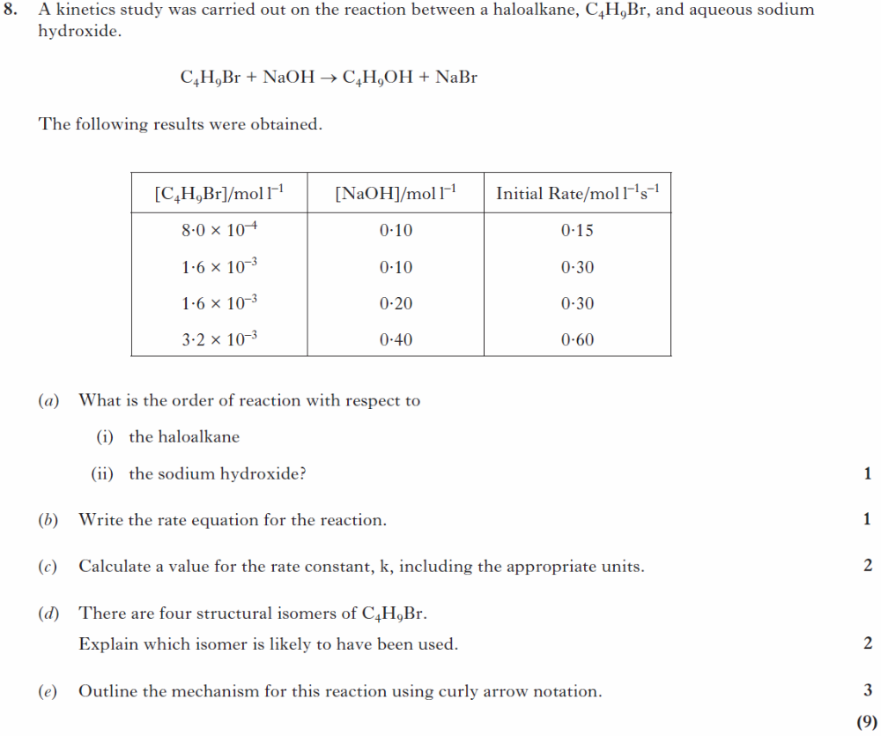 | 2013  Rev/8 | Ai)first order  ii) zero order  b)  Rate = k[C4H9Br] or Rate = k[C4H9Br]1 [NaOH]o  Must be square brackets  k not K  c)  1mark  k =Rate/[C4H9Br] = 0·15/8·0 × 10−4 = 187·5 s−1  1 mark for correct units. Accept 188 and 190 s−1  (Don’t penalise for K in place of k)  Correct follow through from (a) or (b)  d)  1 mark  The tertiary haloalkane or 2-bromomethylpropane or 2-bromo-2-methylpropane  Accept 2-methyl-2-bromopropane  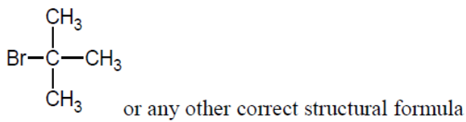  1 mark  And  Correct explanation in terms of  Stability of carbocation or Steric hindrance  Notes  Cancelling errors apply if correct structure and wrong name or vice-versa but accept “methy” as a slip if the structure is correct  But if only the name is given then do not accept errors such as “brom” or “methy”  2-methylbromopropane  e)  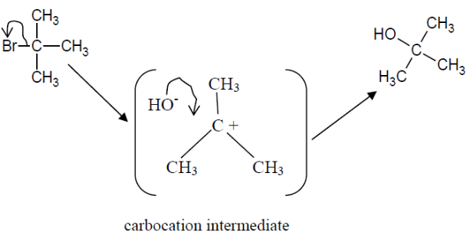  1 mark for reactant and for curly arrow  showing heterolytic fission of C – Br bond  1 mark for correct carbocation intermediate  1 mark for 2nd curly arrow and final product

Experimental determination of structure
Section A Answers
Experimental microanalysis
Q |  | Source | Answer
1 | 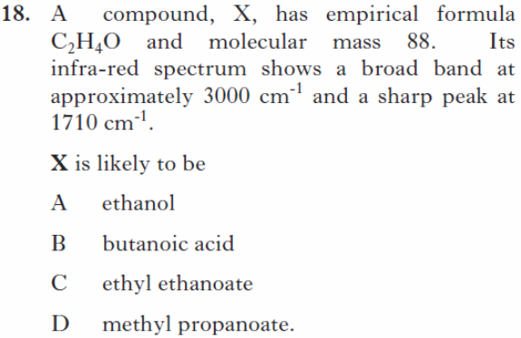 | SQP/18 | B
Spectroscopy
Q |  | Source | Answer
2 | 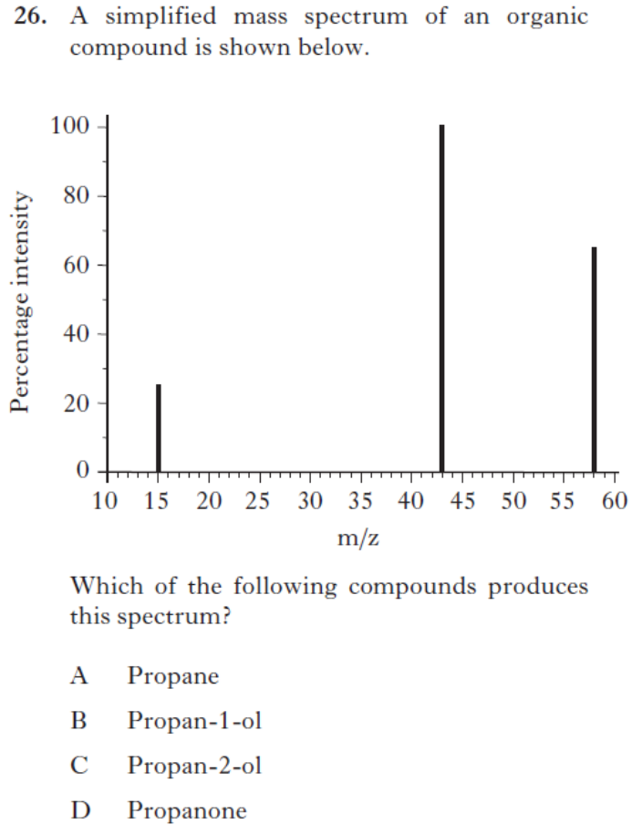 | 2014Rev/26 | D
3 | 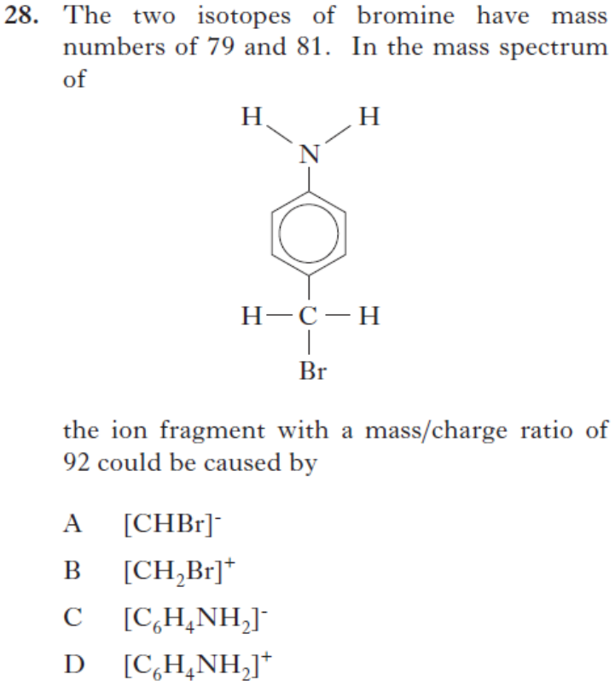 | 2014Rev28 | D
4 | 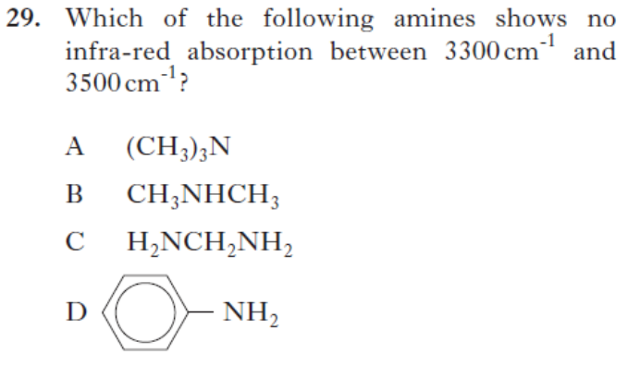 | 2014Rev/29 | A
5 | 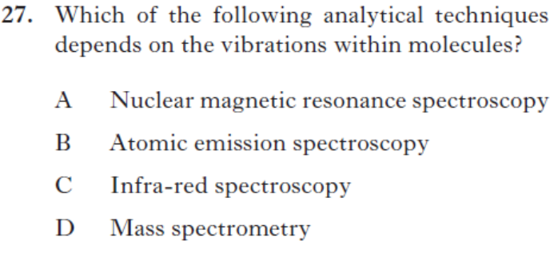 | 2014Rev/27 | C

Section B Answers
Q |  | Source | Answer (from SQA Mark Scheme)
1 | 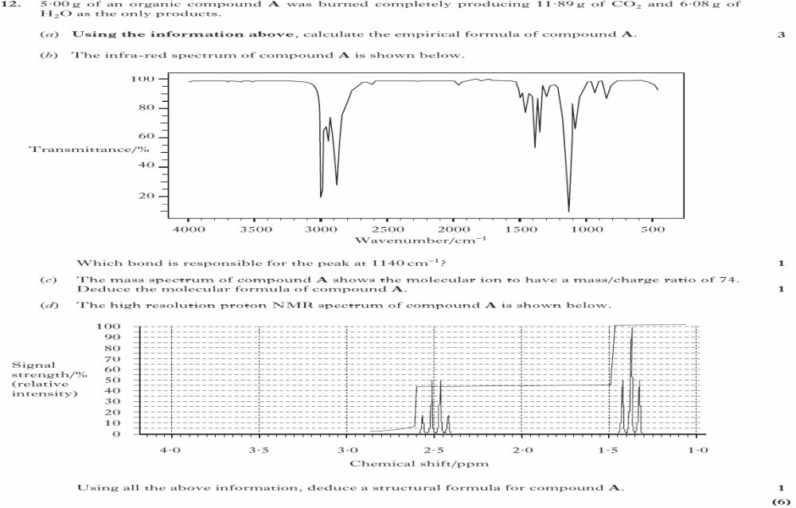 | 2013  Rev/12 | a)  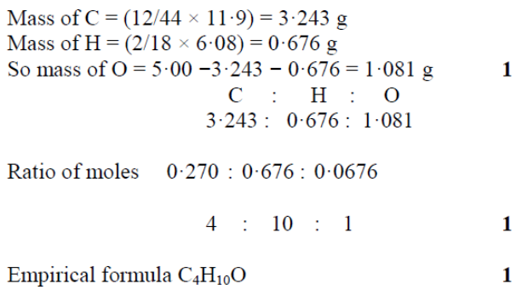  Correct answer, no working= 1 mark  - C-O (stretch)  - C₄H₁₀O  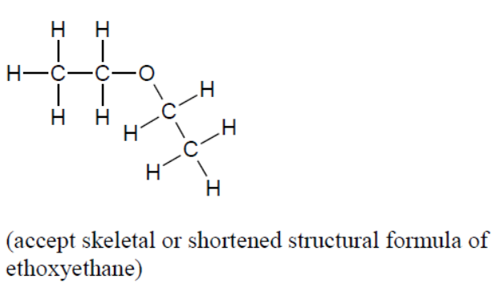
2 | 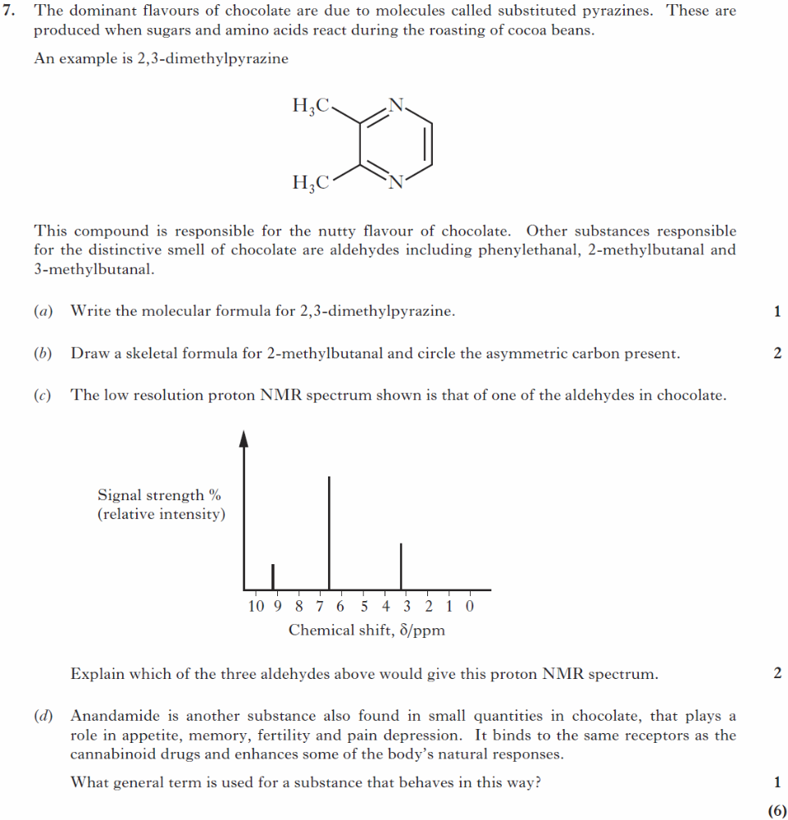 | 2013  Rev/7 | - C6H8N2  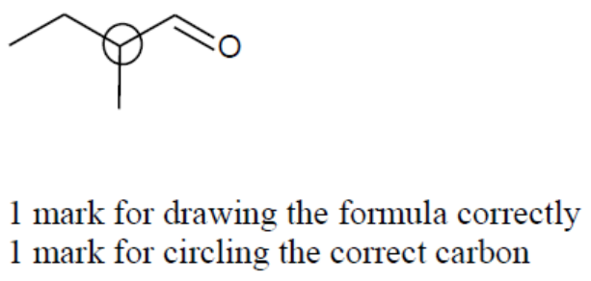  c)  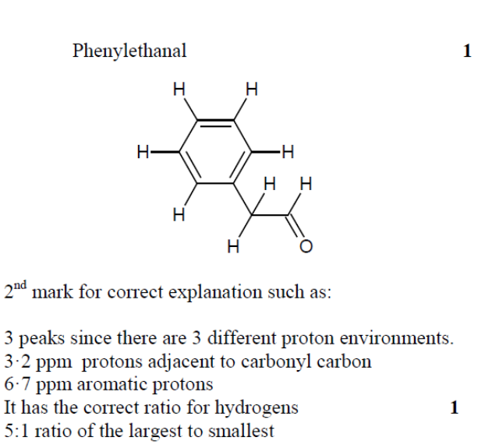  d)agonist
3 | 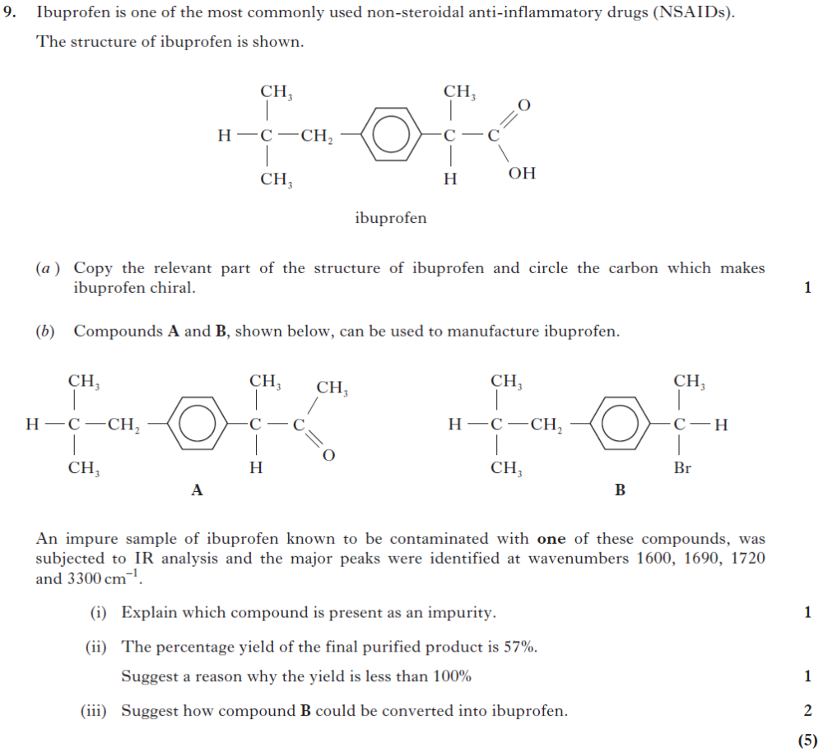 | 2014  Rev/9 | a)  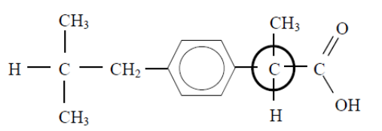  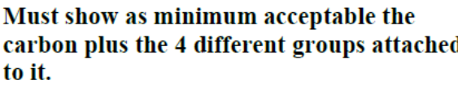  b)i)  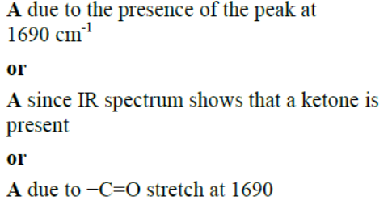  Unacceptable  A since IR spectrum shows that an aldehyde is present  A since IR spectrum shows that a C=O is present  1720(unless specifying due to ibuprofen)=cancelling  ii) 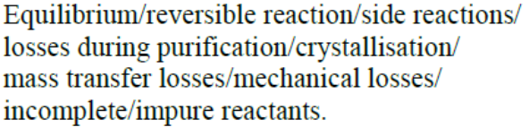  iii)  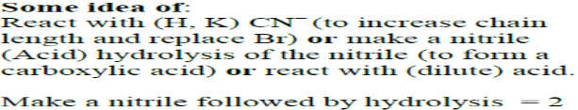  For first mark  For second, or..
4 | 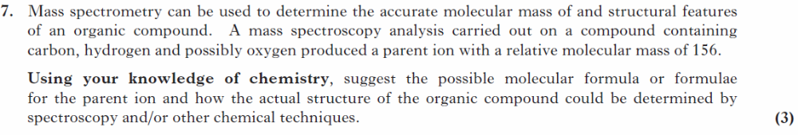 | SQP/7 | 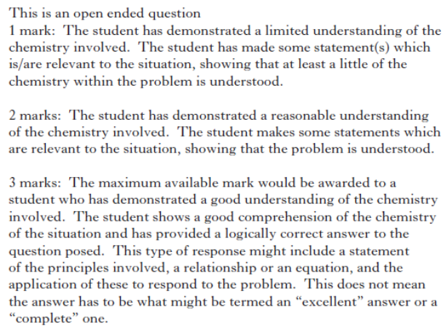  Given in the unacceptable  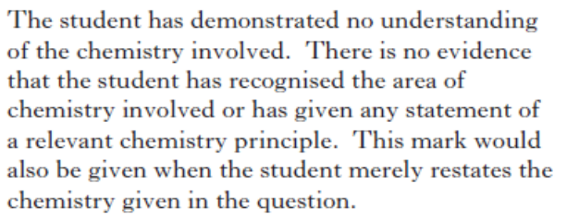

Pharmaceutical Chemistry
Section A Answers
Q |  | Source | Answer
1 | 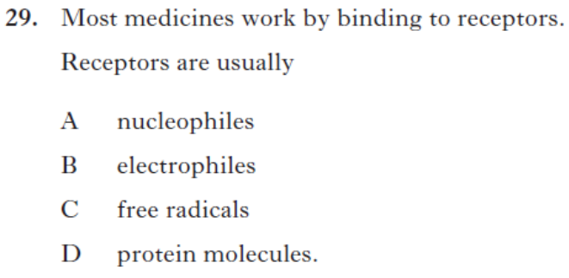 | 2013Rev/29 | D
2 |  | SQP/30 | C
3 | 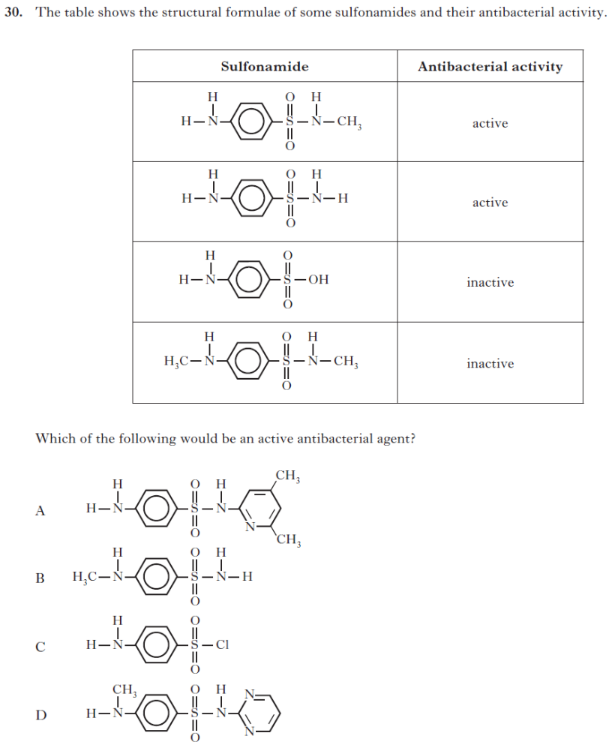 | 2014Rev/30 | A

Section B Answers
Q |  | Source | Answer (from SQA Mark Scheme)
1 | 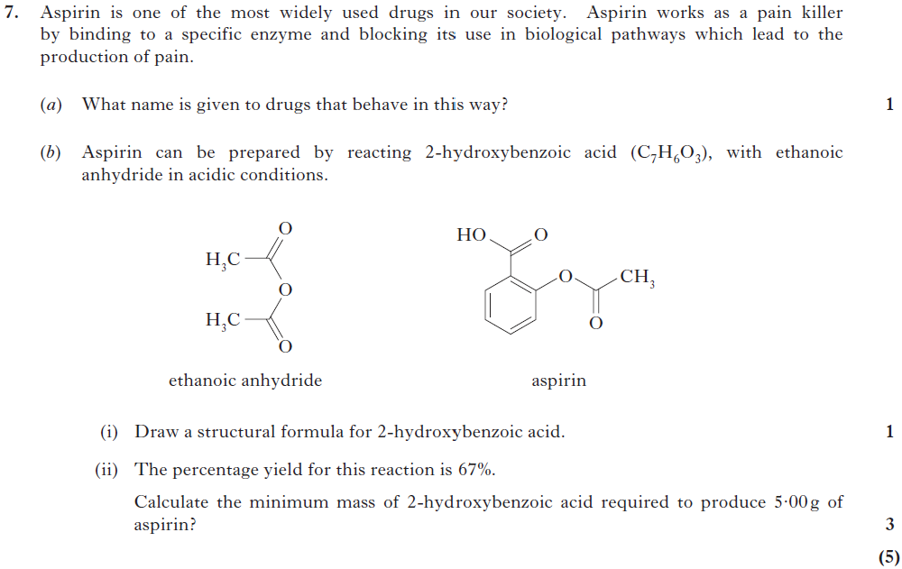 | 2014  Rev/7 | a)antagonist  bi)  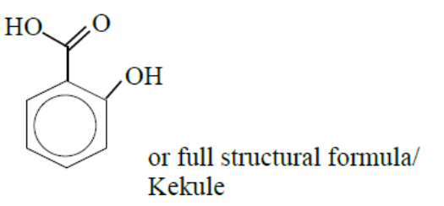  ii)1 mark for  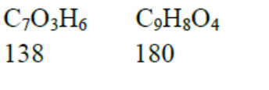  1 mark for  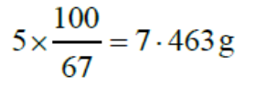  1 mark for  

