CfE Higher Chemistry

Unit 2:
Nature’s Chemistry



Homework Booklet

Hydrocarbons

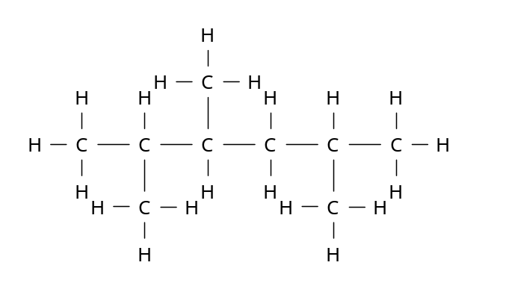
1. Write the systematic names for
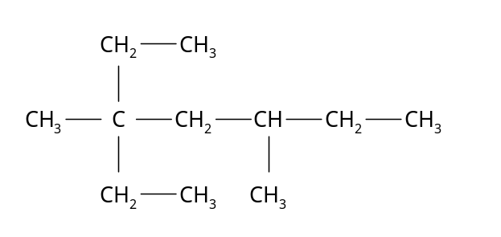
a) b)

2. Write the structural formulae and names of 3 isomers of pentene.

3. Identify the homologous series each of the following molecules belongs to and name the
functional group present.
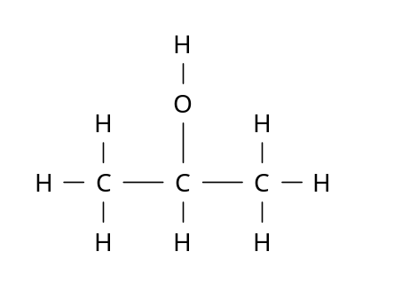
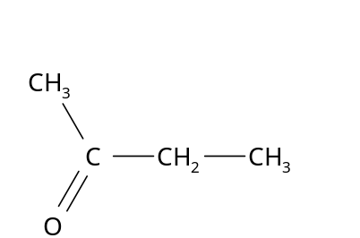
a) b)

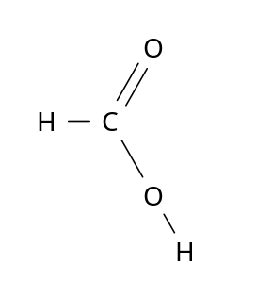
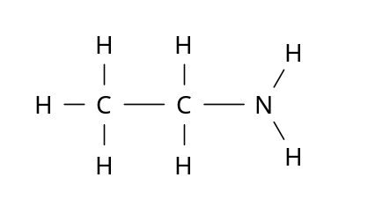
c) d)

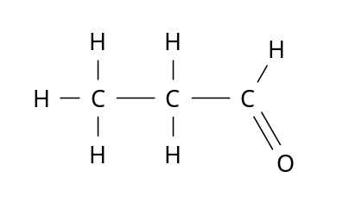
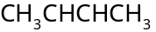
e) f)

4. Draw the full structural formulae for each of the following compounds.

a) 2,4-dimethylheptane b) 3-ethyl-2-methylpentane. c) Butan-2-ol

d) Pentan-1-ol e) Ethanoic acid f) Methylbenzene (toluene).
5. The percentage of carbon by mass in pentane is

A 85.7
B 83.3
C 81.8
D 29.4

6. Which of the following has isomeric forms?

A C₂H₃Cl
B C₂H₅Cl
C C₂HCl
D C₂H₄Cl₂

7. Which hydrocarbon is not a member of the same homologous series as the others?

 | Relative formula mass
A | 44
B | 72
C | 84
D | 100

8. Which equation could represent an industrial cracking process?

A CH₃(CH₂)₆CH₃ CH₃(CH₂)₄CH₃ + CH₂=CH₂
B CH₃(CH₂)₆CH₂OH CH₃(CH₂)₅CH= CH₂ + H₂O
C CH₃(CH₂)₆CH₃ CH₃C(CH₃)₂CH₂CH(CH₃)₂
D 4CH₂=CH₂ (CH₂CH₂)₄

9. Which of the following hydrocarbons always gives the same product when one of its hydrogen atoms is replaced by a chlorine atom.

A Hexane
B Hex-1-ene
C Cyclohexane
D Cyclohexene

10. Which of the following statements about benzene is correct?

A Benzene is an isomer of cyclohexane.
B Benzene reacts with bromine solution as if it is unsaturated.
C The ratio of carbon to hydrogen atoms in benzene is the same as in ethyne.
D Benzene undergoes addition reactions more readily than hexene.

11. The extensive use of which type of compound is thought to contribute significantly to the depletion of the ozone layer?

A Oxides of carbon
B Hydrocarbons
C Oxides of sulphur
D Chlorofluorocarbons

12. Propene is used in the manufacture of addition polymers.
What type of reaction is used to produce propene from propane?

A Addition
B Cracking
C Hydrogenation
D Oxidation

13. Butadiene is the first member of a homologous series of hydrocarbons called the dienes.
What is the general formula for this series?

A C_{n}H_{n+2}
B C_{n}H_{n+3}
C C_{n}H_{2n}
D C_{n}H_{2n-2}

14. Straight chain hydrocarbons, branched chain hydrocarbons, cyclic hydrocarbons and aromatic hydrocarbons are all obtained from petroleum oil.

(a) State the systematic name for the following molecule.

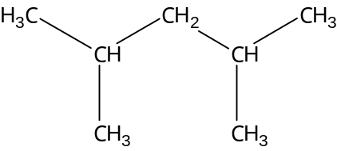

(b) Draw the full structural formula for 1,2 – dimethylcyclohexane.

(c) Name a straight chain hydrocarbon which is an isomer of 1,2 – dimethylcyclohexane.
(d) Draw the full structural formula for an aromatic hydrocarbon with 8 carbon atoms
in the molecule.

15. Petrol is a mixture of chemicals.

(a) The structural formula for a hydrocarbon in petrol is:

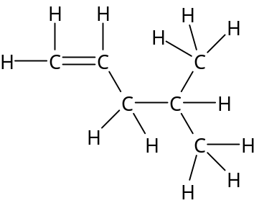

State the systematic name for this hydrocarbon.

(b) A possible route to another compound found in petrol is

C₆H₁₄ _{(l)} ^{catalyst} 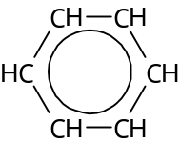 _{(l)} + 4H_{2(g)}
_{product X}

- Name product X

- Name the process taking place.

(c) Nitrogen oxides are polluting gases found in the exhaust mixture from petrol engines.
The production of these gases is not a problem with diesel engines. Explain why this is
the case.

16. Markovnikoff’s rule states:

“Addition of hydrogen chloride to an alkene can give two products.
The hydrogen of the hydrogen chloride mainly attaches to the carbon atom of the double bond which already has the most hydrogen attached to it”.

(a) Draw the full structural formula for the major product formed when hydrogen
chloride reacts with propene.

(b) Why is it not necessary to consider Markovnikoff’s rule when hydrogen chloride
reacts with but-2-ene?

17. Three dicholorbenzenes are known. Their structure depends on the positions of the chlorine
atoms in the benzene ring. Two of the isomers are shown.

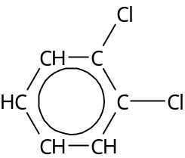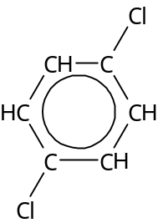

A B

- Draw the structure of the third isomer and name it.

- Give the molecular formula for the three isomers

- Why is molecule A polar while molecule B is non-polar?

18. Chlorofluorocarbons, commonly known as CFC’s are widely used in fridges, aerosols, and to
preserve blood in blood banks.
Information about three CFC’s is shown in the table.

CFC | Name | Structure
12 | Dichlorodifluoromethane
13 | 1,1,2 – trichloro-1,2,2-triflouroethane | 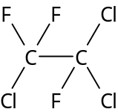
114 |  | 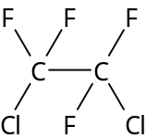

Copy out the table and

- Draw the full structural formula for CFC 12.

- Give the name for CFC 114.

19. Ethyne is the first member of the homologous series called the alkynes.

Ethyne can undergo addition reactions as shown below in the flow diagram,

HCl
compound 1 compound 2
HCl

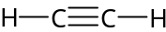 1,2-dichloroethane

reagent A reagent B

compound 3

reagent C

monochloroethane

(a) Compound 2 is an isomer of 1,2-dichloroethane.
Draw a structural formula for compound 2.

(b) Reagents A,B and C are three different diatomic gases.
Using information in the follow diagram, identify reagents A,B and C.

20. Carbon compounds take part in many different types of reactions.
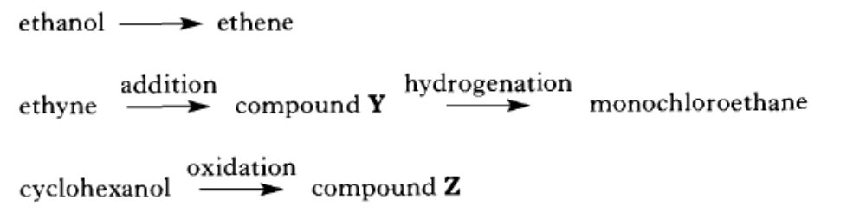

(a) Name the type of reaction that takes place in the formation of ethene from ethanol.

(b) Draw a structural formula for

(i) compound Y;

(ii) compound Z.

Alcohols, Carboxylic Acids and Esters

1. Write the general formula for the alkanols.

2. Draw the structural formulae for each of the following alcohols and state whether the alcohol is
a primary, secondary or tertiary alcohol.

a) Pentan-3-ol. b) 2-methylbutan-1-ol c) 3-ethylpentan-3-ol.

3. What is meant by a hydroxyl group?

4. Compound X is a secondary alcohol.
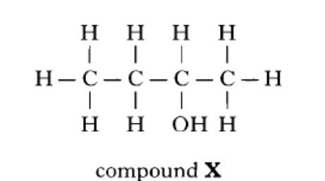

(a) Name compound X.

(b) Draw a structural formula for the tertiary alcohol that is an isomer of compound X.

5. The dehydration of butan-2-ol can form two different isomers of butene.
a) Draw a diagram of the apparatus you could use in the laboratory to bring about the
dehydration of butan-2-ol. Name any chemicals used.

b) What is meant by the term ‘dehydration’?

c) Draw and name the structures of the two butene isomers formed.

d) An isomer of butan-2-ol gives only one product on dehydration. Name this isomer.

6. Write the general formula for the alkanoic acids.

7. Name and draw the functional group found in all carboxylic acids.

8. Draw the structural formulae for the following carboxylic acids:

a) Pentanoic acid b) 2-methylpropanoic acid c) Benzoic acid

9. Which two types of chemicals react together to produce an ester?

10. Copy the chemical structure shown below and circle the ester link.
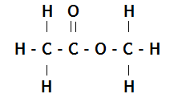

11. Name and draw the structural formula of the ester formed when each of the following chemicals reacts together.

a) ethanol and methanoic acid b) methanol and propanoic acid

c) butanoic acid and pentanol d) ethanoic acid and propanol

12. Which of the following consumer products is least likely to contain esters?

A flavourings
B perfumes
C solvents
D toothpastes

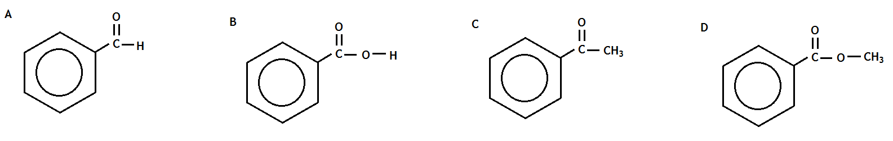
13. Which of the following is an ester?

14. When propanoic acid is reacted with ethanol, one of the products is,

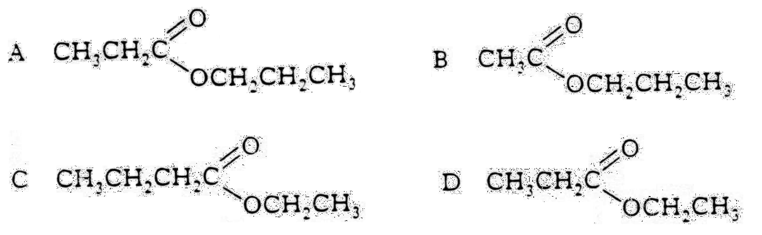

15. Rum flavouring is based on a compound with the formula shown,
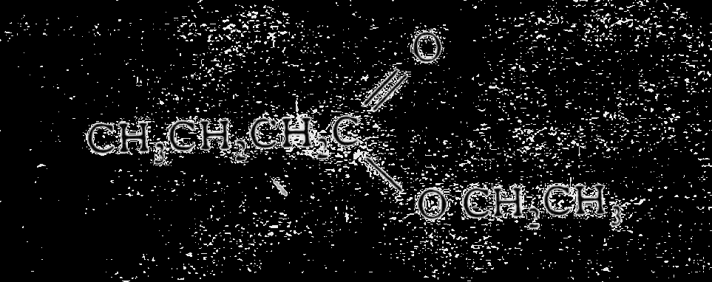

It can be made from

A ethanol and butanoic acid
B propanol and ethanoic acid
C butanol and methanoic acid
D propanol and propanoic acid

16. Aspirin is one of the most widely used pain relievers in the world. It has the structure,
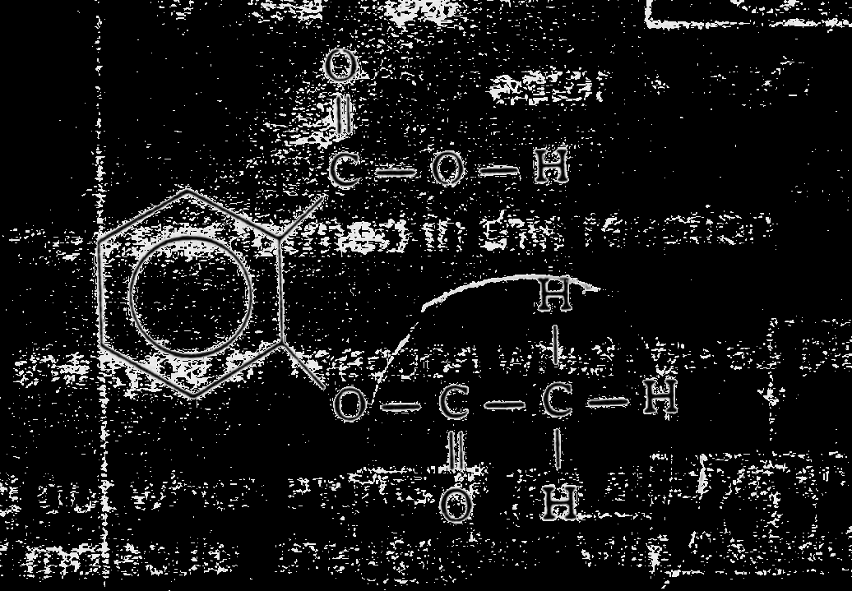
Which two functional groups are present in an aspirin molecule?

A hydroxyl and carbonyl
B aldehyde and ketone
C carboxyl and ester
D ester and aldehyde

17. Give three uses of esters.

18. A pupil made the ester ethyl propanoate in a test tube and poured the reaction mixture into a
beaker containing sodium hydrogen-carbonate solution.

a) Name the acid and alcohol used to make the ester.

b) What two things would the pupil observe when the ester is poured into the sodium
hydrogen- carbonate solution?

c) The pupil heated the reaction mixture using a hot water bath. Why was the reaction
mixture not heated directly with a Bunsen flame?

19. One of the chemicals released in a bee sting is an ester that has the structure shown.
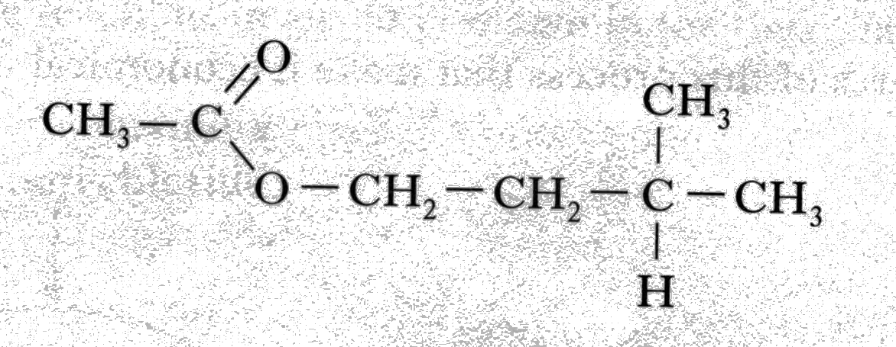
This ester can be produced by the reaction of an alcohol with an alkanoic acid.

(a) Name this acid.
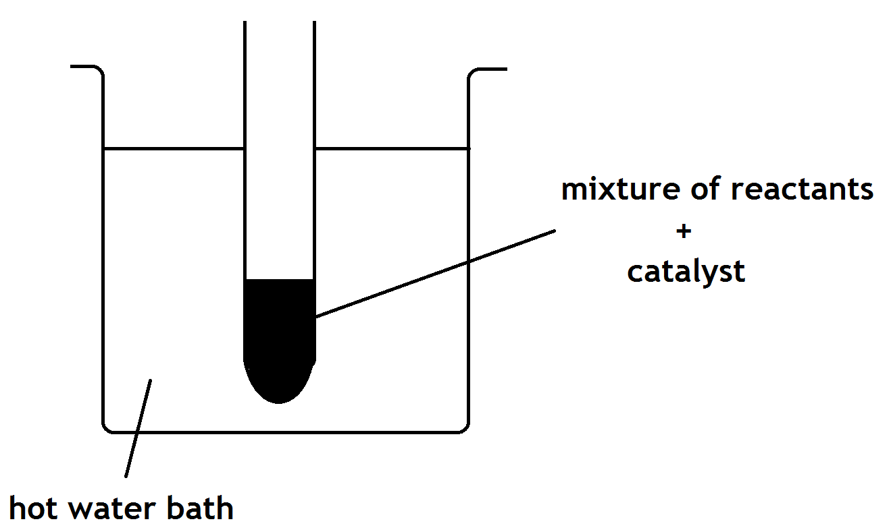
(b) The ester can be prepared in the lab by
heating a mixture of the reactants with
a catalyst.
- Name the catalyst used in the reaction.

- What improvement could be made to the experimental setup shown in the above diagram?

20. The compound diazomethane undergoes an unusual reaction called insertion.
Under certain conditions, the CH₂ group produced can insert itself into any bond which
includes an atom of hydrogen.
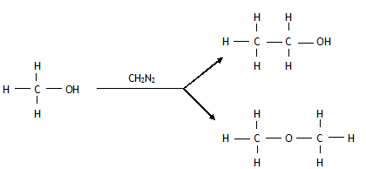

Nitrogen is produced in every reaction.
One of the products for the reaction of diazomethane with ethanol is shown below.
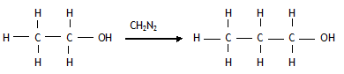

- Name the product shown.

- Draw the full structural formula for the other two organic products which could be formed in this reaction.
Fats, Oils and Soaps

1. Fats and oils can be classified as

A soaps
B fatty acids
C esters
D polyesters

2. Which of the following decolorises bromine water least successfully?

A palm oil
B hex-1-ene
C cod liver oil
D mutton fat

3. In the formation of “hardened” fats from vegetable oils, the hydrogen

A causes cross-linking between the chains
B causes hydrolysis to occur
C increases the carbon chain length
D reduces the number of carbon to carbon double bonds.

4. The structural formula for glycerol is
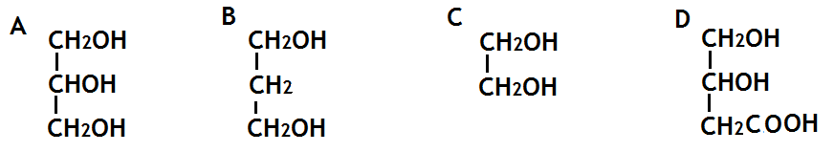

5. The production of fatty acids and glycerol from fats in foods is an example of

A hydrolysis
B hydrogenation
C dehydration
D dehydrogenation

6. Explain, in terms of structure, why fats are solids and oils are liquids at room temperature.

7. Foodstuffs have labels that list ingredients and provide nutritional information.
The label on a tub of margarine lists hydrogenated vegetable oils as one of the ingredients.
Why have some of the vegetable oils in this product been hydrogenated?

8. a) Draw the extended structural formula for a molecule of glycerol.

b) What is the systematic name for a molecule of glycerol.

c) Explain why fats are sometimes referred to as triglycerides

d) What do you understand by the term ‘fatty acid’?

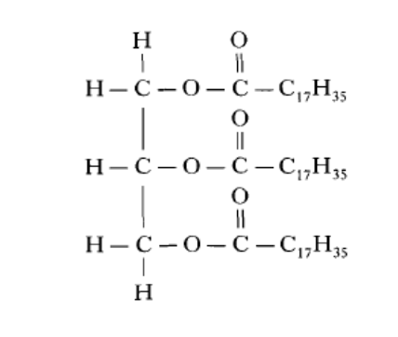
9. The structure of a fat molecule is shown below.
(a) When the fat is hydrolysed, a fatty acid is obtained. Name the other product obtained in
this reaction.

(b) Oils are liquid at room temperature; fats are solid. Why do oils have lower melting
points than fats?

10. Mutton fat contains a compound called as tristearin.
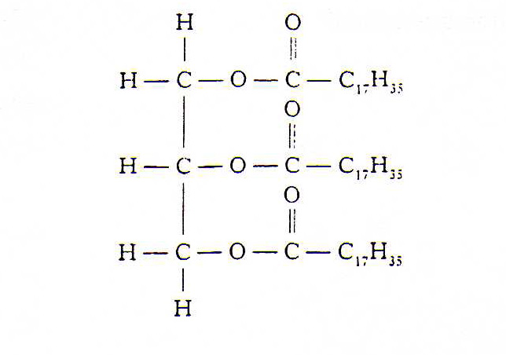

Tristearin is hydrolysed in the body during digestion by an enzyme known as lipase.

(a) Give one reason why fats can be a useful part of a balanced diet.

(b) To which set of compounds do enzymes belong?

(c) The hydrolysis of tristearin produces a fatty acid.
Name the other product of the reaction.

11. Chemists have developed cheeses specifically for use in cheeseburgers.

(a) When ordinary cheddar cheese is grilled the shapes of the protein molecules change and
the proteins and fats separate leaving a chewy solid and an oily liquid.
What name is given to the change in protein structure which occurs when ordinary
cheddar is grilled?

(b) To make cheese for burgers, grated cheddar cheese, soluble milk proteins and some
water are mixed and heated to no more than 82 °C. As the cheese begins to melt an
emulsifying agent is added and the mixture is stirred.

(i) Why would a water bath be used to heat the mixture?

(ii) A section of the structure of a soluble milk protein is shown below.
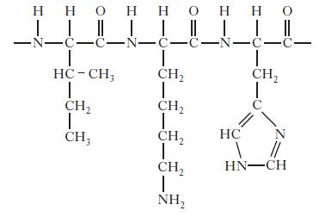

Draw a structural formula for any one of the amino acids formed when this section
of protein is hydrolysed.

(iii) The emulsifier used is trisodium citrate, a salt formed when citric acid is
neutralised using sodium hydroxide.
Copy and complete the equation below showing a structural formula for the
trisodium citrate formed.
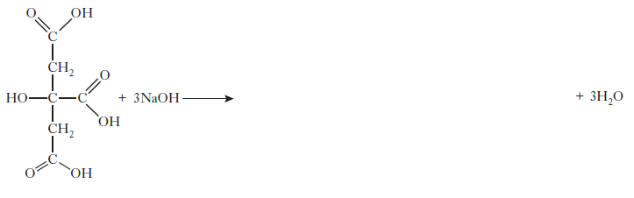

12. The hydrolysis of a fat produces glycerol and fatty acids.

a) What does the term hydrolysis mean?

b) State the ratio of glycerol molecules to fatty acid molecules.

c) A triglyceride produces only glycerol and palmitic acid, CH₃(CH₂)₁₄COOH, on hydrolysis.
i) Draw the structural formula for the triglyceride.

ii) Explain whether the triglyceride is likely to be a fat or an oil.

13. Explain why edible oils are sometimes used as lubricants for farm machinery.

14. Explain what is meant by the terms a) hydrophilic b) hydrophobic.

15. Describe how soap can clean a fat stain from clothing. You should use the following words in
your answer:

ionic head covalent tail hydrophobic hydrophilic polar non-polar

16. Soap can be produced by the reaction of fats and oils with sodium hydroxide solution.

a) Name the kind of reaction that is taking place.

b) Describe the structure of soap

17. Small children can find it difficult to swallow tablets or pills so ibuprofen is supplied as an
“infant formula” emulsion.
The emulsifier used is polysorbate 80. Its structure is shown below.
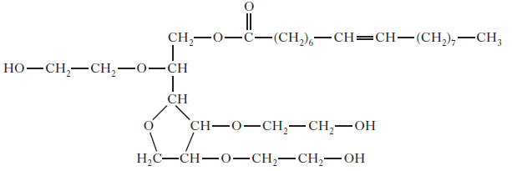

Explain why this molecule acts as an emulsifier.

Proteins

1. Describe two reasons why we need protein in our diet.

2. What four elements are present in proteins?

3. Copy and complete the table giving details of proteins found in the human body.

Name of protein | Where found | Function
Keratin |  | Structural support
Insulin |  | Controls blood glucose
Haemoglobin | Red blood cells
Amylase | Saliva and pancreas
Collagen |  | Structural support
Myosin | Muscles
Immunoglobins | Blood, tears, saliva, skin

4. What is meant by the term essential amino acids?

5. When amino acids join together to form a protein molecule, what other chemical is produced?

6. On complete hydrolysis, a peptide produced 5 amino acids represented by the letters
P, Q, R, S and T. The following fragments were produced on partial hydrolysis.

Peptide ^{partial hydrolysis} TS + QP + RT + SQ

Which one of the sequences below could be the correct one for the arrangement of amino acids
in the peptide?

A P-T-S-Q-R
B R-T-S-P-Q
C Q-P-T-S-R
D R-T-S-Q-P

7. Which of the following must contain nitrogen?

A an enzyme
B an oil
C a polyester
D a carbohydrate

8. Proteins can be denatured under acid conditions. During this denaturing, the protein molecule

A changes shape
B is dehydrated
C is neutralised
D is polymerised

9. When two amino acids condense together, water is eliminated and a peptide link is formed.
Which of the following represents this process?
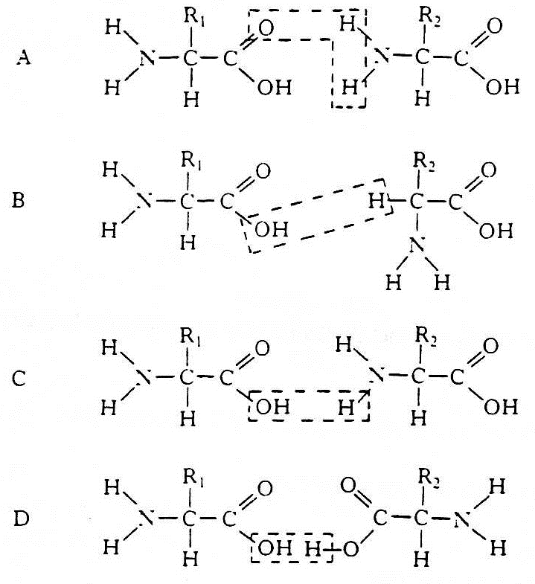

10. Some amino acids are called α(alpha) amino acids because the amino is on the carbon atom
next to the acid group.
Which of the following is an α(alpha) amino acid?

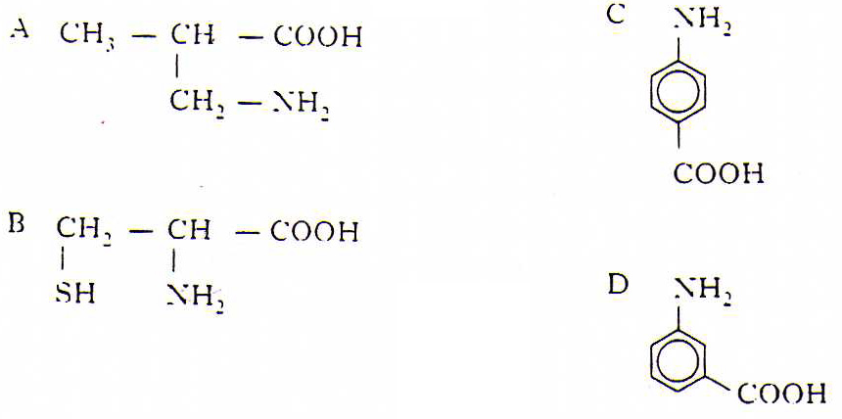

11. The following is part of a protein molecule (the bond angles are not correctly shown).
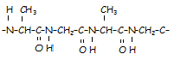

a) Draw the extended structural formula of two amino acids obtained on hydrolysis of this
protein.

b) Draw an amide link.

12. An enzyme found in potatoes can catalyse the decomposition of hydrogen peroxide.
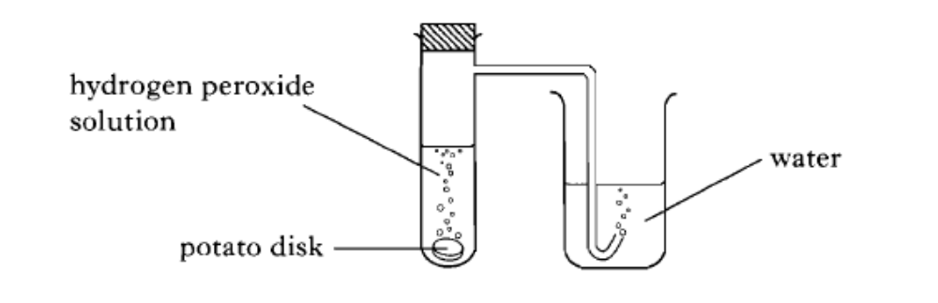
The rate of the decomposition of hydrogen peroxide can be studied using the apparatus shown.
(a) Describe how this apparatus can be used to investigate the effect of temperature on the
rate of decomposition of hydrogen peroxide.

(b) The graph shows how the rate of the enzyme catalysed reaction changes with temperature.

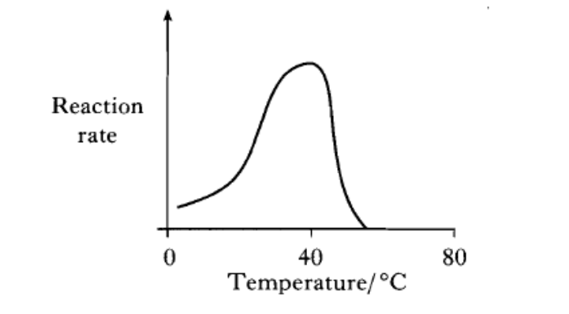
Why does the reaction rate decrease above the optimum temperature of 40 "C?

13. Examine the graphs below.
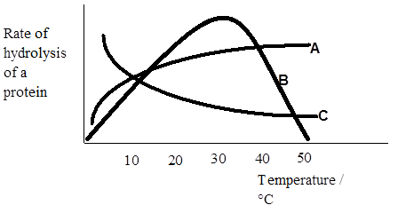

a) Which graph is likely to represent the results from a series of reactions using an enzyme?
Explain your answer

b) To which family of compounds do enzymes belong?

c) Name the four elements which must be present in all enzyme molecules.

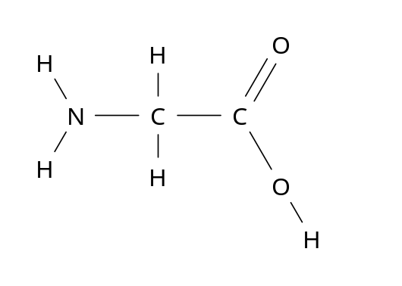
14. Glycine is an amino acid with the following structure.

a) Draw the structure of part of the polymer chain that would be formed when three glycine
molecules polymerise.

b) What type of polymerisation process is taking place?

The Chemistry of Cooking and Oxidation of Food

1. What is the general formula for aldehydes and ketones?

2. What is the name of the functional group found in aldehydes and ketones?

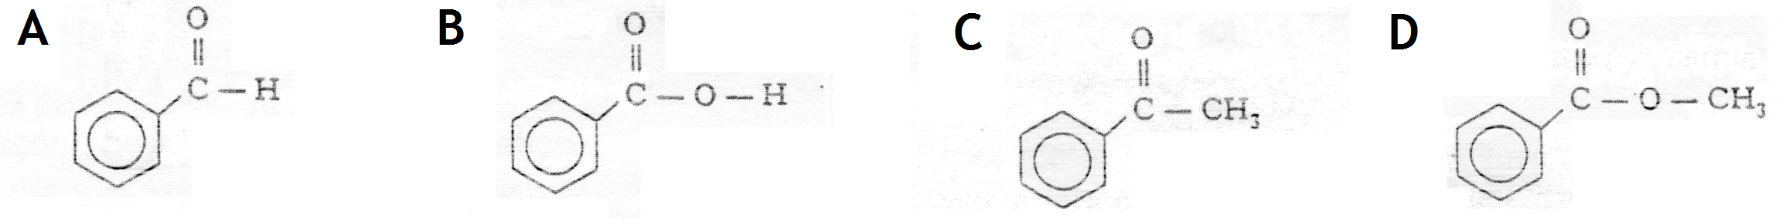
3. Which of the following is an aldehyde?

4. Which is true of a compound with the following formula?

CH₃CH(OH)CH₃

A It is a primary alcohol
B It can be oxidised to an aldehyde
C It is a tertiary alcohol
D It can be oxidised to a ketone.

5. Which process is used to convert methanol to methanal?

A oxidation
B condensation
C hydration
D hydrogenation

6. Which of the following alcohols can be oxidised to give a ketone?

A 2-methylbutan-1-ol
B 2,3-dimethylpentan-1-ol
C 3-methylbutan-2-ol
D 2-methylbutan-2-ol

7. Ethanol vapour is passed over hot aluminium oxide.
What kind of reaction occurs?

A Hydrogenation
B Dehydration
C Hydrolysis
D Dehydrogenation
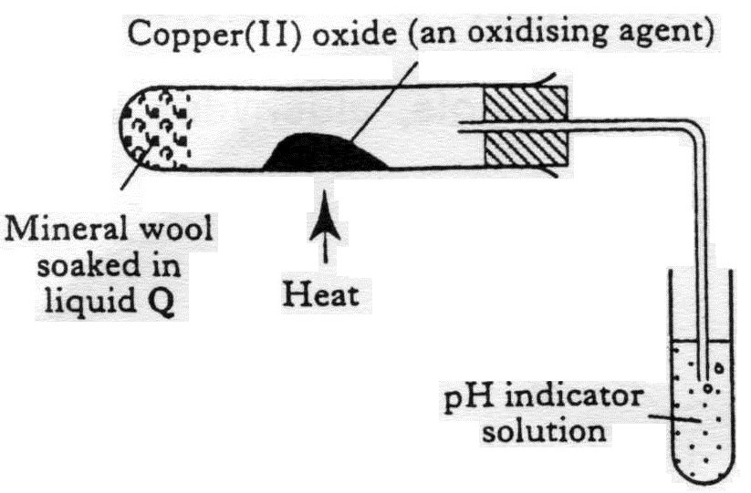
8. After heating for several minutes as shown in the diagram, the pH indicator solution turned red. Liquid Q could be

A propanone
B paraffin
C butan-1-ol
D butan-2-ol

9. What compound is formed by the oxidation of propan-2-ol?

A CH₃CH₂CHO
B CH₃CO CH₃
C CH₃CH₂COOH
D CH₃CH₂ CH₂OH

10. During oxidation, what happens to the ratio of O:H atoms in a hydrocarbon?

11. Two compounds A and B, both have the formula C₄H₈O. They were both mixed separately
with Fehling’s solution and the mixtures warmed in a water bath. Only compound B gave an
orange-red precipitate.

a) Name compounds A and B.

b) Draw the extended structural formulae of A and B.
c) Name another reagent which could also be used to show the difference between
compound A and B and say what would happen when this reagent is reacted with A and B.

12. Which box, or boxes, show(s) a substance which
A CH₃CH₂OH | B CH₃CHOHCH₃ | C CH₃CH₂COOH
D CH₃COCH₃ | E CH₃CH₂CHO | F CH₃COOH
a) can be oxidised to an alkanal (aldehyde)?

b) is an alkanone (ketone)?

c) is an alkanoic (carboxylic) acid?

d) is a primary alcohol?

e) can be formed by the oxidation of B?
13. Propan-1-ol, can be oxidised by passing the alcohol vapour over hot copper(II) oxide.

a) Draw a labelled diagram of the apparatus that would be used to carry out this
experiment in the aboratory.

b) Oxidation of propan-1-ol yields a compound X, formula C₃H₆O, which can be further
oxidised to compound Y, formula C₃H₆O₂.

i) Name and draw the structure of compound X.

ii) Name and draw the structure of compound Y.
c) Name two other oxidising agents which could be used to carry out the oxidation.

d) If propan-2-ol was used in place of propan-1-ol there would be only one oxidation
product. Name and draw the structure of this product.

14. "Self-test" kits can be used to check the quantity of alcohol present in a person's breath.
The person blows through a glass tube until a plastic bag at the end is completely filled.
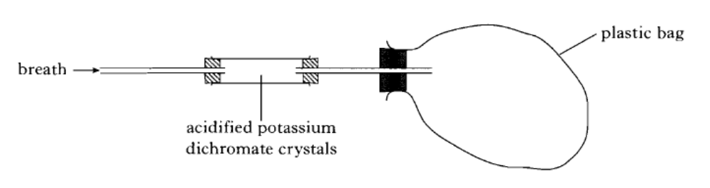
The tube contains orange acidified potassium dichromate crystals that turn green when they
react with ethanol. The chemical reaction causing the colour change is:
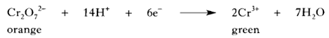

The more ethanol present in the person's breath, the further along the tube the green colour
travels.

a) What is the purpose of the plastic bag?

b) Why are the potassium dichromate crystals acidified?

c) Name a carbon compound formed by the reaction of ethanol with acidified potassium
dichromate crystals.

15. Propanone is a widely used solvent. It can be made from propene.
Using full structural formulae show the steps involved in this preparation and name the reagent used in each step.

16. Alkanols can be oxidised to alkanoic acids.

CH₃CH₂CH₂OH ^{step 1} CH₃CH₂CHO ^{step 2} CH₃CH₂COOH
Propan-1-ol propanal propanoic acid

(a) Why can step 1 be described as an oxidation reaction?

(b) Acidified potassium dichromate solution can be used to oxidise propanal in step 2 . What
colour change would be observed in this reaction?

17. Butan – 2-ol reacts in different ways

dehydration

butan-2-ol

oxidation condensation with
ethanoic acid

butanone

- Name the two products formed by the dehydration of butan-2-ol.

- Name a reagent which could be used to oxidise butan-2-ol to butanone.

18. Two reactions involving a carbon compound, A, are shown.
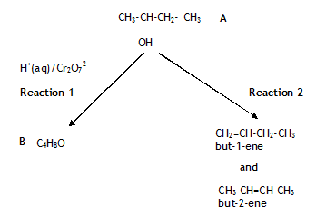

- Name compound A.

- Draw a structural formula for compound B.

- Name a substance used to convert compound A into but-2-ene and but-1-ene.
19. Give 3 ways that fatty foods are affected when they react with oxygen.

20. Why are antioxidants added to foods?

21. What is meant by a free radical?

22. Give the names of 3 natural antioxidants and state which foods they are found in.

23. Describe how orange juice can stop apples from going brown after they have been cut.

24. Apples and bananas turn brown when cut or bruised. The first step of the reaction causing
the browning is shown below.
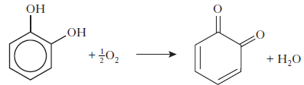

What type of reaction is this?

25. A student closed his eyes and held his nose. Another pupil gave him a teaspoon of
strawberry jam to eat. Explain why the student could tell that the food was sweet, but not
what the actual flavor was.

26. Explain why broccoli should be cooked in water but asparagus should be cooked in oil.

Fragrances

1. Which unit makes up every terpene?

2. How many carbons there are in an isoprene unit?

3. What is the systematic name for isoprene?

4. What is an oxidised terpene known as?

5. Give 3 uses of essential oils.

6. Two typical compounds that are present in many perfumes are shown.
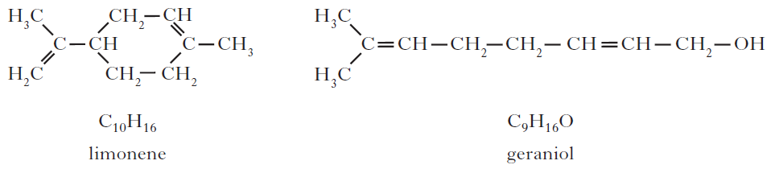

(a) Why does geraniol evaporate more slowly than limonene?

(b) The structure of one of the first synthetic scents used in perfume is shown below.
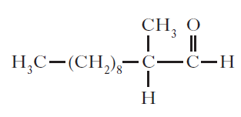

(i) Name the family of carbonyl compounds to which this synthetic scent belongs.

(ii) Copy and complete the structure below to show the product formed when this scent
is oxidised.
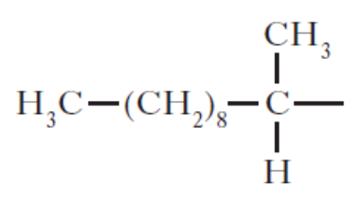

7. A team of chemists are developing a fragrance for use in a shower gel for men.

(a) To give the gel a fruity smell the chemists are considering adding an ester.
They synthesise six isomeric esters. Volunteers smell each ester and give it a rating out
of one hundred depending on how fruity the smell is.
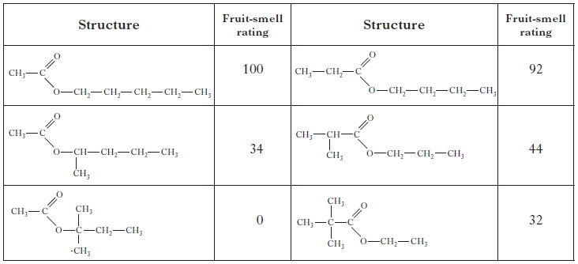
(i) Name the ester with the fruit-smell rating of 92.

(ii) Shown below are the structures of three more isomers.

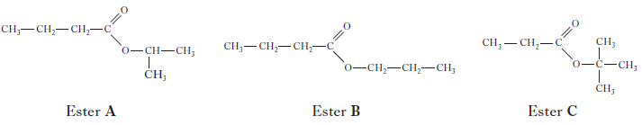

Put these esters in order of decreasing fruit-smell rating.

(b) To create a fragrance for men, the compound civetone is added.
Draw a structural formula for the alcohol that can be oxidised to form civetone.
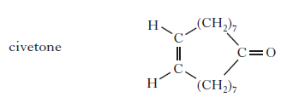

(c) To make the shower gel produce a cold, tingling sensation when applied to the skin,
menthol is added.
Like terpenes, menthol is formed from isoprene (2-methylbuta-1,3-diene).
Copy the diagram of the structure of menthol below and circle an isoprene unit.
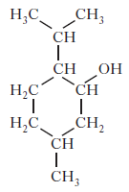

Skin Care

1. What are the three steps for the reaction between alkanes and halogens?

2. Write out each of the three steps for the reaction between fluorine gas and ethane under the
action of UV light.

3. What is meant by a free-radical scavenger?

4. Suncreams contain antioxidants.

(a) The antioxidant, compound A, can prevent damage to skin by reacting with free radicals
such as NO2•.
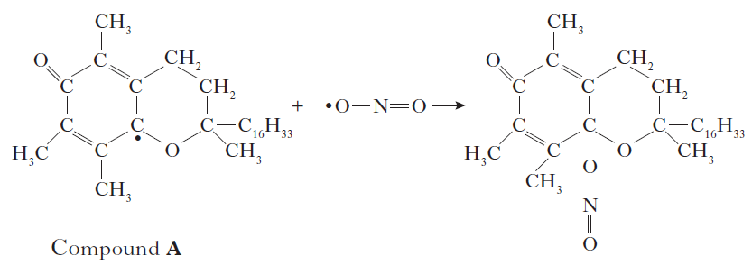

Why can compound A be described as a free radical scavenger in the reaction shown above?

(b) Another antioxidant used in skin care products is vitamin C, C₆H₈O₆.

Copy and complete the ion-electron equation for the oxidation of vitamin C.

Open Ended Questions

1. A student makes the following statement:

‘Sugar can be used to produce alcohol, a carboxylic acid and the ester ethyl ethanoate’

Using your knowledge of chemistry, comment on the accuracy of the student’s statement.

2. Aspirin is a widely used medicine. It is advised that it is stored in dry, cool conditions.

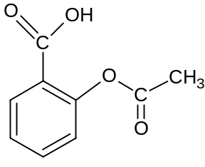

Using your knowledge of chemistry, comment on the reasons why aspirin should be stored under these conditions.

3. To improve the shelf-life of foods, food manufacturers use several methods to remove oxygen
from inside the food packaging. In one method, an enzyme is added which catalyses a reaction
between oxygen and glucose present in the foods.

Using your knowledge of Chemistry, comment on why this method may not be suitable to
improve the shelf-life for all foods.

