St Andrew’s Academy

S3 BGE Business

Homework







Seek help from your teacher before the due date.

Homework can be completed in your jotter.

Read every question and command word carefully.

Be aware of the mark allocation.

**Business Management Command Words**

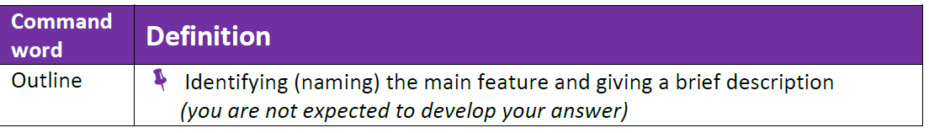

1 mark per sentence

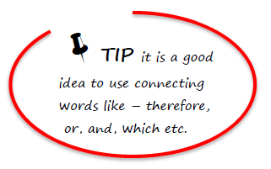

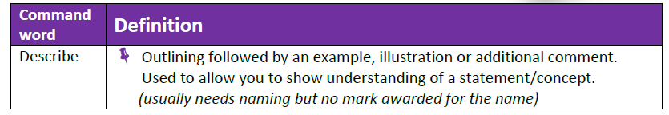

1 mark per 2 points

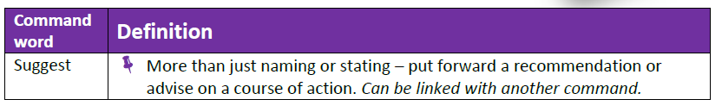

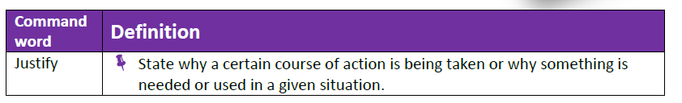

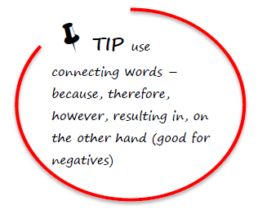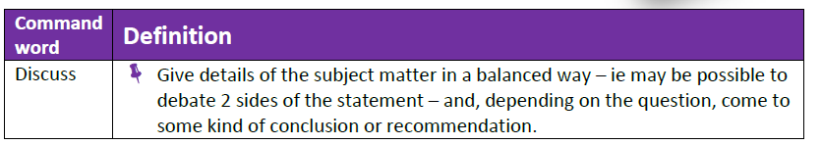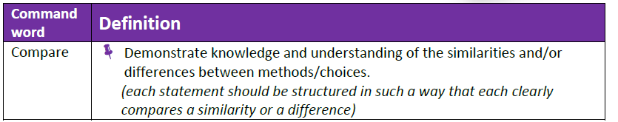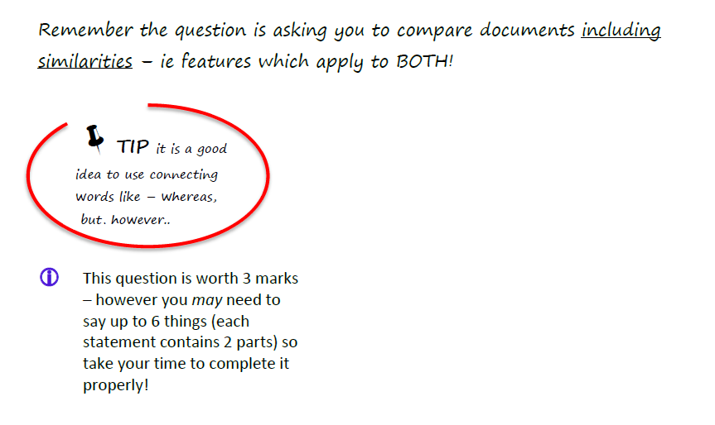

1 mark per advantage and disadvantage

|  |  |  |  |  |
| --- | --- | --- | --- | --- |
| **Homework 1**  **Needs and wants, Meeting customer needs** | | |  | |
| 1 | a | Copy and complete the following: The band Arctic Monkeys gave a live concert at Glasgow’s SECC. A concert is an example of a …………………… [good or service] | | 1 |
|  |  |  | |  |
|  | b | Fans can buy Arctic Monkeys’ music at the concert. Suggest 2 other places the Arctic Monkeys could sell their music. | | 2 |
|  |  |  | |  |
|  | c | Suggest a reason why the members of the Arctic Monkeys formed a group. | | 1 |
|  |  |  | |  |
| 2 |  | Businesses provide goods and services to satisfy our needs and wants.  Define the terms “needs” and “wants” and give a different example of each.   |  |  |  | | --- | --- | --- | |  | Definition | Example | | Needs |  |  | | Wants |  |  | | | 4 |
|  |  |  | |  |
| 3 |  | Suggest 2 ways Coca-Cola can satisfy the needs of their customers. | | 2 |
|  |  |  | | **10** |
|  |  |  | |  |
| **Homework 2**  **Entrepreneurship** | | |  | |
| 4 |  | Brian Souter and Ann Gloag founded the **Stagecoach** Group. The company operates a range of luxury buses called the **Goldline**. These buses have wi-fi and leather seats. | |  |
|  | a | Brian Souter and Ann Gloag are examples of Scottish entrepreneurs.  Describe the role of an entrepreneur. | | 2 |
|  |  |  | |  |
|  | b | Other than wi-fi and leather seats, suggest 2 ways Goldline could attract passengers onto their buses. | | 2 |
|  |  |  | |  |
| 5 |  | Michelle Mone [founder of Ultimo Lingerie] would be considered a strong leader. Identify 2 other roles of an entrepreneur. | | 2 |
|  |  |  | |  |
| 6 |  | http://start-upsuccessnow.com/wp-content/uploads/2011/09/internet-research.jpgChoose a well-known entrepreneur. Research using the Internet and write a **paragraph** covering the following points:   * Product/service they offer * What makes him/her successful * Skills and qualities they possess * Estimated wealth * Any other interesting facts | | 10 |
|  |  |  | | **16** |

|  |  |  |  |  |
| --- | --- | --- | --- | --- |
| **Homework 3**  **Factors of Production and Business Plans** | | |  | |
| 7 |  | Enterprise is a factor of production. Identify and describe the other 3 factors of production. | | 6 |
|  |  |  | |  |
| 8 |  | Entrepreneurs will complete a Business Plan when starting up. Give **2** headings which might appear in a Business Plan. | | 2 |
|  |  |  | | **8** |
|  |  |  | |  |
| **Homework 4**  **Types of business + objectives [sole trader, partnership, small franchises, non-profit making orgs]** | | |  | |
| 9 |  | Alba Knitwear Ltd is a small business in the Scottish Borders.  Identify **2** features of a small business. | | 2 |
|  |  |  | |  |
| 10 |  | Describe the following types of business organisation:   * Sole trader * Partnership | | 2 |
|  |  |  | |  |
| 11 |  | **Mary’s Meals**  This Scottish charity feeds 300,000 children daily in Africa, Eastern Europe, Asia and Latin America. Food is provided at school to encourage children to learn.  marys-meals | |  |
| 12 |  | Suggest 2 different aims of a charity like Mary’s Meals. | | 2 |
|  |  |  | |  |
| 13 |  | Give 2 advantages of a Partnership. | | 2 |
|  |  |  | |  |
| 14 |  | Compare the objectives of a charity with those of a partnership. | | 2 |
|  |  |  | |  |
| 15 |  | Describe **2** advantages and **2** disadvantages of franchising. | | 4 |
|  |  |  | |  |
| 16 |  | **Copy and complete the following:**  When a business is owned and controlled by one person it is known as a ………………………………….. however a partnership is when the business is owned by between 2 and ……… partners.  A partnership can raise finance by asking their bank for a loan or …………………….. Charities can raise finance by asking for a lottery grant or …………………………………. | | 4 |
|  |  |  | | **18** |

|  |  |  |  |  |
| --- | --- | --- | --- | --- |
| **Homework 5**  **Sources of finance and advice** | | |  | |
| 17 |  | **Cool Kidz Nursery**  Carla and her brother Fabio always wanted to be entrepreneurs. They decided to go into partnership opening a children’s nursery in Peebles. | |  |
|  |  | Suggest and justify **one** source of finance for Carla and Fabio when starting their business. | | 2 |
|  |  |  | |  |
| 18 |  | Identify **2** sources of advice available to business start-ups. | | 2 |
|  |  |  | |  |
| 19 |  | Identify **2** sources of finance available to an organisation when looking to expand. | | 2 |
|  |  |  | |  |
| 20 |  | Describe the type of advice the following individuals/groups could offer an organisation [a different type of advice must be given for each]:   * Bank Manager * Local Business Owners * Inland Revenue * Lawyers | | 4 |
|  |  |  | | **10** |

|  |  |  |  |  |
| --- | --- | --- | --- | --- |
| **Homework 6**  **Marketing** | | |  | |
| 21 |  | Outline the 4P’s. | | 4 |
| 22 |  | Explain advertising. | | 1 |
|  |  |  | |  |
| 23 |  | Describe the **2** types of advertising. | | 2 |
|  |  |  | |  |
| 24 |  | Identify and justify the **2** types of market research. | | 4 |
|  |  |  | | **11** |

|  |  |  |  |  |
| --- | --- | --- | --- | --- |
| **Homework 7**  **Objectives** | | |  | |
| 25 |  | Identify and justify **3** objectives of a Private Limited Company. | | 6 |
| 26 |  | Compare the objectives of a Public Limited Company with those in the Third Sector. | | 2 |
|  |  |  | |  |
|  |  |  | | **8** |

|  |  |  |  |  |
| --- | --- | --- | --- | --- |
| **Homework 8**  **Customer Service** | | |  | |
|  |  |  | |  |
| 2 |  | Describe the features of an effective customer care policy. | | 3 |
|  |  |  | |  |
| 3 |  | Outline the features of good customer service. | | 3 |
|  |  |  | |  |
| 4 |  | Describe the benefits of an organisation providing good customer service and the impacts of poor customer service. | | 6 |
|  |  |  | |  |
|  |  |  | | **12** |

|  |  |  |  |  |
| --- | --- | --- | --- | --- |
| **Homework 9**  **Stakeholders** | | |  | |
| 27 |  | Outline **4** stakeholders. | | 4 |
| 28 |  | Describe the influence that stakeholders can have on an organisation. | | 4 |
|  |  |  | |  |
| 29 |  | Describe the interest that stakeholders can have on an organisation. | |  |
|  |  |  | | **8** |

|  |  |  |  |  |
| --- | --- | --- | --- | --- |
| **Homework 10**  **External Factors** | | |  | |
| 30 |  | Outline Political and Economic Factors that could affect an organisation. | | 2 |
| 31 |  | Describe news articles that apply to Political and Economic factors. | | 2 |
|  |  |  | |  |
| 32 |  | Outline Social, Technological, Environmental and Competition factors that could affect an organisation. | | 4 |
|  |  |  | |  |
| 33 |  | Describe news articles that apply to Social, Technological, Environmental and Competition factors. | | 4 |
|  |  |  | | **14** |

|  |  |  |  |  |
| --- | --- | --- | --- | --- |
| **Homework 11**  **Internal Factors** | | |  | |
| 34 |  | Explain internal factors that could affect an organisation. | | 4 |
|  |  |  | | **4** |