**Remove all distractions. PUT YOUR PHONE AWAY!**

**3. Flash Cards**

* On the front write a question, key word or prompt
* On the back, write the info you need to memorise

[](https://www.google.co.uk/url?sa=i&url=https%3A%2F%2Fgeographyiseasy.wordpress.com%2F2015%2F10%2F24%2Fyear-4-time-to-revise-for-the-test-on-population-change%2F&psig=AOvVaw3z9bQ7k-TV1_hh36sb436Y&ust=1583406376614000&source=images&cd=vfe&ved=0CAIQjRxqFwoTCMDh29XWgOgCFQAAAAAdAAAAABAP)

[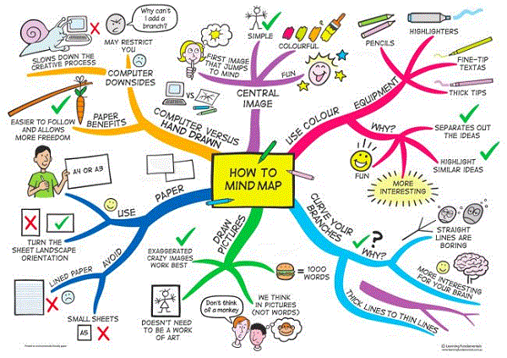](https://www.google.co.uk/url?sa=i&url=https%3A%2F%2Fwww.pinterest.com%2Fpin%2F764978686681495558%2F&psig=AOvVaw0rIKw0RQIGypqkXV5iwIJ4&ust=1583405800709000&source=images&cd=vfe&ved=0CAIQjRxqFwoTCND9jcPUgOgCFQAAAAAdAAAAABAE)

**4. Knowledge Organisers**

Create some knowledge organisers: mind maps, diagrams, graphic organisers. 