St Andrew’s Academy



N5 Chemistry

Open ended questions

**General advice on what you could include in your answers:**

If the question is about **elements**:

Try to mention correct information about

* atomic number and mass number
* group in the periodic table, number of outer electrons
* elements in the same group have the same chemical properties
* as you go down a group the physical properties change
* whether they are solid, liquid or gas

If the question involves **molecules**, **compounds**:

Try to mention information about

* bonding and properties (revise here <http://www.bbc.co.uk/schools/gcsebitesize/science/add_edexcel/periodic_table/metalsrev4.shtml>)
* include conduction
* solubility, melting and boiling points (from the data book)

If the question involves **electricity**:

Try to mention information about

* the electrochemical series (from the data book)
* an explanation of oxidation (loss of electrons), reduction (gain of electrons)
* how electrons flow from metals higher in the electrochemical series to lower in the electrochemical series
* any advantages or disadvantages about the environment (pollution, recycling, lack of availability of metals from the Earth’s crust)

If the question involves **homologous** **series**:

Try to mention information about

* functional groups (carbon to carbon double bonds C=C, hydroxyl OH, carboxyl COOH)
* formula – molecular, structural
* increasing the number of carbons increase the boiling point and viscosity, decrease the volatility
* any advantages or disadvantages about the environment (pollution, recycling, use as fuels etc)

If the question is about **Fertilisers**:

Try to mention information about

* N, P and K essential elements
* Solubility
* Pollution
* Haber / Ostwald
* Natural v Synthetic

If the question is about **metals**:

Try to mention information about

* Reactivity series
* Whether it is found combined (reactive element) or uncombined (silver, gold)
* Energy needed to extract the metal (cost)
* Pollution – CO2 formed to produce that energy
* Availability of metals is low as they are finite
* Properties and uses

If the question involves **acids** and **bases** (alkalis are soluble bases):

Try to mention information about

* Neutralisation reactions
  + Acid + alkali → Salt + water
  + Acid + carbonate → salt + water + carbon dioxide
* Write balanced equations
* Names of salts
* pH
* H+ ions in acids, OH- ions in alkalis

If the question is about **fuels**:

Try to mention information about

* Combustion products – usually CO2 and H2O
* Pollution – from sulphur (burns to make SO2), soot (unburned hydrocarbons)
* Eh = cmΔT experiment
* CO2 impact on Global Warming (this is not pollution)

1. In 1825 bromine had been isolated from sea waterby Liebig who mistakenly thought it was a compound of iodine and chlorine.

Using your knowledge of chemistry, comment on why he might have made the mistake.

1. Two bottles containing different white crystals have lost their labels. The Science teacher says that one of them contains potassium chloride and the other glucose (C6H12O6).

Using your knowledge of chemistry, describe how you would decide which bottle is which.

1. A new element was discovered. Using your knowledge of chemistry explain how you would decide if the element belonged in group 1, group 7 or group 0.

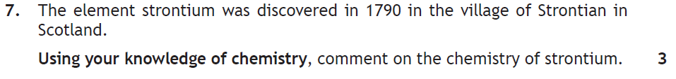

1. Using your knowledge of chemistry describe how 4 metals could be placed in order of reactivity.
2. 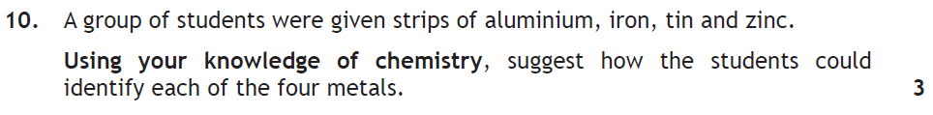
3. Using your knowledge of chemistry describe how you could distinguish between ethanoic acid and hydrochloric acid.
4. Describe how you could distinguish between copper sulphate and calcium sulphate.
5. Using your knowledge of chemistry describe how you could prepare the salt calcium sulphate.
6. Titanium(IV) chloride is a colourless liquid at room temperature. Using your knowledge of chemistry explain the type of bonding found in titanium chloride.
7. A student reacted acidified potassium permanganate solution with oxalic acid C2H2O4.

2MnO4-(aq) + 5C2H2O4(aq) + 6H+(aq) 🡪 2Mn2+(aq) + 10CO2(g) + 8H2O(l)

Using your knowledge of Chemistry describe how a pupil could have determined the rate of reaction.

1. In the film Dante peak, a family trapped by a red hot lava escape by crossing a large lake in a boat made from aluminium. The volcano releases heat and the gases hydrogen chloride, sulfur dioxide and sulfur trioxide into the water. While crossing the lake, holes begin to appear in the bottom of the boat. Just after the family leave the boat, on the other side of the lake, the boat sinks.

Using your knowledge of chemistry, comment on whenever or not the events described in the film could take place.

1. Titanium(IV) chloride is a colourless liquid at room temperature. It is used in the production of titanium metal and titanium dioxide.

Using your knowledge of chemistry, discuss the chemistry of titanium(IV) chloride and how you would determine the type of bonding present.

1. Using your knowledge of chemistry, suggest a method of producing alcohols and how you could determine that you had produced this alcohol.
2. A student was measuring the pH of various solutions and concluded that only acids contained hydrogen ions and only alkalis contained hydroxide ions. Using your knowledge of chemistry comment on the statement made
3. 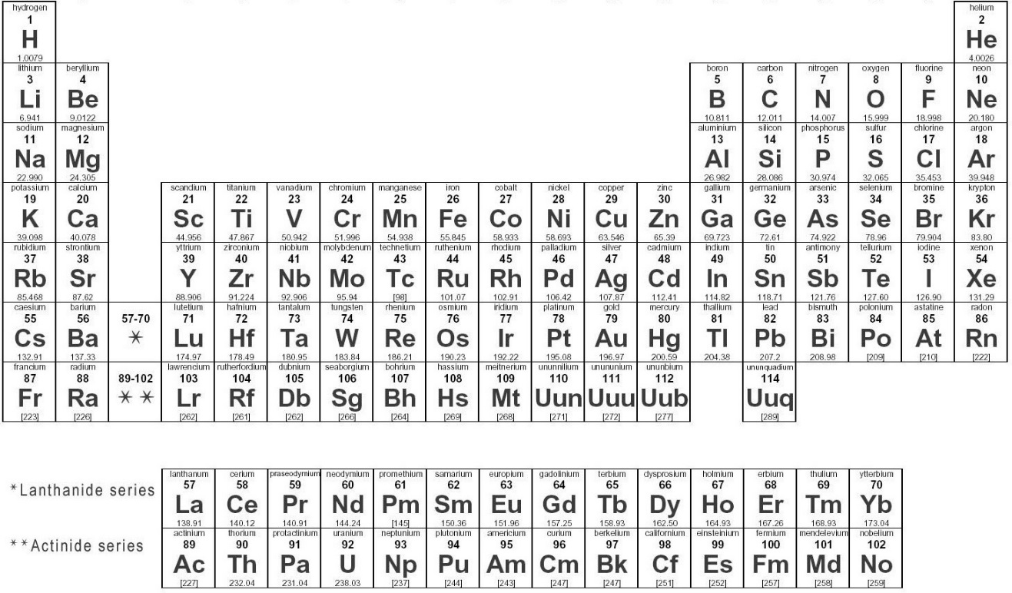The periodic table of the elements in its current form is an astonishing achievement with major contributions from famous chemists and other important scientists.

Using you knowledge of chemistry, comment on 2 different elements comparing the properties and position of your chosen elements?

1. [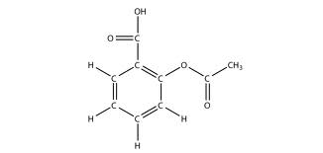](http://www.google.co.uk/url?sa=i&rct=j&q=aspirin+structure&source=images&cd=&cad=rja&docid=SPbtShECyvB_TM&tbnid=XRRHK7ZMRmfrFM:&ved=0CAUQjRw&url=http://catalog.flatworldknowledge.com/bookhub/reader/2273?e=ball-ch16_s04&ei=JbAVU6KNF5To7AaC9wE&bvm=bv.62286460,d.ZGU&psig=AFQjCNGeHxqGMNcuSpnRlL_lbZIsQ25ZRQ&ust=1394016651847818)Aspirin is widely used as a medicine. The structure of aspirin is shown below.

Using your knowledge of chemistry, comment on physical and chemical properties you would expect aspirin to demonstrate.

1. The labels have dropped off three bottles containing organic compounds. The chemistry technician has asked a National 5 chemistry class to identify these compounds.

Using your knowledge of chemistry, comment on how would the class could identify the alcohol, alkene and carboxylic acid.

1. We are told that radioactivity is dangerous but it is often used in medicine. Use your knowledge of chemistry to comment on why this is the case.
2. Aluminium can be extracted from aluminium oxide and iron from iron(III) oxide. Aluminium oxide is more abundant than iron(III) oxide yet aluminium is more expensive than iron.

Use your knowledge of chemistry to comment on why this is the case.

1. Dentists use an amalgam (an alloy of mercury, silver and tin). A person with an amalgam filling accidently touched a steel fork against it while eating and immediately felt a sharp pain in the tooth. A dentist said that the pain was caused by an electric current produced in the tooth and would have been more painful if they had touched the tooth with aluminium foil.

Use your knowledge of chemistry to comment on why this is the case.

1. A farmer tested his soil and found that it was lacking in nitrogen. He was concerned that nitrogen fertilisers would make the soil too acidic.

Use your knowledge of chemistry to comment on how the farmer can overcome his concerns.

1. A student wrote that polythene and polyester are both plastics so must have been made in the same way. Comment on the accuracy of this question.
2. 
3. The essential elements for plant growth are **nitrogen**, **phosphorus** and **potassium**. A student was asked to prepare **a** **dry** **sample** of a compound which contained **two** of these elements. The student was given access to laboratory equipment and the following chemicals.

|  |  |
| --- | --- |
| **Chemical** | **Formula** |
| ammonium hydroxide | NH4OH |
| magnesium nitrate | Mg(NO3)2 |
| nitric acid | HNO3 |
| phosphoric acid | H3PO4 |
| potassium carbonate | K2CO3 |
| potassium hydroxide | KOH |
| sodium hydroxide | NaOH |
| sulfuric acid | H2SO4 |
| water | H2O |

Using your knowledge of chemistry, comment on how the student could prepare their dry sample.

You may wish to use the data booklet to help you.