St.Andrew’s Academy



Chemistry Department

***Nature’s Chemistry***

**Name: _____________**

**Fuels**

**National 4 Learning Outcomes**

* A fuel is any compound that has stored energy.
* The energy stored in all fuels came, initially, from the Sun’s energy. This energy was stored by plants during photosynthesis.
* The energy contained in a fuel is released during burning (combustion).
* Combustion is the reaction of the fuel with oxygen (known as oxidation).
* Combustion is an example of an exothermic reaction.
* Fossil fuels are decayed and fossilised remains of animals and plants that once lived millions of years ago.
* Fossil fuels will run out eventually. They are said to be ‘finite resources’.
* Coal, crude oil and natural gas are examples of fossil fuels.
* Crude oil is a mixture of hydrocarbons.
* Fractional distillation is a process used to separate crude oil into its fractions
* The different fractions from crude oil have many different uses and properties.
* Hydrocarbons burn in a plentiful supply of oxygen to produce carbon dioxide and water.
* When hydrocarbons are burned in a limited supply of oxygen, carbon monoxide (a poisonous gas) and carbon (soot) are produced.

**Fuels**

Coal, petrol and wood have one thing in common - they can all be used as fuels!

**What is a Fuel?**

A **fuel** is a substance that has stored energy, which it releases when it burns.

Write down the names of three other common substances which can be used as fuels.

A chemical reaction which **gives out heat energy** is described as being **exothermic**. '**Exo**' means *out* and '**thermic**' means *heat*. Burning is, therefore, an example of an exothermic reaction.

**Combustion**

The correct scientific term used to describe the process of burning is ***'combustion'.*** During combustion, substances combine with the oxygen in the air.

**j0186164Activity 1**

1. Collect a candle and a test-tube.

2. Light the candle and allow to burn for a few moments.

3. Place the test-tube over the burning candle and observe what happens.

**Questions**

1. What happened when the test-tube was placed over the candle?

2. Explain why this happened.

3. What is the chemical test for oxygen?

**What is air?**

j0186164The air is a ***mixture*** of many different gases. When a substance burns it only combines with the oxygen in the air.

**Activity 2**

Your teacher will now show you an experiment which should allow you to determine how much of the air is made up of oxygen. Once you have seen the experiment complete the diagram and answer the questions below:

water

**Questions**

1. How far up the gas jar did the water level rise?

2. Approximately, how much of the air is made up of oxygen?

The table below shows the exact composition of the mixture of gases in the air.

|  |  |
| --- | --- |
| Gas | Percentage of Gas in air |
| Nitrogen | 78% |
| Oxygen | 21% |
| Other gases | 1% |

Use the information in the table to complete the pie chart below:

**Where does a fuel’s energy come from?**

All the energy contained in a fuel came from the Sun.

In fuels the energy is in the form of chemical energy contained in the bonds which make up the fuel.

This chemical energy was stored by green plants during a process called photosynthesis (photo means light; synthesis means making something). In order to do this the plants need **light**, **water**, **carbon dioxide** and a special substance called chlorophyll. Chlorophyll is a green pigment found in the leaves of plants - it traps light energy from the sun.

Green plants store this energy in the form of compounds called carbohydrates. First they produce a carbohydrate called **glucose**. **Oxygen** is also produced by the plant.

Complete the diagram and the following word equation to show what happens in a green plant during photosynthesis:

chlorophyll

sunlight

Water + + Oxygen

**Carbohydrates** are compounds which contain **carbon**, **hydrogen** and **oxygen**. Carbohydrates can be thought of as having "trapped" energy from the sun.

When we burn wood we are releasing this “trapped” energy to give us heat and light.

**Fossil Fuels**

The three main fuels which are used in the UK today are **coal**, **oil** and **natural gas**. These fuels are called **fossil fuels** because they were formed from **once living things**. They are the decayed and fossilised remains of animals and plants that once lived millions of years ago.

**Formation of Coal**

The formation of coal started about 300 million years ago, in prehistoric times, when tree-filled swamps became flooded. As the **trees** fell they were **covered with layers of mud and earth**. As the layers built up the trees were gradually broken down and **compressed**. As a result of the **heat and pressure** from the earth the trees eventually formed coal.

The coal contains the chemical energy stored by the trees when they were alive.

**Formation of Oil and Gas**

Oil and gas were formed millions of years ago in the sea when **microscopic creatures** died and sank to the bottom of the sea bed. They were then **covered with layers of sand** and **compressed**. Eventually, the **pressure** of these layers helped to turn them into oil and natural gas.

The oil and natural gas contain the chemical energy stored by plants eaten by the creatures when they were alive.

**Questions**

1. What is a fossil fuel?

2. What are the three main types of fossil fuels?

3. Describe briefly how coal is formed.

4. Describe briefly how oil and natural gas are formed.

**Finite Resources**

Although there are still large amounts of coal, oil and natural gas in the world today they will eventually run out. For this reason, fossil fuels are described as being **non-renewable** or **finite** resources since supplies are limited.

It is estimated that there are supplies of coal to last around 300 years. Oil and gas, however, will probably run out in 50 - 80 years time. In order to prevent a fuel crisis when fossil fuels have been used up alternative sources of energy must be found. These alternative sources should be **renewable** ie they will not run out and should last us forever.

Hopefully, you will already be aware of some alternative sources of energy.

Complete the following table:

|  |  |
| --- | --- |
| **Renewable Energy Sources** | Finite Energy Sources |
| 1. | 1. |
| 2. | 2. |
| 3. | 3. |

**Crude Oil**

The oil that comes out of most oil wells is a black, thick, sticky liquid with a very unpleasant smell. In its crude form it is a fairly useless substance - it doesn't even burn!

However, it is a mixture of many very useful compounds made up mainly of **hydrogen** and **carbon**. These compounds are called **hydrocarbons** and vary in size from very small molecules to large molecules.

**Fractional distillation of crude oil**

**Crude oil** is found under the ground or the sea-bed. It is a mixture of many different liquids and dissolved solids and gases. Although this mixture of compounds is not of immediate use, crude oil is a source of many useful fuels, e.g. gas, petrol, diesel. The fuels that are obtained from crude oil are all fossil fuels and so they are all mixtures of hydrocarbons.

To be of use, the oil has to be separated into **fractions** that contain compounds of roughly the same boiling point. This process is called **fractional distillation**.

Although each one is still a mixture of compounds, a fraction can be used directly as a fuel.

Much of the crude oil that is used in the UK comes from the North Sea. However, crude oil also comes from other countries, e.g. in the Gulf area in the Middle East. The percentage of the different fractions depends on the source of the crude oil.

**Why is crude oil not of immediate use?**

**What is meant by fractional distillation?**

**What is meant by a fraction?**

**Why does the UK import crude oil when this country has its own supplies?**

**Complete the table below to show a use for the different fractions obtained from crude oil.**

|  |  |  |  |  |  |
| --- | --- | --- | --- | --- | --- |
|  | **Gas** | **Petrol**  **(naphtha)** | **Kerosine**  **(paraffin)** | **Diesel** | **Residue** |
| **Use** |  |  |  |  |  |
| **Number of carbon atoms** | 1-4 | 4-10 | 9-16 | 15-25 | 25+ |
| **Boiling point**  **range/ oC** | -160 to 20 | 20 to 120 | 120 to 240 | 240 to 350 | over 350 |

**As the number of carbon atoms in a fraction increases, what happens to the… colour? … ease of evaporation of the fraction?... ability of the fraction to ignite?**

**What is meant by the viscosity of a liquid?**

**As the number of carbon atoms in a fraction increases, what happens to the viscosity of the fraction?**

**Activity 3**

j0186164Your teacher will now demonstrate the experiment below to show you the products of combustion of a hydrocarbon.

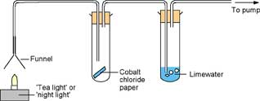

The gases produced by the burning fuel are drawn through the apparatus by a suction pump.

**Questions**

1. Describe what you observed happening in test-tubes A & B.

2. Which gas must have been produced to cause the change in test-tube B?

3. A colourless liquid formed in test-tube A. How could you prove that this liquid was **pure** water?

4. Now complete the word equation below:

Hydrocarbon + Oxygen +

**Incomplete Combustion**

j0186164

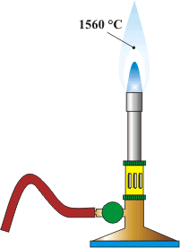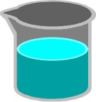

**Activity 4**

Collect a Bunsen burner, tripod, 2 beakers & heat mat.

Half fill both beakers with water.

Put one beaker on the tripod and heat using the Bunsen set on a yellow flame.

Repeat with the second beaker but this time heat the water using a blue flame.

**Questions**

1. What did you notice about the beaker being heated over the yellow bunsen flame?

2. What do you think the substance is?

**Complete combustion** occurs when there is enough oxygen to completely burn all the carbon and hydrogen in a fuel.

**Incomplete combustion** occurs when there is an insufficient supply of oxygen to allow complete combustion. In the experiment above, the supply of oxygen to the bunsen was limited since the air hole was closed. As a result, black soot formed on the beaker. Soot is always formed in flames where there is not enough oxygen. The **soot** is **unburnt carbon** from the gas.

Another product of the incomplete combustion of hydrocarbons is **carbon monoxide** gas. This is a very poisonous gas since it reacts with the haemoglobin in your red blood cells and prevents the haemoglobin from carrying oxygen to your brain and other parts of your body. Carbon monoxide is particularly dangerous since it is a colourless gas with no smell or taste so its presence often goes completely undetected.

**Complete Combustion**

Hydrocarbon + Oxygen Carbon **Di**oxide + Water

**Incomplete Combustion**

Hydrocarbon + Oxygen Carbon **Mon**oxide + Carbon + Water

(soot)

**Hydrocarbons**

**National 5 Learning Outcomes**

* Alkenes are described as unsaturated hydrocarbons and can undergo addition reactions that convert them into alkanes.
* Families of hydrocarbons, like alkanes, are known as Homologous Series.
* A homologous series of hydrocarbons is identified from the name and the general formula.
* A homologous series of hydrocarbons has similar chemical properties, gradually changing physical properties and a general formula.
* The cycloalkane family is a homologous series of hydrocarbons and is identified from the name and the general formula.
* Cycloalkanes, with no more than eight carbon atoms in their longest chain, are named from their full structural formulae, shortened structural formulae and molecular formulae.
* Structural formulae can be drawn and molecular formulae written from systematic names.
* Systematic names can be written from given structural formulae.
* Isomers are compounds containing the same number of atoms of each type (same molecular formula), but have these atoms arranged in a different way (different structural formulae).
* Isomers including alkanes, branched alkanes, alkenes, branched alkenes and cycloalkanes can be identified and drawn.
* Isomers have different properties.

**Hydrocarbons**

Natural Gas and the many compounds obtained from Crude Oil all have one thing in common - they mainly contain molecules called hydrocarbons.

**Hydrocarbons** are compounds which contain the elements **hydrogen** and **carbon** only.

All hydrocarbons will belong to a different **homologous series.**

A **homologous series** is a group of molecules which will all have **similar chemical properties** and have a **GENERAL FORMULA.**

**The Alkanes**

The first, and simplest homologous series of hydrocarbons is the family called the **alkanes**.

Alkanes are very important substances – being hydrocarbons they will burn easily and can be used as fuels. Indeed most of the fuels that we use are made from alkanes e.g.

**Fuel Alkane**

Natural gas methane

Bottled gas propane and butane

Petrol octane

Although the alkanes used as fuels are easily recognisable they are also very important starting materials in the manufacture of a wide range of other substances such as plastics and drugs.

You will notice from the above table that the alkanes all have the same name ending: **-ane.**

**The Structure of the Alkanes**

Methane is the first member of the family with only one carbon atom in its formula CH**4**. The second member is ethane, which has two carbon atoms in its molecule.

We have already noted that the alkanes all share the same name ending – **ane**. The **number of carbon atoms that each alkane molecule has is determined by the first part (prefix) of the name** of the compound.

The following table lists the prefixes and what they mean. The prefixes are the same for all families of hydrocarbons!

|  |  |
| --- | --- |
| **Prefix** | **No. Carbon atoms in the**  **Molecule** |
| meth- | 1 |
| eth- | 2 |
| prop- | 3 |
| but- | 4 |
| pent- | 5 |
| hex- | 6 |
| hept- | 7 |
| oct- | 8 |

Use your notes and data book to help complete the table below.

|  |  |  |  |  |
| --- | --- | --- | --- | --- |
| Alkane | No. of Carbon atoms | Formula | Boiling Point (oC) | State at 25oC |
| Methane | 1 | CH**4** |  | Gas |
| Ethane | 2 | C**2**H**6** |  |  |
|  | 3 | C**3**H**8** |  |  |
|  | 4 | C**4**H**10** |  |  |
|  | 5 |  |  | Liquid |
|  | 6 |  |  |  |
|  | 7 |  |  |  |
|  | 8 |  |  |  |

What is the trend in the boiling point as the number of carbon atoms increases?

Obviously as the alkane molecules get bigger their structure becomes more complicated. To simplify the study of these compounds chemists use special formula called **full structural formula** to give a simplified picture of the molecule. For the alkanes after methane it is sometimes easier to use **shortened structural formulae**. This simply shows how many CH**3** and CH**2** groups are present in the molecule. To illustrate this lets take the example of butane.

Chemical Full Structural Shortened Structural

Formula Formula Formula

H H H H

Butane C**4**H**10** H-C-C-C-C-H CH**3**CH**2**CH**2**CH**3**

H H H H

When drawing full structural formula it is very important to remember that **carbon atoms always make 4 bonds**. When you draw your structure always make sure that there are 4 bonds coming from each C atom.

j0186164

Let’s practice drawing these formulae.

**Activity 1**

1. Collect a set of models

2. Use the models to make molecules of the alkanes listed in the table below.

3. Use the model to help you draw the full structural formula and the shortened structural formula for each alkane (in the table over the page).

|  |  |  |
| --- | --- | --- |
| **Alkane** | **Full Structural Formula** | **Shortened Structural Formula** |
| Methane |  | CH**4** |
| Ethane |  | CH**3**CH**3** |
| Propane |  | CH**3**CH**2**CH**3** |
| Butane |  |  |
| Pentane |  |  |
| Hexane |  |  |
| Heptane |  |  |
| Octane |  |  |

**The General Formula for the Alkanes**

If you look at the full structural formula in the previous table you can see a pattern. Each carbon atom is joined to two hydrogen atoms, and there are two extra hydrogen atoms – one at each end of the molecule. This gives us a general formula for the alkanes: **C*n* H*2n+2***

where ***n*** is the number of carbon atoms in the molecule.

This means that if we know the number of carbon atoms in the molecule we can work out the formula.

j0186164e.g. Ethane  ***n*=2**  thus the formula is C**2** H**(2x2)+2**= C**2**H**6**

**Activity 2**

Use the general formula to work out the chemical formula for the following alkanes:

(i) Decane

(ii) An alkane with 25 carbon atoms

(iii) An alkane with 37 carbon atoms.

**The Alkenes**

The alkenes are similar to the alkanes in many ways. They are both groups of hydrocarbons containing covalent bonds. The main difference between them is that each alkene contains a special bond called a **carbon–to–carbon double bond**, which can be represented by **C=C.** As you will see the presence of this bond affects the chemical properties of the alkenes.

**Naming Alkenes**

To name the alkene family we must remember the prefixes we learned earlier. The **prefix will indicate how many carbon atoms are in the molecule** and is the first part of the name. To show that the compound is a member of the alkene family we end the name in **–ene.**

e.g. ETHENE - the alkene with two carbon atoms in a molecule.

BUTENE - the alkene with four carbon atoms in a molecule

**Drawing Structural Formula**

As always we must remember the rule that **carbon atoms must always make four bonds** (since their valency is four)

We must also appreciate that it is the presence of a **carbon-to-carbon double bond** ( **C=C)** in the molecule that makes it an **alkene**.

e.g. Propene is an alkene with three carbon atoms in a molecule.

Its Structural Formula is : H H H

H-C-C=C-H

H

Its Chemical Formula is: **C3H6**

Its Shortened Structural Formula is : **CH3CH=CH2**

It is important to note that the **first member** of the alkene family is **ETHENE.**

Why is there no alkene with one carbon atom?

j0186164

**Activity 3**

Use models to make molecules of the alkenes in the table.

Use your models to help you complete the table.

|  |  |  |  |
| --- | --- | --- | --- |
| Alkene | Molecular Formula | Full Structural Formula | Shortened Structural Formula |
| Ethene | C2H4 |  | CH2=CH2 |
|  | C3H6 |  |  |
| Butene |  |  |  |
|  |  |  | CH3CH2CH2CH=CH2 |
|  | C6H12 |  |  |

**The General Formula for the Alkenes**

Once again, if you look at the full structural formula in the previous table you can see a pattern. For each carbon atom in the molecule there are two hydrogen atoms

This gives us a general formula for the alkenes: **C*n* H*2n*** where ***n*** is the number of carbon atoms in the molecule.

The alkenes also form a homologous series. They have a general formula – **CnH2n**, share similar chemical properties and show a gradual change in some physical properties such as boiling point.

**Differences Between Alkanes and Alkenes**

What are the differences between alkanes and alkenes?

The diagrams of the molecules below show that they have **different structures.**

H H H H H H

H-C-C- C-H H-C-C=C-H

H H H H

***propane* *propene***

Also, the C=C bond in the alkenes is very reactive, much more so than the C-C single bond in the alkanes. As a result of this, **the alkenes are reactive** molecules that can be changed readily into new products. Since it is the C=C bond which makes the alkenes reactive we call this the **functional group** of the molecule. The alkanes however are relatively unreactive and are really only useful for fuels.

**Reactions of the Alkenes**

As we have just stated, the alkenes are very reactive because they contain a C=C double bond. So, how do they react?

The C=C is a reactive bond and will break easily. We can see this if we look at how the alkenes react with hydrogen gas. Let’s look at propene reacting with hydrogen:

H H H H H H

H-C-C=C-H + H-H H-C-C-C-H

H H H H

*prop****ene*** *+ hydrogen prop****ane***

Notice that the **alkene** propene has turned into an **alkane.** The two hydrogen atoms from the hydrogen molecule have “added on” to the C=C double bond in the alkene. This breaks the double bond and allows it to become a C-C single bond.

This type of reaction is called an **ADDITION REACTION**. All alkene molecules can undergo addition reactions. In this reaction the alkene molecule joins (adds) to another small molecule to produce a larger molecule. The small molecule is usually a diatomic molecule.

*What is a diatomic molecule?*

*Give some examples of diatomic molecules you have already met.*

Addition reactions cannot take place with alkanes. This is because the alkane molecules are “full up” or saturated with hydrogen atoms – no more hydrogen atoms can be added on.

Alkanes are described as **SATURATED** molecules because they cannot add on any extra hydrogen atoms.

Alkenes are described as **UNSATURATED** molecules because they can add on extra hydrogen atoms since they contain C=C.

**Test for Unsaturation**

Suppose you were given two liquids. One is a saturated alkane and the other is an unsaturated alkene. Both are colourless, and both burn. How could you tell them part?

One way is to use a coloured diatomic liquid – like bromine.

Bromine molecules, like hydrogen, can add on to a double bond and so will react with an alkene. In addition, since bromine is an orange liquid, there is a change in colour when the reaction takes place.

**j0186164Your teacher will show you how to test for unsaturation.**

In the demonstration you will be shown how bromine reacts with an alkene and an alkane.

Describe what happens in the space below.

Alkane result:

Alkene result:

**Explaining the Unsaturation Test**

To see how alkenes decolourise the bromine immediately we must look at the addition reaction involved. Let’s consider the reaction between propene and bromine.

H H H H H H

H-C-C=C-H + Br-Br H-C-C-C-H

H H Br Br

propene bromine 1,2-dibromopropane

(*colourless ) (orange) (colourless)*

It is clear to see that the orange colour of the bromine disappears quickly as the orange bromine molecules break up and the bromine atoms add across the C=C double bond thus, changing it to C-C single bond.

This reaction is very important and one that you will be asked about often. Learn it!

**Activity 4 - More Addition Reactions**

As we have seen the alkenes react well because of the presence of the C=C double bond in their structure. They all undergo Addition Reactions. To see if you fully understand addition reactions use full structural formula to answer the following questions. When you have finished try to name the product formed. If you have problems with any of the names ask your teacher for help.

1. Propene + Bromine

2. Butene + Bromine

3. Ethene + Hydrogen

4. Pentene + Hydrogen

5. Butene + Chlorine

6. Propene + Hydrogen chloride

7. Ethene + Hydrogen bromide

**Supply and Demand - Cracking**

The fractional distillation of oil generally produces more long-chain alkanes than are needed by industry. Since there is a greater demand for lighter fuels, such as petrol (from gasoline and naphtha) and diesel, chemists “chop up” some of the longer molecules from the heavier fractions to get smaller molecules. The smaller molecules are more useful since they are in greater demand.

Breaking down the long-chain alkanes into smaller molecules is called **cracking.**

In cracking, heat is used and a catalyst provides a reaction surface. The hot surface of the catalyst helps speed up the reaction.

Cracking can be carried out in the laboratory. The set-up is shown below:

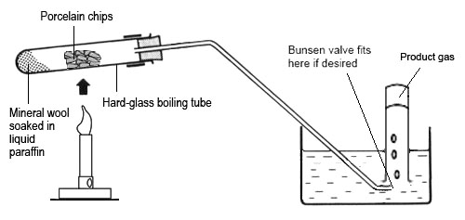

**Your teacher will demonstrate the above experiment.**

Describe what happened below.

**Questions**

1. What happened to the bromine solution?

2. What does this tell you about the products in the reaction.

3. Why does the delivery tube have to be removed from the water before heating is stopped?

4. What is the catalyst used in the experiment?

**The Importance of Cracking**

As we have seen in the previous experiment, cracking not only provides us with more useful short chain molecules; it also provides us with unsaturated alkene molecules.

**When a long-chain molecule is cracked it produces a mixture of smaller alkanes and alkenes.** While the shorter alkanes are useful as fuels such as petrol and diesel, the alkenes are often used in the plastics industry.

**Cycloalkanes**

The cycloalkanes are another homologous series.

The alkanes have shown us that carbon atoms can join to form chains. In the cycloalkanes we see that the carbon atoms can also join to form ring structures.

To form a ring structure a minimum of 3 carbon atoms must be in the molecule. This means that the first member of the family of cycloalkanes must be **cyclopropane**.

The cycloalkanes are named in a similar way to the alkanes. The main difference is that the names all begin with **“cyclo”** to show that the molecules contain rings of carbon atoms e.g.

The member of the cycloalkanes containing **six** carbon atoms would be called:

**Cyclohexane**

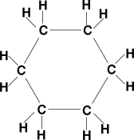

**Activity 6**

Collect a set of models and use them, and the information on the previous page, to help you complete the table below:

|  |  |  |  |  |
| --- | --- | --- | --- | --- |
| Name | Molecular formula | Full structural formula | Shortened structural formula | Physical state at 250C |
| cyclopropane | C3H6 |  |  | gas |
| cyclobutane |  |  |  | gas |
|  |  |  |  | liquid |
|  | C6H12 |  |  | liquid |

**Problem to Solve!**

The cycloalkanes are another homologous series. This means that they must share a general formula.

Use the above completed table to work out the general formula for the cycloalkanes.

Get your teacher to check your answer.

Now complete the sentence below:

**The general formula of the cycloalkanes is:**

**Isomers**

Butane has the chemical formula: **C4H10**

Collect a set of molecular models and make up two **different** structures using four carbon atoms and ten hydrogen atoms.

Draw the two different structures below.

**Structure 1 Structure 2**

Both of these molecules burn in the same way but they have slightly different boiling points. Their chemical formula is that of butane but as their boiling points are different they cannot both be a butane molecule. Their **chemical formula is the same** but their **structural formula is different**. These types of molecules are known to chemists as **ISOMERS**.

**Isomers** are defined as molecules that have the **same molecular formula** but **different structural formula**. In other words, isomers contain the same numbers of each kind of atom, but they are arranged differently. As they have different structures isomers have different physical properties i.e. different melting and boiling points.

There are no isomers of methane, ethane or propane, but after that the number of possible isomers increases rapidly. Pentane has three isomers, hexane five and octane eighteen.

**j0186164Your teacher will demonstrate how to determine the different isomers of pentane. Pay close attention so that you will be able to complete Activity 7 yourself!**

**Activity 7**

Draw the five structural formulae for the isomers of hexane. You may use models if you wish. (Practise on paper before filling in the table!)

|  |  |  |
| --- | --- | --- |
| **Isomers of hexane**  **C6H14** | Isomer 1 | **Isomer 2** |
| **Isomer 3** | **Isomer 4** | **Isomer 5** |

Alkenes also have isomers. You have seen that both **alkenes** and **cycloalkanes** have the same general formula **CnH2n**. This means that for each cycloalkane there is an alkene with the same molecular formula but with a different structural formula. In other words, each cycloalkane is an isomer of the alkene that contains the same number of carbon atoms e.g.

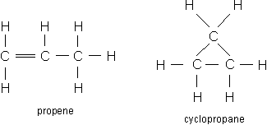

Similarly, butene and cyclobutane are isomers as are pentene and cyclopentane.

## Question

There is one alkene that does not have a cycloalkane as an isomer.

Which alkene is it?

There is another type of isomer for the alkenes which are bigger than propene. When the alkene molecule contains four or more carbon atoms the carbon to carbon double bond can be put in a different position. Consider the butene molecules below:

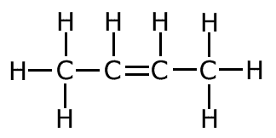

but-2-ene

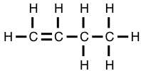

but-1-ene

The carbon to carbon double bond The carbon to carbon double bond

is between carbon 1 and carbon 2 in is between carbon 2 and carbon 3 in

the carbon chain. in the carbon chain.

These two molecules are two of the several isomers of butene :  **C4H8**

Name a third isomer which would be **saturated** i.e. does not contain carbon to carbon double bonds?

To which **Homologous Series of saturated hydrocarbons** does this isomer belong?

**j0186164**

**Actvity 8**

Draw the structural formula of four isomers of hexene. You may use models to help you if you wish.

**Cracking Revisited!**

Cracking is the process which is used to break up the larger heavier fractions into smaller more useful fractions. It is also the method of production of the very important ALKENES! So, why does cracking produce a mixture of alkanes and alkenes?

Let’s consider the cracking of the alkane decane C10H22.

If one of the products is the alkane hexane, C6H14, then that has accounted for 6 of the 10 carbon atoms in the original decane molecule. It has also accounted for 14 of the 22 hydrogen atoms in the original decane molecule. Since cracking is simply breaking up and no other reactants are involved, this leaves 4 carbon atoms and 8 hydrogen atoms remaining. This means that the other product must have the molecular formula C4H8. This product is butene:

C10 H22 C6H14 + C4H8

**decane hexane butene**

*saturated saturated unsaturated*

When an alkane breaks there are not enough hydrogen atoms to produce two alkanes and so one of the products is an unsaturated alkene.

In practice, when an alkane is cracked the carbon chain may break at different points on different molecules. This means that usually a mixture of products is obtained.

**Questions**

Complete the following cracking equations. For each equation do the following:

* Highlight the alkanes in YELLOW and the alkenes in PINK.
* Name the saturated product
* State which product would decolourise bromine water immediately.

1. C16H34 C9H18 +

2. C4H8 + C5H12

3. C20H42 C9H18 +

**Systematic Naming of Hydrocarbons**

All prganic chemicals are given a systematic name according to internationally accepted convention.

There are three different structures for the compound with the molecular formular C5H12. Their shortened structural formulae are shown below:

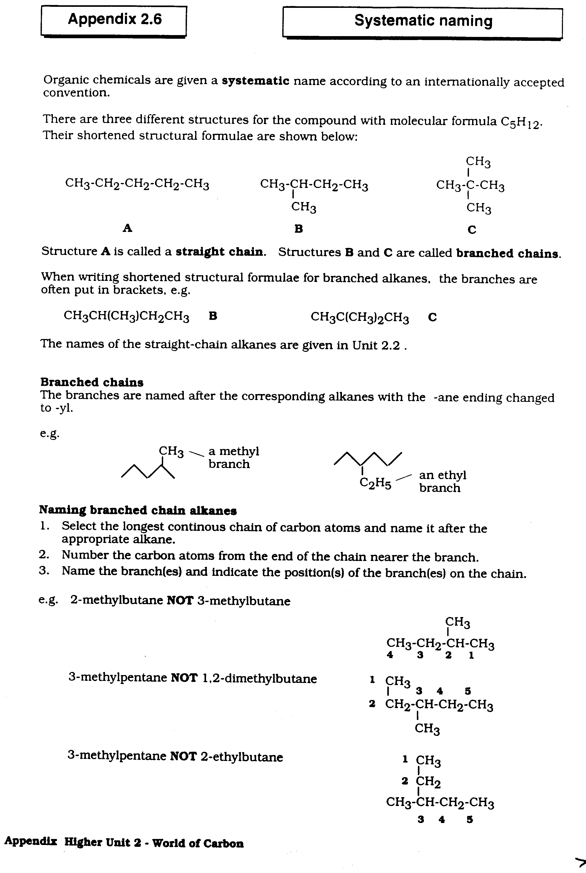

When writing shortened structural formulae for branched alkanes, the branches are often put in brackets, e.g

CH3CH(CH3)CH2CH3 CH3C(CH3)2CH3

**B C**

**Branched Chains**

The branches are named after the corresponding alkanes with the –ane ending changed to –yl

-CH**3** is known as a methyl branch -C**2**H**5** is known as an ethyl branch

What would be the formula of an propyl branch?

## Rules for naming branched chain alkanes

**STEP 1:** Identify the **longest chain** of carbon atoms

**STEP 2:** **Name** the **branches (methyl, ethyl)** – in alphabetical order

**STEP 3:** If there are more branches with a prefix:

**di for 2, tri for 3, tetra for 4**

**STEP 4:** Number the carbon chain and identify the **position** of the branches

Counting from the right the longest continuous

chain is four carbons so, **butane.**

There is a methyl branch attached to the second

carbon from the end so,

**2-methylbutane**

The longest continuous chain has six carbon

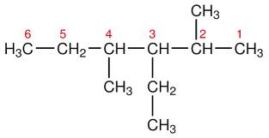

atoms so, **hexane.**

There are methyl branches attached to carbon

number two and number four; and an ethyl

attached to carbon number three so,

**3-ethyl-2,4-dimethylhexane**

**Cycloalkanes** are named in a similar way.

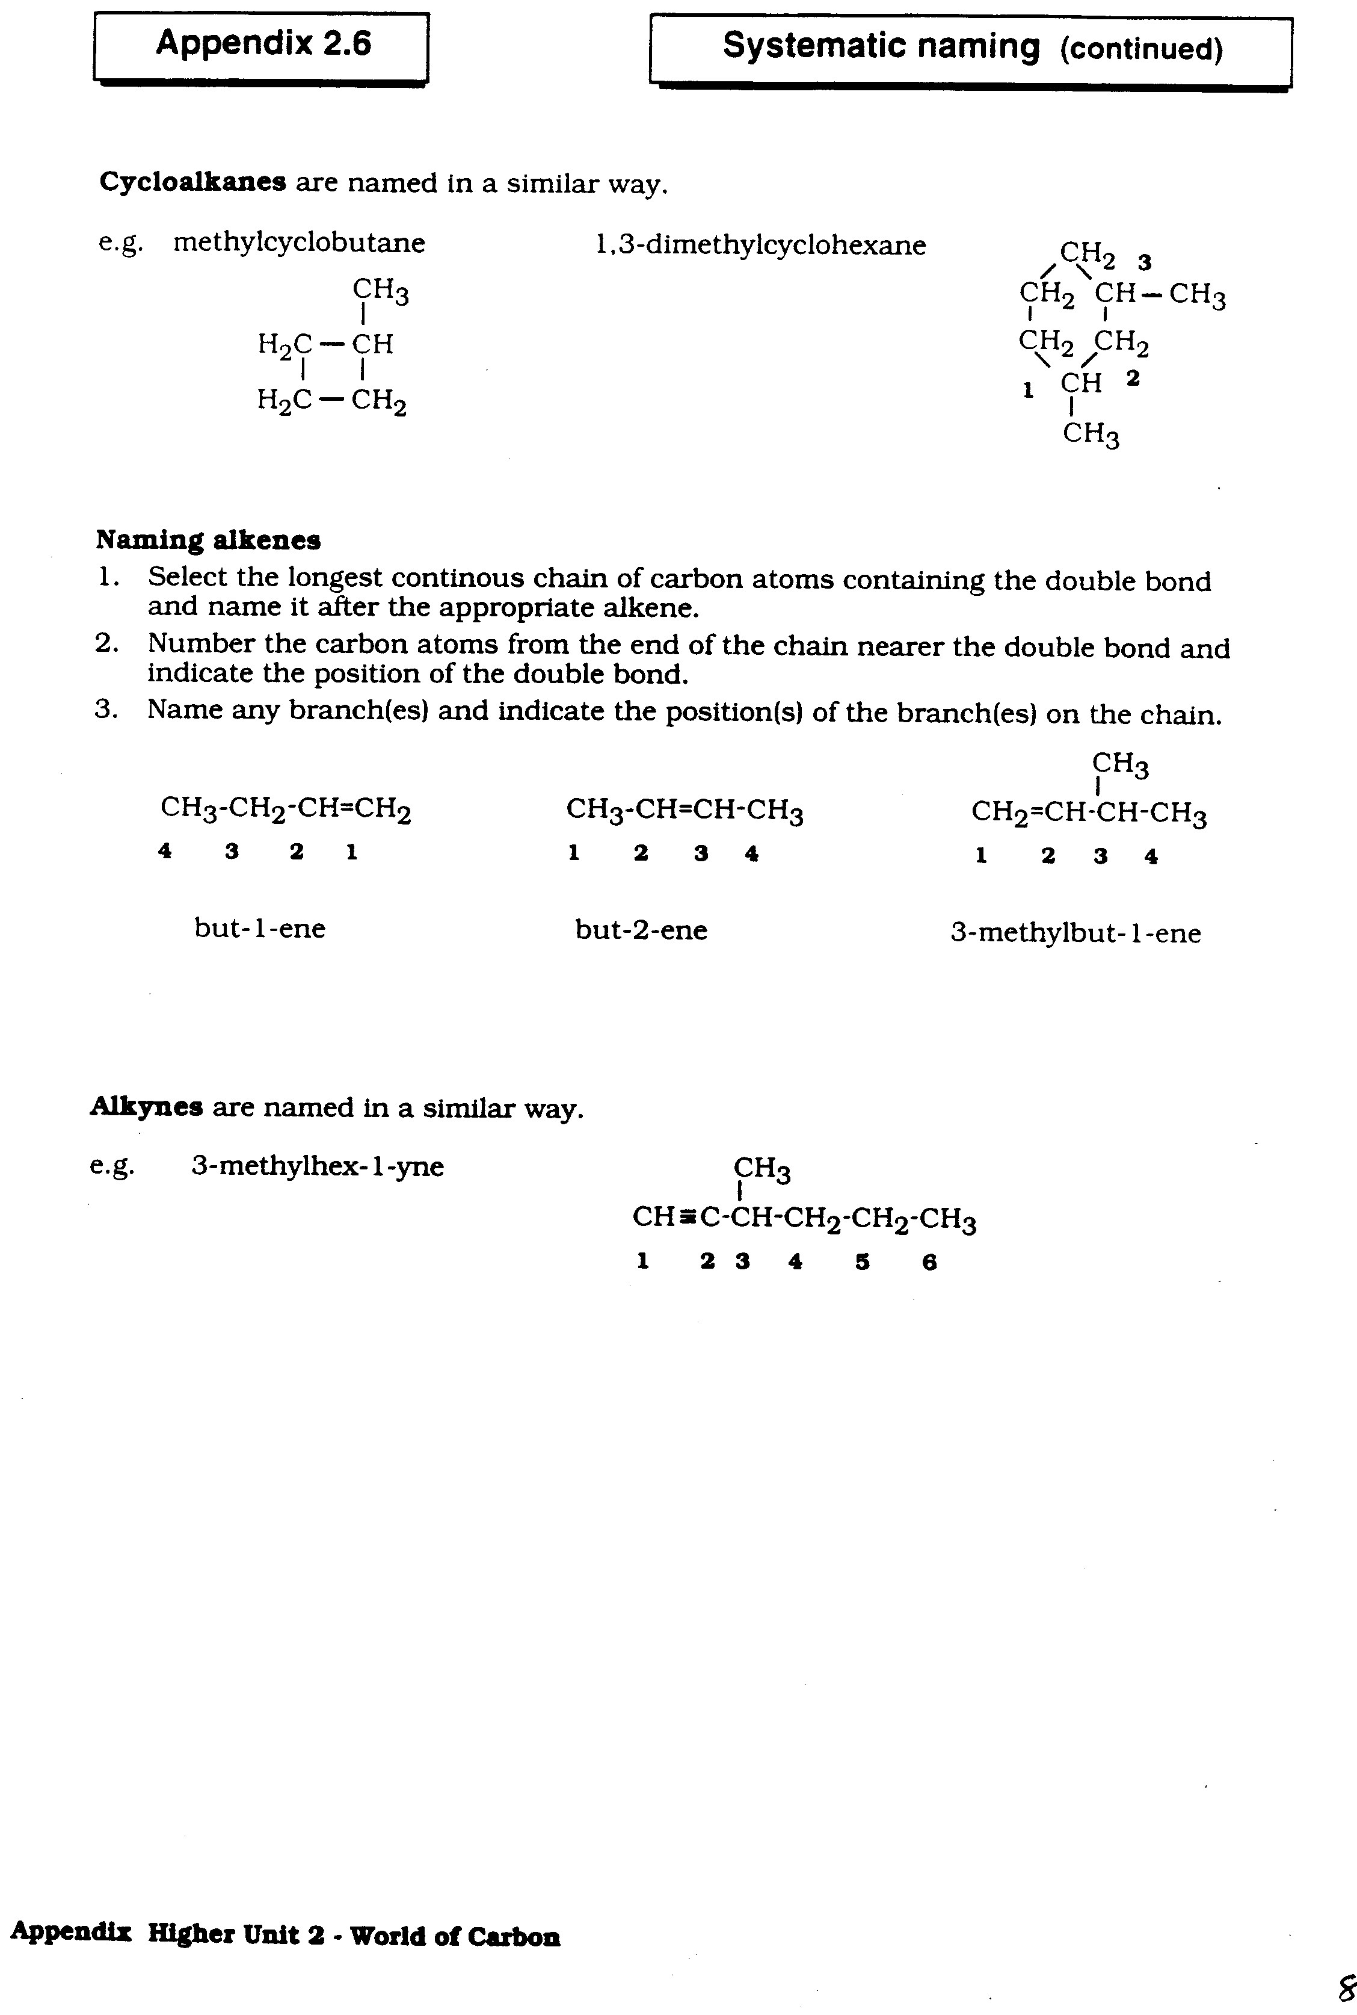**Naming alkenes**

1. Select the longest continuous chain of carbon atoms **containing the double bond** and name it after the appropriate alkene.

2. Number the carbon atoms from the end of the chain nearer the double bond and indicate the position of the double bond.

3. Name any branch(es) and indicate the position(s) of the branch(es) on the chain.

4. Branches named alphabetically as before, and numbers separated from each other with commas and numbers and words with hyphens as before.



**Practice Questions**

Give the systematic name for each of the following hydrocarbons.

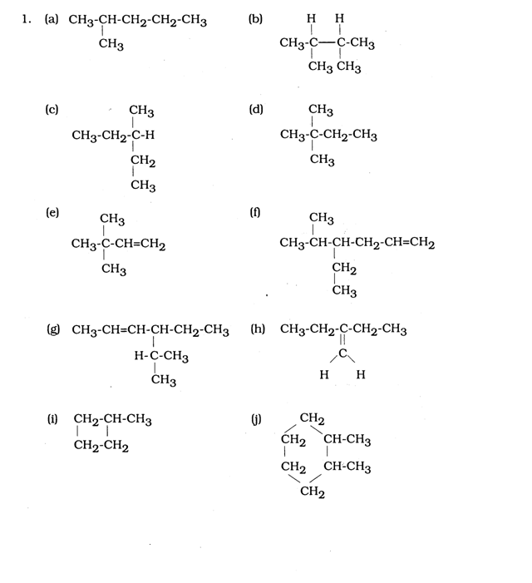

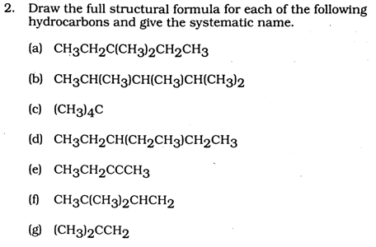

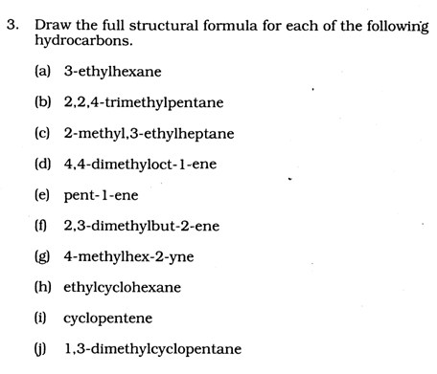

**Everyday Consumer Products**

**National 4 Learning Outcomes**

* Carbohydrates are made up of carbon, hydrogen and oxygen only.
* Carbohydrates are found in a variety of foodstuffs.
* Starch and glucose are both carbohydrates.
* Glucose can dissolve in water whereas starch cannot.
* Iodine solution can be used to test for starch. When starch is present the iodine solution changes from orange/brown to blue/black.
* Alcoholic drinks can be made by fermenting glucose.
* Distillationis a method of separating liquids because of the difference in boiling points.
* Plants are used by chemists in the design and manufacture of many everyday products such as pharmaceuticals, soaps, cosmetic, dyes and medicines.

**Carbohydrates**

Many of our foods contain a class of compound called **carbohydrates**.

We can work out the elements in a carbohydrate from the name:

**carbo** - for carbon

**hydrate** - from the Greek word for water

However, the hydrogen and oxygen atoms in carbohydrates are **not** present as water molecules … but the two elements are present in the same ratio as in water, i.e. two hydrogen atoms for every one oxygen atom.

Carbon, hydrogen and oxygen are non-metal elements and so carbohydrates are made up of molecules with atoms joined by covalent bonds.

**Which THREE elements are present in carbohydrates?**

**Name THREE foodstuffs that contain a carbohydrate.**

**Complete the following table.**

|  |  |  |
| --- | --- | --- |
| **Name** | **Formula** | **Carbohydrate**  **(yes or no)** |
| glucose | C6H12O6 |  |
| acetone | C3H6O |  |
| carbon monoxide | CO |  |
| hexene | C6H12 |  |
| sucrose | C12H22O11 |  |
| water | H2O |  |
| alcohol | C2H5OH |  |

**Starch and glucose**

Starch and glucose are both carbohydrates. They are both made up of carbon, hydrogen and oxygen (the hydrogen and oxygen in the ratio of two to one) but they have quite different structures.

Unlike starch, glucose has a sweet taste just like ordinary sugar. However, in the interest of safety, we cannot use taste to distinguish between starch and glucose in the lab!

**What is observed when … a little glucose is added to a test tube of water?… a little starch is added to a test tube of water?**

**Complete the diagram to show what is observed when each test tube is held in a beam of light.**





**glucose**

**starch**

Starch does not dissolve in water to form a solution … the solid particles are ‘suspended’ in the water. They are too small to be seen by the naked eye but large enough to reflect a beam of light. The suspension of a solid in a liquid is known as a **colloid**. Many substances form a colloid in water so, although this can be used to distinguish starch from glucose, this **cannot** be used as a test for starch.

**What is meant be a colloid?**

**Which carbohydrate, glucose or starch, forms a colloid when added to water?**

**Why can the formation of a colloid in water not be used as a test for starch?**

**Testing for starch and glucose**

Chemical tests are needed to distinguish starch from glucose and to identify each from other white powders.

**What solution can be used to test for starch?**

**What is the colour change that takes place?**

**Is heat necessary for the colour change to take place?**

**Name THREE foods that contain … glucose? … starch?**

**Alcoholic drinks**

Alcohol, for alcoholic drinks, can be made by the **fermentation** of glucose.

Carbon dioxide gas is also produced in the process.

The glucose can come from any fruit or vegetable that is a source of carbohydrate.

The type of alcoholic drink varies with the plant source of the carbohydrate.

|  |  |
| --- | --- |
| **Source** | **Drink** |
| grape | wine |
| barley | beer, whisky |
| apples | cider |
| potatoes | vodka |

The alcohol content of drinks is measured in units of alcohol.

|  |  |
| --- | --- |
| **Drink** | **Alcohol content in units** |
| pint of beer/lager | approx. 2.5 |
| small glass of wine | approx. 2 |
| large glass of wine | approx. 3 |
| single measure of spirit | approx. 1 |
| bottle of alcopop | approx. 1.5 |

Alcohol is a sedative and slows down the nervous system. This can lead to loss of control and can affect balance. A high intake of alcohol can result in unconsciousness and even death. Long term abuse of alcohol can cause cirrhosis of the liver.

For health reasons, it is advised that we should not regularly drink more than the daily unit guidelines. For men, this is 3 to 4 units of alcohol and for women this is 2 to 3 units of alcohol.

An enzyme in yeast acts as a catalyst for the fermentation reaction. At concentrations above about 15% the alcohol poisons the living organisms in the yeast. There is therefore a limit to the alcohol concentration of fermentation products.

**Distillation** is a method of separating liquids because of the difference in boiling points. Water and alcohol can be separated in this way … alcohol (b.p. 78 oC) boils off first.

Distillation is the process used to increase the alcohol concentration of fermentation products in the manufacture of ‘spirit’ drinks, e.g. gin, vodka, whisky.

**What is meant by fermentation?**

**Write a word equation for the fermentation process.**

**What is the name of the process used to increase the alcohol concentration of fermentation products in the manufacture of ‘spirit’ drinks?**

**Upon what does the process depend?**

**Describe the effects of alcohol intake?**

**Plants to Products**

Scientists are researching many different uses of using plants as a source of new products. Some examples include new, renewable **fuels** eg. biomass such as vegetable oils used to make biodiesel, plant sugars & starch made into bioethanol for cars.

Complete the table below:

|  |  |
| --- | --- |
| **Object** | **Natural material** |
| Window frame |  |
| Jumper |  |
| Shopping bag |  |
| String |  |

Essential oils from plants are used in many cosmetics, soaps, shampoos and perfumes. Product labels should say which essential oils are in it. By smelling the fragrance of an essential oil you can tell which plant or herb the oil was extracted from. Examples of essential oils include lavender, orange, geranium, peppermint, ginger, eucalyptus, rosemary and spearmint.

Complete the table below:

|  |  |  |  |  |
| --- | --- | --- | --- | --- |
| **Product** | **Essential oils** |  | **Product** | **Essential oils** |
| Toothpaste |  |  | Shampoo |  |
| Hand cream / body lotion |  |  | Sinus sprays |  |
| Muscle rub |  |  | Shower gel |  |

**Everyday Consumer Products**

**National 5 Learning Outcomes**

* Alcohols are useful solvents.
* Alcohols are highly flammable, and burn with very clean flames. Alcohols are used as fuels.
* Alcohols can be made by fermentation of glucose.
* Alcohols can also be made by hydration (addition of water) of alkenes.
* Straight-chain alcohols can be named and identified from full structural formulae and molecular formulae up to C8.
* Straight-chain alcohols can be identified from the ‘-ol’ name ending and by the hydroxyl functional group.
* Structural formulae of straight chain alcohols, up to C8, can be drawn and molecular formulae written from systematic names.
* Straight-chain carboxylic acids can be named and identified from full structural formulae and molecular formulae up to C8.
* Structural formulae of straight chain carboxylic acids, up to C8, can be drawn and molecular formulae written from systematic names.
* Straight chain carboxylic acids can be identified by the ‘-COOH’, carboxyl, functional group, and the ‘-oic acid’ name ending.
* Vinegar is a solution of ethanoic acid.
* Vinegar is used in household cleaning products designed to remove limescale (a build up of insoluble carbonates on plumbing fixtures), and as a preservative in the food industry.
* Esters can be made by reacting a carboxylic acid with an alcohol.
* Some esters are used as food flavourings, industrial solvents and fragrances.

**Alcohols (Alkanols)**

All alcohols contain the hydroxyl functional group **(-OH)**. Alcohols with only single bonds between carbon atoms are called **Alkanols**.

Alkanols are a homologous series based on the corresponding alkanes. Ethanol (found in alcoholic drinks) is an example of an alkanol. Ethanol is the second member of the series. Each member has a name which ends in **–anol** and a prefix which indicates the number of carbon atoms in the molecule.

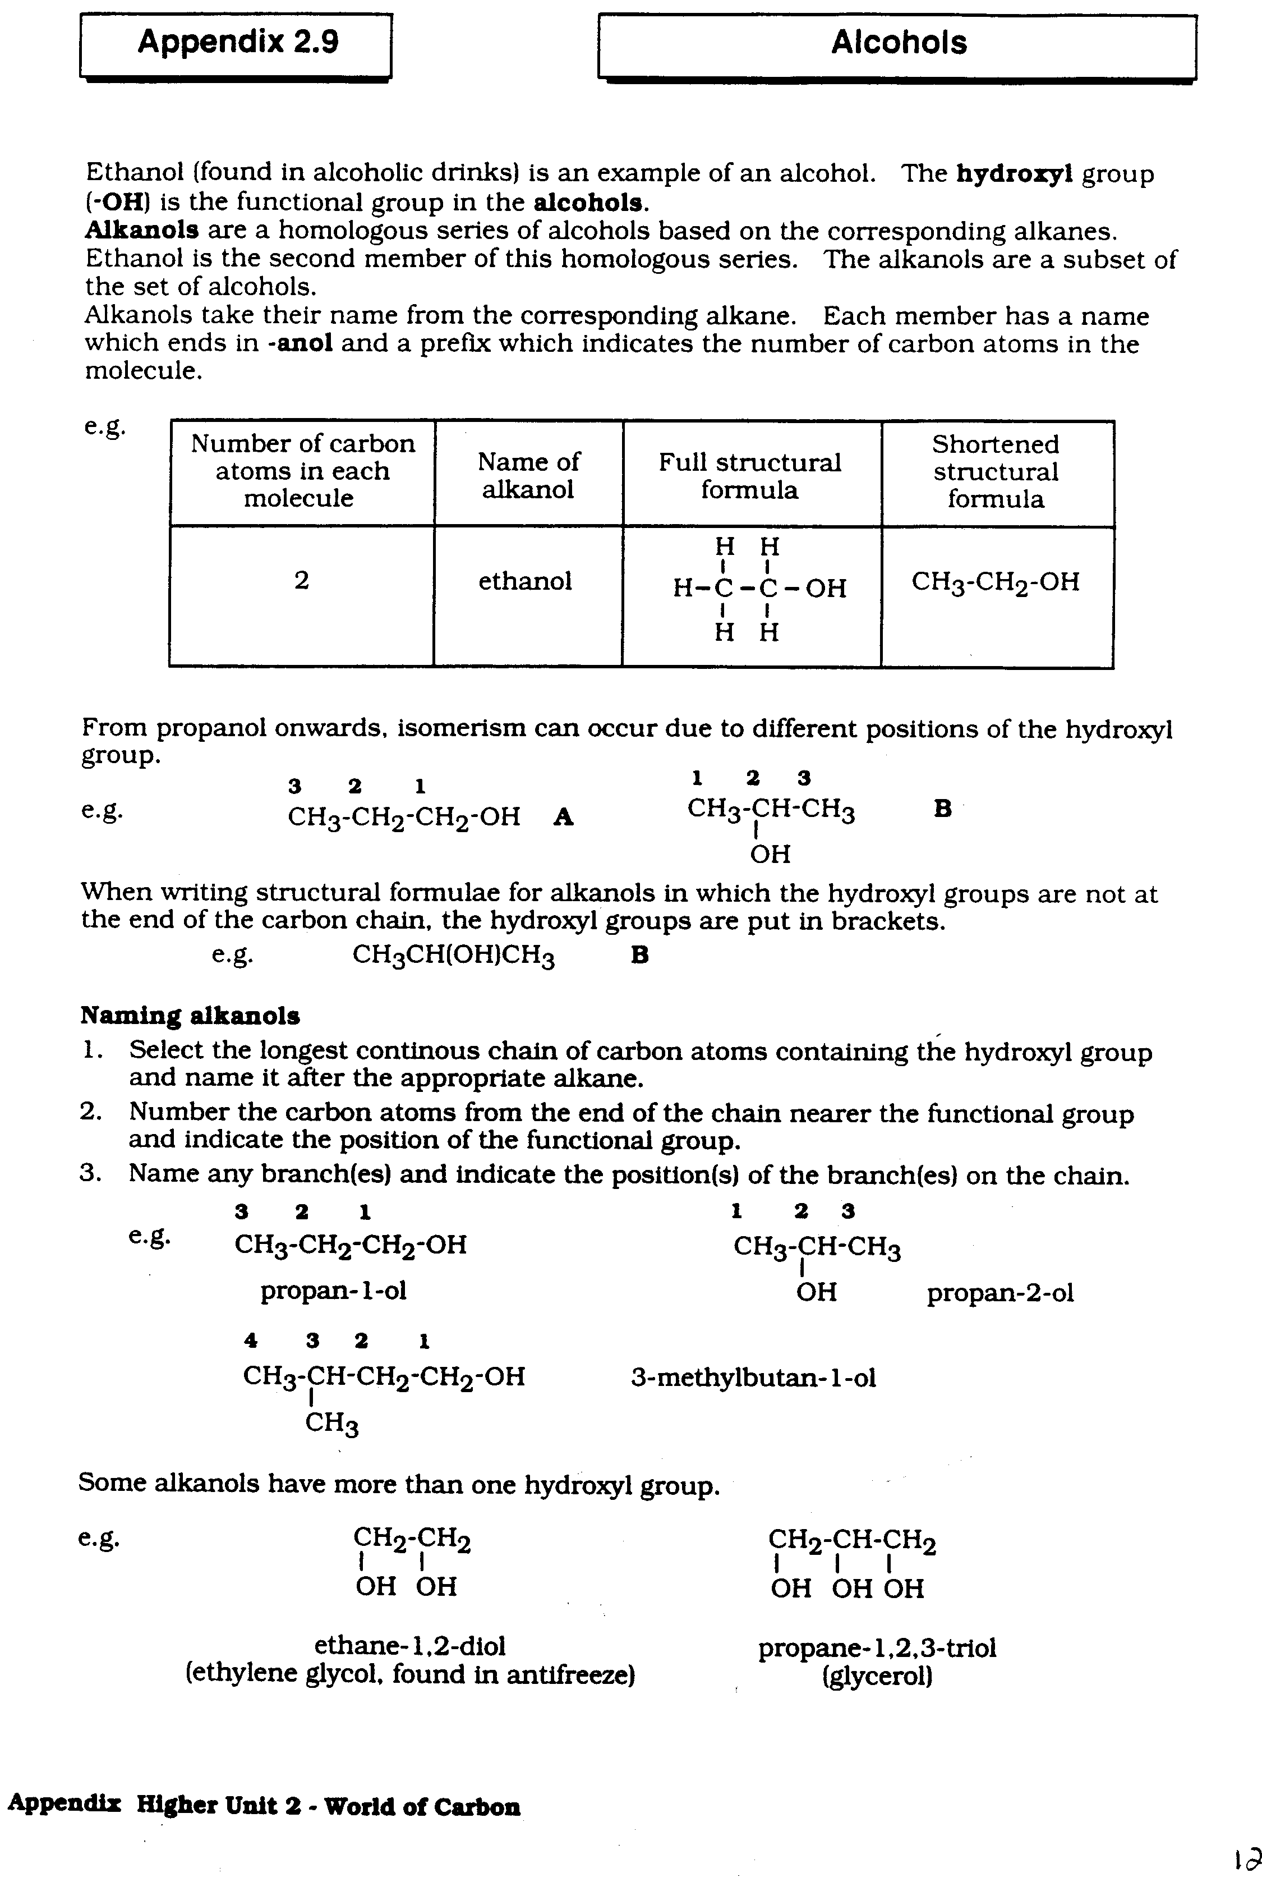

Complete the table below for the first six members of the series

|  |  |  |  |
| --- | --- | --- | --- |
| **Name** | **Full structural formula** | **Shortened structural formula** | **Molecular formula** |
|  |  |  |  |
|  |  |  |  |
|  |  |  |  |
|  |  |  |  |
|  |  |  |  |
|  |  |  |  |

From propanol onwards, isomerism can occur due to different positions of the hydroxyl group.

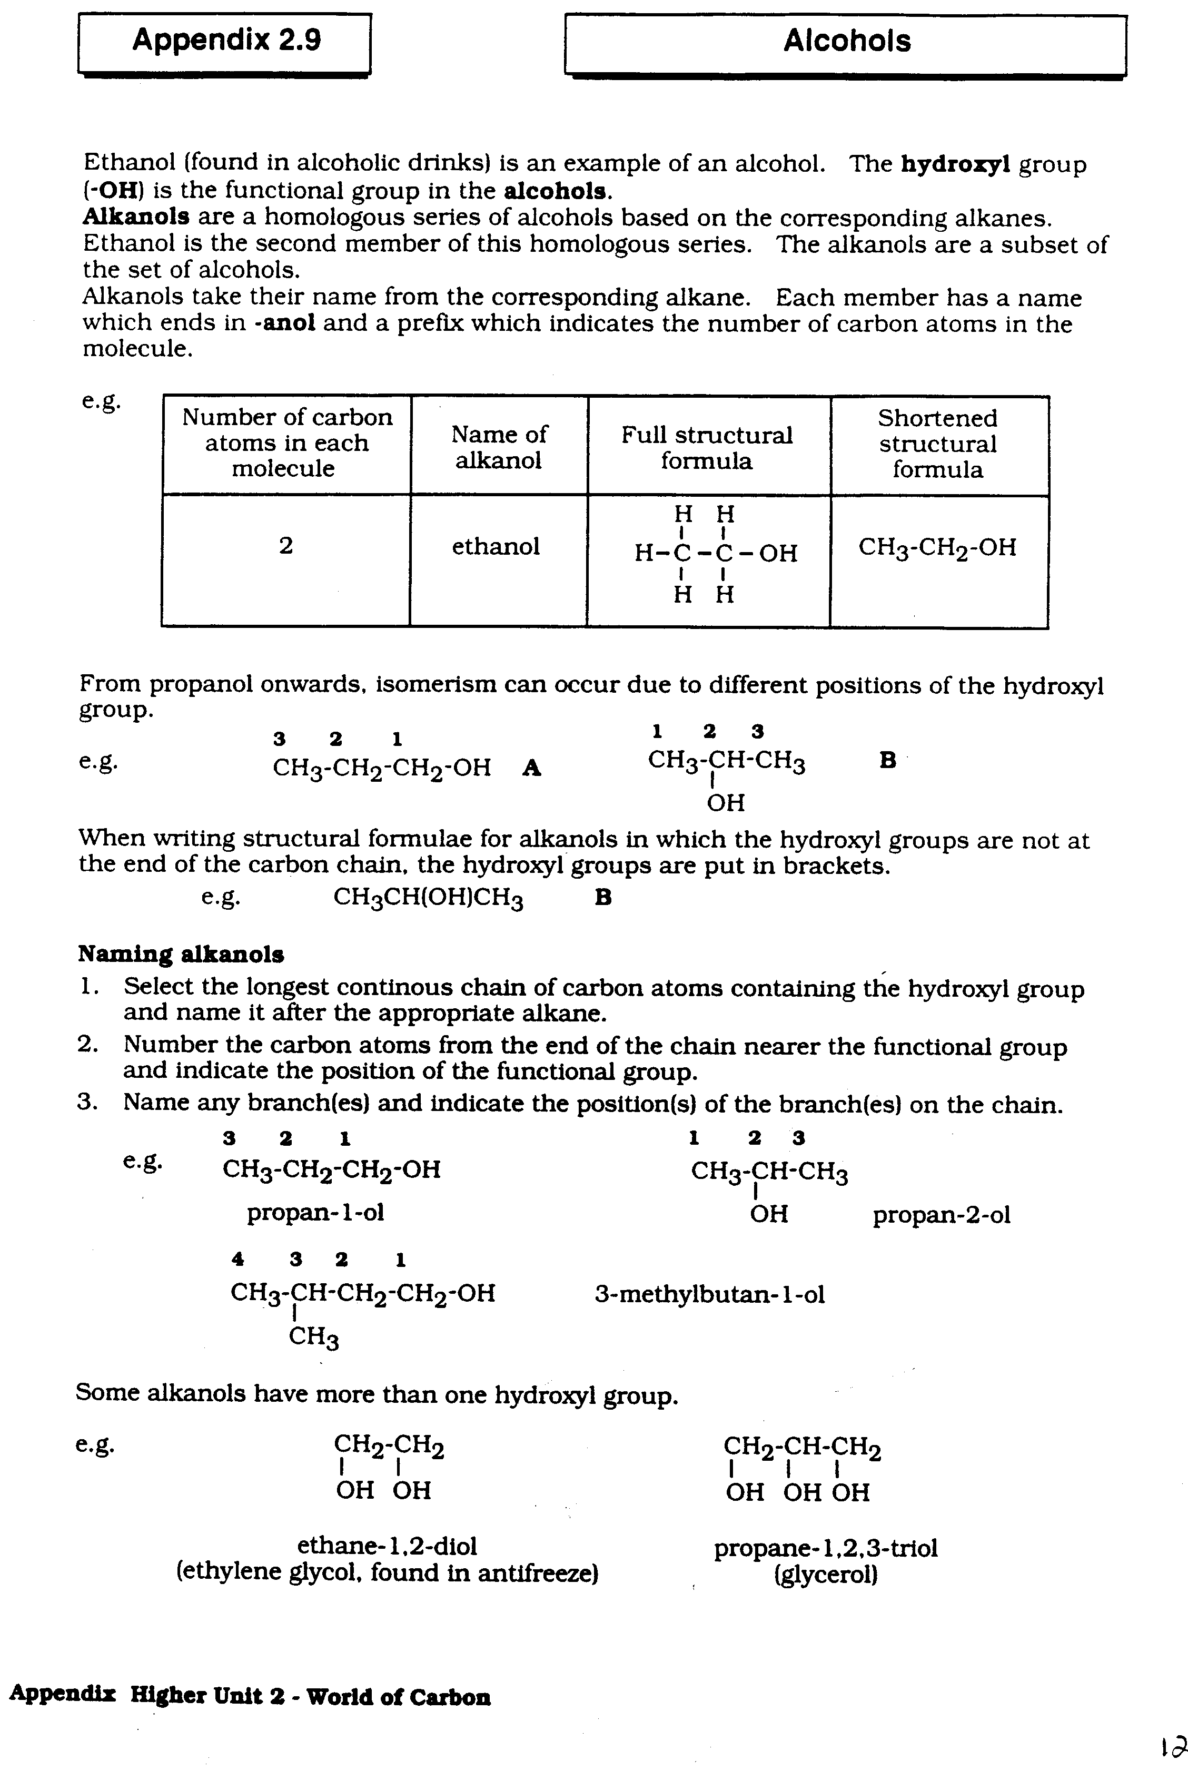

When writing structural formulae for alkanols in which the hydroxyl groups are not at the end of the carbon chain, the hydroxyl groups are put in brackets, so compound B above becomes:

CH3CH(OH)CH3

## Naming alkanols

1. Select the longest continuous chain containing the hydroxyl group and name it after the appropriate alkane.

2. Number the carbon atoms from the end nearer the functional group and indicate the position of the functional group.

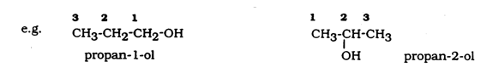

**6 5 4 3 2 1 6 5 4 3 2 1**

CH3-CH2-CH2-CH2-CH-CH3 CH3-CH2-CH2-CH-CH2-CH3

OH OH

hexan-2-ol hexan-3-ol

Some alcohols have more than one hydroxyl group, e.g.



**Questions**

1. Give the systematic name for each of the following alkanols

(a) CH3-CH-CH2-CH3 (b) OH

OH CH3 – CH – CH2 – CH2– CH3

(c) CH3-CH2-CH2-CH2-CH-CH2-CH3 (d) CH3-CH2-CH2-CH2-OH

OH

2. Draw the full structural formula for each of the following alkanols and give the systematic name.

(a) CH3CH2CH2OH (b) CH3CH2CH(OH)CH2CH3

(c) CH3CH2CH(OH)CH3 (d) CH3CH2CH2CH(OH)CH2CH2CH3

3. Draw the full structural formula for each of the following alkanols.

(a) pentan-1-ol (b) butan-2-ol

(c) octan-4-ol (d) heptan-2-ol

4. Look back at the table on page 2. What is the general formula for the alkanols?

**Production of Alkanols**

##### **Fermentation**

The alkanol produced by the fermentation of glucose (C6H12O6) is called ethanol (C2H5OH).

j0186164Carbon dioxide gas is produced in the process. This reaction can be carried out in the lab as shown below. The yeast contains the enzyme called zymase which catalyses the reaction.

**Activity 1**

Collect a conical flask. Put approximately 2 spatulas of glucose into the flask and dissolve this in water (just enough water to dissolve the glucose and no more). Add a very small amount of yeast to the glucose solution and stopper the flask with a loose plug of cotton wool. Leave this aside for a few days in a warm place. After a few days carefully smell the contents of the conical flask.

Draw a labelled diagram, below, for the apparatus used.

The process of **fermentation** is only used to produce ethanol for **alcoholic drinks**.

The process is far too slow and to meet market demand ethanol and most other alkanols (**not methanol**) are made by a process called **catalytic hydration**. This involves the addition of water to an alkene in the presence of a catalyst.

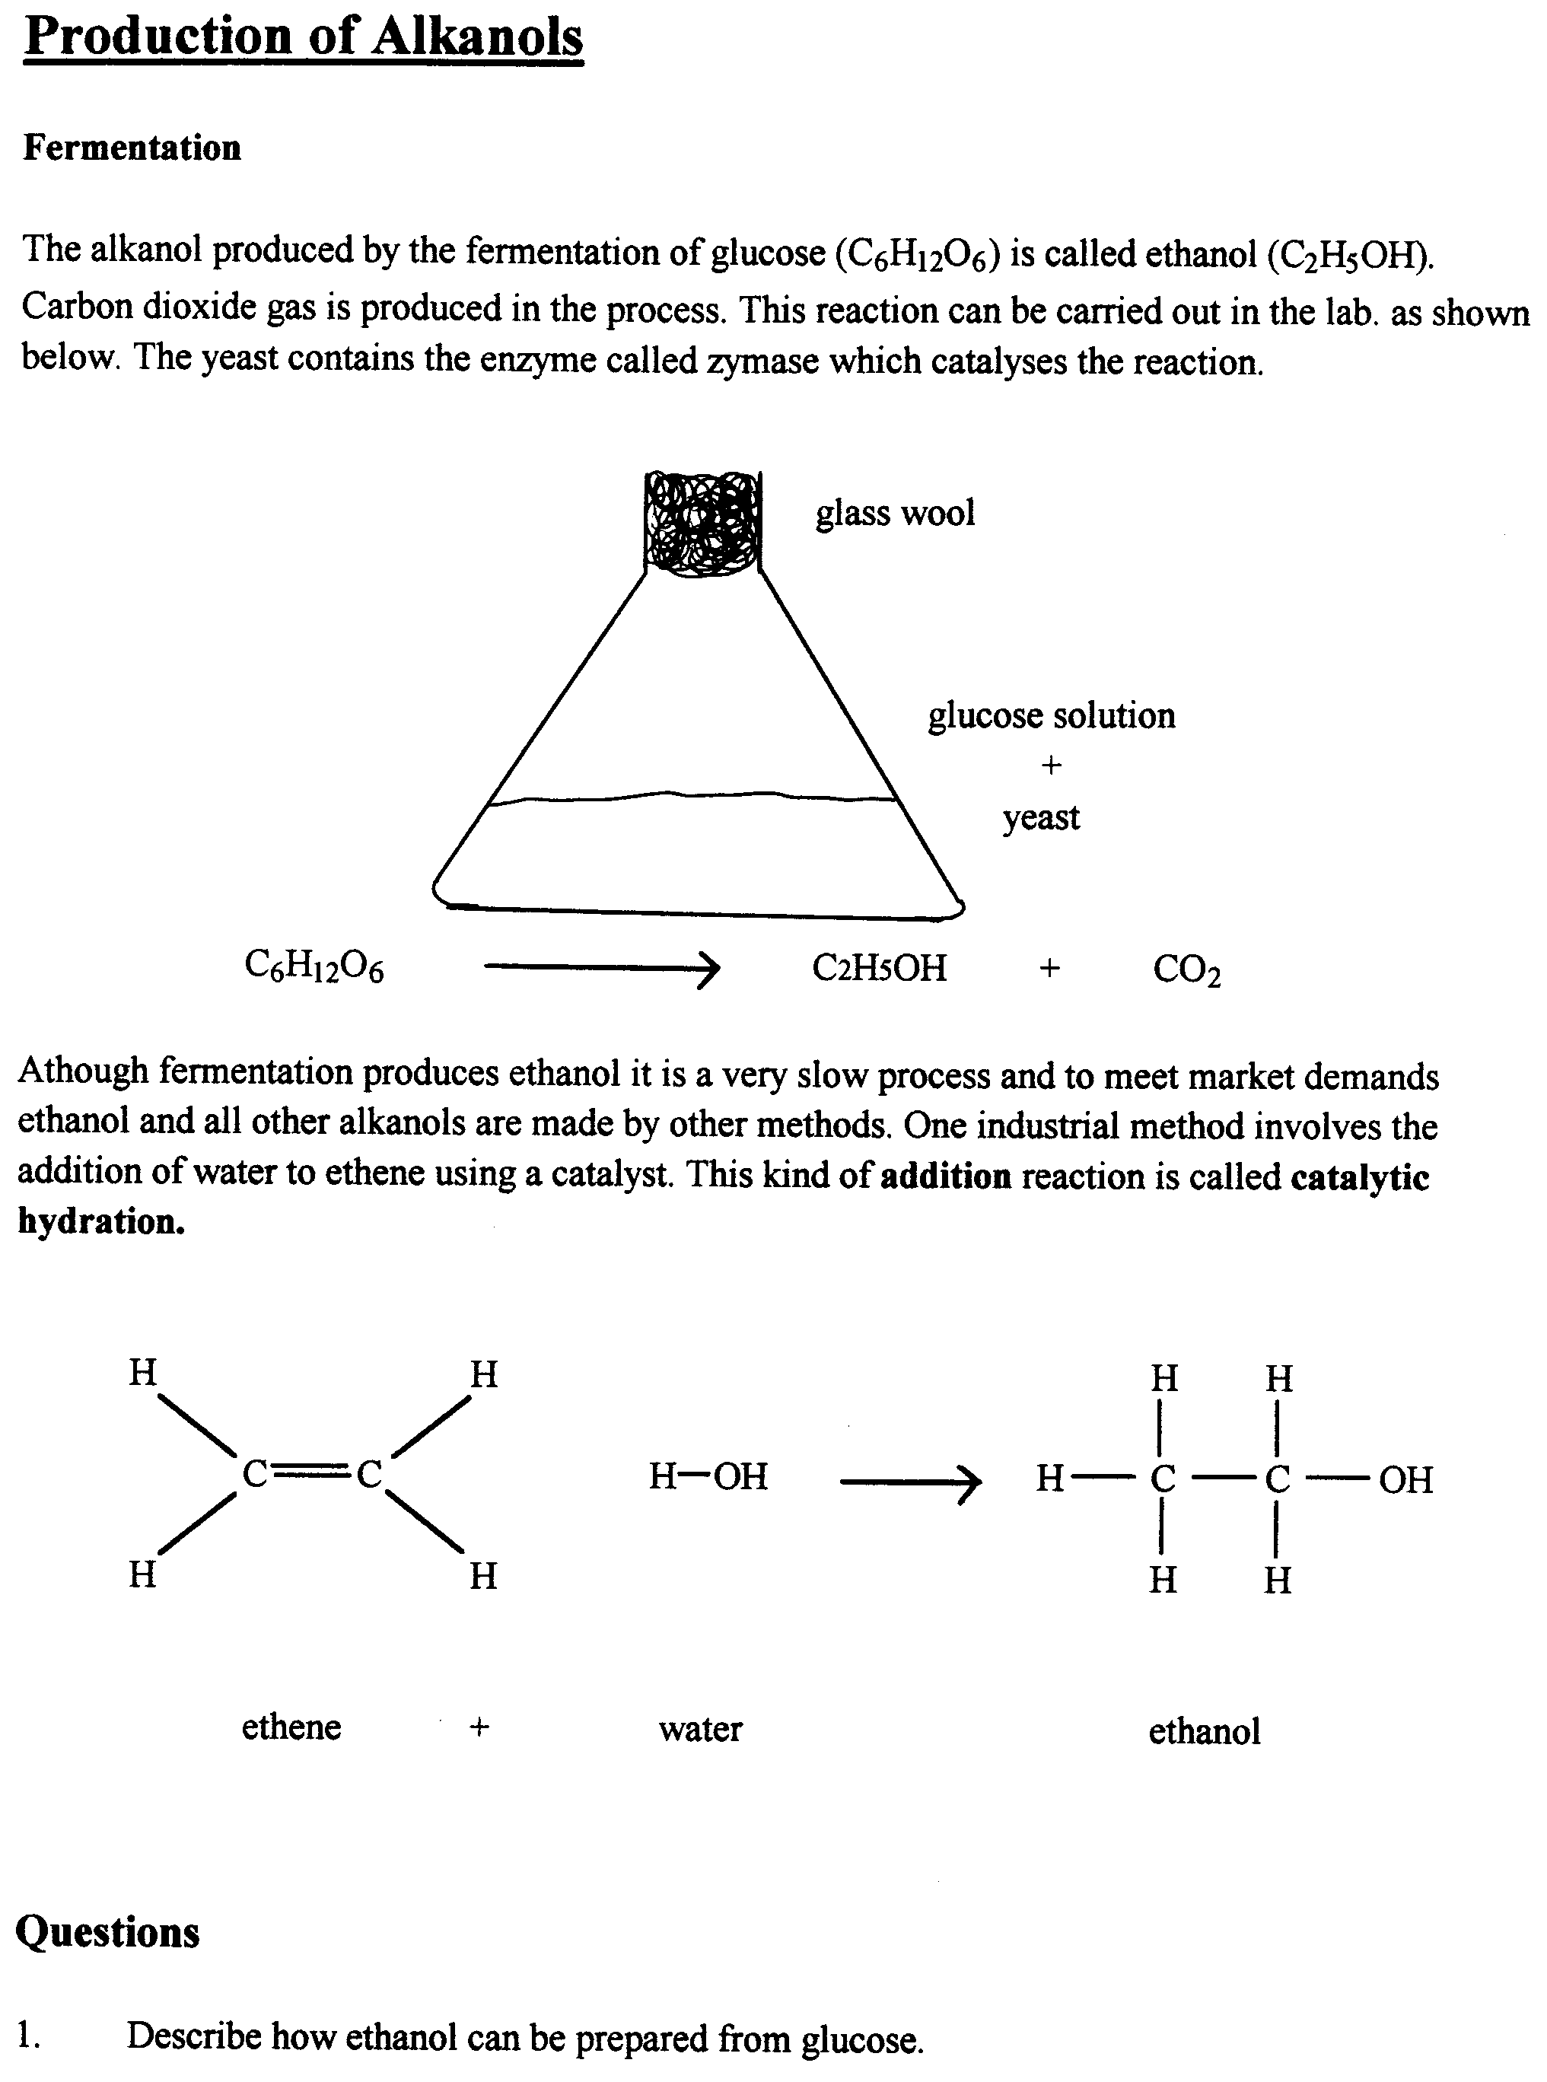

ethene + water ethanol

## Questions

1. Describe how ethanol can be prepared from glucose.

2. What is the purpose of the yeast?

3. Which gas is produced in the reaction?

4. Explain why ethanol and other alkanols are made by methods other than fermentation.

5. Name another industrial method of producing alkanols.

6. What name is given to this **type** of reaction?

7. Using full structural formulae, write an equation to show the addition of water to propene.

8. Name the alkanol produced in question 7.

9. Name another alkanol that could also be produced in this reaction.

**Reactions of alcohols**

All alcohols burn, so can be used as fuels. Alcohols burn in a plentiful supply of oxygen to produce carbon dioxide and water.

j0186164Ethanol + oxygen carbon dioxide + water

**Activity 2**

Your teacher will burn an alcohol, an alkane and an alkene.

1 What do you notice about the alcohol flame? _________________________________________________________________________________

_________________________________________________________________________________

2 Write a balanced equation for the burning of butanol.

**Uses of Alcohols**

Alcohols have a number of uses:

|  |  |
| --- | --- |
| **Alcohol** | **Use** |
| Methanol | An alternative fuel |
| Ethanol | Fuel (as a substitute or additive to petrol)  Alcoholic drinks  Solvent in felt pens  Antiseptic wipes |
| Propan-2-ol | Hand sanitizer gels  Solvent |
| Butanol | Solvent  Paint thinner |

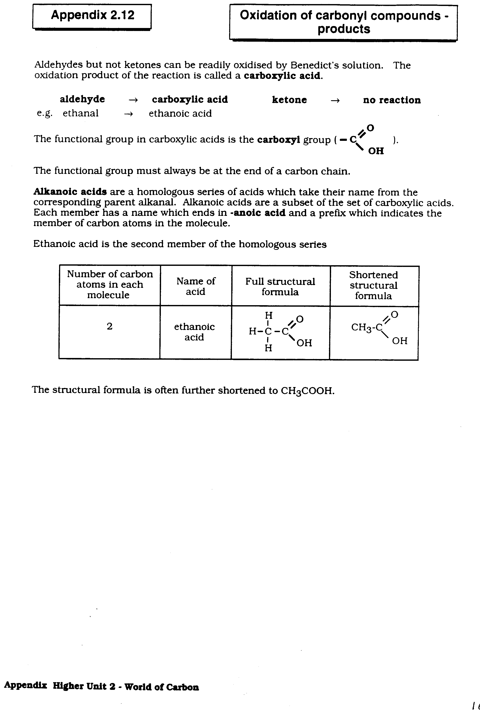**Carboxylic Acids (Alkanoic Acids)**

All carboxylic acids contain the carboxyl functional group **(-COOH** or **)**.

Carboxylic acids with only single bonds between carbon atoms are called **Alkanoic acids**.

Alkanoic acids are a homologous series based on the corresponding alkanes. Ethanoic acid (found in vinegar) is an example of an alkanoic acid.

Ethanoic acid is the second member of the series. Each member has a name which ends in **–anoic acid** and a prefix which indicates the number of carbon atoms in the molecule.



The structural formula is often further shortened to CH3COOH

Complete the table for the first four alkanoic acids in the series.

|  |  |  |  |
| --- | --- | --- | --- |
| Name | Full structural formula | Shortened structural formula | Molecular formula |
|  |  |  |  |
|  |  |  |  |
|  |  |  |  |
|  |  |  |  |

## Questions

1. Give the systematic name for each of the following alkanoic acids

a) CH**3**CH**2**CH**2**CH**2**CH**2**CH**2**CH**2**COOH b) CH**3**CH**2**CH**2**CH**2**COOH

2. Draw the full structural formula for the following alkanoic acids

a) hexanoic acid b) heptanoic acid

3. What is the general formula for the alkanoic acids?

**Uses of carboxylic acids**

Carboxylic acids have a variety of uses. Many are used as food preservatives e.g. ethanoic acid is vinegar, used in pickling; benzoic acid and propanoic acids are also used as preservatives for food. Vinegar is also used as a cleaning products designed to remove limescale. Stearic acid and palmitic acid are used in the manufacture of soap.

Citric acid is found as a natural ingredient in fruit, and methanoic acid is found in insect stings.

Carboxylic acids are also used, in reactions with alcohols, in the manufacture of Esters.

**Energy From Fuels**

**National 5 Learning Outcomes**

* Alkanes and alcohols can be used as fuels.
* Reactions which give out energy to the surroundings, such as combustion reactions, are known as exothermic reactions.
* The opposite of an exothermic reaction is an endothermic reaction. Endothermic reactions take in energy from the surroundings.
* When a substance is combusted (burned) the reaction can be represented using a balanced formula equation.
* The quantities of reactants and products in these reactions can be calculated.
* Different fuels provide different quantities of energy. This can be measured experimentally and calculated using Eh = cmΔT.
* In the equation Eh = cmΔT,

Eh = energy produced by the reaction (in kJ)

c = the specific heat capacity of water = 4.18 kJ kg**-1** **o**C**-1**

m = mass of water heated (in kg)

ΔT = temperature increase in the water (in **o**C)

**Energy From Fuels**

A **Fuel** is a substance that is burned to release energy (usually heat).

**Activity 1 –** Find out about some compounds that we use as fuels, and make up a poster or presentation on ‘Fuels’.

What two families of compounds that we have met in this Unit are commonly used as fuels?

**Activity 2 –** Your teacher will show you some fuels burning and may demonstrate the ‘alcohol gun’.

What is the chemical term for a ‘burning’ reaction?

The combustion (burning) of a fuel uses up the oxygen of the air. The fuel uses it up as it react to form new substances. For example, when alkanes and alcohols combust they use up oxygen forming carbon dioxide and water.

CH**4** + 2O**2** CO**2** + 2H**2**O

(methane)

C**2**H**5**OH + 3O**2** 2CO**2** + 3H**2**O

(ethanol)

Write balanced equations for:

a) Propane burning in oxygen

b) Hexanol burning in oxygen

**ALL COMPOUNDS CONTAINING CARBON AND HYDROGEN WILL COMBUST (BURN) TO PRODUCE CARBON DIOXIDE AND WATER.**

**Exothermic and Endothermic**

Reactions, like combustion, which release energy are known as **Exothermic.**

Reactions which need to take in energy from the surroundings are called **Endothermic.**

**Activity 3 – An Endothermic Reaction**

1. Collect a jar of sodium carbonate crystals, a jar of citric acid powder and a thermometer.

2. Add one spatulaful of each of the chemicals to a test tube and add a dropper full of water.

3. Stir the reaction mixture with the thermometer.

4. What do you notice about the reading on the thermometer?

**Calculations Based On Balanced Equations**

If you know the quantity of a fuel you are going to burn you should be able to work out how much oxygen will be used up, and how much of each product you will make.

Example: What mass of carbon dioxide is produced when 64g of methane is burned completely in oxygen?

CH**4** + 2O**2** CO**2** + 2H**2**O

1 mole 2 moles 1 mole 2 moles

12 + (1x4) g 12 + (16x2) g

= 16 g = 44 g

1 g 44/16 g

64 g 64 x 44/16 g

= 176 g

Now carry out the following calculations (in your jotters):

1. Calculate the mass of water produced if 11g of propane are completely burned in oxygen.

C**3**H**8** + 5O**2** 3CO**2** + 4H**2**O

2. Calculate the mass of ethanol which would require to be completely burned to produce 3.6g of water.

C**2**H**5**OH + 3O**2** 2CO**2** + 3H**2**O

3. Calculate the mass of carbon dioxide produced if 9.6g of methanol is burned completely in oxygen.

CH**3**OH + **½** O**2** CO**2** + 2H**2**O

4. Petrol is made up mostly of octane (C**8**H**18**). The equation for the complete combustion of octane is:

C**8**H**18** + 12**½** O**2** 8CO**2** + 9H**2**O

a) In travelling 1 km, a car uses up 40g of petrol. How many grams of carbon dioxide does it produce every kilometer?

b) Road Tax bands for 2013-14 are:

|  |  |
| --- | --- |
| Vehicle CO**2** Emissions (g/km) | Road Tax per year (£) |
| up to 100 | 0 |
| 101 – 110 | 20 |
| 111 – 120 | 30 |
| 121 – 130 | 105 |
| 131 – 140 | 140 |
| 141 – 150 | 175 |

How much will the owner of the car pay in road tax in 2013-14?

**How much energy is released when a fuel burns?**

The amount of energy released when a fuel burns can be calculated by using the heat energy produced to heat up a known mass of water.

We use the formula Eh = cmΔT, where

Eh = energy produced by the reaction (in kJ)

c = the specific heat capacity of water = 4.18 kJ kg**-1** **o**C**-1**

m = mass of water heated (in kg)

ΔT = temperature increase in the water (in **o**C)

**Example:** When 1g of ethanol is burned, the energy produced heated 100g of water by 12 **o**C. Calculate the amount of energy produced by the burning ethanol.

Eh = cmΔT

= 4.18 x 0.1 x 12

= 5.016 kJ

**Activity:** For each of the following results, calculate the heat energy released by the burning of the fuel. (Note that 1cm**3** of water weighs 1g)

1. The temperature of 50 cm**3** of water is increased by 15 **o**C.

2. The temperature of 250 cm**3** of water is increased by 12.8 **o**C.

3. The temperature of 500 cm**3** of water is increased by 8.6 **o**C.

**Energy from Fuels**

Different fuels provide different quantities of energy. The energy released from the burning of different fuels can be compared by calculating the energy released for the burning of one mole of each.

|  |  |  |
| --- | --- | --- |
| **Name of alcohol** | **Structural Formula** | **Energy released (kJmol-1)** |
| methanol | CH**3**OH | 727 |
| ethanol | CH**3**CH**2**OH | 1367 |
| propan-1-ol | CH**3**CH**2**CH**2**OH | 2020 |
| butan-1-ol | CH**3**CH**2**CH**2**CH**2**OH | 2676 |
| pentan-1-ol | CH**3**CH**2**CH**2**CH**2**CH**2**OH | 3329 |

There is a fairly constant difference between the energy released per mole for any two successive members of a homologous series. This is because as you go from one member of the homologous series to the next you are increasing the size of the molecule by - CH**2-** each time, so there are more carbons and hydrogens to burn.

Predict what the value would be for heptan-1-ol. ­­­­­­­­­­­­­­­_____________________kJmol**-1**

**Activity 4 – Combustion of an alcohol**

**Hazards**

Ethanol is highly flammable and the main risk is from burns.

**Care**

Wear eye protection.

Ensure the spirit burner is always sitting in a stable position.

**Procedure**

1. Weigh the spirit burner (already containing ethanol) with its cap on and record its mass. (The cap should be kept on to cut down the loss of ethanol through evaporation)

2. Using the measuring cylinder, measure out 100 cm**3** of water into a 250 cm**3** beaker.

3. Set up the apparatus as directed by your teacher/lecturer.

4. Measure and record the temperature of the water.

5. Remove the cap from the spirit burner and immediately light the burner.

6. Slowly and continuously stir the water with the thermometer. When the temperature has risen by about 10 °C, recap the spirit burner and measure and record the maximum temperature of the water.

7. Reweigh the spirit burner and record its mass.

Now calculate how much energy was given to the water, in kJ) using Eh = cmΔT (remember that 100 cm**3** of water weighs 0.1 kg).

What was the change in mass of your burner during the experiment? __________________g

Try to work out how much energy would have been produced if you had burned one mole of ethanol.

Look back to the table on page 6 at the real value for heat released when you burn one mole of ethanol. Why is your answer much, much lower? Where did all the energy go?