

**Administration & IT**

Assignment Tasks

Ediary



**ELYSIUM SPA AND HEALTH CLUB**

Elysium Spa and Health Club has recently opened in Troon. Facilities will include a gym, spa, swimming pool, studios and personal trainers, with timetabled classes available to all members. A Launch Evening will take place on the third Thursday of next month from 6-9 pm.

You have just started your new job as an Admin Assistant reporting to Ms Audrey Lauder, the General Manager of Elysium Spa and Health Club.

**Task 1**

Audrey has a few appointments in different locations on the day of the Launch Evening. Enter the following appointments in her e-diary for that day, **including the locations**. Print the diary in daily view.

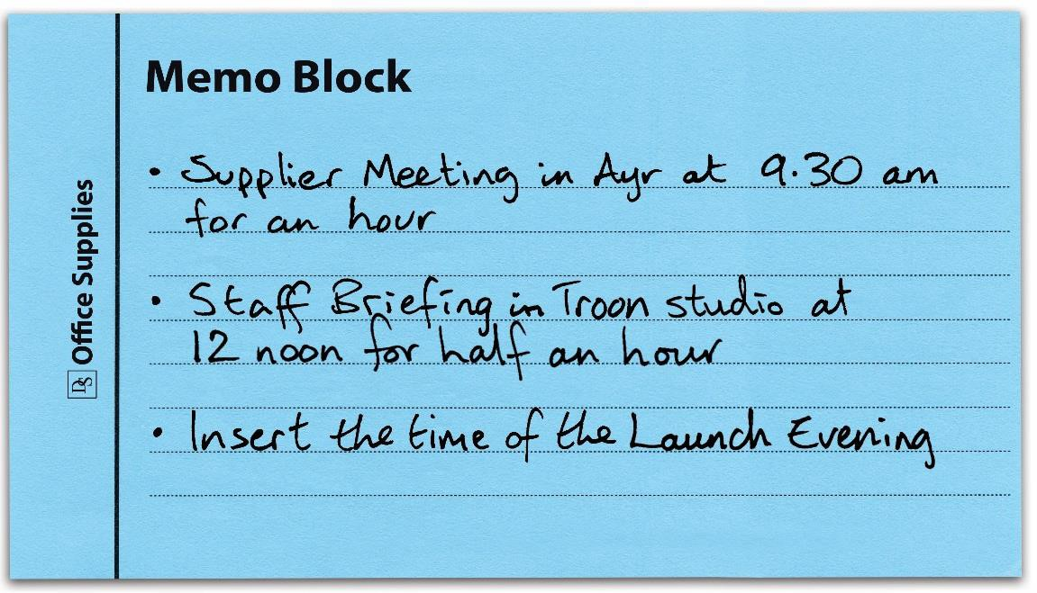

**Task 2**

Update Audrey’s e-diary for the day of the Launch Evening. Set a 30-minute reminder for the appointment below which is taking place at Scott’s Bar and Restaurant, Troon. Print evidence of the reminder showing the time and **location** of the lunch.

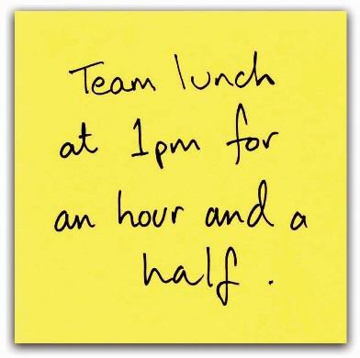

**SCOTLAND CARES**

You work as an Admin Assistant at Scotland Cares, a charity raising funds for the young people of Scotland. You work with Mr George Sullivan, the Head Office Manager. He has asked you to complete the following task.

Enter the following meetings and task in next week’s electronic diary. Print a copy of the diary in weekly view and details of the task.

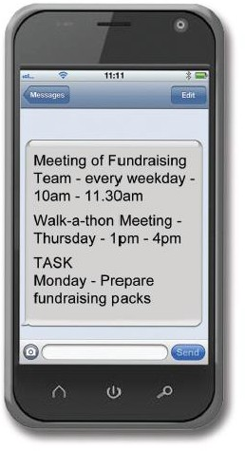

**SOUNDS ON THE SHORE**

Your company, Sounds on the Shore**,** is organising a music festival which is taking place on the South Beach, Aberdeen, for the first time on the last Friday and Saturday of July.

You work as an Admin Assistant with Mitch Goodwin, the Festival Organiser, and he has asked you to organise and support this event.

Enter the following information in the e-diary for the first week of next month.

Print a copy in weekly view.

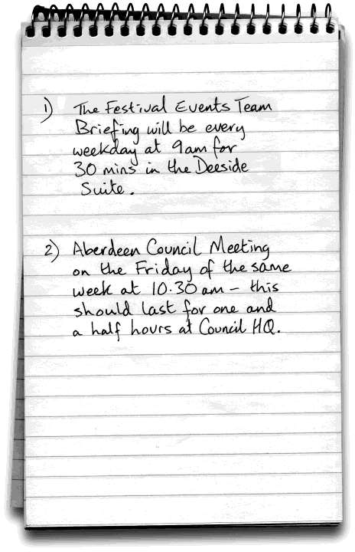

**SCHOOL TRIP TO PARIS, FRANCE**

You work as an Admin Assistant at Park View High School. Ms Susan MacFarlane, the teacher in charge of organising this year’s school trip to Paris, France during the mid-term October break, has asked you to complete the following task.

Transfer the following meetings to next week’s electronic diary.

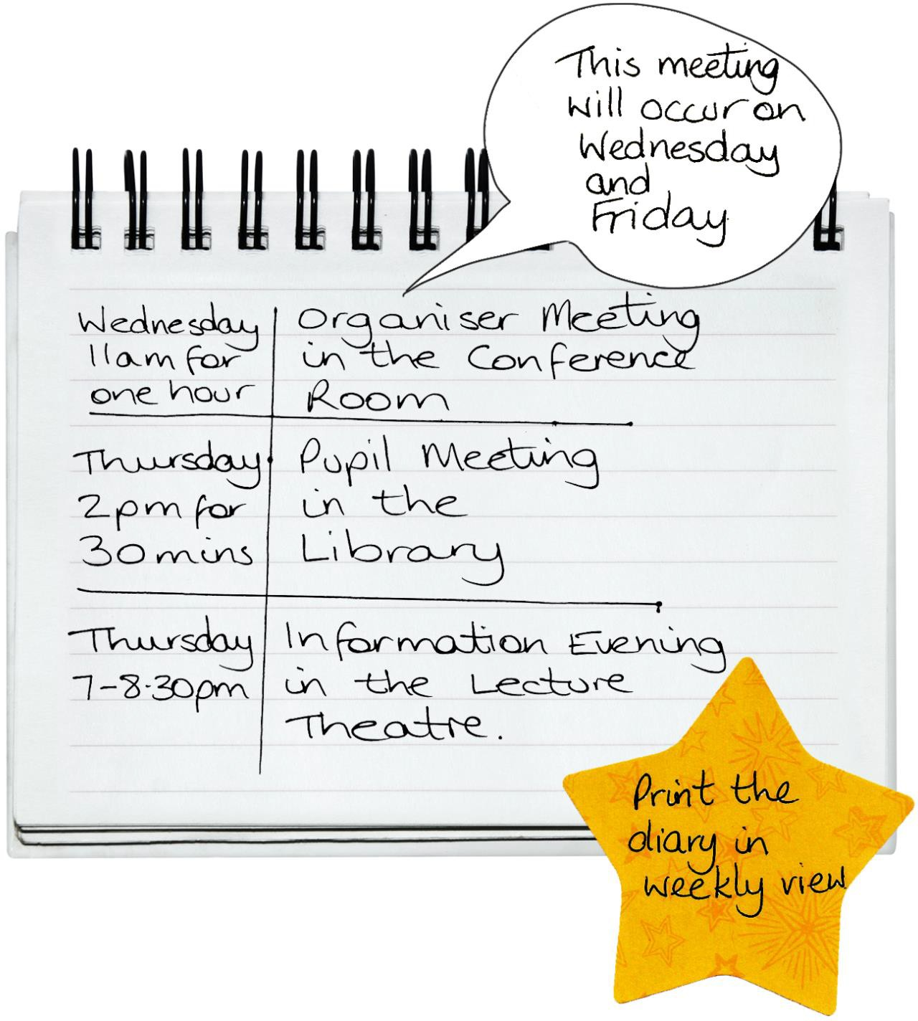

**MORVEN’S CAKE PLACE**

Morven Adams is the owner of Morven’s Cake Place, a small cake and coffee shop based in Glasgow. She is keen to expand her business into catering for various functions and is taking a stand to promote her business at the Good Food Exhibition taking place at the SECC next month.

You work as an Admin Assistant with Morven and she has asked you to complete the following task:

Enter the following meetings in the electronic diary. Print a copy of the diary in weekly view.

