Wave Characteristics

Longitudinal and transverse waves
Waves transfer energy from one place to another. There are two types of wave.

Transverse wave. Examples of a transverse wave are water waves and light. The particles of the medium carrying the wave move at right angles to the direction of energy travel.

The particles of the medium transmitting the wave travel at right angles to the direction of energy travel.
direction of energy travel

Longitudinal wave. An example of a longitudinal wave is sound. The particles of the medium carrying the wave move parallel to the direction of energy travel.
direction of energy travel

The particles of the medium transmitting the wave travel to and fro in the same direction as the direction of energy travel.

Wave definitions
period - time taken for one wave to pass a point.
frequency - number of waves each second.
amplitude - distance from the mid line to a wave crest or wave trough.
wavelength - distance from one crest to the next or one trough to the next.
wave speed - distance the wave travels each second.
amplitude
amplitude
1 wavelength
zero line
1 wavelength
1 wavelength

Calculating wave speed using frequency and wavelength
The speed of a wave can be calculated if you know its wavelength and frequency.

Use the equation wave speed = frequency × wavelength

v = f λ

where v = speed of wave measured in metres per second
λ = wavelength measured in metres
f = frequency measured in hertz

Calculating wave speed using distance and time
The speed of a wave can also be calculated from the distance it travels in a given time.

Use the equation 

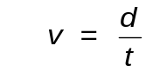

where v = speed of wave measured in metres per second
d = distance wave travels in metres
t = time taken for wave to travel given distance

Sound

Sound waves
Sound waves can be analysed by connecting a microphone or signal input into an oscilloscope like the one shown opposite. Changes in the frequency (pitch) and amplitude (loudness) can be examined.

This is what a trace of music or speech looks like. Controls on the oscilloscope can be altered to spread out the trace or make it taller.

Trace 1
Trace 3
Trace 2
Trace 4
Trace 5
Information about a sound wave can be found by examing the oscilloscope trace.

original wave

higher frequency (higher pitch)
lower frequency
(lower pitch)

Changing the frequency or pitch of the signal means that more or less waves will be displayed on the oscilloscope screen.

higher amplitude (louder)
lower amplitude (quieter)

Changing the amplitude or loudness of the signal changes the vertical height of the trace on the oscilloscope screen.


Measuring the Speed of Sound
If you watch fireworks, you see the flash of light from an exploding firework before you hear the bang. Sound travels much more slowly (340 metres per second) than light (300 000 000 metres per second).
This fact can be used to measure the speed of sound.

Method 1
Two people stand a known distance apart. One has a starting pistol and the other a stopwatch. When the starting pistol is fired the person with the stopwatch sees a puff of smoke (light travels very quickly) and starts the stopwatch. When they hear the bang (sound travels slowly) they stop the stopwatch.

The speed of sound can be calculated using the formula:

Method 2
A similar method can be used by standing a known distance, say 200 to 300 metres, from a large building and firing the starting pistol. The sound wave travels to the building and back as an echo. A second person can time how long after the starting pistol is fired before the echo is heard. The speed is calculated as in method one but remember the distance the sound travels is double the distance between the starting pistol and the building.

large building
starting pistol fired to create a loud sound

Method 3
The speed of sound can be measured using an electronic timer. A hammer hits a metal plate which creates a sharp pulse of sound. As this passes the first microphone the timers starts and stops when the sound wave passes the second microphone.

microphone 1
microphone 2
electronic timer
hammer
distance

metal plate

Again, use the formula: to calculate the speed of sound.
Method 3 is the most accurate due to reaction times in starting and stopping stopwatches in methods 1 and 2.
Ultrasound and sonar

Ultrasound waves are waves which have the same speed as normal sound waves but they have a higher frequency. Humans can hear sound with a frequency ranging from 20 hertz to 20 000 hertz. Ultrasound has a frequency higher than 20 000 hertz and cannot be heard by humans.

Animals such as dogs can hear these higher frequencies though.

Ultrasound has many uses, especially in medicine. These include

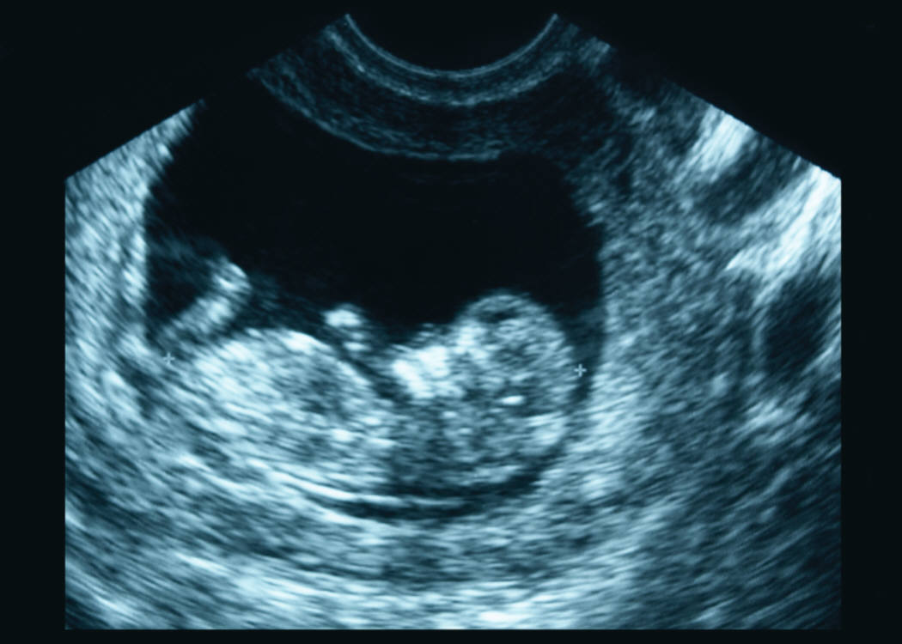
- cleaning delicate instruments;
An example of an ultrasound scan of a baby in its mother’s womb.
- scanning unborn children in their mother’s womb;
- detecting cracks or flaws in metal;
- detecting tumours;
- measuring blood flow through the heart;
- detecting kidney stones.

Ultrasound can also be used in sonar devices for detecting the depth of water. The boat sends out a series of ultrasound pulses and these are reflected back from the sea bed. The depth of water can be calculated from the time between the pulse being sent out and the echo returning.

Sound production
All musical instruments produce sound by causing vibrations to pass through the air. The instrument might have a vibrating string, membrane, reed (a thin splinter of wood) or air.
A cello has vibrating strings.
A trumpet produces sound due to the vibrating lips of the trumpet player.
When a key on a piano is pressed a hammer hits a string which vibrates.
(The stretched skin on a kettle drum vibrates when hit.

coil of wire
permanent magnet
flexible cone of paper or plastic attached to coil of wire
electrical connections to coil of wire

The sound produced by a loudspeaker or headphones is produced by making a paper cone or metal membrane vibrate. In a loudspeaker, a small current passes through a coil of wire which becomes an electromagnet. This interacts with a permanent magnet to produce movement of the cone which matches the fluctuations in the current.

Sound levels and Noise Pollution
The loudness of a sound is measured in decibels. Some common sound levels are given below.
Activity Sound level
Normal talking 60 dB
pneumatic drill 90 dB
jet engine 140 dB
Prolonged exposure to loud sound or even a short exposure to very loud sounds, can damage your hearing. People who work in noisy environments wear ear defenders which block out the sound or at least reduce the sound level received by the ear.

Electromagnetic Spectrum

The electromagnetic spectrum
The electromagnetic spectrum consists of a family of waves, one of which is light. They all travel with the speed of light. Their properties vary however, depending upon the frequency and wavelength of the waves. All the waves are transverse and are able to travel through a vacuum.
microwaves
infrared
visible light
Radio and TV waves
ultraviolet
X-rays
gamma radiation
low frequency
long wavelength
high frequency
short wavelength

Radio and TV waves
Radio and TV waves are all around us. These have the longest wavelength of any wave in the electromagnetic spectrum. They are detected by a receiver tuned to the particular frequency of the wave – whether it is a TV signal or a radio signal. The waves carry information which can be decoded by the receiver to produce sound or visual images.

Microwaves
Microwaves have a shorter wavelength than radio and TV waves. They are often used in telecommunication and in mobile telephones. In high doses they could present some danger, for example excessive use of a mobile phone close to the head. Microwaves can also be used in microwave ovens where they cause water molecules in food to vibrate and generate heat.

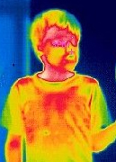
Infrared Radiation
Any object which is hotter than its surroundings will emit infra red radiation. It can be detected with special cameras or infrared film. Infrared can be used to treat muscle injuries and thermal images can be used to help diagnose disease.

Infra red photography can also help identify where houses are losing heat or where overhead electric cables are overheating due to a fault.

Visible Light
Visible light is the electromagnetic radiation we are most familiar with. It is detected by our eyes and the colour we see depends upon the wavelength or frequency of the light.

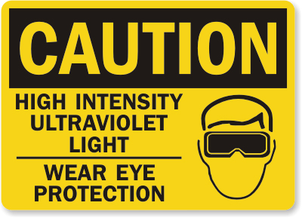
Ultraviolet light
Ultraviolet light comes from the Sun or can be produced by special lamps. It causes our skin to tan but it can also be dangerous and cause severe skin damage including skin cancer.

Ultraviolet light causes certain materials to fluoresce or glow. It can be used to show up security marking or special dyes used to print genuine bank notes.

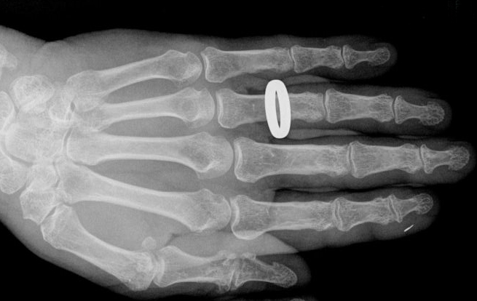
X-rays
X-rays have the ability to pass through the human body. They can be detected by photographic film. These properties are made use of in hospitals when X-ray pictures are taken of patients. Dense tissue like bone blocks the X-rays most and these show up as pale on the images whilst soft tissue appears darker. A metal object will appear white as it completely blocks the X-rays.

Gamma Radiation
Gamma radiation is potentially the most dangerous of the electromagnetic radiations but even it can be put to use in medicine. A gamma emitting liquid is injected into the patient.
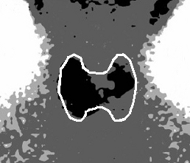
The radioactive liquid can be used to show up blood flow or tumours or particular organs such as the thyroid gland.

The picture opposite shows the thyroid gland of a patient taken with a gamma camera.

Gamma radiation can also be used to destroy tumours inside a patient’s body. A beam of radiation is directed at the tumour from several different directions. The tumour receives a full dose but surrounding healthy tissue a lesser dose.

Long and Short Sight
Two of the problems that can affect people’s eyesight is long and short sight.

People who have long sight are able to see objects in the distance clearly but close objects are blurred.
People who have short sight are able to see close objects clearly but objects in the distance are blurred.

Lenses can be used to correct eyesight problems. These can be one of two types. Convex lenses, also known as converging lenses, bring parallel rays to a focus. Concave or diverging lenses spread parallel rays outwards.
Convex lenses bring parallel rays of light to a focus
Concave lenses cause parallel rays of light to spread out

Correcting long sight
When rays of light from a nearby object enter the eye of someone with long sight the rays come to a focus behind the retina. To make them focus more quickly, a convex or converging lens is placed in front of the eye.

Correcting short sight
When rays of light from a distant object enter the eye of someone with short sight the rays come to a focus too quickly, in front of the retina. To make them focus less quickly, a concave or diverging lens is placed in front of the eye.

Nuclear Radiation

Types of radiation
All nuclear radiation comes from the atom. An atom consists of protons (positively charged) and neutrons (no charge) surrounded by orbiting electrons (negatively charged).
neutron
+
+
+
+
+
proton
electron

There are three types of nuclear radiation; alpha and beta which are particles and gamma radiation which is a wave and part of the electromagnetic spectrum.

The properties of the three types of ionising radiation are given in the table below.

Type of radiation | alpha | beta | gamma
Symbol | α | β | γ
Consists of | 2 protons and 2 neutrons | a fast moving electron | a wave, part of the electromagnetic spectrum
Blocked by | thin sheet of paper or a few cm of air | about 3 mm of aluminium | about 3 cm of lead
Ability to ionise | strong | weak | weak

Ionisation occurs when radiation causes an atom to become charged.

The more a radiation is able to ionise the more likely it is to cause damage to living cells. Alpha is the most dangerous in this respect but it is also the least able to enter the body unless swallowed or breathed in.

Sources of radiation
Radiation can be produced by either man made sources or from naturally occurring sources.

Man made sources include building materials, radioactive material used in medicine and radioactive materials used in smoke detectors or luminous watches.

Natural sources of radiation include cosmic radiation from outer space, rocks and minerals such as granite, radon gas from underground and even the food we eat.

Applications of radiation
Medical uses
- used to treat tumours by killing the cancer cells present in the tumour.
- radioactive liquid can be injected into a patient and its path around the body traced using special instruments.
- radiation can be concentrated in certain organs in the body and this helps a doctor to diagnose or treat disease.
- can sterilise medical instruments by destroying any organisms on them.

Industrial uses
- used in smoke detectors.
- can be used in control processes in manufacturing e.g. to measure the thickness of a material by the amount of radiation absorbed.
- tracing leaks and cracks in pipes.

Nuclear Power Stations
Nuclear reactors use uranium as a source of energy. The uranium is stored in fuel rods inside the reactor and a process called nuclear fission takes place where atoms split and release heat energy.
NUCLEAR REACTOR
produces heat
BOILER
produces steam
STEAM turns turbine
GENERATOR produces electricity

The heat energy released from the nuclear reactions is used to turn water into high pressure steam. The steam drives a turbine which then rotates the generator to produce electricity.

Advantages of Nuclear Power
- A small amount of radioactive material can produce a lot of energy.
- Nuclear reactors do not produce carbon dioxide, sulphur dioxide or other pollutants.
- Nuclear reactors can supply large amounts of energy, replacing power stations powered by fossil fuels.
- The fuel for nuclear reactors will last for some time.

Disadvantages of Nuclear Power
- Waste from nuclear reactors must be stored underground for a long time until the radiation emitted decreases.
- Nuclear reactors are expensive to build and the time from deciding to build one and it being operational can be many years.
- Leaks of radioactive materials can have a major impact on the surrounding environment.

Wave Characteristics

Longitudinal and transverse waves
1. Look at the two diagrams below. State which represents a longitudinal wave and which a transverse wave.

Wave A

Wave B

2. Describe how you could use a ‘Slinky’ spring to demonstrate:
(a) a transverse wave
(b) a longitudinal wave.

3. State which of the waves below are longitudinal waves and which are transverse waves:
water waves light sound

Wave speed, frequency, wavelength and amplitude
4. Copy the following terms down then match them against their correct definitions.

Term | Definition
(a) period - | distance from the mid line to a wave crest or wave trough.
(b) frequency - | distance from a crest to next crest or trough to next trough.
(c) amplitude - | time taken for one wave to pass a point.
(d) wavelength - | number of waves each second.

5. Ripples are produced on a ripple tank like the one shown opposite.

Calculate the frequency when:

(a) 10 waves pass a point in 2 seconds;

(b) 18 waves pass a point in 6 seconds;

(c) 4 waves pass a point in 4 seconds;

(d) 100 waves pass a point in 20 seconds;

(e) 5 waves pass a point in 10 seconds.

6. Look at the pictures of the waves below. From the information provided, find the frequency of the waves.
time
0·5 seconds
time
4 seconds
time
2 seconds
time
2 seconds
(a)
(b)
(c)
(d)

7. Use the information provided on the diagrams below to find the amplitude of each wave.
0·1 metres
1 metre
20 centimetres metre
2 metres
(c)
(b)
(a)
(d)

8. A loudspeaker vibrates at a frequency of 256 hertz to produce the note we call “middle C”

(a) How many waves does it produce in one second?

(b) How many waves does it produce in one minute?

9. Longitudinal waves are sent along a slinky spring. Four waves pass a point in
2 seconds. What is the frequency of the waves.
10. An alarm on a phone produces a tone with a frequency of 500 hertz. How many waves will be produced in:

(a) 1 second;

(b) 5 seconds;

(c) 0·1 seconds.

Calculating wave speed using frequency and wavelength
11. State an equation that links wave speed, frequency and wavelength.

12. Calculate the missing values in the table below.

Wave speed | Frequency | Wavelength
(a) | 10 hertz | 2 metres
(b) | 0·5 hertz | 10 m
4 metres per second | 2 hertz | (c)
50 metres per second | 10 hertz | (d)
340 metres per second | (e) | 5 metres
2 metres per second | (f) | 10 metres

13. A frequency meter is used in a laboratory to measure frequency. When used to find the highest frequency a student can hear it displays 17 000 hertz. Calculate the wavelength of the sound wave if sound travels at 340 metres per second.

14. A note played on a piano has a wavelength of 0·25 metres. Calculate its frequency if sound waves travel at 340 metres per second.

15. Water waves travelling along a canal have a wavelength of 2·0 metres and a frequency of 0·5 hertz. Calculate their speed.

16. A speedboat produces waves with a frequency of 2·0 hertz and a wavelength of
3·0 metres. Calculate the speed of the waves.

Calculating wave speed using distance and time
17. State an equation that links wave speed, distance and time.
18. Calculate the missing values in the table below.

Speed | Distance | Time
(a) | 40 metres | 5 seconds
(b) | 4 metres | 0·2 seconds
340 metres per second | 1700 metres | (c)
5 metres per second | 2 kilometres | (d)
340 metres per second | (e) | 8 seconds
2 metres per second | (f) | 10 seconds

19. A wave travels along a beach at 1·5 metres per second. Calculate the time it will take to travel 30 metres.

20. Very high waves produced in the ocean due to earthquakes are called tsunamis. A tsunami travelled from Sumatra to Somalia, a distance of 6000 kilometres, in 7 hours. Calculate the speed of this wave in metres per second.

21. How long would it take a sound wave to travel from one end of a football pitch to the other if it is 105 metres long. (Speed of sound in air is 340 metres per second).

22. A surfer rides along the crest of a wave for a distance of 48 metres in 12 seconds. Calculate their speed.

Extension Questions

23. A ripple tank produces water waves through the up and down movement of a wooden bar. The bar moves up and down a total of 20 times in 4 seconds. The distance between each water wave produced is 0·04 metres.

(a) Calculate the frequency of the waves.

(b) State the wavelength of the waves.

(c) Calculate the wave speed of the waves.

(d) The ripple tank is 0·8 metres long. Calculate the time it takes a water wave to travel from one end to the other.

24. Read the passage below about wave motion then answer the questions which follow.
Waves can be categorised into one of two groups – transverse waves and longitudinal waves.
Examples of transverse waves are waves found on the sea or when a stone is dropped into a pond. Transverse waves can be demonstrated by vibrating a rope back and fore. Although the wave travels along the rope the particles of the rope move at right angles to the direction of wave travel. The vibrations of a transverse wave are at right angles to the direction in which the wave transfers energy.
direction of wave travel
rope
direction of rope
movement

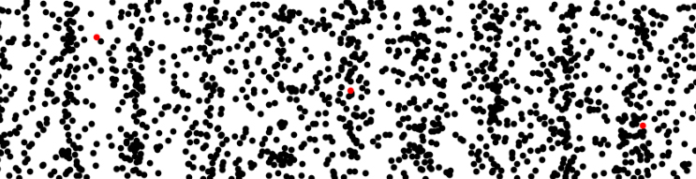
Sound waves are an example of longitudinal waves. When the sound wave travels through the air the air particles vibrate back and fore in the same direction as the direction of travel of the wave. The vibrations of a longitudinal wave are parallel to the direction in which the waves are travelling.
direction of particle movement
direction of wave travel
air particles

(a) What type of waves are:
(i) sound waves;
(ii) water waves?

(b) A knot is tied in a length of rope and a series of waves sent along it.
(i) Describe the direction of energy transfer.
(ii) Describe the movement of the knot.
25. Some pupils watch the passing of a wave along a pier.

waves
pier pile
12 metres

(a) The distance from a wave trough to a wave crest is 0·5 metres. What is the amplitude of the wave?

(b) The distance between two piers is 12 metres. What is the wavelength of the wave?

(c) The waves have a frequency of 0·2 hertz. Calculate the speed of the waves.

Sound

Sound waves
26. An oscilloscope like the one shown opposite can be used to look at sound signals

Oscilloscope traces for a number of different sounds are shown below. The oscilloscope settings are the same for every sound.

Which trace or traces display:

(a) sounds with the same wavelength;

(b) sounds with the same amplitude;

(c) sounds with the lowest frequency;

(d) human speech.

Trace 1
Trace 3
Trace 2
Trace 4
Trace 5

27. Two oscilloscope traces are shown below. The oscilloscope settings are not changed but the sounds are. What changes have been made to the sound between Trace A and Trace B?
Trace A
Trace B

Speed of sound
28. There are lots of different ways in which the speed of sound can be measured. One way is for two people to stand in a large field several hundred metres apart. One fires a starting pistol and when the other person sees the puff of smoke from the pistol they start a stopwatch. When they hear the bang from the pistol they stop the stopwatch.

(a) Why is the second person able to see the puff of smoke immediately the pistol is fired but not hear the bang?

(b) What information is required to calculate the speed of the sound from the pistol?

(c) This experiment is not very accurate. Describe one thing which might cause this inaccuracy.

(d) The two people are 500 metres apart. Calculate the sped of sound if there is 1·5 seconds between the smoke from the pistol being seen and the bang being heard.

29. Calculate the missing values in the table below.

Speed | Distance | Time
340 metres per second | (a) | 6 seconds
340 metres per second | (b) | 0·5 seconds
340 metres per second | 2720 metres | (c)
340 metres per second | 1190 metres | (d)

30. The speed of sound can be measured using an electronic timer. A hammer hits a metal plate which creates a sharp pulse of sound. As this passes the first microphone the timers starts and stops when the sound wave passes the second microphone.
metal plate
microphone 1
microphone 2
electronic timer
hammer

The following results are obtained from the experiment.

distance between microphones 2·00 metres

time recorded on electronic timer 0·006 seconds

Use this information to calculate the speed of sound.

31. An alarm clock is placed in a bell jar attached to a vacuum pump. The alarm clock is set so that it is ringing.
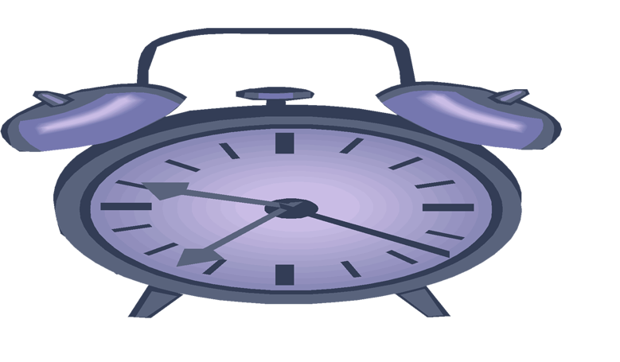
vacuum pump
bell jar
alarm clock

(a) Describe what would be heard:
(i) before the air is pumped of the bell jar;
(ii) after the air is pumped out of the bell jar.

(b) Explain why there is a difference between the answers to the questions above.
Ultrasound and sonar
32. What are the lowest and highest frequencies which humans are able to hear?

33. What name is given to sounds which are above the range of human hearing?

34. Ultrasound waves travel through tissue at 1540 metres per second. They have a frequency of 2 000 000 hertz. Calculate the wavelength of the waves.

35. Ultrasound has many uses as well as for scanning unborn babies.
Some of these are given below:
An example of an ultrasound scan of a baby in its mother’s womb.
- cleaning delicate instruments;
- detecting cracks or flaws in metal;
- sonar in ships to detect the seabed or shoals of fish;
- detecting tumours;
- measuring blood flow through the heart;
- detecting kidney stones.

Choose one of the above, or another of your own choosing and describe how ultrasound is used in this application.

36. A fishing boat uses ultrasound in its sonar system.
20 m
(a) Sound travels at 1600 metres per second in water. Calculate the frequency of the sonar waves if they have a wavelength of 0·04 metres.

(b) The sea bed is 20 metres below the boat. How long will it take the pulse from the boat to reach the seabed and travel back to the boat.
Sound production
37. Sound is produced in a musical instrument by producing vibrations. Look at each of the instruments below and state what it is that is vibrating to create the sound.
(a) cello
(d) trumpet
(b) piano
(c) kettle drum

38. The sound from a tuning fork is fed into an oscilloscope to produce the trace shown below.
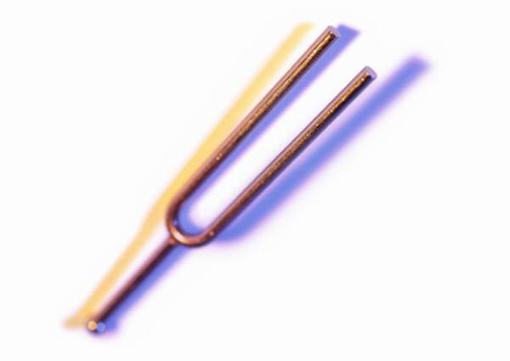

Sketch the oscilloscope trace that would be seen if:

(a) the same tuning fork was used producing a louder note;

(b) a longer tuning fork was used producing a lower pitched note.
coil of wire
permanent magnet
flexible cone of paper or plastic attached to coil of wire
electrical connections to coil of wire
39. A cross-section through a loudspeaker from a sound system is shown opposite. Describe how it produces sound.

40. State the effect on the note produced by a plucked guitar string if:

(a) the string is shortened;

(b) the string is made tighter?
Noise pollution
41. Name the unit in which sound level is measured.

42. (a) Some examples of noise producing activities are listed below. Copy the table then match them against the appropriate sound level.

Activity | Sound level
(a) passing motorbike | 140 dB
(b) vacuum cleaner | 50 dB
(c) pneumatic drill | 70 dB
(d) rain | 100 dB
(e) jet engine | 90 dB

(b) What sound level is regarded as being dangerous to our hearing and can cause permanent damage.

(c) State two ways in which hearing can be protected from loud sounds.

43. An employee working with noisy machinery has been told by his employers to wear ear defenders. Explain what ear defenders are and why he should wear them.

Extension Questions
44. Compare the two oscilloscope traces below. The oscilloscope settings remain the same. Describe in terms of wavelength, amplitude and frequency, the differences between the two traces.
Trace B
Trace A

45. The speed of sound can be measured in a school laboratory using an electronic timer and a sound operated flashgun. The apparatus is set up as shown below.

flashgun and loudspeaker unit
3·4 metres
microphone and light detector
electronic timer
0·01 s

The loudspeaker produces a sharp note which triggers the flash. This starts the timer. When the sound reaches the microphone the timer stops.

(a) Compare the speed of sound and the speed of light in air.

(b) The light and sound detectors are placed 3·4 metres away from the loudspeaker and flashgun. The time recorded on the timer is 0·01 seconds. Use this information to calculate the speed of sound.

46. Very high frequency sound waves can be used to make medical examinations of organs inside a patient’s body. They are also used to scan unborn babies in their mother’s womb.

(a) What are these high frequency sounds called?

(b) The diameter of the baby’s head can be measured and compared against a graph of the expected diameter of babies at different stages. This baby’s head measures 6 centimetres and the baby is 20 weeks old.
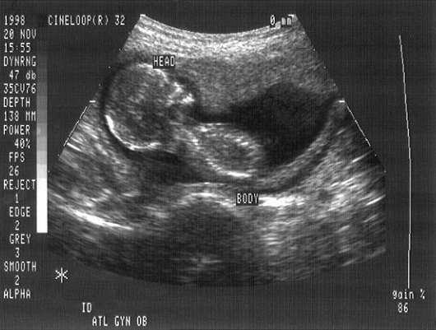
6 centimetres

Use the graph below to find if the baby is within the expected range.

diameter of babies head in centimetres
14
26
24
22
20
18
16
age in weeks
12
10
8
6
4
2
upper limit
lower limit
average diameter

47. An experiment is set up to measure how well sound travels through different mediums ie. a gas, a liquid and a solid.
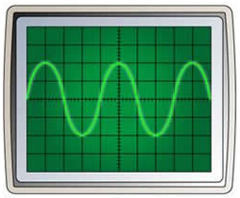
oscilloscope
signal generator connected to microphone
microphone
tank

A tank can be filled with either a solid, liquid or gas. A microphone attached to a signal generator produces a sound which travels through the medium to a microphone at the other end. The microphone is connected to an oscilloscope.

The oscilloscope screens below show the sound picked up by the microphone for each sound.
Liquid
Solid
Gas

(a) Why is it important that the same frequency and amplitude of sound is used for each test?

(b) The distance between the speaker and microphone is the same in each test. Why is this important?

(c) Which of the three mediums is best at transmitting sound? Give a reason for your answer.

(d) A vacuum is now created in the tank. Describe what would be seen on the oscilloscope now, giving reasons for your answer.
48. Read the passage below about noise cancellation then answer the questions which follow.
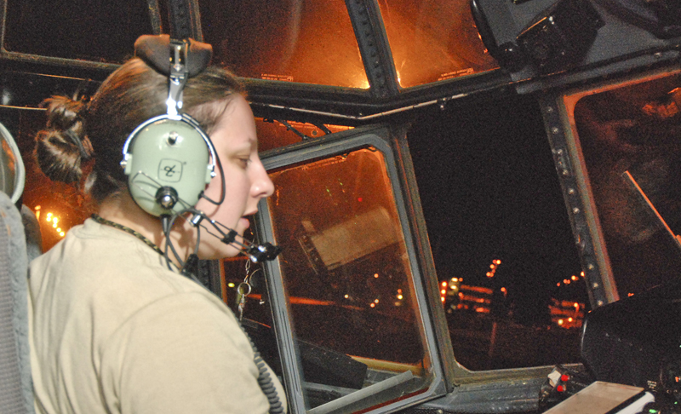
People often work in a noisy workplace or simply want to listen to music in an otherwise noisy environment, such as inside an aircraft cabin. Prolonged exposure to loud sounds can damage our hearing and can even become painful. One way of overcoming these problems is to use noise cancellation technology in headphones.
A helicopter pilot uses noise cancelling headphones to reduce the noise in a very noisy cockpit

Noise cancellation can be either passive or active. Passive noise cancelling headphones usually completely cover the ear and are packed with layers of high density foam or other sound absorbing materials. This reduces external sounds by up to 20 decibels.

In noisy environments such as inside an aircraft cabin where sound levels can be up to 80 decibels, active noise cancelling earphones have to be used. These use special electronics to cancel out the sounds from outside the headphones. Small microphones pick up external sounds and an electronic circuit turns the sound wave ‘upside down’.
+
=
sound wave from cockpit noise
sound wave turned ‘upside down’ and added to cockpit noise
silence

This is then played through small speakers inside the headphones which, when combined with the outside noise, effectively cancels out the sound.

(a) Explain why prolonged exposure to loud sounds should be avoided.

(b) How does ‘passive noise cancellation’ reduces noise levels?

(c) Explain how ‘active noise cancellation’ reduces noise levels.

Electromagnetic Spectrum

The electromagnetic spectrum
49. Look at the list of different sorts of waves below Copy and complete the table by putting a tick in the appropriate column to show whether the waves are part of the electromagnetic spectrum (EM spectrum) or not. The first is done for you.

Wave | EM spectrum | Not EM spectrum
Visible light | ✓
Ultrasound
Gamma radiation
Ultraviolet
Seismic waves
Infrared
Sound waves
Water waves
TV waves
Microwaves
Radio waves
X-rays

50. The table below gives types of electromagnetic radiation and a possible source or detector Match the letters and numbers to correctly link them together.

Wave | Source or detector
(a) radio & TV | 1 – sun bed
(b) microwave | 2 – glow stick
(c) infrared | 3 – Geiger counter
(d) visible light | 4 – mobile phone
(e) ultraviolet | 5 – radio one transmitter
(f) x ray | 6 – toaster
(g) gamma ray | 7 – photographic plate

51. The diagram below shows the waves that form the electromagnetic spectrum.

radio and TV waves
microwaves
infrared radiation
visible light
ultraviolet radiation
X-rays
gamma radiation

(a) At what speed do waves in the electromagnetic spectrum travel at?

(b) The Sun emits both visible light and X-rays. If they are emitted at the same time, which will reach the Earth first?

(c) Copy and complete the following sentences using the words below
the same as smaller than greater than

(i) The wavelength of visible light is ______________________ the wavelength of radio and TV waves.

(ii) The frequency of ultraviolet radiation is ______________________ the frequency of infrared radiation.

(iii) The speed of microwaves is ______________________ the speed of X-rays.

52. Mobile phones use waves to transmit information.

(a) Name the radiation adjacent to microwaves which has a longer wavelength than microwaves.

(b) Name the radiation adjacent to microwaves which has a shorter wavelength than microwaves.

(c) Part of the microwave spectrum can have applications other than communication. Name one of these.

(d) Other waves in the electromagnetic spectrum are also used for communication in optical fibres. Name this radiation.

53. Infra red radiation is part of the electromagnetic spectrum.

(a) Name a possible source of infrared radiation.

(b) How can infrared radiation be detected.

(c) Describe one use of infrared radiation.
54. The sign shown opposite is often displayed where there is the risk of exposure to high intensity ultraviolet light.

(a) How can ultraviolet light be detected?

(b) Explain why ultraviolet light can pose health risks for people who sunbathe.

(c) Ultraviolet light can have uses. Describe one medical and one non-medical use for ultraviolet light.

55. X rays are used in hospitals to help with the diagnosis of a patient.
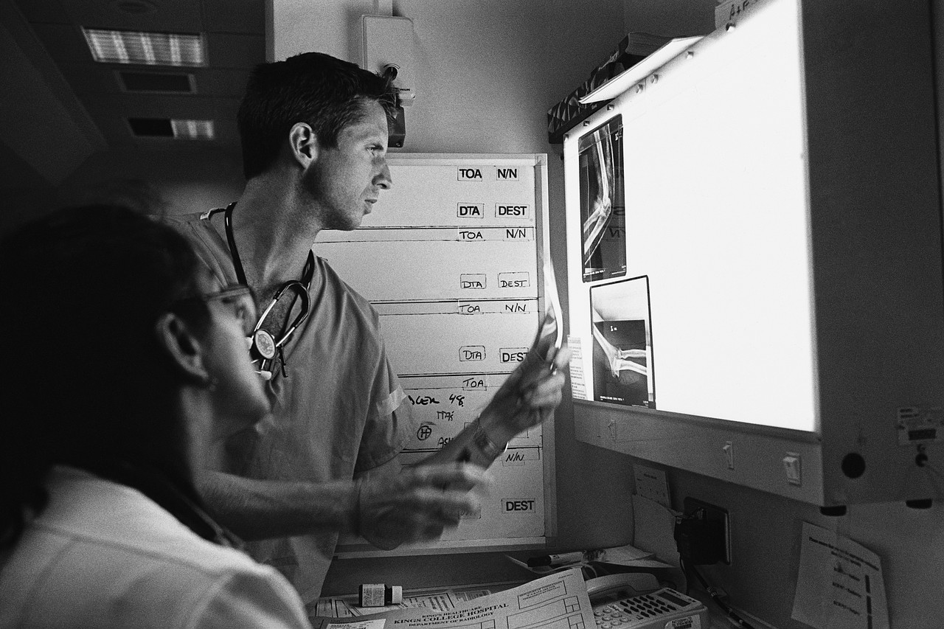

(a) Copy and complete the following sentences using the words below
pass through damage block

(i) Thick lead sheets ______________________ X-rays.

(ii) X-rays ______________________ thin metal sheets

(iii) X-rays can ______________________ living tissue.

(b) Doctors avoid exposing healthy tissue to X-rays. Why is this?
(c) The picture opposite shows an X-ray of a hand wearing a gold ring. Explain why the ring shows up so clearly.

56. A radioactive source is stored in a lead lined box. Explain why this is necessary.

57. Name two uses of gamma radiation in medicine.

58. Gamma radiation can be used to sterilise instruments. Explain why it is especially useful for this purpose.

Long and Short Sight
59. The diagrams below show parallel rays of light entering glass blocks.

(a) Name the shape of each lens
(i)
(ii)

(b) Copy and complete the ray diagrams to show the path of the rays after they have passed through the lens.

60. When out hill walking, a pupil notices that distant objects are sharp but the map the pupil is holding is slightly blurred. What eye defect does the pupil suffer from?

61. A pupil who is sitting at the back of a classroom has difficulty seeing his teacher’s powerpoint presentation. When moved to the front of the class the presentation is much sharper.

(a) What eye defect does the pupil suffer from?

(b) What shape of lens would be required in a pair of spectacles to allow the pupil to see clearly from the back of the class?

62. An optician prescribes a pair of glasses for a patient who is short sighted.

(a) Copy the diagram below and complete the rays to show how the patient has blurred vision when viewing a distant object
light from a distant object

(b) State the shape of lens required to correct this vision defect.
63. An optician prescribes a pair of glasses for a patient who is long sighted.

(a) Copy the diagram below and complete the rays to show how the patient has blurred vision when viewing a nearby object
light from a nearby object

(b) State the shape of lens required in the patients glasses to correct this vision defect.

Extension Questions
64. The diagram below shows the electromagnetic spectrum.
radio and TV waves
microwaves
infrared radiation
visible light
ultraviolet radiation
X-rays
gamma radiation

(a) Which waves have the highest frequency?

(b) Give one use in medicine of:

(i). infrared radiation;

(ii). ultraviolet radiation.

(b) Exposure to too much ultraviolet radiation can be dangerous. Explain why.

(c) Sunglasses should block most of the ultraviolet radiation from the sun. This could be checked by placing the lens from sunglasses between an ultraviolet lamp and a material which will fluoresce.

ultra violet lamp
fluorescent screen
lens

(i) What is meant by the term fluoresce?

(ii) The ultraviolet lamp is switched on. What will be observed if no lens is present?

(iii) What changes will be noticed if a lens which blocks ultraviolet light, is placed in front of the lamp?

65. An X-ray is taken of a patient’s shoulder.
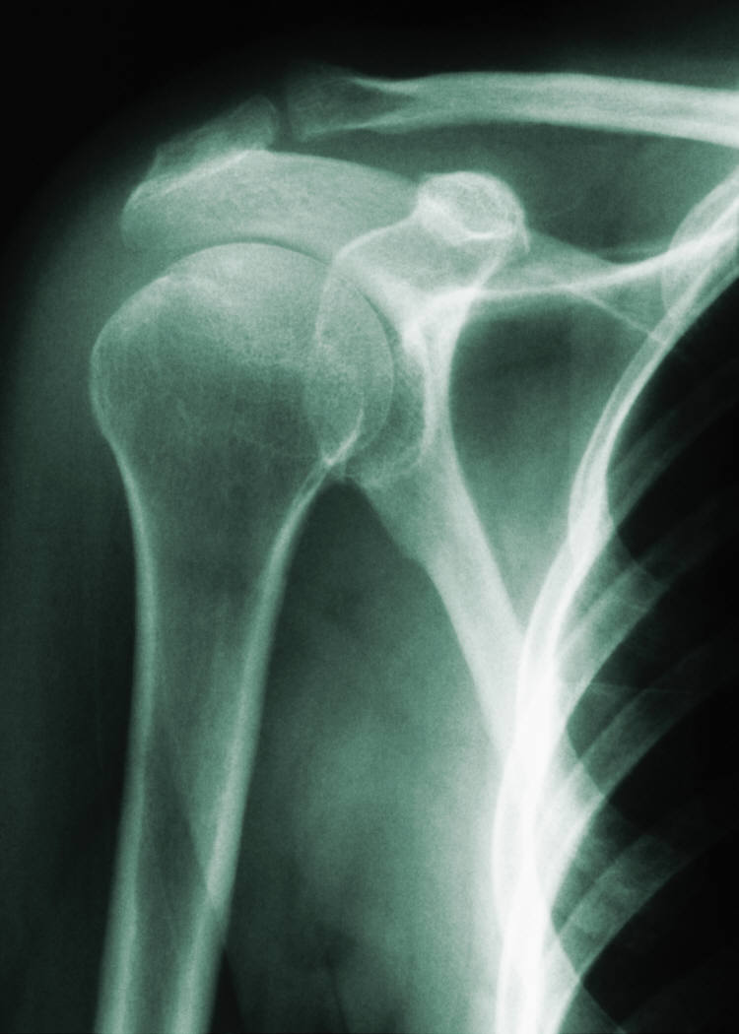

(a) What is used to detect the X-rays?

(b) Why do bones appear on the X-ray image?

(c) How would the X-ray image be different if there was a break in a bone? Explain this difference.

(d) The radiographer who takes the picture operates the equipment from a separate room. Why is this?

(e) Name a material that is good at blocking x-rays.

(f) Ultrasound is often used to examine patients. What advantage is there in using ultrasound rather than X-rays?

Nuclear Radiation

Types of radiation
66. The diagram below represents and atom. Name the parts labelled (a), (b)
and (c).
(a)
+
+
+
+
+
(b)
(c)

67. An atom is described as being neutral. What does this tell you about the numbers of electrons and protons in the atom?

68. Copy and complete the paragraph on nuclear radiation using the words given below.
air wave positive lead strongly
paper negative weakly

There are three different types of nuclear radiation – alpha, beta and gamma. Alpha radiation has a ___________ charge. It is a ___________ ionising radiation so will damage cells if it gets into the body. Fortunately, it is blocked by a thin sheet of ___________ or a few centimetres of ___________. Beta radiation has a ___________ charge and requires 3 millimetres of aluminium to block it. The last type is gamma radiation which is not a particle but a ___________ and part of the electromagnetic spectrum. Gamma requires 3 centimetres of ___________ to block its path. Beta and gamma are ___________ ionising radiations and do not ionise as strongly as alpha radiation.

69. Look at the list of sources of nuclear radiation below. Copy and complete the table by putting a tick in the appropriate column to show whether the sources are natural or man-made. The first is done for you.

Source | Natural | Man-made
Building materials |  | ✓
Nuclear medicine
Nuclear power stations
Cosmic radiation
Granite rock
Radon gas
Bananas
Water
Tobacco
Smoke detectors
Coal
Luminous watches

70. What happens to the level of radiation emitted by a source over time?

Applications of nuclear radiation
71. A manufacturer of tin foil uses an automatic thickness monitoring system which uses nuclear radiation. The pressure applied to the rollers will determine the thickness of the foil - the greater the pressure the thinner the foil. The radiation passing through the foil will vary with the thickness of the foil.

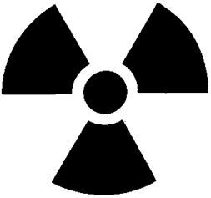
rollers
beta source
detector
aluminium foil

(a) Why is beta radiation used rather than alpha or gamma radiation?

(b) The count rate of the beta radiation decreases. What does this mean has happened to the thickness of the foil?

(c) How will the roller pressure be altered if the foil is found to be too thin?
72. A doctor uses radioactive tracers to check the flow of blood through a patient’s kidneys. One kidney is functioning normally and the other is blocked.
A radioactive liquid which emits gamma radiation, is injected into the patients bloodstream. The level of radiation emitted from the kidney increases then falls for a normal kidney but increases and remains steady for a blocked kidney.

The two graphs below show the radiation levels for each kidney.
radiation
level
time
Left kidney
radiation
level
time
Right kidney

(a) Give two reasons why a gamma emitter is used rather than an alpha emitter as the radioactive source.

(b) Examine the graphs above and state which kidney is blocked.

(c) Why will the level of radiation in the patient slowly decrease?

(d) Iodine is naturally absorbed by the thyroid gland found in the neck. Radioactive iodine is injected into a patient and a gamma camera used to produce an image of their thyroid area. The image produced is shown below. The normal size and location of the thyroid is outlined.
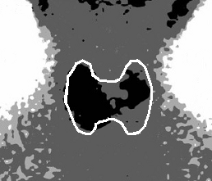
normal thyroid
right side
left side

(i) What information does the image from the gamma camera give about the absorption of the radioactive iodine?
(ii) The radioactive iodine injected into the patient is prepared shortly before use. Why are larger batches not produced and stored.

73. A long section of underground water main has developed a leak. To find its location some radioactive liquid is added to the water flowing through the pipe and levels of radioactivity measured in the area above the pipe.

The diagram below shows the radiation levels in counts per minute.
water main
houses
source
0
20
40
60
80
100
120
140
distance from source in metres
activity in counts per minute
95
120
103
116
82
308
1060
95
rocks and soil

(a) Why are the water supplies to houses supplied by the pipe disconnected during the test?

(b) Suggest the distance from the source where the leak might be.

(c) Why must a gamma emitting source be used for this test?

74. (a) What type of nuclear reaction takes place in a nuclear reactor power
station – nuclear fission or nuclear fusion?

(b) Below are four statements numbered 1 to 4. Put these in their correct order to describe what happens in a nuclear reactor.

1. Energy is released
2. A uranium nucleus splits
3. A uranium nucleus is hit by a neutron
4. Neutrons are released

75. A chain reaction takes place in a nuclear reactor. Explain what is meant by a chain reaction
76. Look at the block diagram of a nuclear power station below.

NUCLEAR REACTOR
BOILER
PRODUCES STEAM

A

GENERATOR

(a) Name the part labelled A.

(b) Heat is produced by the nuclear reaction. What happens to this heat?

(c) Describe the purpose of the generator.

(d) What energy conversion takes place in the nuclear reactor?
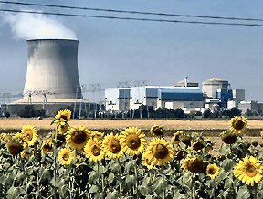
77. Listed below are some statements relating to the generating of electricity using nuclear reactors. For each statement, say whether you think it is true or false.

1. The vast majority of radiation we are exposed to comes from space and the ground beneath our feet.
2. Nuclear power stations will run out of fuel in just a few years.
3. Waste from nuclear reactors must be stored underground for a long time until the radiation emitted decreases.
4. Nuclear reactors use the process of nuclear fission to produce heat.
5. Nuclear reactors can be built very quickly.
6. Nuclear reactors produce a large amount of sulphur dioxide which produces acid rain.
7. Most of the radiation we are exposed to comes from nuclear power stations.
8. Nuclear reactors cannot generate enough electricity to meet high power demands like industry.
9. Nuclear reactors produce large volumes of greenhouse gases.
10. All the nuclear reactors in the world are the same type as the one that exploded in Chernobyl.
78. A handbook for a technician who is working with nuclear radiation lists a number of simple rules. Some of these are as follows.

1. Anyone present when radioactive substances are being handled must be over 16 years of age.
2. Always wear rubber gloves and a laboratory overall when handling radioactive sources.
3. There should be no smoking or eating within areas where radioactive substances are present.
4. Radioactive sources should always be handled using tongs.
5. Radioactive sources should always be pointed away from the body.
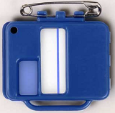6. A radiation badge must be worn at all times when handling radioactive substances.

For each of the rules above, suggest how it would help reduce the risk posed by nuclear radiation.

Extension Questions
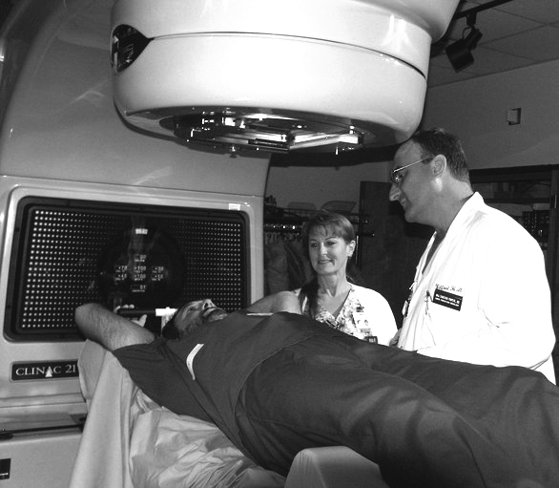
79. Radiation is used to destroy cancer tumours within a patient’s body without the need for surgery. Beams of penetrating radiation are produced by a special machine housed in a lead-lined room to protect the radiographers who remain outside.

beam of radiation
radiation source
tumour
patient

The machine sends the narrow beams through the body and targeted area—the tumour—for the required length of time. It is then rotated around to different positions and the beam of radiation fired again. In this way the radiation is continually aimed at the tumour but only passes through healthy tissue for a short time.

(a) What type of radiation would have been used in the treatment described above?

(b) Why is it important that the dose of radiation used in treating cancer is not too high?

(c) Why is the beam of radiation direct from three different angles rather than just a single beam?

(d) Name one other use of radiation in:
(i) medicine;
(ii) industry.

80. A radioactive source is placed above a Geiger counter which will detect any radiation emitted. A shielding material separates the radiation from the Geiger counter.
10 centimetres
Geiger counter to detect radiation
radioactive source
shielding material

(a) Initially there is no shielding material between the source and the counter and they are separated by 10 centimetres. No radiation is picked up from the source until the separation between the source and the Geiger counter is less than 3 centimetres. What sort of radiation does this show is being emitted by the source?

(b) The source is replaced with one which emits alpha, beta and gamma radiation. What shielding material would be required to block each of these radiations.

(c) Give three safety precautions that would have to be followed to handle the radioactive source safely.

Wave Characteristics

Longitudinal and transverse waves
1. A – transverse, B – longitudinal.

2. (a) Stretch the spring and move sideways, back and fore at right angles to length of spring.
(b) Stretch the spring and move spring back and fore in direction of spring.

3. Water waves – transverse, Light – transverse, Sound – longitudinal.

Wave speed, frequency, wavelength and amplitude
4.
Term | Definition
(a) period - | time taken for one wave to pass a point.
(b) frequency - | number of waves each second.
(c) amplitude - | distance from the mid line to a wave crest or wave trough.
(d) wavelength - | distance from a crest to next crest or trough to next trough.

5. (a) 5 hertz
(b) 3 hertz
(c) 1 hertz
(d) 5 hertz
(e) 0·5 hertz

6. (a) 1 hertz
(b) 2 hertz
(c) 5 hertz
(d) 4 hertz

7. (a) 0·1 metres
(b) 0·5 metres
(c) 10 centimetres or 0·1 metres
(d) 2 metres

8. (a) 256
(b) 15 360

9. 2 hertz

10. (a) 500
(b) 2500
(c) 50

Calculating wave speed using frequency and wavelength
11. v = f × λ

12. (a) 20 metres per second
(b) 5 metres per second
(c) 2 metres
(d) 5 metres
(e) 68 hertz
(f) 0·2 hertz

13. 0·02 metres

14. 170 hertz

15. 1 metre per second

16. 6 metres per second

Calculating wave speed using distance and time
17. d = v × t

18. (a) 8 metres per second
(b) 20 metres per second
(c) 5 seconds
(d) 400 seconds
(e) 2720 metres
(f) 20 metres

19.20 seconds

20. 238 metres per second

21. 0·3 seconds

22. 4 metres per second

Extension Questions
23. (a) 5 hertz
(b) 0·04 metres
(c) 0·2 metres per second
(d) 4 seconds

24. (a) (i) Longitudinal
(ii) Transverse
(b) (i) Parallel with rope, along rope, forwards.
(ii) Perpendicular to rope, sideways.

25. (a) 0·25 metres
(b) 4 metres
(c) 0·8 metres per second

Sound

Sound waves
26. (a) 1 and 3
(b) 2 and 4
(c) 4
(d) 5

27. Trace B has a greater amplitude (louder) and a higher frequency (higher pitched).

Speed of sound
28. (a) Light travels much faster.
(b) The distance the sound wave travelled and the time it took.
(c) Delay in starting and stopping stopwatch (reaction time), wind blowing against or with sound wave.
(d) 333 metres per second

29. (a) 2040 metres
(b) 170 metres
(c) 8 seconds
(d) 3·5 seconds

30. 333 metres per second

31. (a) (i) The bell would be heard ringing.
(ii) Bell would be quieter or no sound at all.
(b) Sound cannot travel through a vacuum.

Ultrasound and sonar
32. Lowest is 20 hertz and highest 20 000 hertz.

33. Ultrasound

34. 0·00077 metres
35.
cleaning delicate instruments;
Item is placed in cleaning solution and ultrasonic vibrations agitate item in solution causing dirt to be lifted from the surface.

detecting cracks or flaws in metal;
Ultrasounds are reflected back at crack, allowing an image to be created by a computer.

sonar in ships to detect the seabed or shoals of fish;
Ultrasounds are reflected back from fish or seabed as an echo, allowing an their depth to be measured.

detecting tumours;
Ultrasounds are reflected back when tissue changes density such as from normal tissue to tumour tissue, allowing an image to be created by a computer.

measuring blood flow through the heart;
Ultrasounds are reflected back when tissue changes density such as from heart tissue to blood, allowing an image to be created by a computer.

detecting kidney stones.
Ultrasounds are reflected back when tissue changes density such as from normal tissue to the kidney stone, allowing an image to be created by a computer.

36. (a) 40 000 hertz
(b) 0·025 seconds

Sound production
37. (a) strings
(b) strings
(c) skin
(d) air or lips of player

38. (a) (b)

39. The current flowing through the coil of the speaker creates an electromagnet which is either pushed outwards or pulled inwards by the permanent magnet. This moves the paper cone to create sound.
40. (a) Higher pitched.
(b) Higher pitched.

Noise pollution
41. Decibel.

42. (a)
Activity | Sound level
(a) passing motorbike | 90 dB
(b) vacuum cleaner | 70 dB
(c) pneumatic drill | 100 dB
(d) rain | 50 dB
(e) jet engine | 140 dB

(b) 90 decibels.
(c) Wearing earplugs or ear defenders. Insulate the object making the sound with sound absorbing insulation.

43. The defenders cut out sound and prevent deafness caused by excessive noise.

Extension Questions
44. Trace B has a smaller amplitude and a higher frequency than trace A.

45. (a) Speed of light is much faster than the speed of sound.
(b) 340 metres per second

46. (a) Ultrasound.
(b) Range for 20 weeks is 5·5 - 7·5 centimetres so diameter of 6·6 centimetres is in the expected range.

47. (a) The frequency might affect the transmission of sound in different mediums.
(b) The sound level will change if the distance changes.
(c) Solid is the best as it has the highest amplitude.
(d) Nothing would be heard as sound cannot travel through a vacuum.

48. (a) It can damage your hearing.
(b) The earphones are packed with foam which absorbs the sound.
(c) The sound waves outside the earphones are picked up by a microphone. An electronic circuit turns the sound wave upside down and it is added to these sounds inside the headphones. This cancels this noise out.

Electromagnetic Spectrum

The electromagnetic spectrum

49.
Wave | EM spectrum | Not EM spectrum
Visible light | ✓
Ultrasound |  | ✓
Gamma radiation | ✓
Ultraviolet | ✓
Seismic waves |  | ✓
Infrared | ✓
Sound waves |  | ✓
Water waves |  | ✓
TV waves | ✓
Microwaves | ✓
Radio waves | ✓
X-rays | ✓

50. (a) 5
(b) 4
(c) 6
(d) 2
(e) 1
(f) 7
(g) 3

51. (a) 300 000 000 metres per second
(b) Neither, they reach the earth at the same time.
(c) (i) shorter than
(ii) greater than
(iii) the same as.

52. (a) Radio and TV waves.
(b) Infrared.
(c) Heating food in a microwave oven.
(d) Visible or Infrared.
53. (a) A hot object.
(b) An infrared camera or infrared sensitive film. It will also cause objects which absorb it to warm up.
(c) Thermographs, treating muscle injuries, remote controls, burglar alarm activators.

54. (a) Using materials which fluoresce (glow) under ultraviolet light.
(b) It can cause skin cancer.
(c) Ultraviolet can be used in the treatment of skin diseases. Ultraviolet markers can be used to security mark objects.

55. (a) (i) block
(ii) pass through
(iii) can damage.
(b) X-rays can damage living cells.
(c) It completely blocks more of the X-rays.

56. The radiation can be dangerous so the lead stops radiation from the source from escaping.

57. Treating tumours/cancer, gamma camera to detect radiation.

58. It will destroy any bacteria or living cells but is able to pass through the packaging around the instruments.

Long and Short Sight
59. (a) (i) convex
(ii) concave
(b)
(i)
(ii)

60. Long sight.

61. (a) Short sight.
(b) Diverging or concave.
light from a distant object
62. (a)

(b) Diverging or concave.
63. (a)
light from a nearby object

(b) Convex or converging.

64. (a) Gamma radiation.
(b) (i) Treating muscle injuries.
(ii) Treating skin conditions, acne.
(c) Can burn the skin and cause damage to skin cells/cancer.
(d) (i) A material will glow when exposed to ultraviolet light.
(ii) The screen will glow.
(iii) The screen will stop glowing or fluorescing.

65. (a) Photographic film.
(b) They block the X-rays more than the soft tissue. (note. The X-ray photograph is a negative image)
(c) X-rays pass easily through the break so it appears black.
(d) The X-rays can damage tissue and the radiographer would be frequently exposed to X-rays.
(e) |Lead.
(f) Ultrasound does not damage living cells.

66. (a) Neutron.
(b) Proton
(c) Electron

67. They are equal in number.

68. There are three different types of nuclear radiation – alpha, beta and gamma. Alpha radiation has a positive charge. It is a strongly ionising radiation so will damage cells if it gets into the body. Fortunately, it is blocked by a thin sheet of paper or a few centimetres of air. Beta radiation has a negative charge and requires 3 millimetres of aluminium to block it. The last type is gamma radiation which is not a particle but a wave and part of the electromagnetic spectrum. Gamma requires 3 centimetres of lead to block its path. Beta and gamma are weakly ionising radiations and do not ionise as strongly as alpha radiation.

69.
Source | Natural | Man-made
Building materials |  | ✓
Nuclear medicine |  | ✓
Nuclear power stations |  | ✓
Cosmic radiation | ✓
Granite rock | ✓
Radon gas |  | ✓
Bananas | ✓
Water | ✓
Tobacco |  | ✓
Smoke detectors |  | ✓
Coal | ✓
Luminous watches |  | ✓

70. It decreases.

71. (a) Alpha will be blocked by the aluminium foil while gamma will pass straight through unaffected.
(b) It has become thicker.
(c) It would be reduced.

72. (a) Gamma radiation can escape from the body, alpha radiation is very harmful within the body.
(b) The right kidney.
(c) Radioactivity decreases with time.
(d) (i) The left side of the thyroid has not absorbed the radioactive iodine (as well).
(ii) The radioactivity of the iodine may decrease to a low level before it is used.

73. (a) So that householders do not receive radiation in their water.
(b) About 40 metres.
(c) Only gamma will be able to travel through the rocks and soil to the surface.

74. (a) Nuclear fission.
(b) 3, 2, 1, 4.

75. Neutrons are released by nuclear fission which go on to produce more fission which releases more neutrons and so on.

76. (a) Turbine.
(b) It is used to produce steam.
(c) It converts the kinetic energy of the turbine into electricity.
(d) Nuclear energy into heat.
77. 1. TRUE – Most radiation comes from cosmic rays from space and from radon gas escaping from underground rocks.
2. FALSE – Estimates vary, but there is sufficient nuclear fuel, in the form of uranium, to last for at least a hundred years. Newer types of nuclear reactors could make this last a lot longer.
3. TRUE – Radioactive waste from nuclear reactors remains radioactive for a long tome so needs to be stored underground till the radiation levels decrease enough.
4. TRUE - Nuclear fission is currently used though scientists are working on using nuclear fusion to produce energy.
5. FALSE - Nuclear reactors take many years to plan and build so can’t be built quickly.
6. FALSE - Nuclear reactors do not produce any sulphur dioxide.
7. FALSE – Only a tiny fraction of the overall background radiation comes from nuclear power stations though there have been some major disasters such as Chernobyl power station in Russia which blew up as a result of workers switching off safety mechanisms.
8. FALSE – Industry can create demands for large quantities of energy but like fossil fuelled power stations, this can be supplied by nuclear power stations.
9. FALSE - Nuclear reactors do not produce any greenhouse gases.
10. FALSE – None of the nuclear power stations in the west are of the type that exploded in chernobyl.

78. 1. Radiation is potentially more harmful to a younger person as they are actively growing.
2. Gloves prevent possible contamination of the hands by radioactive material.
3. This reduces the chances of any radioactive material being eaten or getting into the body.
4. This increases the distance between the handler and the radiation.
5. Reduces exposure to radiation.
6. This records the exposure of the wearer to radiation so that a check can be kept on how much they have been exposed to.

79. (a) Gamma radiation.
(b) It could damage healthy cells.
(c) The tumour receives the full dose of radiation and the surrounding tissue only 1/3 of the total.
(d) Gamma radiation is often used as a ‘tracer’ in industry. In medicine it is used with gamma cameras to provide information about internal organs.
80. (a) Alpha.
(b) Alpha is blocked by a sheet of paper, beta by 3 mm of aluminium and gamma by 3 cm of lead.
(c) See Q 78.

