By Unit then Key Areas; Section A Questions followed by Section B (section B where covering multiple key areas are given when the last content in the question is covered – assuming order as key areas)

Inorganic and Physical Chemistry Unit 2
Electromagnetic radiation and atomic spectra 2
Atomic orbitals, electronic configurations and the Periodic Table 3
Shapes of molecules and polyatomic ions 6
Transition metals 8
Chemical equilibrium 10
Reaction feasibility 15
Kinetics 17
Organic Chemistry and Instrumental Analysis Unit 19
Molecular orbitals 19
Molecular structure 19
Stereochemistry 20
Synthesis 23
Experimental determination of structure 34
Pharmaceutical Chemistry 38
Researching Chemistry unit 41
Gravimetric Analysis 41
Volumetric Analysis 41
Practical skills and Techniques 42
Stoichiometric Calculations 48
Across Units 48

Inorganic and Physical Chemistry Unit

Electromagnetic radiation and atomic spectra

Section A Questions

Electromagnetic Radiation
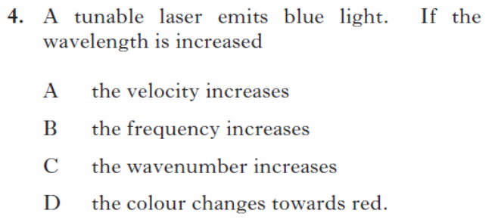
1

SQP/4
2
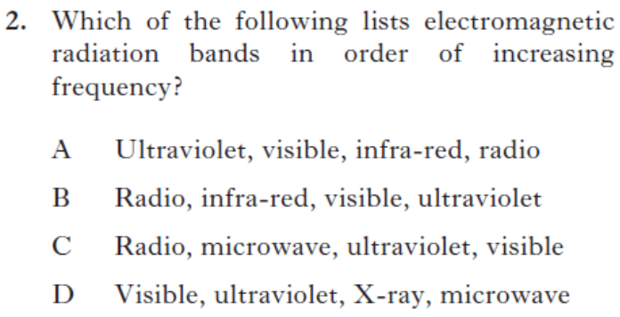
2013Rev/2
3
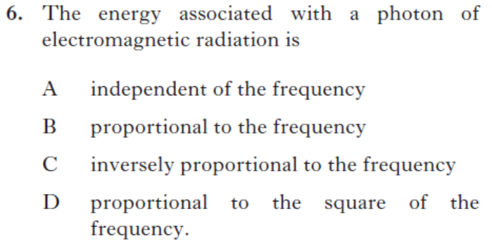
2014Rev/6

Atomic Spectra
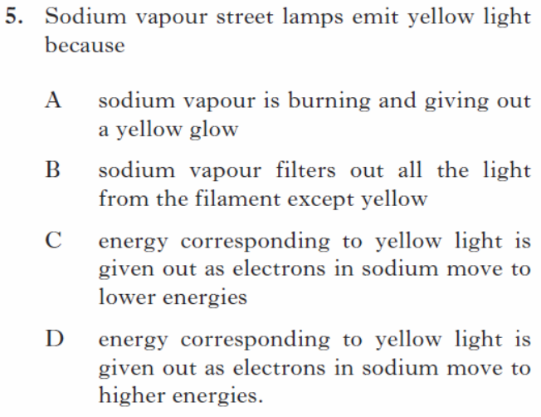 SQP/5
44
54
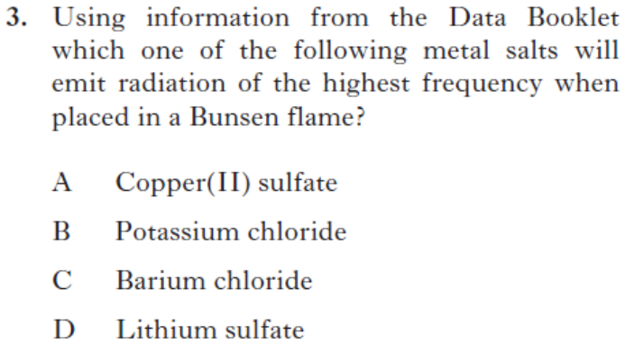2013Rev/3
64
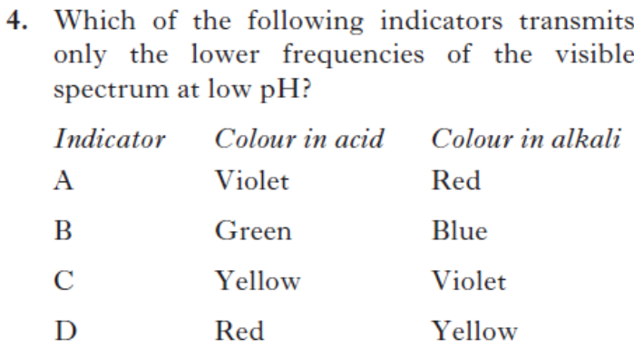
2013Rev/4
74
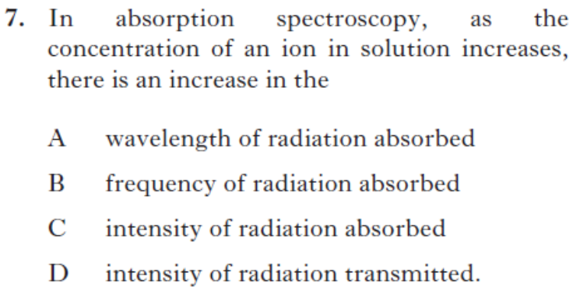
2014Rev/7
84
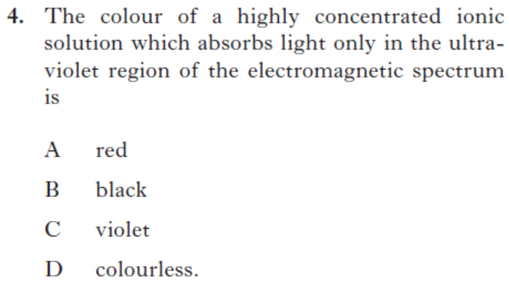
2014Rev/4

Atomic orbitals, electronic configurations and the Periodic Table
Section A Questions
44

Shapes and the four quantum numbers
1
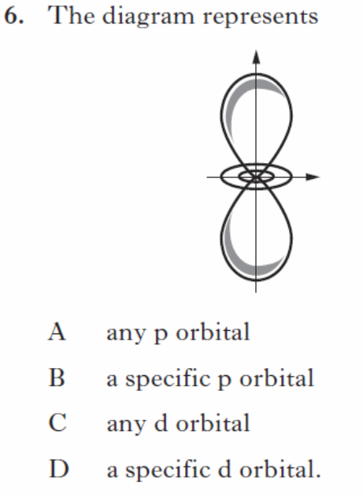 SQP/6
2
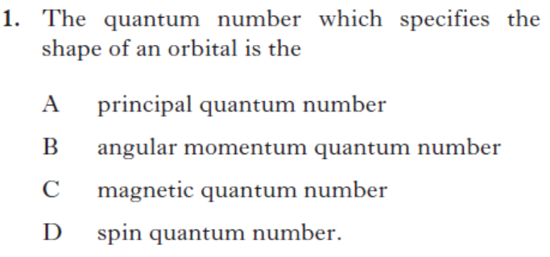
2014Rev/1

Electron configuration
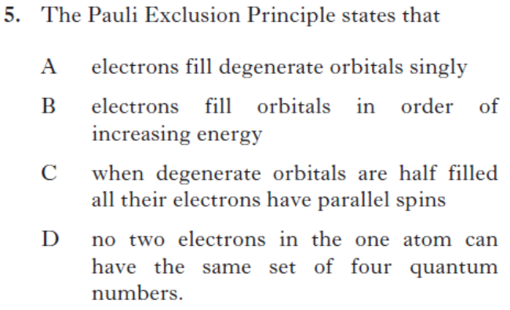
3
2014Rev/5

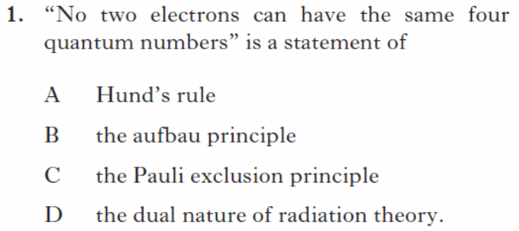
SQP/1
54
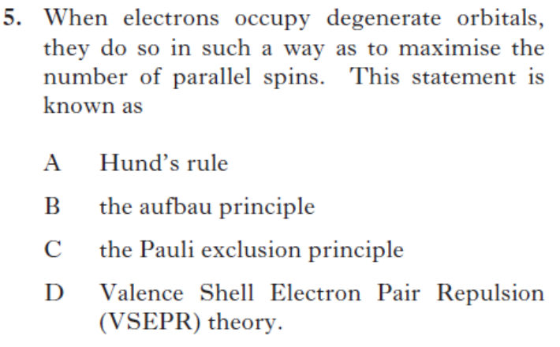
2013Rev/5
64
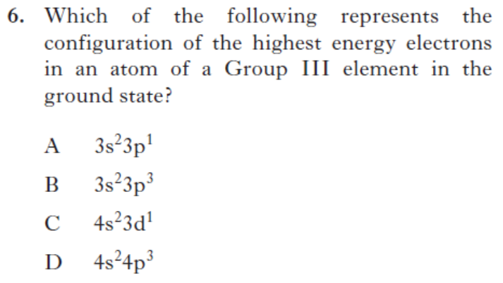

2013Rev/6

The periodic table and Ionisation Energies
74
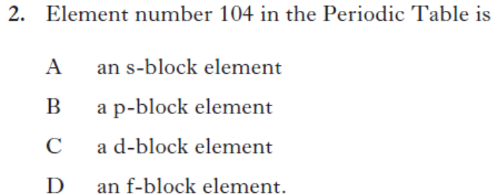

2014Rev/2
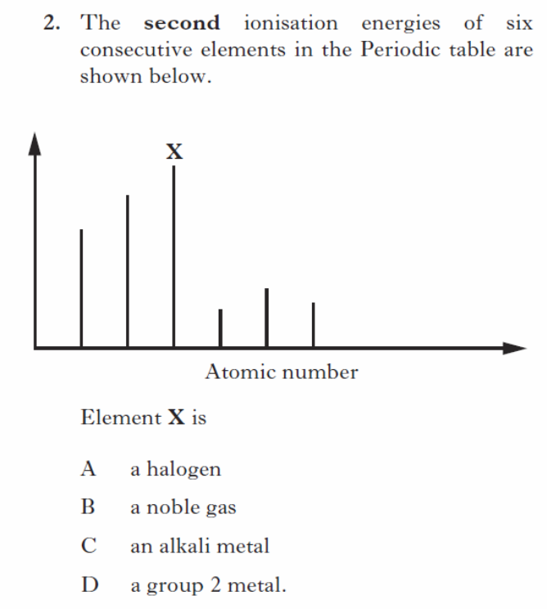
84
SQP/2
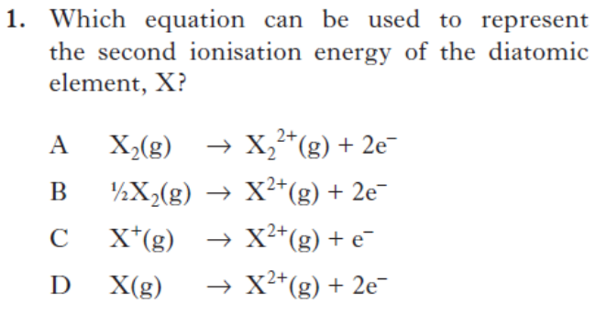
94

2013Rev/1

Section B Questions
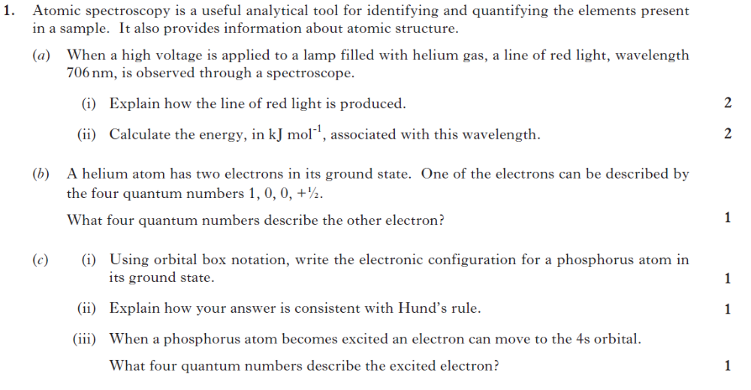
2014Rev/1

Shapes of molecules and polyatomic ions
44

Section A Questions
1
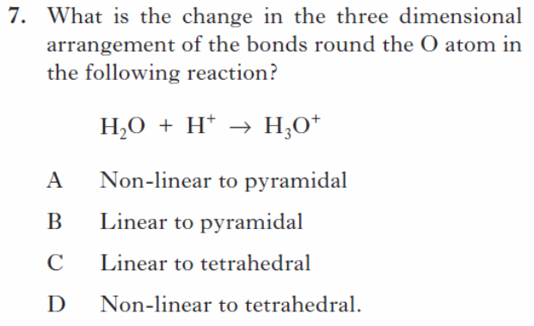
SQP/7
2
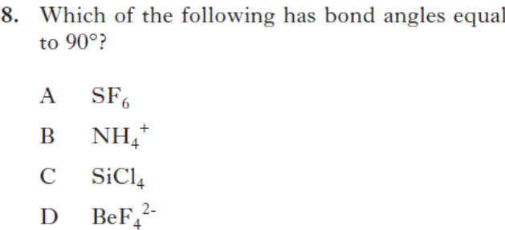
2014Rev/8
3
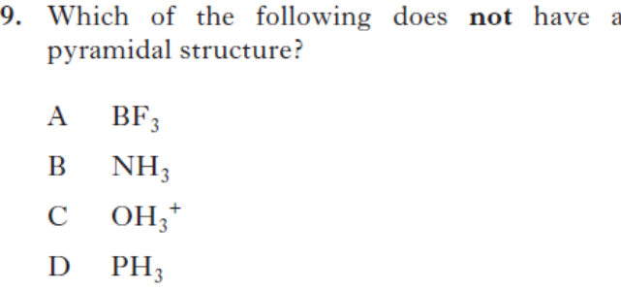
2014Rev/9

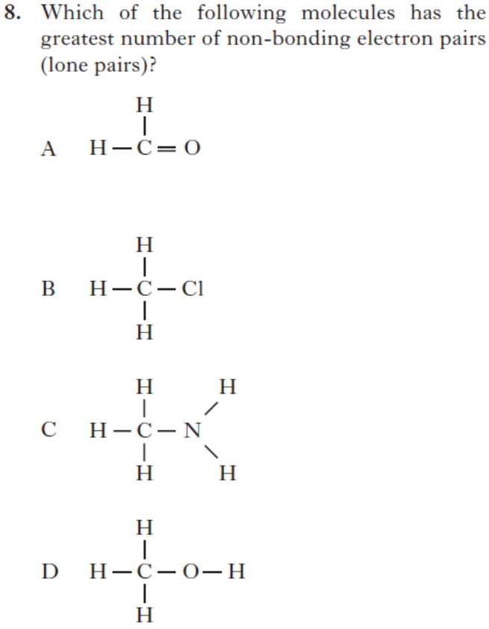
2013Rev/8
54
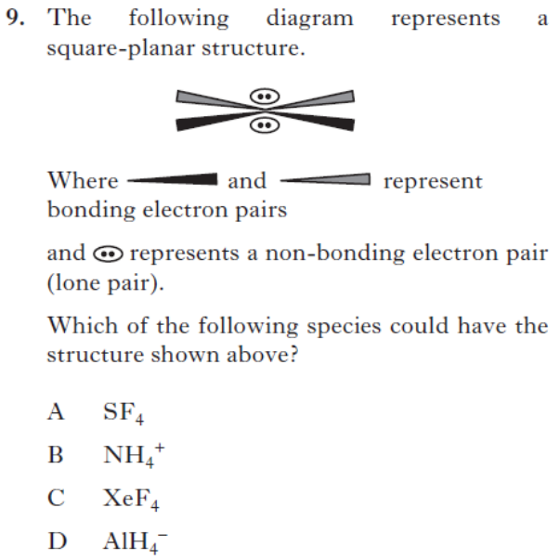

2013Rev/9

Section B Questions
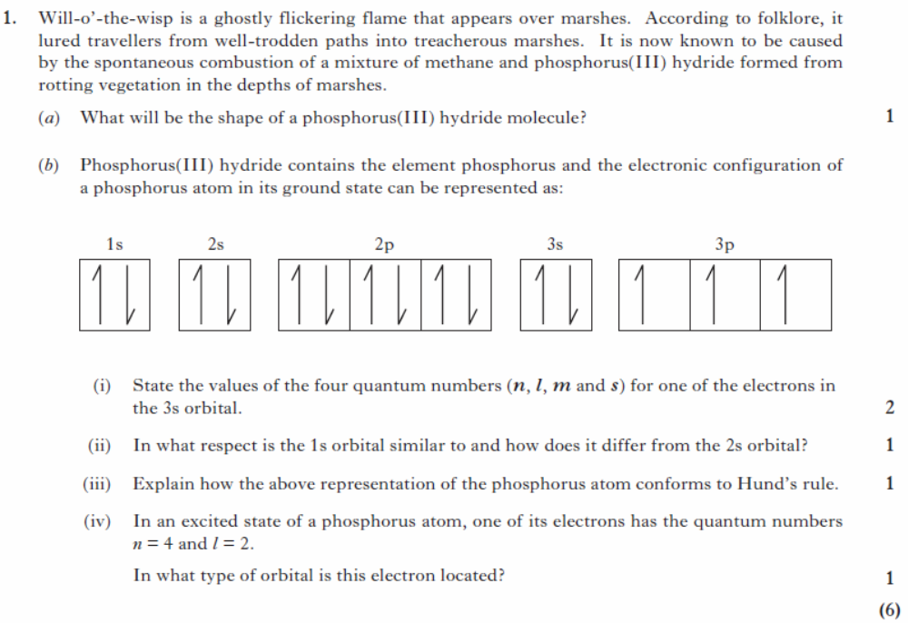
SQP/1

Transition metals
Section A Questions
44

Electron configuration
1
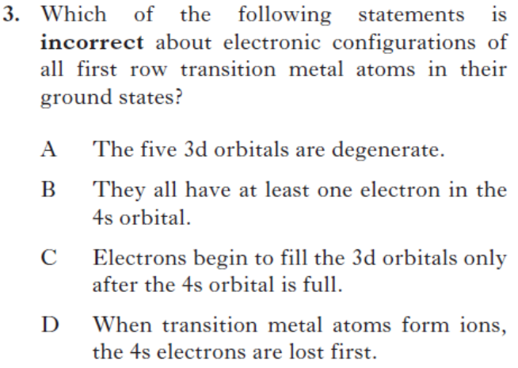
2014Rev/3
2
2014Rev/10
Oxidation States
3
SQP/22
2014Rev/11
54
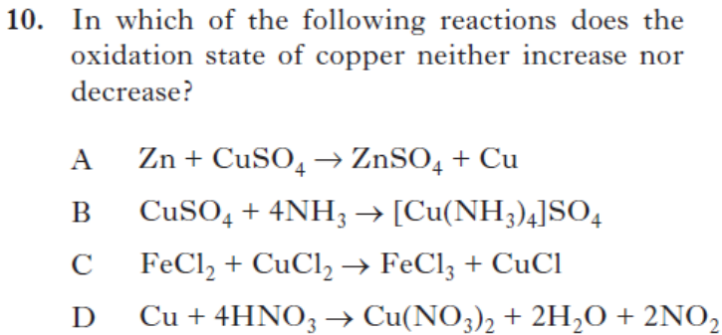
2013Rev/10
Ligands
64
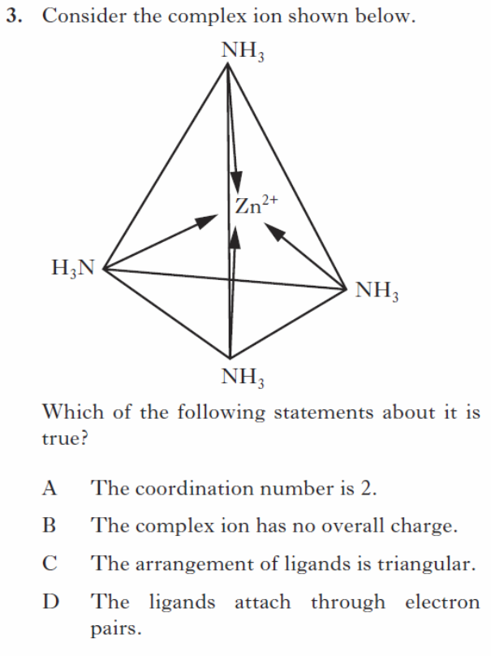
SQP/3

Section B Questions
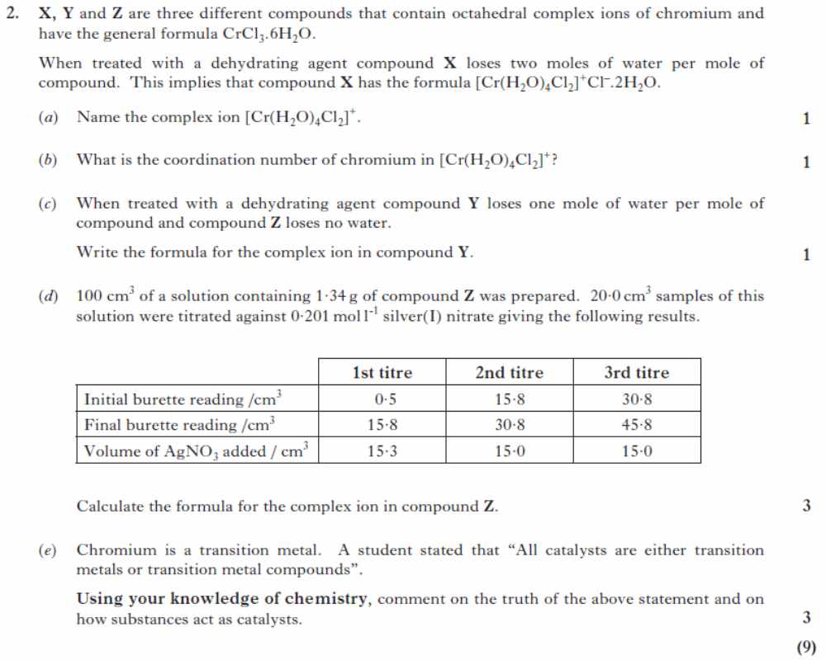
1
SQP/2

Chemical equilibrium
Section A Questions

Equilibrium expressions & constants
1
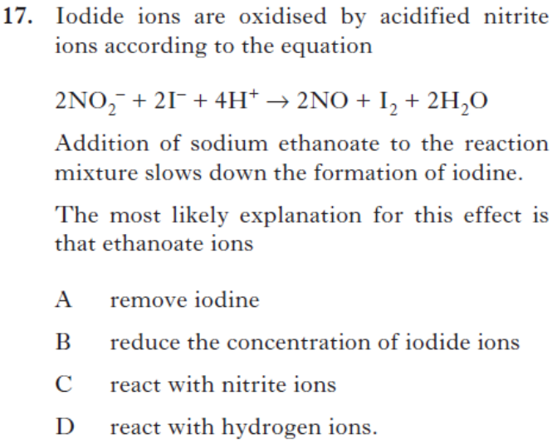
2013Rev/17
2
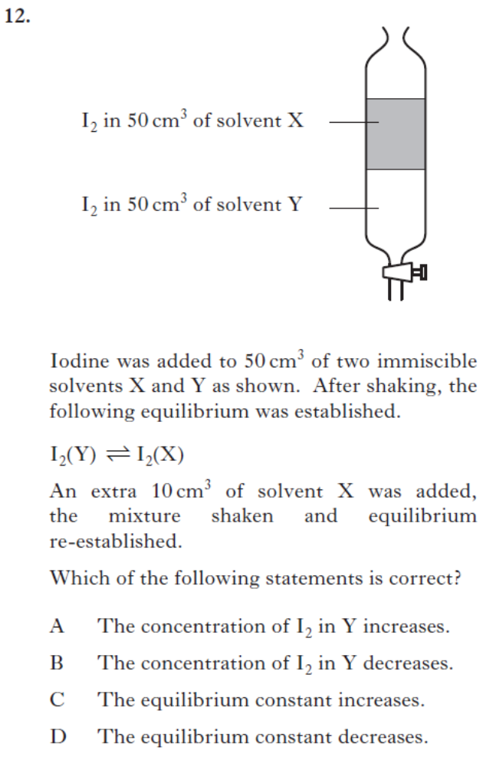
2014Rev/12

3
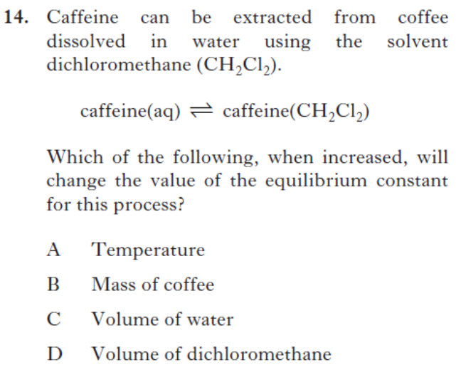
2013Rev/14
44
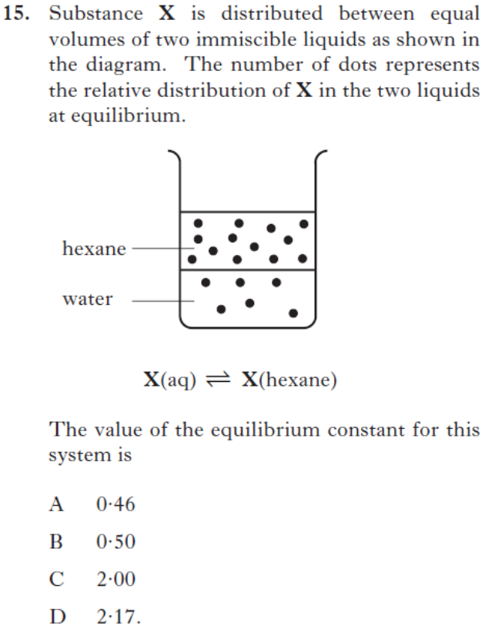
2013Rev/15

Ionic product of water, calculations of pH, buffers and indicators
5
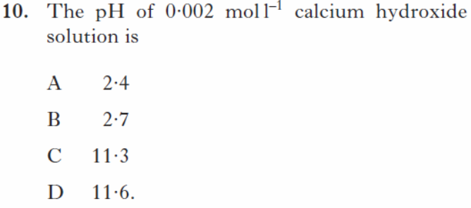
SQP/10
6
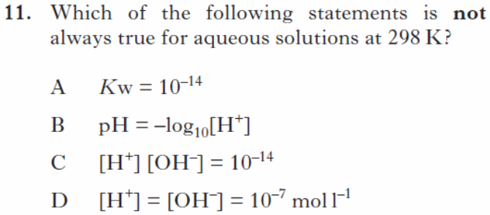
SQP/11
7
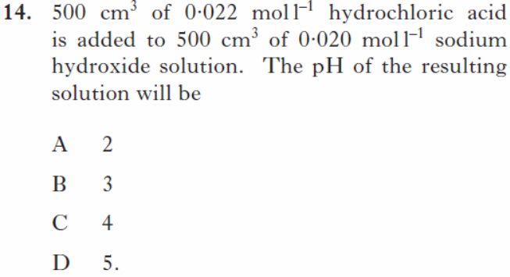
SQP/14

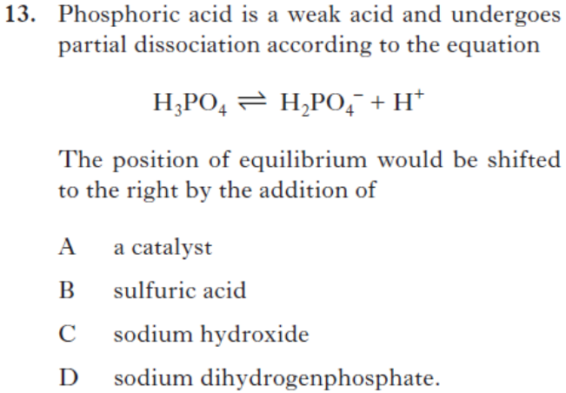
84
2013Rev/13
94
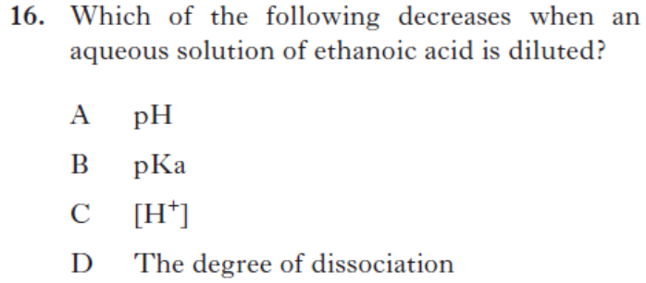
2013Rev/16

104
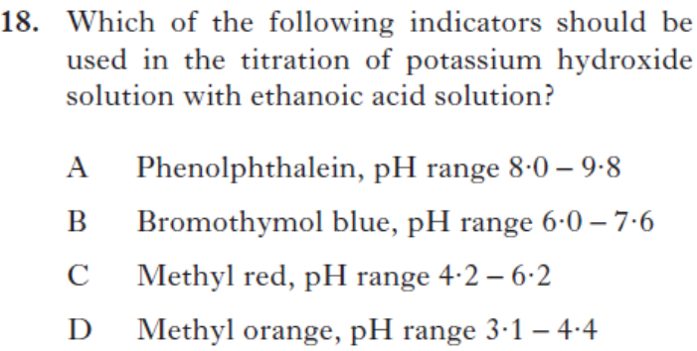
2013Rev/18

Section B Questions
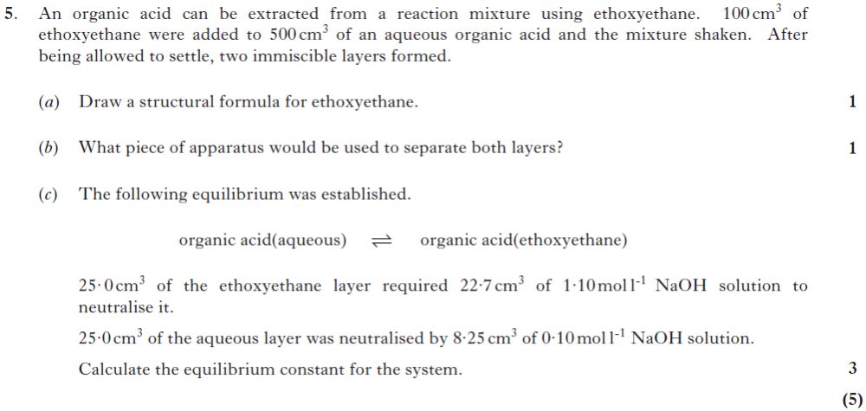
1
2014Rev/5
2
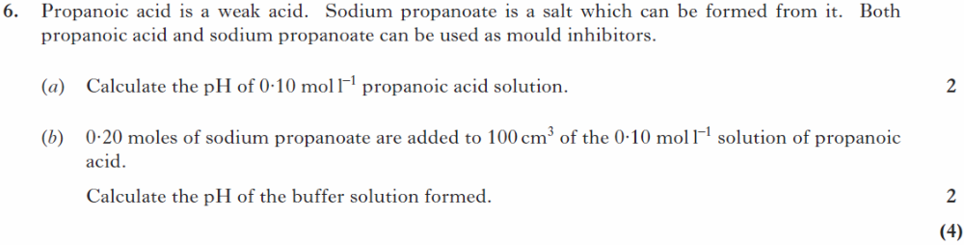

2013Rev/6
3
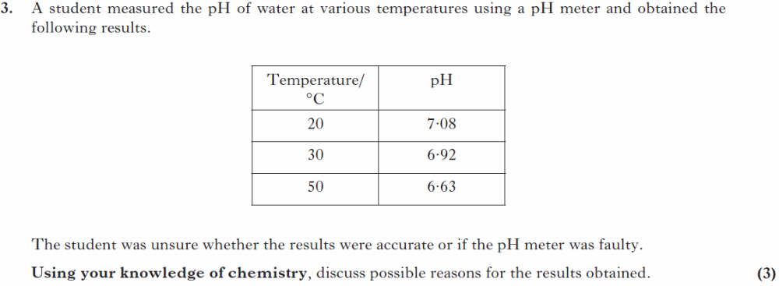

2013Rev/3

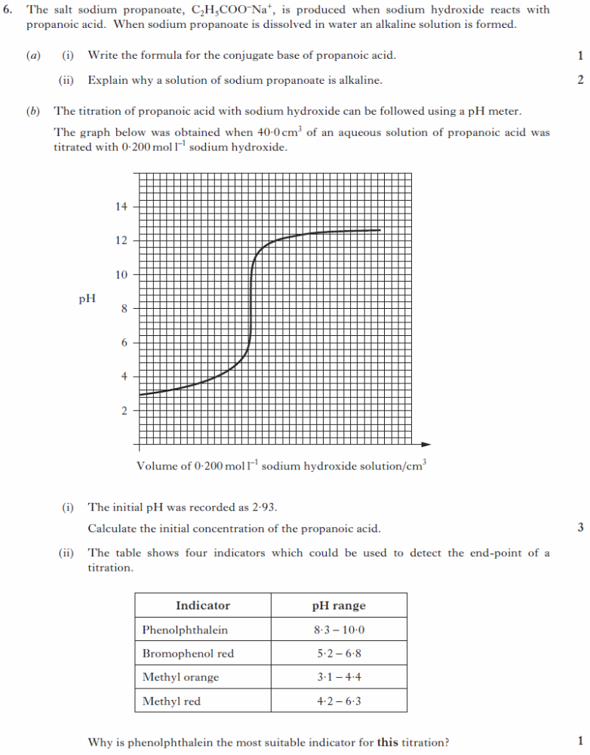
4
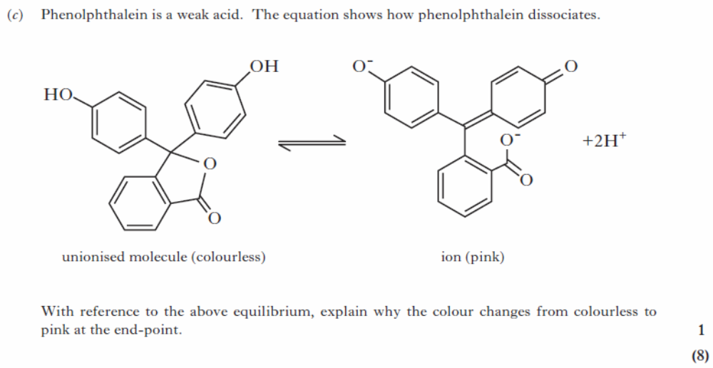
SQP/6
5
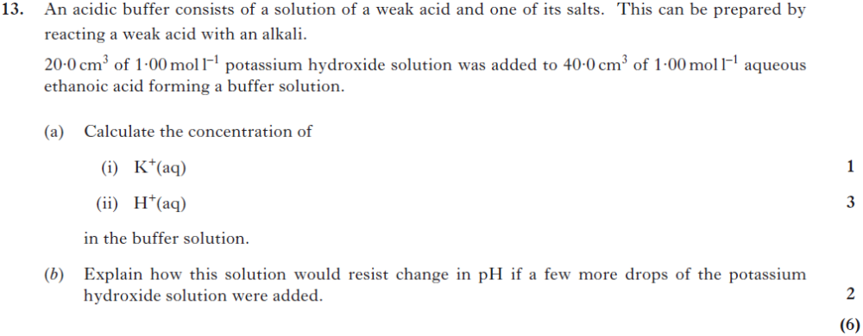2014Rev/13

Reaction feasibility
Section A Questions

Enthalpy
1
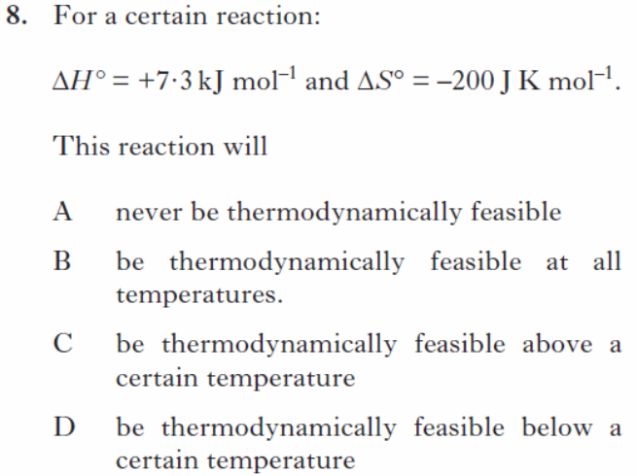
SQP/8
Entropy
2
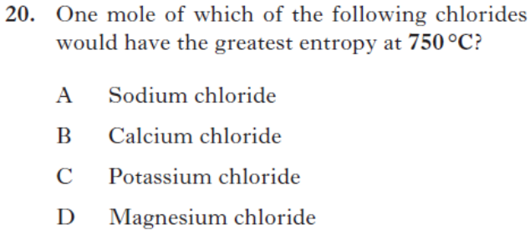
2013Rev/20
3
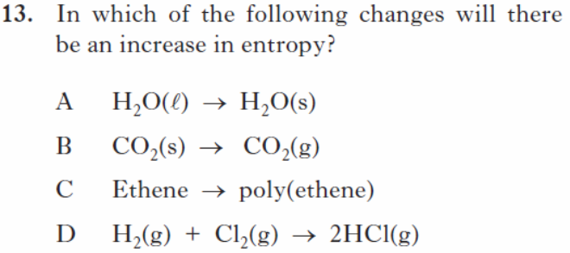
SQP/13
Free Energy
44
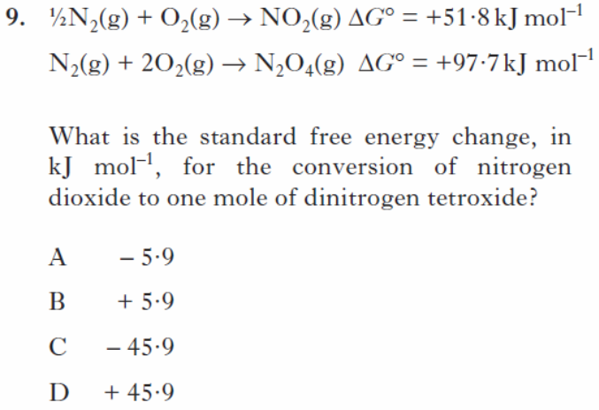
SQP/9
54
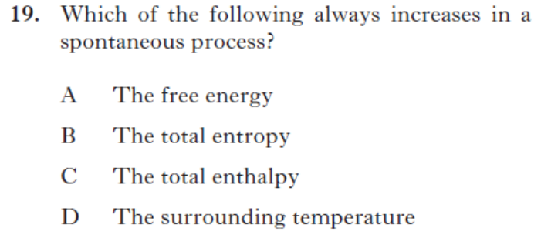
2013Rev/19

Section B Questions
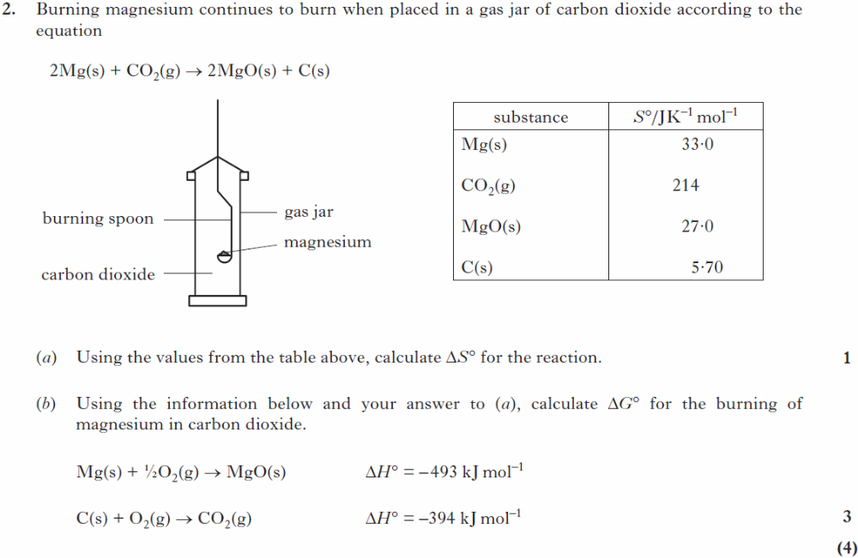
1
2013Rev/2
2
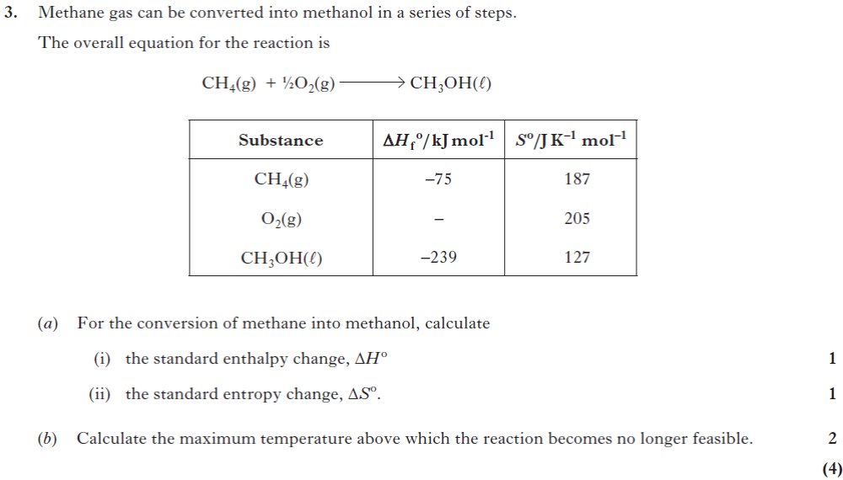
2014Rev/3

Kinetics
Section A Questions

Order of reaction
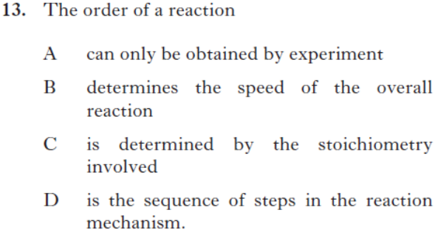
1
2014Rev/13

Reaction mechanisms
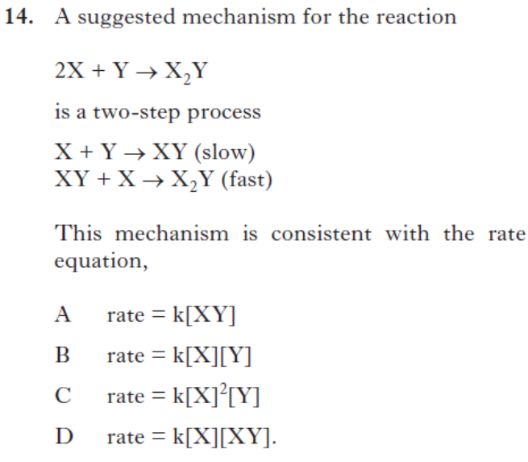
2
2014Rev/14

Section B Questions
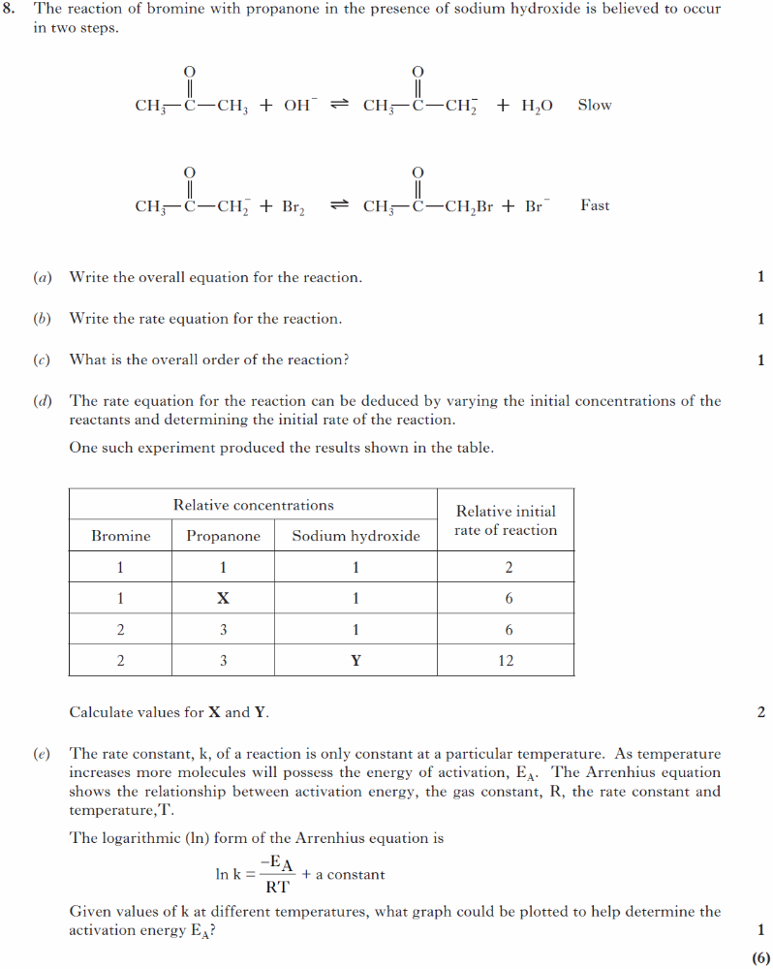
1
SQP/8

Organic Chemistry and Instrumental Analysis Unit

Molecular orbitals

Section A Questions
1
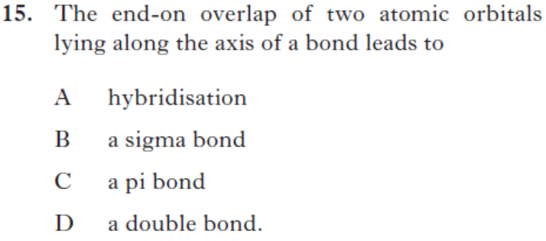2014Rev/15

Section B Questions
1
2013Rev/1

Molecular structure
Section A Questions
SQP/23
1

Stereochemistry
3

Section A Questions
1
SQP/29

2
SQP/28
SQP/16
4
2014Rev/16
5

2014Rev/17

Section B Questions
1
(6) SQP/3

Synthesis
Section A Questions
44

Haloalkanes
1
SQP/24
2
2014Rev/18
3
2014Rev/19

2013Rev/24
Alcohols
5
SQP/25
6
2014Rev/21

7

2013Rev/23
84
2013Rev/22
Ethers
94
SQP/17
104
2014Rev/20
114
2013Rev/26

Aldehydes and Ketones and carboxylic acids
124
2013Rev/30

13
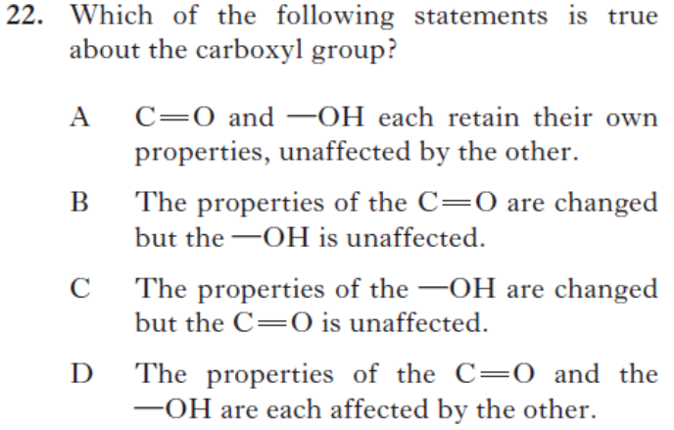

2014Rev/22

Amines
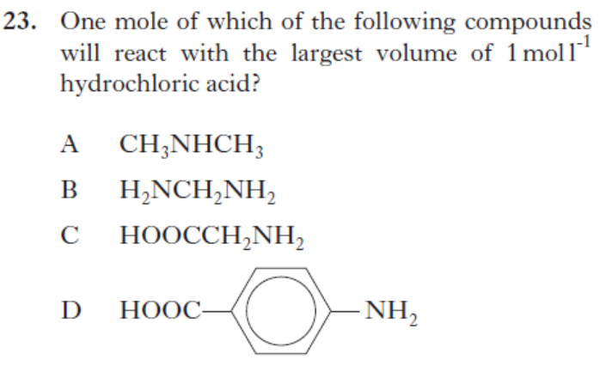
144
2014Rev/23
154
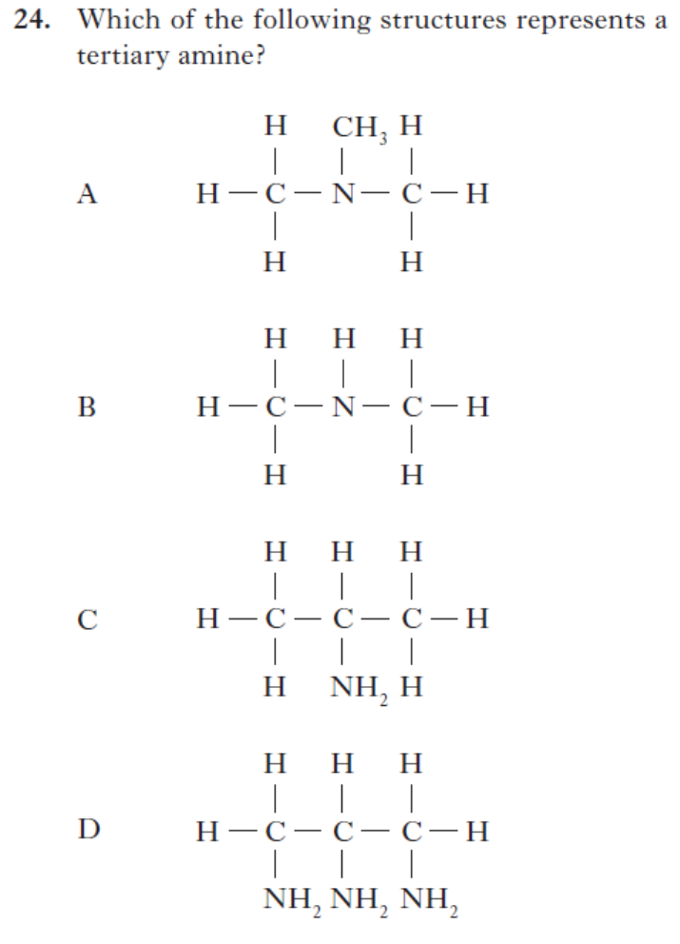
2014Rev/24

Aromatics
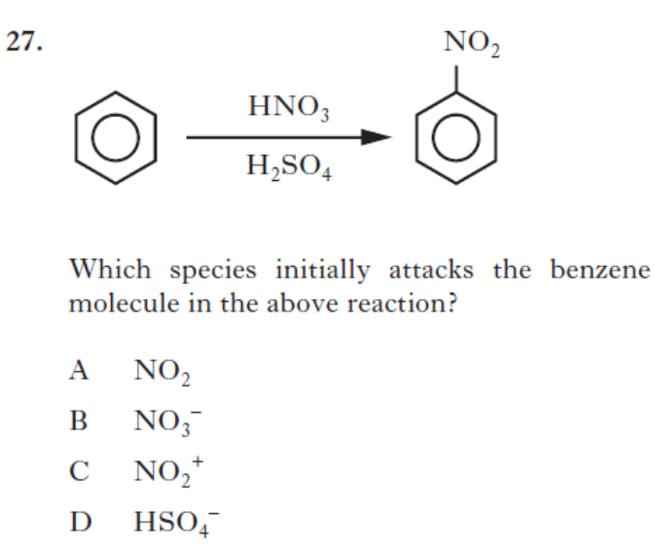
164
2013Rev/27

Reactions Overall
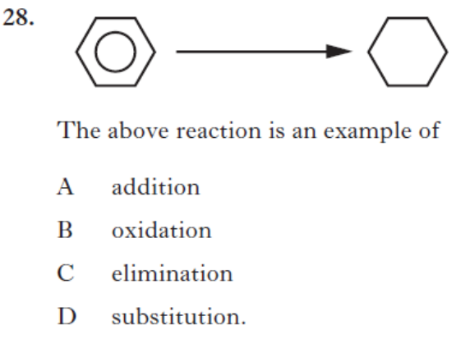
174
2013Rev/28

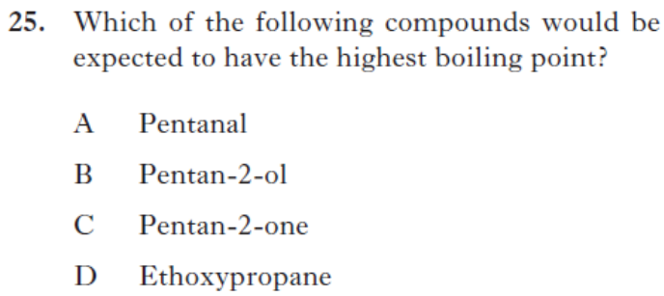
184
2013Rev/25

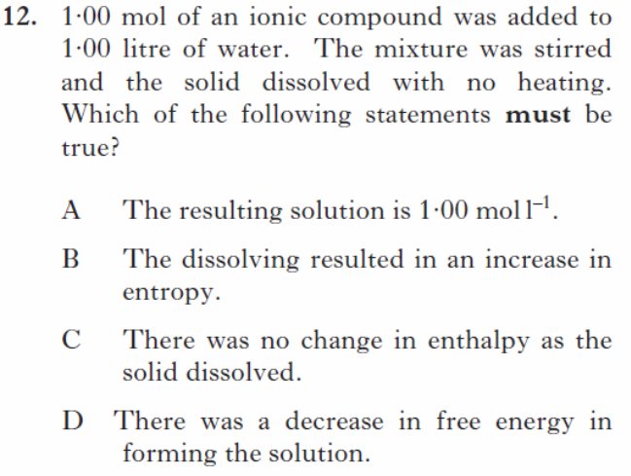
19
SQP/12
20
SQP/19
21
SQP/26

22
SQP/27

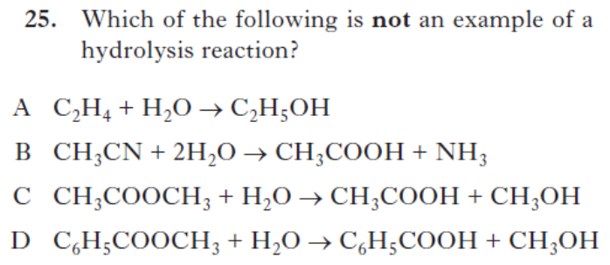
23

2014Rev/25

24
25
SQP20&21

Section B Questions
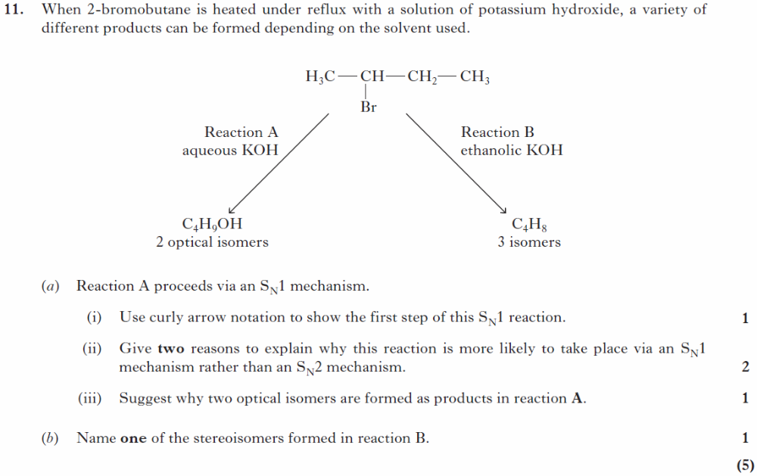
1
SQP/11
2
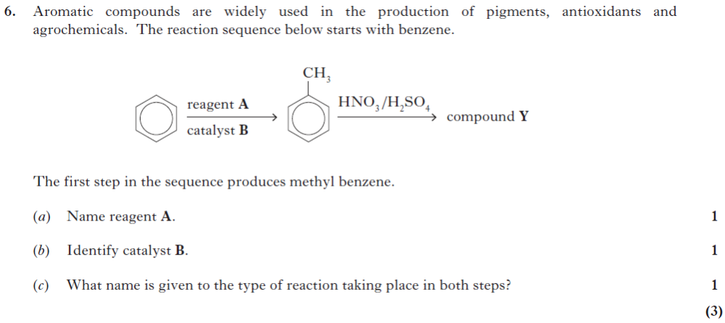
2014Rev/6

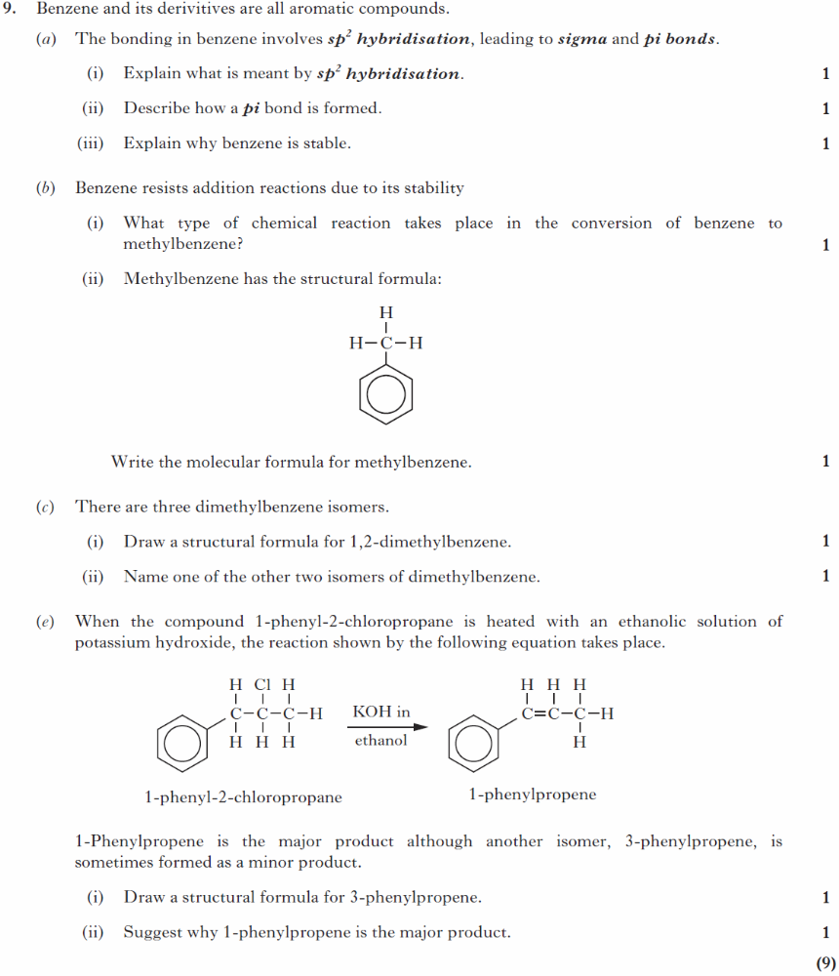
3
SQP/9

4
2014Rev/8

5
2013Rev/11

6
2013Rev/10
7
2013Rev/8

Experimental determination of structure
Section A Questions
3

Experimental microanalysis
1
SQP/18

Spectroscopy
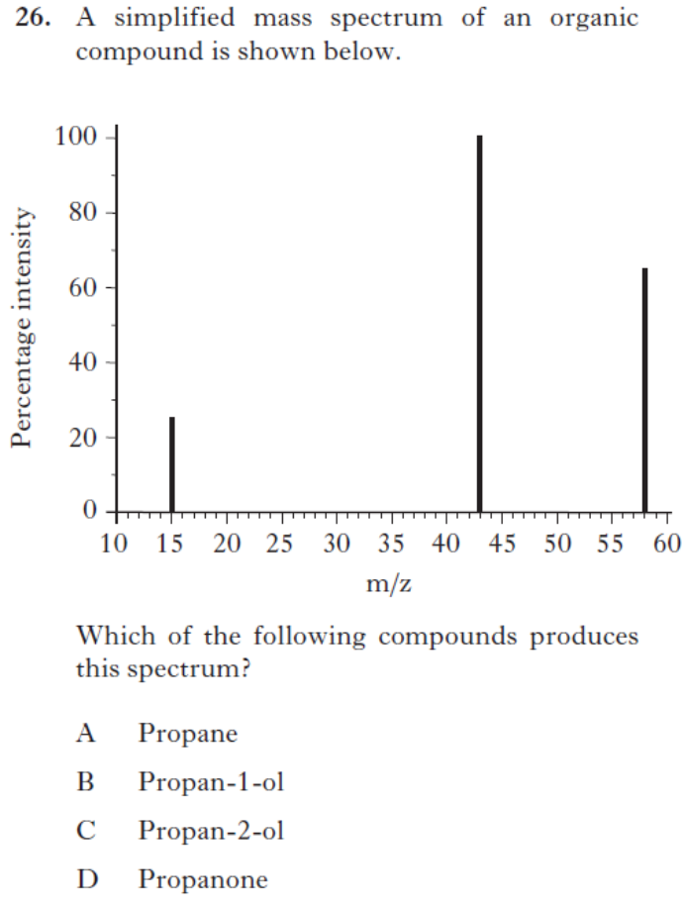
2
2014Rev/26

2014Rev28
44
2014Rev/29
54
2014Rev/27

Section B Questions
14
2013Rev/12
24
2013Rev/7

34

2014Rev/9
44
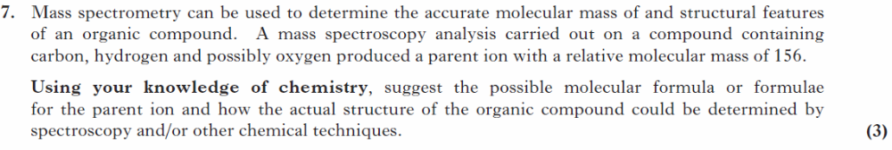
SQP/7

Pharmaceutical Chemistry
Section A Questions
14
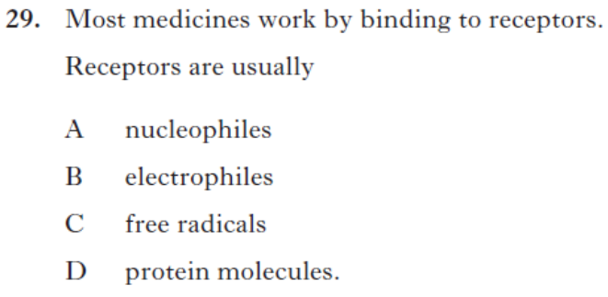2013Rev/29
24
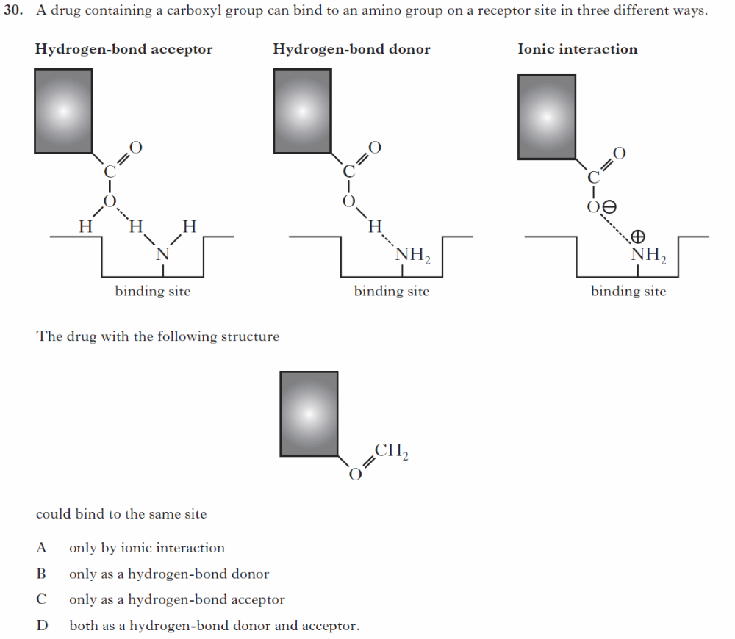

SQP/30
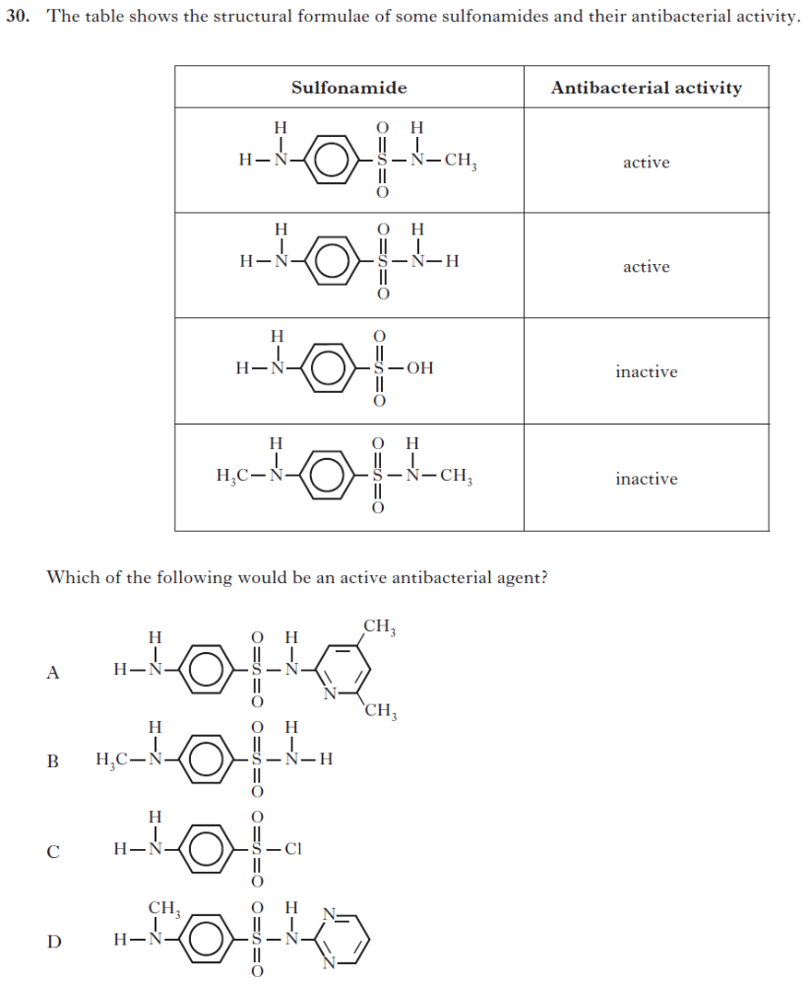
34
2014Rev/30

Section B Questions
14
2014Rev/7

Researching Chemistry unit

Gravimetric Analysis
Section B Questions
14
2014Rev/12

Volumetric Analysis
Section A Questions
2013Rev/12
14

Section B Questions
14
2013Rev/9

2014Rev/2
24

Practical skills and Techniques
Section A Questions
14
2013Rev/21

Section B Questions
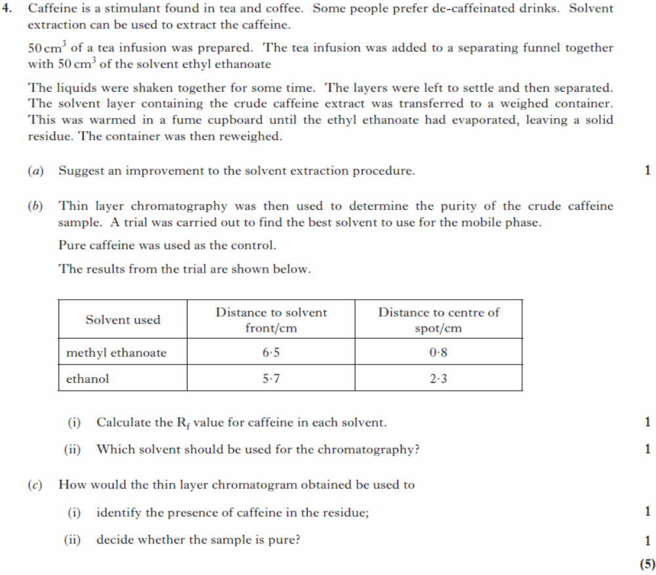
14
SQP/4

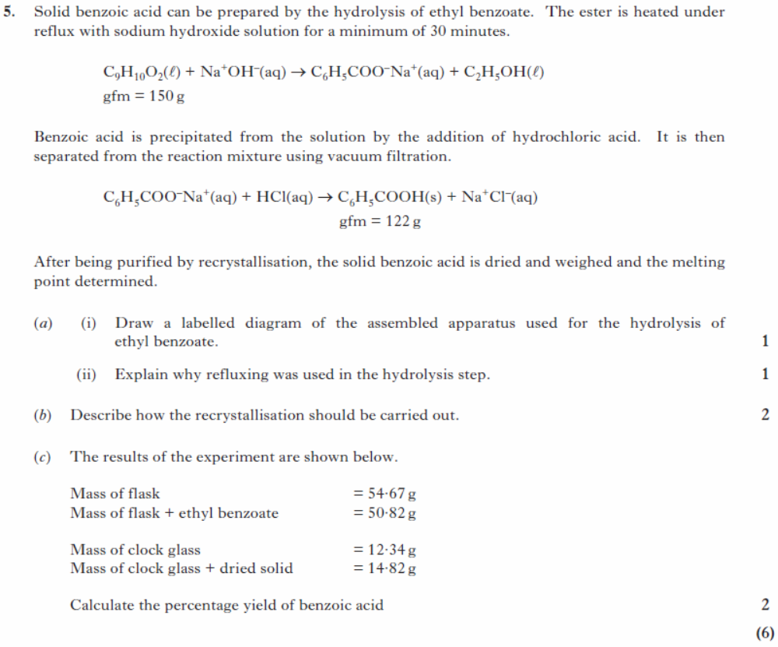
24
SQP/5
34

2014Rev/4

44
2014Rev/10

54
2013Rev/4
64
SQP/10

Stoichiometric Calculations
Section A Questions
14
2013Rev/11

Across Units
24

Section A Questions
14

2013Rev/15

2013Rev/7

Section B Questions
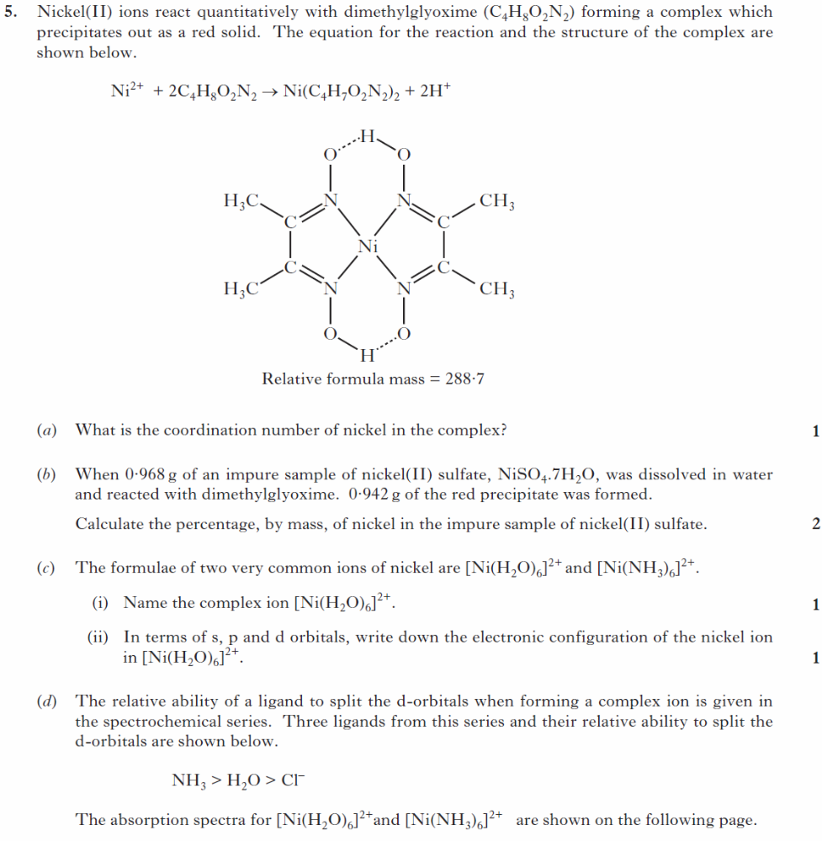
14
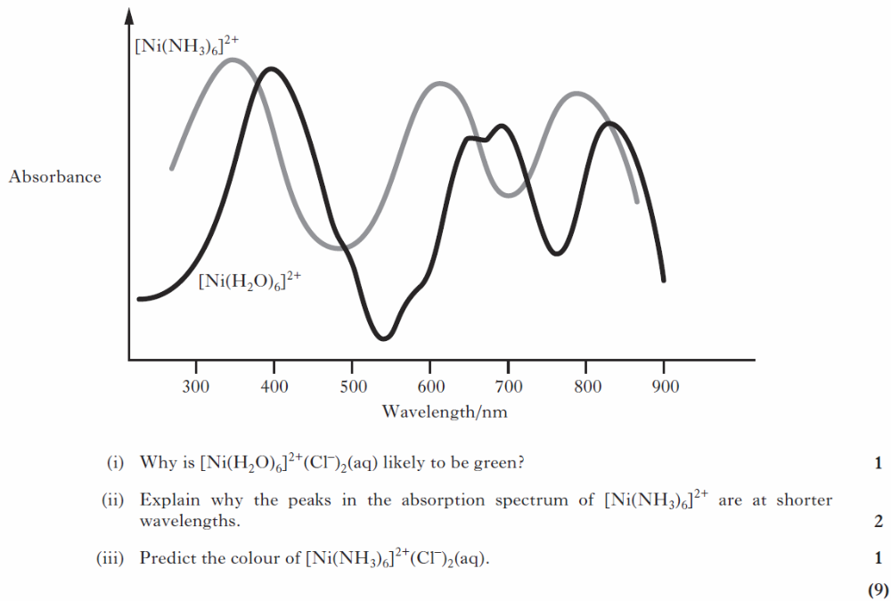
2013Rev/5
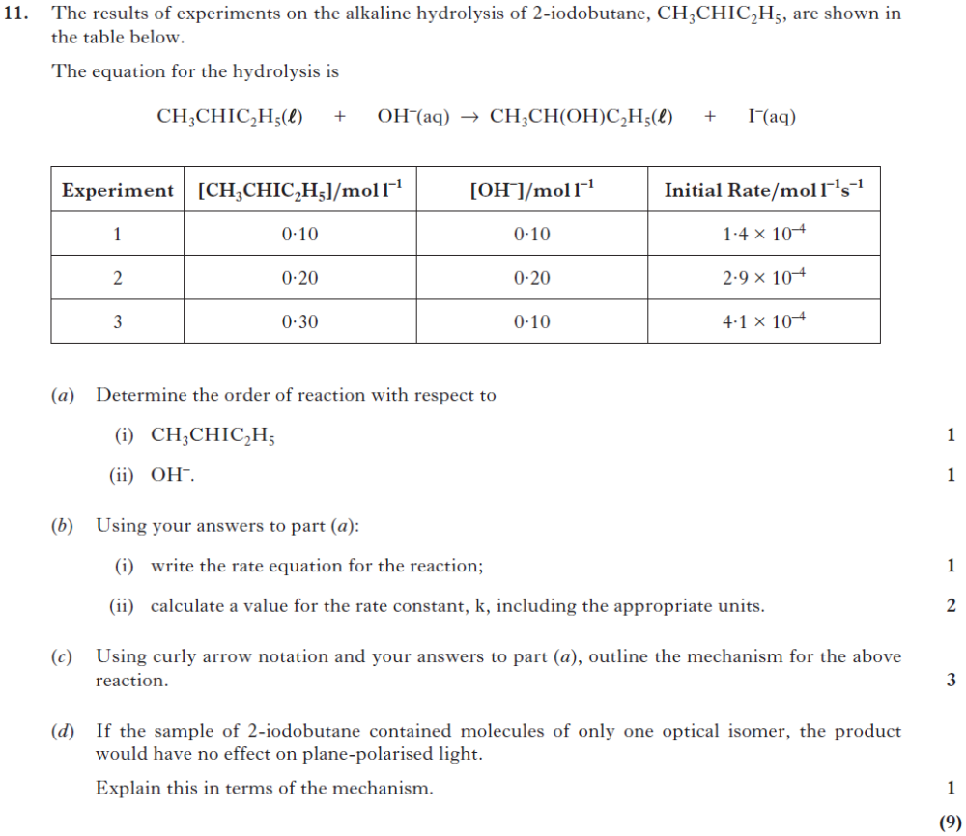
24
2014Rev/11

