St.Andrew’s Academy



Chemistry Department

***Chemistry in Society***

**Name: _____________**

**Metals**

**National 4 Learning Outcomes**

* Different metals have different properties.
* The uses to which metals are put are linked to their chemical and physical properties.
* Metals corrode by reacting with water and oxygen.
* Different metals corrode at different rates.
* When iron corrodes it is said to ‘rust’.
* Rust is detected using Ferroxyl indicator.
* When different metals are connected by an electrolyte, an electric current flows from one metal to the other through the connecting wires.
* By comparing the voltage produced by pairs of metals, an electrochemical series can be constructed.
* An alloy is a mixture of two or more elements, at least one of which is a metal.
* Alloys have different physical properties in comparison to the pure elements.

**National 5 Learning Outcomes**

* Metals are held together by metallic bonds.
* Metallic bonding consists of a lattice of positive ions surrounded by a sea of delocalised electrons.
* Metallic bonding can explain the conductivity of electricity and heat by metals.
* Balanced ionic equations can be written to show the reaction of metals with water, oxygen and acids.
* Oxidation is a reaction involving a loss of electrons. Reduction is a reaction involving gain of electrons. (OILRIG)
* Balanced ionic equations can be written to show the extraction of metals.
* From the balanced equations for the extraction of metals the reducing agent can be identified.
* Ion-electron equations can be written for electrochemical cells, including those involving non-metals. Combinations of these reactions form redox equations..
* Direction of electron flow in a cell can be deduced.
* A displacement reaction is one in which a metal higher in the electrochemical series displaces a metal lower down. Ion-electron equations can be written to show this.
* Fuel cells and rechargeable batteries are two examples of technologies which utilise redox reactions.
* The percentage of a particular metal in an ore can be calculated.(see Unit 3.3 Fertilisers)

**Uses of Metals**

Different metals have a number of similar properties. For example, they are all good conductors of heat and electricity, all are shiny and strong, and can be beaten into shape and stretched into wires, without breaking.

Different metals, however, have some different physical and chemical properties. It is these properties which decide the uses to which different metals are put.

Complete the table below:

|  |  |  |
| --- | --- | --- |
| **Metal** | **Use** | **Useful Property** |
| Mercury | Thermometers |  |
| Aluminium | Aircraft bodies |  |
| Lead | Diver’s weights |  |
| Gold | Jewellery and ornaments |  |
| Titanium | Aircraft engine parts |  |
| Copper | Electric cables |  |

Cost and availability also affect which metal is used for which purpose. For example, aluminium is used for window frames. Titanium is harder wearing but is far too expensive.

**What gives a metal its properties? – Metallic Bonding**

Metals are held together by metallic bonds.

In metals the outer electrons of the metal atoms can move easily from atom to atom. They are said to be **delocalised**.



sea of negative electrons

positive metal ions

Metal structures can be described as ‘positive ions in a sea of delocalised electrons’.

*Using the National 5 Chemistry Textbook:*

1 In your own words, describe what is meant by ‘delocalised’.

2 What are metallic bonds?

3 In what ways do metallic bonds differ from covalent bonds?

4 How does metallic bonding explain a metal’s ability to be beaten into shape, and drawn into wires?

5 How does metallic bonding explain a metal’s ability to conduct electricity?

**Alloys**

An alloy is a mixture of two or more elements, at least one of which is a metal.

The reason we use alloys is that alloys have different properties from pure metals.

For example, pure iron is brittle but if it is mixed with about 1% carbon, steel is made that is much stronger. Steel is therefore an ________ of iron and carbon.

Now investigate other **alloys** and complete the following table:

|  |  |  |  |
| --- | --- | --- | --- |
| **Alloy** | **Main Metal** | **Other Element (s)** | **Uses** |
| Brass | Copper |  |  |
| Bronze |  | Tin |  |
| Duralumin |  | Copper, Manganese |  |
| Mild Steel | Iron |  |  |
| Stainless Steel | Iron |  |  |
|  | Lead | Tin | Sealing water pipe joints |

**Reactions of Metals**

**Reaction of metals with oxygen**

Most metals react with oxygen. The word equation would be:

metal + oxygen

**Activity 2**

Your teacher will show you how to set up the following apparatus:

You will need: a jar of ceramic (rocksil) wool

a jar of potassium permanganate

some magnesium ribbon

clamp stand, Bunsen, heatproof mat, goggles

1 Add 2 spatulas of potassium permanganate to the test tube.

2 Place a loose plug of ceramic wool into the test tube, just above the permanganate.

3 Put two pieces of magnesium ribbon into the middle of the test tube, then another loose plug of ceramic wool above the magnesium.

4 Clamp the test tube horizontally, at the mouth of the test tube.

5 Heat the metal for 1 – 2 minutes.

6 Now heat the potassium permanganate, and reheat the metal.

7 Repeat for the other two metals (copper and zinc) using a clean test tube each time.

Now list the three metals in order

(most reactive first) __________________

__________________

__________________

The balanced equation for magnesium reacting with oxygen is:

2 Mg (s) + O**2** (g)  2 MgO (s)

The balanced (IONIC) equation for this reaction is:

2 Mg (s) + O**2** (g) 2 Mg**2+**O**2-** (s)

Write balanced ionic equations for the following reactions:

(i) aluminium + oxygen aluminium oxide

(ii) zinc + oxygen zinc (II) oxide

(iii) sodium + oxygen sodium oxide

**Reaction of metals with water**

Most metals react with water very slowly, but the alkali metals react very violently with water.

The word equation is:

metal + water metal hydroxide + hydrogen

**Activity 3 (DEMO)**

Your teacher will demonstrate the reaction of potassium, sodium and lithium with water.

Watch carefully then place the three

metals in order (most reactive first) _________________

_________________

_________________

The balanced equation for sodium reacting with water is:

2 Na (s) + 2 H**2**O (ℓ) 2 NaOH (aq) + H**2** (g)

Write the balanced ionic equation for sodium reacting with water.

Write the balanced ionic equation for calcium reacting with water.

**Reaction of metals with acids**

As with water, it is the more reactive metals that react with acids. The word equation is:

metal + acid salt + hydrogen

**Activity 4**

You are going to react some metals with acid.

You will need: a test tube rack

four test tubes

some magnesium ribbon

a jar of iron, zinc, and copper

a dropping bottle of acid

goggles

1 Half fill each test tube with acid.

2 Add a piece of metal (or spatula of metal) to each test tube.

3 Collect the gas produced by the magnesium reaction, and test with a burning splint.

*Answer these questions:*

1. What evidence of a chemical reaction did you observe?

2. What was the gas that was produced and how do you know?

3. Why would you not put lithium, sodium or potassium into acid?

Now list the four metals in order

(most reactive first) __________________

__________________

__________________

__________________

The balanced equation for magnesium reacting with hydrochloric acid is:

Mg (s) + 2HCl (aq) MgCl**2** (aq) + H**2**(g)

The balanced ionic equation for this reaction is:

Mg(s) + 2H**+**(aq) + 2Cl**-**(aq) Mg**2+**(aq) + 2Cl**-**(aq) + H**2**(g)

Write balanced ionic equations for:

(i) zinc + sulfuric acid zinc(II)sulfate + hydrogen

(ii) iron + hydrochloric acid iron (III) chloride + hydrogen

(iii) magnesium + nitric acid magnesium nitrate + hydrogen

**Reactivity Series**

From our experiments, and other information about the reactions of metals, a Reactivity Series of common metals can be produced. Complete the following list using your results:

|  |  |
| --- | --- |
| Most Reactive |  |
|  |  |
|  |  |
|  | calcium |
|  |  |
|  | aluminium |
|  | zinc |
|  |  |
|  | tin |
|  | lead |
|  | hydrogen |
|  |  |
|  | mercury |
|  | silver |
|  | gold |
| Least Reactive | platinum |

The Reactivity Series is very similar to the Electrochemical Series in your data booklet, but with a few differences.

**Extraction of Metals**

Some metals (gold, silver, mercury, platinum) are unreactive and rarely found as compounds. These metals can be found as pure elements in the ground and are known as native metals.

More reactive metals are easily oxidised and tend to be found as metal ores.

**Methods of extraction**

There are three methods we can use for extracting metals from their ores, depending on how reactive they are:

**1. Electrolysis**

**REACTIVITY**

**SERIES**

**Potassium**

**Sodium**

**Lithium**

**Calcium**

**Magnesium**

**Aluminium**

**Zinc**

**Iron**

**Lead**

**Copper**

**Mercury**

**Silver**

**Gold**

**Platinum**

1. Electrolysis

2. Use of

carbon

or CO

zinc

iron

gold

Increasing reactivity

3. Heat

alone

This is used for the most reactive metals,

such as aluminium.

**2. Heating the ore with carbon or carbon monoxide**

This method works with ores of medium reactivity,

such as copper, iron & nickel.

**3. Heating the ore**

This method of extraction can only be used for ores of unreactive metals, such as silver & mercury.

**Heating the Ore**

When silver (I) oxide is heated there are two products. Complete the word, formula and ionic equations for the reaction.

**Word Equation** silver(I)oxide +

**Formula equation**

**Ionic equation**

Now write the two ion-electron equations, and label them ‘oxidation’ and ‘reduction’:

Extracting a metal from its ore is a reduction.

**Heating the Ore with Carbon or Carbon monoxide**

When iron(III)oxide is heated with carbon the iron ions are reduced to iron atoms.

iron(III)oxide + carbon iron + carbon dioxide

2Fe**2**O**3** + 3C 4Fe + 3CO**2**

2 (Fe**3+**)**2** (O**2-**)**3** + 3C 4Fe + 3CO**2**

The ion-electron equations are

Fe**3+** + 3e**-** Fe

C + 2O**2-** CO**2** + 2e**-**

Because the iron ions are reduced by the reaction with carbon, carbon is called the **reducing agent.**

When zinc(II)oxide is heated with carbon monoxide, zinc ions are reduced to zinc atoms.

Write equations for the reaction:

**Word equation**

**Formula equation**

**Ionic equation**

**Ion-electron equations**

What is the reducing agent in the reaction?

**Using Electricity (Electrolysis)**

Aluminium is obtained by passing electricity through molten aluminium oxide. Positive aluminium ions are attracted to the negative electrode where they gain electrons and are reduced, producing aluminium atoms.

Al**3+** + 3e**-** Al

**Rusting**

Our modern world depends on metals. However, there is one big problem with metals … when some are left in the open air, the metal breaks up. This is because there is a chemical reaction at the surface of the metal … the atoms react to form a compound that can flake off, exposing fresh metal. This process is called **corrosion** and in the special case of iron, it is called **rusting**.

Some metals corrode easily, e.g. iron, while others hardly corrode at all, e.g. silver and gold.

Rust is not an element. When iron rusts, the iron atoms lose two electrons, forming iron ions, Fe2+ (aq).

Fe (s) Fe2+ (aq) + 2e-

… so rust is an ionic compound.

Corrosion of any metal involves the metal atoms losing electrons to form ions, e.g. magnesium ions are formed when magnesium corrodes.

Mg (s) Mg2+ (aq) + 2e-

1. What is meant by … corrosion? … rusting?
2. What happens to the atoms when iron rusts?
3. Give the name of a metal that corrodes … easily… hardly at all.

**A rusting indicator**

When iron rusts, the iron atoms lose two electrons, forming iron ions, Fe2+ (aq).

Ferroxyl indicator is a solution that can be used to show that rusting is taking place. This indicator reacts with iron ions, Fe2+ (aq), to form a distinctive colour.

**What is required for rusting?**

When iron rusts, the metal atoms react to form a compound. The metal gradually disappears as the surface breaks up.

The conditions that cause rusting can be found by setting up test tubes in which iron nails are exposed to different conditions and then examined to find out which nails have rusted.



**moist**

**air**

**film of oil**

**dry air**

**boiled water**

**drying agent**

**test tube C**

iron in a moist-air atmosphere

**test tube B**

iron immersed in water which has been boiled to drive out any dissolved air, and covered with a film of oil to prevent any air re-dissolving

**test tube A**

iron in a tube of air; moisture of the air removed by a drying agent.

1. In which test tube(s) does rusting occur?
2. What TWO substances are required for rusting?

Water and oxygen (air) are required for the corrosion of any metal. The electrons lost by the metal atoms are accepted by the water and oxygen.

2H2O (l) + O2 (g) + 4 e- 4OH- (aq)

**The effect of other metals**

Attaching another metal to iron affects the rusting process. Different metals attached to iron affect the rusting to different extents. A gel containing ferroxyl indicator can be used to find out the effect of attaching magnesium and copper to different iron nails.



**Experiment A**

iron nail alone

in a ferroxyl gel



**Experiment B**

copper attached to iron nail

in a ferroxyl gel

**Experiment C**

magnesium attached to iron nail

in a ferroxyl gel

1. Use a blue colour to show the extent of the rusting around each of the three nails.
2. In which experiment(s) does rusting occur?
3. How does the intensity of the blue colour in experiment B compare to that in experiment A?
4. What does this indicate about the rate of rusting in experiment B compared to the rate of rusting in experiment A?

The electrochemical series places metals in order of their ability to lose electrons to form positive ions. When two metals are attached to each other, there is always a flow of electrons from the metal higher in the electrochemical series to the metal lower in the electrochemical series.

Compared to iron, magnesium has a greater ability to lose electrons.

Mg (s) Mg2+ (aq) + 2e-

Electrons flow from the magnesium to the iron as the magnesium corrodes. This helps to prevent the iron atoms losing electrons.

Fe (s) Fe2+ (aq) + 2e-

electrons from the scrap magnesium

help to prevent rusting

Attaching a metal higher up in the electrochemical series to iron to prevent rusting is known as electrochemical protection.

Compared to copper, iron has a greater ability to lose electrons.

Fe (s) Fe2+ (aq) + 2e-

Electrons flow from the iron to the copper. Attaching a metal lower down in the electrochemical series to iron speeds up rusting.

1. Why is it inadvisable for a plumber to … attach copper piping to an iron storage tank? … use solder containing lead to join copper pipes?
2. X and Y are two metals. When each is attached to iron foil only Y increases the rate of rusting.

Which metal is higher up in the electrochemical series, X or Y?

**Physical protection of iron**

The process of rusting requires water and oxygen. One way to prevent rusting is to keep water and oxygen away from the metal. There are different ways of providing a surface barrier.

**Painting, greasing and oiling**

This is a very common method of trying to prevent rusting. It is used for both large and small structures. It is essential to keep the paint in good condition since rusting results when the paintwork is not properly maintained.

**Coating with plastic**

Iron or steel can be dip-coated with plastic to prevent rusting.

**Electroplating**

The iron or steel is coated with a thin layer of another metal, e.g. chromium, silver or gold.

**Tin plating**

This is a special form of electroplating. Unfortunately, if the surface layer of tin is broken and the iron becomes exposed, the iron will rust faster as a result of the contact with tin.

**Galvanising**

A thin surface coat of zinc is put on an object by dipping the object in molten zinc. If the surface coat of zinc is broken, the iron still does not rust. This is an example of sacrificial protection.

1. In the context of rusting, what is meant by physical protection?
2. Give an everyday situation in which each protection method is put to use:

* Painting, greasing and oiling
* Coating with plastic
* Tin plating
* Electroplating

* Galvanising

1. Why does iron rust faster when the surface layer of tin on an iron can is broken?
2. Why is zinc preferred to tin for coating iron dustbins?

**Electrochemical protection: attaching to scrap magnesium**

Rusting can be prevented by attaching iron to a metal that is higher up in the electrochemical series, e.g. scrap magnesium, a relatively cheap source of the metal, can be used. This is known as electrochemical protection.

Magnesium has a great ability to lose electrons

Mg (s) Mg2+ (aq) + 2e-

Electrons flow from the magnesium to the iron as the magnesium corrodes. This helps to prevent the iron atoms losing electrons.

Fe (s) Fe2+ (aq) + 2e-

electrons from the scrap magnesium

help to prevent rusting

Since lumps of magnesium are sacrificed to protect the iron, this method of stopping rusting is also called sacrificial protection. From time to time, new pieces of magnesium must be attached to the iron to replace the corroded scrap.

Scrap zinc can also be used for sacrificial protection.

1. Explain why magnesium metal can be used to protect iron.
2. What name is given to this method of protection?
3. Give some everyday situations in which this method of protection is put to use.
4. Why can scrap zinc also be used for sacrificial protection?

**Electrochemical protection: attaching to the negative terminal of a battery**

The rusting of iron is considerably reduced by attaching the metal to the negative terminal of a battery. This is another form of electrochemical protection.

**T**he chemical reaction at the negative terminal of a battery produces electrons. Electrons flow from the battery to the iron. As with sacrificial protection the flow of electrons helps to prevent the iron atoms from losing electrons.

Fe (s) Fe2+ (aq) + 2e-

electrons from battery

help to prevent rusting

1. Explain why attaching iron to the negative terminal of a battery be used to protect iron.
2. Give an everyday situation in which this method of protection is put to use.

**Oxidation and Reduction**

Let’s look back at the reaction between magnesium and oxygen:

2 Mg (s) + O**2** (g) 2 Mg**2+**O**2-** (s)

In this reaction, magnesium atoms lose electrons, becoming magnesium two positive ions i.e.

Mg Mg**2+** + 2e**-**

When a substance loses electrons this is known as **OXIDATION**.

The two electrons are picked up by oxygen atoms, becoming oxygen (or oxide) two negative ions i.e.

**½** O**2** + 2e**-** O**2-**

When a substance gains electrons this is known as **REDUCTION**.

This can be easily remembered using the **OILRIG** mnemonic:

**[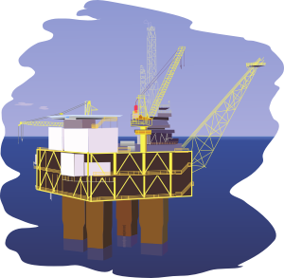](http://www.google.co.uk/url?sa=i&rct=j&q=oil%20rig%20cartoon%20pictures&source=images&cd=&cad=rja&docid=hT5Joylwhl9isM&tbnid=XBJVM6ihkboxOM:&ved=0CAUQjRw&url=http://www.clker.com/clipart-13859.html&ei=g7YoUZjSGenO0QWW3IHwDQ&psig=AFQjCNEJcGbV8AJ9V62S4WiSt4Lq3ZtiKA&ust=1361709053542509)**

**O**xidation

**I**s

**L**oss

**R**eduction

**I**s

**G**ain

Equations like these:

Mg Mg**2+** + 2e**-** and

**½** O**2** + 2e**-** O**2-**

are known as ION-ELECTRON equations.

Write oxidation and reduction ion-electron equations for the reaction between magnesium and hydrochloric acid:

Mg(s) + 2H**+**(aq) + 2Cl**-**(aq) Mg**2+**(aq) + 2Cl**-**(aq) + H**2**(g)

Notice that nothing happens to the chloride ions.

What do we call ions that take no part in reactions?

Write oxidation and reduction ion-electron equations for the reaction between zinc and sulfuric acid.

Write ion-electron equations for the reaction between sodium and chlorine.

Write ion-electron equations for the reaction between zinc and nitric acid.

Oxidation and reduction reactions always occur together so these reactions are known as **REDOX REACTIONS.**

**Combining Ion-Electron Equations**

Remember, oxidation and reduction are two halves of the same chemical reaction. The combined reaction is called a Redox reaction.

To form an overall redox reaction, the ion-electron equations for the oxidation and reduction must be combined, ensuring that the electrons cancel.

For example, when magnesium reacts with a silver(I) ion solution, magnesium ions and silver are produced.

Oxidation: Mg Mg**2+** + 2e**-**

Reduction: Ag**+** + e**-** Ag (x2)

Mg + 2Ag**+** Mg**2+** + 2Ag

When aluminium reacts with an acid, aluminium ions and hydrogen gas are produced.

Oxidation:Al Al**3+** + 3e**-** (x2)

Reduction: 2H**+** + 2e H**2** (x3)

2Al + 6H**+** 2Al**3+** + 3H**2**

For each of the following reactions, combine the oxidation and reduction steps to form a balanced redox reaction.

(a) Ce**4+** + e**-** Ce**3+**

2Br**-** Br**2** + 2e**-**

(b) Cu Cu**2+** + 2e**-**

Ag**+** + e**-** Ag

(c) MnO**4-** + 8H**+** 5e**-** Mn**2+** + 4H**2**O

Fe**2+** Fe**3+**  + e**-**

**Cells**

Our lives have been transformed by the use of mobile devices, such as iphones, ipads and computers. The development of chemical cells and batteries has led to this massive increase in the use of mobile technology.

Using two different metals and an **electrolyte** (a compound which conducts due to the movement of ions) we can produce electricity from a simple chemical cell like that shown below.

In this experiment different metals are connected together and the voltage produced is measured.

**Activity 6**



Record your results in the table on the next page.

|  |  |  |
| --- | --- | --- |
| **Metal 1** | **Metal 2** | **Voltage (V)** |
| Copper | Magnesium |  |
| Copper | Tin |  |
| Copper | Aluminium |  |
| Copper | Copper |  |
| Copper | Zinc |  |

What do you notice about the reactivity of the metal and the voltage produced?

Which particles move through the external circuit between the two metals and the wires?

Which particles move through the electrolyte between the metals?

Now list the metals in order of the voltage they produced with copper.

Highest

Lowest

Chemists call this the **Electrochemical Series** (see page 10 of Data Book)**.**

Note that the electrochemical series and the reactivity series are similar but not exactly the same.

In a cell, electrons always flow from the metal high in the electrochemical series to the metal lower down.

Using the Electrochemical Series on page 10 of your Data Book, predict the direction of electron flow in the following cells.

1 silver/magnesium cell

From______________ to_____________through the ___________.

2 zinc/nickel cell

From______________ to_____________through the ___________.

3 lead/copper cell

From______________ to_____________through the ___________.

**More Cells**

**Activity 7 - DEMO**

Your teacher will demonstrate the following experiment.



copper(II)sulfate solution

zinc(II)sulfate solution

zinc

What voltage is produced by the cell?

What is the voltage when the ion bridge is removed?

The purpose of the ion bridge is to the .

The ion bridge gives a path for to flow.

Electrons flow from the metal up the electrochemical series to the metal in the series.

Mark the direction of electron flow on your diagram.

In the chemical cell above the flow of electrons was from Zinc (higher in electrochemical series, P10 data book) to copper (lower in electrochemical series).

The metal which is identified to be higher in electrochemical series e.g. Zinc will go in reverse to that written in the data book.

Zn(s) Zn**2+**(aq) + 2e**-**

This is an example of a loss of electrons so is an reaction.

The metal which is identified to be lower in electrochemical series e.g. Copper will go in the direction written in the data book.

Cu**2+**(aq) + 2e**-** Cu(s)

This is an example of a reaction.

Reduction and oxidation always take place together, so the two ion-electron equations can be combined to get an overall Redox equation for the cell:

Zn(s) + Cu**2+**(aq) Zn**2+**(aq) + Cu(s)

Another cell:



magnesium sulphate

solution

magnesium

On the diagram, mark the direction of electron flow.

Write ion electron equations for what is happening at each electrode, and label them ‘oxidation’ and ‘reduction’. (Assume the iron ion is Fe**2+**)

Combine the two ion-electron equations to give the overall redox equation.

**DISPLACEMENT REACTIONS**

A **DISPLACEMENT REACTION** will happen when a metal higher in the electrochemical series is added to a solution containing a metal lower in the electrochemical series.

The metal which is lower in the series is displaced or pushed out of its compound which is in solution.

**Displacement of Metals**

When copper metal is added to the colourless silver(I) nitrate solution, the colour changes will be the **loss** of the brown copper, the appearance of silver metal and the solution turning blue as the copper dissolves.

Cu + 2AgNO3 Cu(NO3)2 + 2Ag

brown colourless blue silver

Copper has displaced silver from a compound containing silver ions.

Cu + 2Ag+NO3- Cu2+(NO3-)2 + 2Ag

When the nitrate spectator ions are removed, the reaction is between copper atoms and silver(I) ions.

Cu + 2Ag+ Cu2+ + 2Ag

**Displacement of Hydrogen**

The reactions of metals with acids (which contain the hydrogen ion), used to place hydrogen in the reactivity series is a further example of a displacement reaction.

In this reaction, hydrogen is displaced from an acid by a metal.

As with other displacements, only metals above hydrogen can cause this to happen e.g. magnesium will react but copper will not.

As lead will displace hydrogen from an acid, hydrogen is placed between lead and copper in the electrochemical series.

**Rechargeable Batteries**

We all use rechargeable batteries every day, in our mobile phones, ipods, tablets, and laptops.

The first rechargeable battery was the lead-acid battery, invented in 1859. It is still used today as the main battery in cars.

**Fuel cells**

A battery is a device that generates electricity, e.g. for lighting or turning a motor. A battery has all of its chemicals stored inside and when in use, these are being converted to products. A battery will eventually ‘run down’ and you either throw it away or recharge it.

A **fuel cell** is also a device that makes electricity. Hydrogen is the most common fuel and the other reactant is usually oxygen. With a fuel cell, as long as there is a flow of reactants into the cell, the electricity flows out of the cell.

Every fuel cell has two electrodes, one positive and one negative. The reactions that produce electricity take place at the electrodes and their rate is increased by the presence of suitable catalysts. Every fuel cell also has an electrolyte that allows ions to move from one electrode to the other.

Although the basic workings of a fuel cell may not be difficult understand, the building of inexpensive, efficient, reliable fuel cells is as yet a complicated and uncertain business.

**The hydrogen/oxygen fuel cell**

**electron flow**

**light**



**surface catalyst**

**surface catalyst**

**hydrogen from storage tank**

**oxygen**

**from air**

**positive electrode**

**negative electrode**

**water out**

**electrolyte**

At the negative electrode of the cell the hydrogen molecules dissociate to form atoms on the catalyst surface.

H2 2H

Oxidation of the hydrogen atoms result in the formation of positively charged hydrogen ions and negatively charged electrons.

2H 2H+ + 2e-

**oxidation**

The freed electrons travel through a wire creating the electric current. The ions travel through the electrolyte to the positive electrode of the cell. On reaching the cathode, the hydrogen ions are reunited with the electrons and the two react with oxygen to produce water. This is reduction.

4H+ + O2 + 4e-  2H2O

**reduction**

One great appeal of the hydrogen/oxygen fuel cell is that electricity is generated with very little pollution since the product of the two reactions is water.

2H2 4H+ + 4e-

4H+ + O2 + 4e-  2H2O

2H2 + O2 2H2O

1. What is the difference between a fuel cell and a battery?
2. In the hydrogen / oxygen fuel cell, what is happening … at the positive electrode? … at the negative electrode?
3. What is the great appeal of the hydrogen / oxygen fuel cell?

**Properties of Plastics**

**National 4 Learning Outcomes**

* Monomers are small molecules that combine to form polymers.
* ‘Mono’ means one, ‘poly’ means many, ‘mer’ means unit.
* A polymer is a large molecule made up of very many monomers joined together.
* Polymerisation is a process by which many monomer molecules combine to form a polymer.
* The name of a polymer can be deduced from the name of the monomer.
* Plastics are synthetic (man-made) polymers.

**National 5 Learning Outcomes**

* There are two types of polymerisation – addition and condensation.
* Molecules with double bonds (alkenes) are the monomers used to make addition polymers.
* Ethene monomers are used to make poly(ethene). Poly(propene) is made from propene monomers.
* A repeating unit is a shortened version of a polymer structure.
* The monomer unit and repeating unit for poly(propene) are:

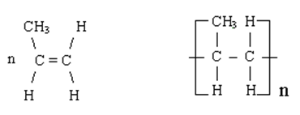

Monomer unit Repeating unit

* Condensation polymerisation is similar to addition polymerisation in that many small molecules combine to form one large molecule. The difference is that, during condensation polymerisation, water or other small molecules are also produced.
* Polyesters and polyamides are examples of synthetic condensation polymers.
* Starch and cellulose are examples of natural condensation polymers.

**Properties of Plastics**

Plastics belong to a family of compounds called polymers. There are two types of polymers – Addition polymers and Condensation polymers.

**Addition Polymerisation**

Unsaturated molecules (like alkenes) contain a carbon to carbon double bond. The double bond on each molecule opens up and the molecules link together to form the polymer. These unsaturated molecules are made from ‘cracking’ of crude oil fractions.

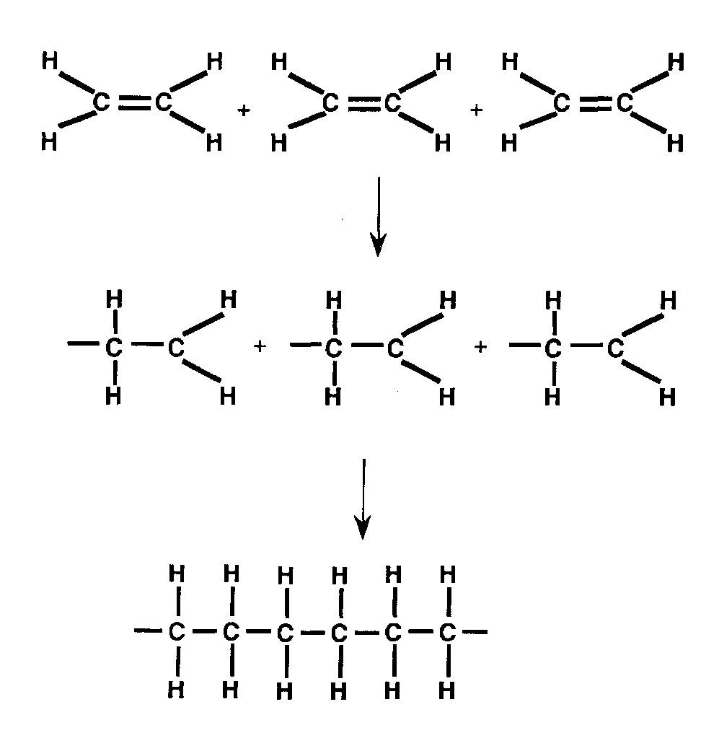

3 molecules of ethene

Their double bond opens

They join together

to form a polymer.

Since the monomer is called ethene, the polymer is called

The process of forming a polymer from an alkene is called

**polymerisation**.

**Can you make a Polymer?**

Other polymers can be made in the same way. Here is propene.

3 molecules of propene

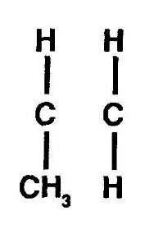

+

+

Open their double bond

Join them together.

Since the monomer is called propene, the polymer is called

Sometimes the repeating unit of the polymer is shown eg polyethene, polypropene:

[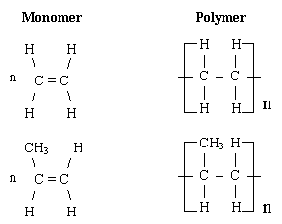](http://www.google.co.uk/url?sa=i&rct=j&q=repeating%20unit%20propene&source=images&cd=&cad=rja&docid=lB-5MZ_4oD0T6M&tbnid=uu6c0IKCAranCM:&ved=0CAUQjRw&url=http://www.swotrevision.com/pages/alevel/chemistry/m2_part5.htm&ei=il88Ud63M4Ox0QWHkYCQCw&psig=AFQjCNGHjd2kwWjIS_zWq0JafFiExQq2IQ&ust=13629974893069)

The repeating units are drawn as a part of the polymer chain and bonds extending from each carbon atoms are drawn and brackets are placed around each ‘unit’ with an n (n stands for many of these units joined) subscript outside the brackets.

**Naming polymers**

|  |  |
| --- | --- |
| **Monomer** | **Polymer** |
| ethene | poly(ethene) |
| tetrafluoroethene | poly(tetrafluoroethene) |
| styrene |  |
|  | poly(vinylchloride) |
| urethane |  |
|  | poly(vinylacetate) |

**Questions**

1. (a) Draw the full structural formula for but-1-ene.

1. Draw three units of but-1-ene in the shape of an H.

(c) Draw part of the polymer when these three units join.

(d) What is the name of the polymer?

(e) Draw the repeating unit.

2. (a) Draw the full structural formula for pent-1-ene.

1. Draw three units of pent-1-ene in the shape of an H.
2. Draw part of the polymer when these three units join.
3. What is the name of the polymer?
4. Draw the repeating unit.

3. Another common polymer is poly(vinylchloride) (PVC)

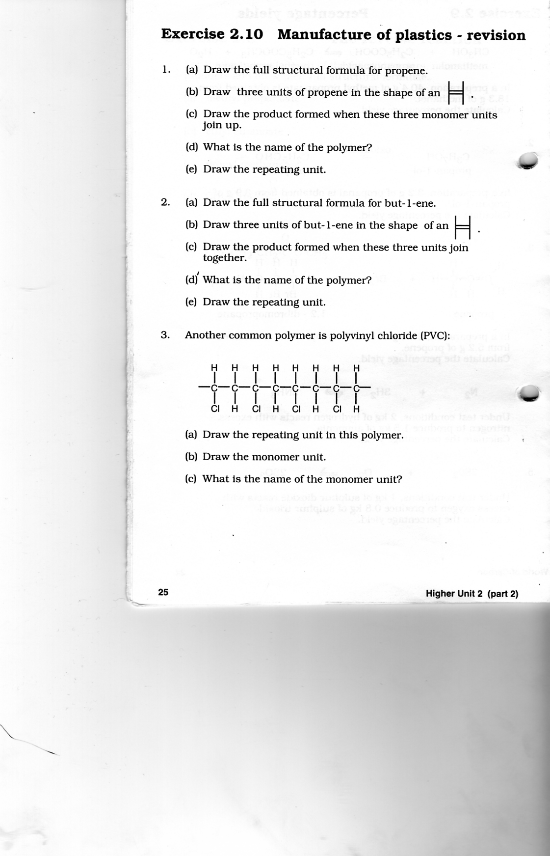

1. Draw the repeating unit in this polymer
2. Draw the monomer unit
3. What is the name of the monomer unit?

4. PTFE is an addition polymer made from **tetrafluoroethene**.

1. What does PTFE stand for?
2. Draw the full structural formula for tetrafluoroethene.
3. Draw the structure of part of a PTFE chain to show how **three** monomer units have joined together.

**Condensation Polymers**

**Polyesters**

In Unit 2 we met **esters**, a group of sweet smelling compounds used in perfumes, artificial flavourings, and as solvents in paints, cosmetics and adhesives.

**Ester formation**

The reaction between an alkanoic acid and an alcohol produces an **ester**.

[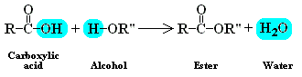](http://www.google.co.uk/url?sa=i&rct=j&q=forming+esters&source=images&cd=&cad=rja&docid=b5UXHJWyI4_PtM&tbnid=kLGXFzrhJUEZBM:&ved=0CAUQjRw&url=http://www.materialsworldmodules.org/resources/polimarization/4-condensation.html&ei=zPYYUdO7JOSY0QXd0ICACg&psig=AFQjCNHV_NBdm-ejmhEjBKybUltX7pdglw&ust=13606769340395)

R, R’’= alkyl groups, e.g. –CH**3** or methyl; –C**2**H**5** or ethyl etc.

Water is lost in this reaction so this is known as a ___________________________ reaction.

The water is formed from the hydrogen of the alcohol, together with the –OH from the carboxylicic acid.

Try this one:

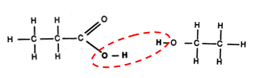

propanoic acid + ethanol ester + water

(ethyl propanoate)

**Making polyesters**

Polyesters are prepared from monomers with two functional groups per monomer unit. In other words, a dicarboxylic acid and a dialcohol.

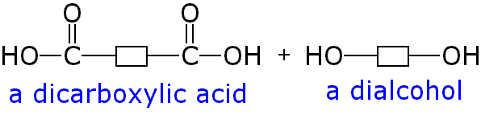

This means that when one pair of functional groups have reacted, there is still a functional group at each end of the new molecule to continue the reaction.



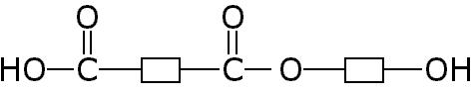

carboxyl group hydroxyl group

The carboxyl group can now react with a hydroxyl group on another dialcohol molecule, and

The hydroxyl group can now react with a carboxyl group on another dicarboxylic acid molecule and so on…

Show how two of each of these molecules can join together to form part of a polyester:

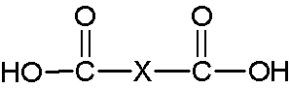

DiolDiol

A is formed when thousands of these monomer units react together and is lost during this reaction, so it is called a polymerisation reaction.

**Uses of polyester**

Polyester is used to make plastic soft drinks bottles, as it is very strong. It is also glossy so looks attractive. Polyester is also used in clothing materials – in fact your school tie and school blazer is made entirely of polyester and your shirt/blouse probably contains up to 65% polyester (mixed with cotton).

Polyester resins are thermosetting polymers. They can be mixed with glass fibre to form glass reinforced plastic (GRP).

**Problems with plastics**

Plastics are quite cheap, light and can be easily moulded into any shape. They are also highly durable and have a variety of other useful properties. However, plastics can also be a problem.

The leaves from the trees are biodegradable ('bio' refers to living things and 'degradable' means 'able to rot away'). Leaves are broken down by bacteria (living organisms) and weather and eventually decompose. Plastics are not biodegradable.

1. What is meant by biodegradable?
2. What problems can arise from the non-biodegradability of plastics?

Further problems can arise with the melting and burning of plastics. Fires involving plastics are extremely dangerous.

1. Do plastics melt when heated? Do plastics burn?

Poisonous fumes can contribute to further pollution problems. Since polymers have carbon atoms in the chains, carbon monoxide, CO, can be given off from just about any burning plastic.



can burn to give CO

Other gases produced include hydrogen chloride, HCl (g), from poly(vinylchloride) and hydrogen cyanide, HCN (g), from polyurethane.



poly(vinylchloride) can burn to give HCl



polyurethane can burn to give HCN

**T**he gases produced depend on the elements in the plastic.

1. What problems can arise from burning plastics?

**Effect of heat**

Plastics can be classified according to what happens to them on heating.

Thermoplastics (thermosoftening plastics) soften on heating. This enables them to be reshaped over and over again. Thermosetting plastics harden on heating and do not melt on reheating. Thermosetting plastics have quite different uses from thermoplastics.

1. What is meant by … a thermoplastic? … a thermosetting plastic?
2. Complete the tables to show the names of some thermoplastics/thermosetting plastics and their uses.

|  |  |
| --- | --- |
| Thermoplastic | Use |
|  |  |

|  |  |
| --- | --- |
| Thermosetting plastic | Use |
|  |  |

**Ceramic materials**

The early ceramic materials (ceramics) include porcelain, used to make decorative items and objects of fine art, e.g. vases, plates and tiles.

Ceramic materials display a wide range of properties that offer many advantages compared to other materials, e.g. in general, they are hard (wear resistant), resistant to corrosion and high temperatures and most are poor/non-conductors of heat and electricity. This leads to their modern use in a wide variety of domestic, industrial and building products.

**Complete the table for THREE properties of ceramic materials**.

|  |  |
| --- | --- |
| **Property** | **Use** |
|  |  |
|  |  |
|  |  |

**Novel Materials**

Plastics are constantly being used for many modern materials. Read pages 99-101 in the National 5 textbook and write a summary of the information you have found.

**Fertilisers**

**National 4 Learning Outcomes**

* Fertilisers are required for the production of crops.
* Fertilisers provide the three main nutrients that plants require in order to grow.
* The three main nutrients are nitrogen (**N**), phosphorus (**P**) and potassium (**K**).
* Fertilisers can be natural (eg manure or compost) or synthetic.
* Different fertilisers, for different plants, have different proportions of N, P and K.

**National 5 Learning Outcomes**

* Ammonium nitrate (NH**4**NO**3**)is a major component of synthetic fertilisers.
* Ammonium nitrate is a salt which can be made by reacting ammonia (NH**3**) with nitric acid (HNO**3**) in a neutralisation reaction.
* Ammonia is made from nitrogen and hydrogen in a process called the Haber process.
* The Haber process is a reversible reaction.
* The Haber process is carried out at around 450**o**C and a pressure of 200 atmospheres, using an iron catalyst.
* Nitric acid is made using some of the ammonia from the Haber process.
* Calculating the percentage composition, by mass, of a fertiliser.

**What are fertilisers?**

Fertilisers contain compounds that are essential for plant growth. These are known as plant nutrients.

The three essential elements for plant growth are Nitrogen (N), Phosphorus (P) and Potassium (K).

Fertilisers can be natural, like manure or compost, or synthetic (made by chemists).

**Why do we need synthetic fertilisers?**

Read Pages 103-104 of ‘National 5 Chemistry’.

1 What is the estimated world population going to be in 2050?

2 Why are artificial fertilisers now needed?

3 What other resources are needed to grow enough food to feed the world’s population?

4 What are the essential elements needed for plant growth?

5 What is the important gas which is produced by a process developed by Fritz Haber?

**Ammonia (NH3)**

Ammonia is the key substance in the production of fertilisers. The chemical name for ammonia is nitrogen hydride. Ammonia is a pungent (sharp) gas with a strong smell. It is the smell associated with wet nappies!

Your teacher will demonstrate an experiment to show you the solubility of ammonia in water:

**Activity 1 (DEMO)**

Ammonia gas

Water + universal indicator

Results:

1. What colour does the universal indicator turn?
2. What does this tell us?
3. What ion is therefore present in the solution?
4. The alkali produced is called **ammonium hydroxide**. **Ammonia gas** is therefore described as being an **alkaline gas**. Write a word equation and then a formula equation for the reaction between ammonia gas and water.

**Word equation: +**

**Formula equation: +**

1. Which of the following compounds would you expect to react with ammonia?

Circle your answers.

nitric acid sodium hydroxide copper(II)oxide

lithium oxide sulfur dioxide calcium carbonate

1. Explain why you picked these particular compounds.

**The Haber Process**

Industrially, ammonia is formed in the **Haber Process.**

The formula of ammonia is **NH3**.

1. Which two elements do you require in order to make ammonia?
2. Where do you think you would find each of these elements?

Nitrogen is obtained from the air. Air is about 80% nitrogen.

Hydrogen is obtained from either water or methane.

Read pages 104-105 of ‘National 5 Chemistry’ and answer the following questions on the Haber Process.

In the space below, draw the diagram shown on P105 of the Haber Process:

**Manufacture of Nitric Acid – The Ostwald Process**

Ammonia is oxidised with the help of a platinum catalyst to form oxides of nitrogen, eventually nitrogen dioxide (so the process is described as catalytic oxidation)

This nitrogen dioxide is then mixed with more oxygen and dissolved in water to form nitric acid.

Here is a flow diagram of the process:

ammonia

oxygen

water

nitric acid

Moderately high temperature (600oC)

platinum catalyst

mixer

oxygen

oxides of

nitrogen

Write formula equations for theword equations below (there is no need to balance the equations):

ammonia + oxygen nitrogen dioxide + water

+  +

oxygen + nitrogen dioxide + water nitric acid

+ +

Reasonably high temperatures are needed to start the catalytic oxidation of ammonia (about 900oC). This uses up a lot of energy and costs a lot of money. The reaction, however, is very exothermic. This means that heat energy is produced during the reaction and so the electricity supplied to heat the gases can be gradually reduced. This saves both energy and money.

These two compounds, **ammonia** and **nitric acid**, can react together in a neutralization reaction to form ammonium nitrate.

**Calculating the percentage mass composition of fertilisers**

A good fertiliser must contain at least one of the essential elements (N, P and K), and must be soluble in water so that it can be absorbed through the roots of plants.

Ammonium nitrate is a commonly used compound in fertilisers.

How to calculate percentage mass:

Step 1 – Calculate the mass of 1 mole of the compound (the Formula Mass!)

Step 2 – Calculate how much of the element is contained in 1 mole of the compound

Step 3 – Calculate the percentage

Example: Calculate the percentage mass of nitrogen in ammonium nitrate.

Step 1 NH**4**NO**3**

1 mole = 14 + (1x4) + 14 + (16x3)

= 80g

Step 2 There are 28 g of nitrogen in one mole (i.e. 14 x2)

Step 3 Percentage mass = 28 x 100

80

= 35%

Exercise:

1 Calculate the percentage mass of nitrogen in urea, (NH**2**)**2**CO.

2 Calculate the percentage mass of nitrogen, and potassium, in potassium nitrate.

3 Calculate the percentage mass of nitrogen in ammonium sulfate.

4 Calculate the percentage mass of nitrogen, and phosphorus, in ammonium phosphate.

**Nuclear Chemistry**

**National 5 Learning Outcomes**

* Radioactive elements can become more stable by emitting alpha, beta or gamma radiation.
* Alpha, beta and gamma radiations have specific properties such as their charge, mass and ability to penetrate different materials.
* The time for half of the nuclei of a particular radioisotope to decay is fixed, and is called the half-life.
* Half-life, for a particular radioisotope, can be calculated from measured data.
* The half-life for a particular radioisotope is a constant so radioisotopes can be used to date materials.
* Radioisotopes have medical, scientific and industrial uses.
* Nuclear equations can be written to describe nuclear reactions.

**What is Nuclear Chemistry?**

Nuclear Chemistry is concerned with the nucleus, what makes some nuclei unstable, and what happens when those nuclei disintegrate.

Unstable nuclei (radioisotopes) are transformed into more stable nuclei by disintegration. The disintegration of the nucleus can give rise to

* Particles being ejected from the nucleus at high speed
* A large amount of energy being released

The breakdown or disintegration is random, with some isotopes decaying very quickly and others taking many years.

**Changes in temperature, pressure, physical state or chemical composition make no difference to the rate of radioactive decay.**

It is important to remember that nuclear reactions take place inside the nucleus whereas chemical reactions involve the sharing or transfer of outer electrons.

**Background Radiation**

Background radiation comes from a number of sources. Complete the table below to list sources of natural and artificial background radiation.

|  |  |
| --- | --- |
| **Natural** | **Artificial** |
|  |  |
|  |  |
|  |  |

**Types of Radiation**

There are three types of radiation – **alpha ()**, **beta (β)** and **gamma ()**

**Alpha Particles ()**

Alpha particles can be thought of as being helium nuclei, each containing two protons and two neutrons: **4**

**He**

**2+**

**2**

**4**

He

**2**

**Beta Particles (β)**

**e**

**-1**

**0**

The particles in beta radiation are high energy electrons: **0**

e

**-1**

Beta particles are formed inside the nucleus when a neutron breaks up into a proton and an electron:

**1 1 0**

n p + e

**0 1 -1**

As soon as they form, these high energy electrons are ejected from the nucleus as beta radiation.

**Gamma Waves ()**

While alpha and beta radiations are made up of particles, gamma radiation consists of **electromagnetic waves** and therefore has no mass.

**Properties and behaviour of Radiation.**

The following diagram shows how the three types of radiation are deflected in an electric field:

**β**

****

**α**

Source of ****, **β** and

**** radiation

**β**

****

****

Alpha, beta and gamma radiations also have different penetrating powers:

ppaper

0.6cm

aluminium

thick concrete or lead



**β**

****

   ****

****

**    **

paper

Alpha particles are quite large, so cannot get through a thin sheet of paper.

Beta particles are much, much smaller so can get through paper, but are stopped by a sheet of aluminium.

Gamma waves pass through the paper and aluminium, but are blocked by a block of concrete or a thick sheet of lead.

**Nuclear Reactions**

When radioactive atoms disintegrate (decay) it is the nuclei which are involved. The changes which take place in these nuclei depend on the type of radiation emitted.

**Alpha Decay**

An alpha particle is a _____________ nucleus and thus contains ___________ protons and ____________ neutrons. When a nucleus emits an alpha particle its atomic number will decrease by ________(loss of two protons) and its mass number will fall by________ (loss of two protons and two neutrons) e.g.

**232 228 4**

Th Ra + He

**90 88 2**

In balanced nuclear equations the total mass number on the LHS of the equation is _____________ to the total mass number on the RHS. The same is true for the atomic number.

**4**

**228**

**232**

**Beta Decay**

A beta particle is a fast moving __________ which is formed along with a ________ when a neutron in a radioactive nucleus breaks down. As a result of beta decay, the atomic number of the nucleus will increase by _______ but the mass number will remain unaffected e.g.

**0**

**212**

**212**

**212 212 0**

Bi Po + e

**83 84 -1**

**Gamma Decay**

Since gamma rays have no mass and no charge, their emission will have no effect on the mass number or the atomic number of the radioisotope.

**Exercise – Radioactivity**

1. Alpha, beta and gamma radiation have different penetrating properties. Name the type of radiation which is

(a) stopped by thick concrete

(b) stopped by a sheet of paper

(c) stopped by aluminium

2. **225 225**

**y**

**225**

Ac

Ra

Ra Ac + Y

**88 89**

**217 213**

At Bi + Z

**85 83**

Identify particles Y and Z.

3. Identify the isotope which is formed when

**89**

**+**

**z**

Bi

At

**83**

**85**

1. sodium-24 emits beta particles
2. plutonium-242 emits alpha particles

4. Write a nuclear equation for

1. **** decay of polonium-210
2. **β** decay of strontium-90
3. **** decay of radium-226

5. Part of a radioactive decay series is shown below.

**227**

Th

**90**

**231**

Th

**90**

Th

**90**

**231**

Isotope X

Isotope Y

Th

**90**

**227**

β-decay

β-decay

1. Identify isotopes X and Y
2. Which type of decay occurs between isotope X and isotope Y?

6. An atom loses successively an alpha particle, a beta particle and a gamma ray. What net effect would this have on the parent nucleus?

7. P is a radioisotope which undergoes emissions as follows:

β β β

P Q R S

If the atomic number of P is 88, and its mass number is 228, what are the atomic number and mass number of isotope S?

8. The radioactive isotope Fr-227 decays to form a stable isotope by the following sequence of emissions:

**, **, **β**, ****, **β**

Determine the mass number, atomic number and identify the stable isotope formed by this sequence of emissions.

9. What is the source of Pb-206 if it is formed by ****-emission followed by β-emission?

**Artificial Radioisotopes**

Radioisotopes can be made by bombarding nuclei with various particles including alpha particles, protons and neutrons. When protons and neutrons are used and are incorporated into the parent atom we call this proton capture and neutron capture respectively.

Phosphorus-30 was the first radioisotope to be produced artificially. It was made by bombarding a target of aluminium-27 with alpha particles:

**27 4 30 1**

Al + He P + n

**13 2 15 0**

For nuclear reactions to occur, the bombarding particles must have a high kinetic energy to overcome the forces of repulsion exerted by the target nuclei. With the advent of nuclear reactors and particle accelerators it is now much easier to make radioisotopes. For example, cobalt-60, used in cancer therapy, is made in nuclear reactors where a target of stable cobalt-59 is bombarded by neutrons:

**59 1 60**

Co + n Co

**27 0 27**

This type of nuclear reaction is called **neutron capture**.

**Proton capture** can occur when protons are used as the bombarding particles:

**14 1 15**

N + p O

**7 1 8**

**Exercise – Artificial Radioisotopes**

1. Complete each of the following nuclear equations and identify R and S

**6 1 3**

Li + n H + R

**3 0 1**

**238 4 239**

U + He Pu + 3S

**92 2 94**

2. Identify particles X and Y

**14 4 17**

N + He O + X

**7 2 8**

**14 9 1**

N + B H + Y

**7 5 1**

**Half-Life**

In a sample of a radioactive material, the individual unstable nuclei decay in a random way. Nevertheless, when the disintegration of the many millions of unstable atoms present in the sample is averaged out the decay of a radioisotope follows a definite pattern. The decay curve will always be the same shape.

This is the decay curve for technetium-99.



The mass of technetium-99 falls from 1∙0g to 0∙5g in 6 hours, so the half-life of technetium-99 is 6 hours.The half-life is the time taken for the **mass** or **activity** of a radioisotope to halve.

Radioactive decay is a spontaneous and **random** occurrence and is not affected by external conditions such as chemical changes, temperature, pressure or the physical state of the sample.

The half-life of a given radioisotope is a constant. No matter how many atoms of sample are present, or what temperature or state it is in, **half will decay over a fixed time period**, known as the half-life, (**t1/2**).

In addition, the **half-life** of a radioisotope is the **same** whether the isotope is present as **atoms** or as **ions in a compound**, i.e. the half life of lead-206 in the element is the same as the half-life of lead-206 in PbCl2. This is because radioactive decay is a nuclear reaction and the formation of a compound involves only electrons and not the nucleus.

# Worked example 1

If 100kg of a radioisotope with a half-life of 2.5 years is left buried for 10 years what mass of the original sample will remain?

After 2.5 years 100kg will decay to 50kg.

After another 2.5 years 50kg will decay to 25kg

After another 2.5 years 25kg will decay to 12.5kg

After another 2.5 years 12.5kg will decay to **6.25kg**

**WORKED EXAMPLE 2**

An 80gram sample of a radioisotope of phosphorus has a half-life of 14 days. Calculate the remaining mass of the sample after 56 days.

56 days is four half-lives.

t**1/2** t**1/2** t**1/2** t**1/2**

80g 40g 20g 10g 5g

# Worked example 3

A radioisotope with an activity of 200 counts per minute is kept for 40 minutes and the count rate drops to 50 counts per minute. What is the half-life of the isotope?

t**1/2** t**1/2**

200 100 50

To drop from 200 cpm to 50 cpm requires two half-lives.

So each half-life = 20 minutes.

**Exercise – Half-life**

1. Na-24 is a radioactive isotope of sodium with a half-life of 15 hours. A sample of Na-24 has a mass of 200g.

1. What is meant by half-life?
2. What will be the mass of the sample after 120 hours?

2. The initial radioactivity from a sample of actinium chloride is 120 counts/minute. If the half-life of actinium is 6 hours, how long will it take for the sample of the chloride to reach a reading of 15 counts/minute?

3. The rate of alpha emission from a 48 day old sample of a radioactive isotope was found to be a quarter of that of the original sample. What is the half-life of the sample?

4. After 15 days a sample contained 7.7 x 1021 atoms of radioactive bismuth, half-life 5 days. How many atoms were in the sample originally?

5. A radioisotope used in a hospital has a half-life of 1.5 hours. It has a count rate of 8000 counts per minute at 9am.

1. What would the count rate be at 1.30pm on the same day?
2. An aqueous solution of a compound containing the radioisotope was prepared. What effect would this have on the half-life?

6. Samples of radium oxide and radium sulfate both contain the same radioisotope. Why does a 1g sample of the oxide show a different intensity of radiation from the sulfate?

10. Polonium-218 is an alpha emitting radioisotope. After 6 minutes the mass of the radioisotope was found to be one eighth of the original. What is the half-life of the radioisotope?

**Uses of Radioisotopes**

**Medical**

Radioisotopes are used in medicine for both treatment and diagnosis. Deep seated tumours can be bombarded with a focused beam of gamma rays from cobalt-60 to kill cancerous cells. Cancer cells near the surface of the skin can be treated with a beta emitter like phosphorus-32. Iodine-131 is used to trace and treat thyroid disorders since its rate of uptake, measured by detecting the gamma and beta radiation given off, can be compared with a normal thyroid gland.

**Industrial**

The gamma rays from cobalt-60 can be used to control the thickness of sheet steel. The cobalt-60 is placed on one side of the sheet and the detector is on the other. If the intensity falls the steel is too thick and if it rises the steel is too thin. A computer controls the thickness of the steel and makes automatic adjustments according to the data received from the detector.

Americium-241 is used in smoke detectors. The smoke triggers a change in the alpha radiation level reaching the detector. The detector is usually linked directly to a buzzer or a sprinkler.

**Scientific Research**

Carbon-14 is absorbed by plants during the process of photosynthesis and so the tissues of all living plants and animals contain the radioisotope. The level of carbon-14 in living material is also constant since its rate of decay is equal to its rate of uptake from the atmosphere.

When the living organism dies it can no longer absorb carbon-14 and the level of radioactivity will decrease.

By comparing the activity of plant or animal remains with that of living material and knowing the half-life of carbon-14 it is possible to work out the age of the remains.

E.g. Carbon from a wooden beam in an ancient tomb has an activity of 3.75 counts per minute. New wood has an activity of 15 counts per minute. 2 half-lives must have passed to reduce the activity from 15 to 3.75 counts and so the wooden beam must be 2 x 5600 ie 11200 years old.

**Energy Production**

Nuclear reactions are accompanied by an overall decrease in mass. The mass lost is converted into energy which can then be harnessed.

**Nuclear Fission**

To produce energy on a large scale the naturally occurring radioisotope uranium-235 can be used. Its heavy nuclei are bombarded with neutrons. They then undergo nuclear fission. This means the atom splits releasing large amounts of energy. The fission process is accompanied by the emission of more neutrons. These neutrons will cause fission in other uranium-235 nuclei and a chain reaction results.

In a nuclear reactor the chain reaction is controlled by the absorption of some of the neutrons by non-fissionable material. The large amounts of energy generated by nuclear fission are used to generate electricity.

**Nuclear fusion**

At present, many countries are researching into energy production from nuclear fusion. In this process two light nuclei fuse together to form a heavier nucleus, e.g.

**+**

**+**

The light nuclei have to be heated to temperatures of around 100 000 000 **O**C so that they collide with each other at sufficiently high speed to overcome the repulsion between them. When they do fuse, the energy released is even greater than that produced by nuclear fission.

**Chemical Analysis**

**National 5 Learning Outcomes**

* Qualitative analysis gives an indication of the identity of a chemical in a sample (i.e. what is in it).
* Quantitative analysis determines the quantity of a chemical in a sample (i.e. how much is in it).
* Examples of qualitative analysis techniques include:

**Flame Tests**

**Precipitation**

**pH testing**

* Examples of quantitative analysis techniques include:

**Titration**

**Chromatography**

**Qualitative Analysis**

Qualitative analysis only **gives an indication of what element/compound/ion may be present.**

**Flame Tests**

When some metal compounds are placed in a Bunsen flame characteristic colours are observed. For example, sodium compounds give a bright yellow colour. Flame test results are listed in your Data Book, on page 6.

**Activity 1 – Flame Tests**

You will need: a piece of nichrome wire with a loop at the end

a dropping bottle of hydrochloric acid

a beaker of water

jars of metal compounds

Bunsen, heatproof mat, goggles

1. Clean your nichrome wire by dipping the loop into the acid, then into the water.

2. Dip the loop into one of the jars of metal compound.

3. Put the loop into the edge of a blue Bunsen flame.

4. Record your flame colour in the table below.

5. Repeat steps 1-4 for the other metal compounds.

|  |  |
| --- | --- |
| **Metal ion** | **Flame colour** |
| Cu**2+** |  |
| Li**+** |  |
| K**+** |  |
| Na**+** |  |

**Quantitative Analysis**

Qualitative analysis techniques will let you **calculate how much of an element/compound/ion is present** in a sample.

**Separation Techniques**

**Activity 2 – Analysis of Rock Salt**

Rock salt is a mixture of pure salt and rock impurities.

You will need to collect 20g of rock salt.

Working with your group, come up with a plan to find out the mass of pure salt in your 20g sample of rock salt.

Once you have discussed your plan with your teacher you can start your analysis.

Record your method and your results below.

*(Hint! Salt dissolves and the rock impurities won’t!)*

**Titrations**

**Activity 3 – Analysis of Vinegar**

You have already seen Titrations in *Unit 1.9 Acids & Bases*.

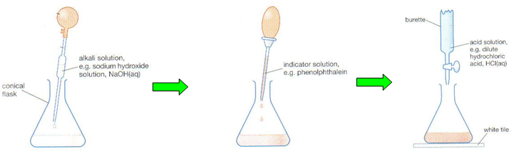

You are going to neutralise a 25cm3 sample of sodium hydroxide (0.1moll-1), with vinegar (ethanoic acid), and use the results to calculate the concentration of the vinegar.

|  |  |  |  |
| --- | --- | --- | --- |
| Titration | Start Volume (cm3) | End Volume (cm3) | Volume Added (cm3) |
| 1 |  |  |  |
| 2 |  |  |  |
| 3 |  |  |  |
| Average volume of ethanoic acid | | |  |

***Warning! Do not use any volumes that are more than 0.2cm3 away from the others!***

**Calculation:**

#### **CH3COOH + NaOH NaCH3COO + H2O**

#### Put values into the formula for everything you have been given in the question.

#### **Cac x Vac** **=** **Cal x Val**

**nac  nal**

#### 

**Exercises:**

1. What volume of hydrochloric acid (concentration 0.1 mol l-1) is required to neutralise 100 cm3 of sodium hydroxide solution (concentration 0.5 mol l-1)?

**HCl + NaOH NaCl + H2O**

2. What volume of potassium hydroxide solution (concentration 2 mol l-1) is required to neutralise 50 cm3 sulphuric acid (concentration 1 mol l-1)?

**H2SO4 + 2 KOH K2SO4 + 2 H2O**

1. What volume of nitric acid (concentration 0.5 mol l-1) is required to neutralise 25cm3 sodium hydroxide solution (concentration 4 mol l-1)?

**HNO3 + NaOH NaNO3 + H2O**