**St. Andrew’s Academy**



**CFE Higher Chemistry**

**Calculations**

Contents

Reacting Masses

Excess Calculations

Gas Calculations

Percentage Yield

Atom Economy

Bond Enthalpy

Enthalpy

Hess’s Law

Hess Law Extra

Redox Titrations

Page 1

Page 2

Page 3 Page 5

Page 7 Page 8

Page 10 Page 19

Page 22

Page 24

**REACTING MASSES**

1. 2Mg + O2 → 2MgO

What mass of MgO would be formed from 4·86g of Mg?

2. 2AgNO3 + Zn → 2Ag + Zn(NO3)2

What mass of silver will be deposited if 1·962g Zn reacts completely?

1. CaCO3 + 2HCl → CaCl2 + CO2 + H2O

Calculate the mass of carbon dioxide produced when 5g of calcium carbonate reacts completely with acid?

4. MgCO3 → MgO + CO2

Calculate the mass of magnesium oxide formed when 100g magnesium carbonate decomposes on heating.

1. A dragster can accelerate from 0 to 270mph in 5secs. The fuel is nitromethane which burns as follows:

4CH3NO2 + 3O2 → 4CO2 + 6H2O + 2N2

During a race, 45kg of fuel is used. Calculate the mass of oxygen needed to burn this fuel.

1. A Perth company buys in ammonia and phosphoric acid to make the fertiliser ammonium phosphate.

3NH3 +H3PO4 → (NH4)3PO4

What mass of fertiliser would be made from 500g of NH3?

1. At Grangemouth, BP make large quantities of ethanol by a process called catalytic hydration of ethene:

C2H4 + H2O → C2H5OH

What mass of ethanol would be produced from 560kg of ethene

1. During WW2 US Pilots carried lithium hydride tablets. If their plane crashed, the tablets reacted with sea water to produce hydrogen to fill the lifeboats.

What mass of hydrogen would be produced from 1kg of lithium hydride?

LiH + H2O → LiOH + H 2

**EXCESS CALCULATIONS**

1. 2Mg + O2 → 2MgO

0·24g is burned in 0·24 mol of oxygen. Calculate which reactant is in excess

1. AgNO3 + HCl → AgCl + HNO3

A pupil mixed 20cm3 of silver nitrate solution, concentration of 0·5 mol l-1

with 15cm3 of hydrochloric acid, concentration 1·0 mol l-1

Show by calculation which reactant was in excess.

1. 2AgNO3 + Zn → 2Ag + Zn(NO3)2

0·5g of zinc was added to 20cm3 of silver nitrate concentration 0·25 mol l-1

Show by calculation which reactant is in excess

4. NH4Cl + NaOH → NH3 + NaCl + H2O

A common method of preparing ammonia is to heat an ammonium salt with soda lime. A student heated 5g of each chemical together.

Which one was in excess?

5**.** (a) In a small scale smelter, 5kg CuO is reduced using 0·25kg carbon (charcoal).

Which reactant is in excess?

2CuO + C → 2Cu + CO2

Copper oxide casts £50 per kilogram

Charcoal costs £3 per kilogram

1. Suggest a modification to the process that would make it more cost effective.

**Gas Calculations - Molar volume**

1**.** The volume of 0.22g of propene is 118cm3. Calculate the volume of 2 moles of propene

2**.** The volume of 1 g of hydrogen is 11.6 Litres. Calculate the volume of 4 mol of hydrogen.

3**.** A flask, capacity 600cm3, was used to calculate the molar volume of sulphur dioxide.

The following data was obtained.

Mass of evacuated flask = 512.97g

Mass of flask+ sulphur dioxide = 514.57g

Calculate the molar volume of sulphur dioxide.

4. From the data calculate the approximate formula mass of gas X.

Mass of plastic bottle empty = 112.80g

Mass of plastic bottle + gas X = 113.52g

Capacity of plastic bottle = 1 Litre

Molar gas volume of gas = 23.6 litres mol-1

**In questions 5 and 6 take the molar gas volume of the gases to be 23.0 litres mol-1.**

5**.** Calculate the volume of

1. 10g of neon b) 3.2g of oxygen

6**.** Calculate the mass of

a) 2.3 Litres of ammonia b) 1 Litre of hydrogen

7.2NH3 (g) + H2SO4 (aq) → (NH4)2SO4(aq)

Calculate the volume of ammonia gas that would react with excess sulphuric acid to produce 33g of ammonium sulphate. Take the molar gas volume to be 24 litres mol-1.

8**.** Zn (s) + 2HCl(aq) → ZnCl2 (aq) + H2 (g)

Use the equation above to calculate the volume of hydrogen gas produced when the following reactions go to completion. Vmol = 24 litres mol-1.

1. 13.1g of zinc are added to excess dilute hydrochloric acid.
2. Excess zinc is added to 100cm3 of 2 moll-1 hydrochloric acid.

9. 12.25g potassium chlorate (KlO3) on heating decomposed to potassium chloride and oxygen. Calculate the volume of oxygen produced. (When the molar gas volume is 22.4L)

10. 2C + O2 → 2CO

Under a set of experimental conditions, the volume of 1 mole of gas was found to be 22.4L. What mass of carbon will be required to form 2.24 litres of carbon monoxide under the same conditions?

**PERCENTAGE YIELD**

1) Sulfur dioxide reacts with oxygen to make sulfur trioxide. 2SO2 + O2 → 2SO3

a) Calculate the maximum theoretical mass of sulfur trioxide that can be made by reacting 96 g of sulfur dioxide with an excess of oxygen.

b) In the reaction, only 90 g of sulfur trioxide was made. Calculate the percentage yield.

2) Iron is extracted from iron oxide in the Blast Furnace as shown:

Fe2O3 + 3CO → 2Fe + 3CO2

a) Calculate the maximum theoretical mass of iron that can be made from 1 tonne of iron oxide.

b) In the reaction, only 650000 g of iron was made. Calculate the percentage yield.

3) Nitrogen reacts with hydrogen to make ammonia:

N2 + 3H2 → 2NH3

a) Calculate the maximum theoretical mass of ammonia that can be made by reacting 90g of hydrogen with an excess of nitrogen.

b) In the reaction, only 153 g of ammonia was produced. Calculate the percentage yield.

4) Titanium can be extracted from titanium chloride by the following reaction:

TiCl4 + 2Mg → Ti + 2MgCl2

a) Calculate the maximum theoretical mass of titanium that can be extracted from 100 g oft titanium chloride.

b) In the reaction, only 20 g of titanium was made. Calculate the percentage yield.

.

5) Aluminium is extracted from aluminium oxide in the following reaction. 2Al2O3 → 4Al + 3O2

a) Calculate the maximum theoretical mass of aluminium that can be made from 1 kg of aluminium oxide.

b) In the reaction, only 500 g of aluminium was made. Calculate the percentage yield.

6) The fertiliser ammonium sulpfate is made as follows:

2NH3 + H2SO4 → (NH4)2SO4

a) Calculate the maximum theoretical mass of ammonium sulfate that can be made by reacting 85 g of ammonia with an excess of sulfuric acid.

b) What mass was produced if the yield was 60%?

**ATOM ECONOMY**

|  |  |  |
| --- | --- | --- |
| 1. Calculate the atom economy to make sodium from sodium chloride. |  | 2NaCl → 2Na + Cl2 |
| 1. Calculate the atom economy to make hydrogen from the reaction of zinc with hydrochloric acid. |  | Zn + 2HCl → ZnCl2 + H2 |
| 1. Calculate the atom economy to make iron from iron oxide in the Blast Furnace. |  | Fe2O3 + 3CO → 2 Fe + 3CO2 |
| 1. Calculate the atom economy to make calcium oxide from calcium carbonate. |  | CaCO3 → CaO + CO2 |
| 1. Calculate the atom economy to make sulfur trioxide from sulfur dioxide. |  | 2SO2 + O2 → 2SO3 |
| 1. Calculate the atom economy to make oxygen from hydrogen peroxide. |  | 2H2O2 → 2H2O + O2 |





Enthalpy

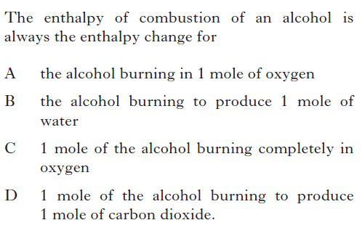1.

2.

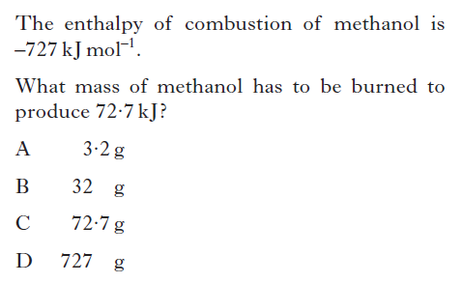

3.

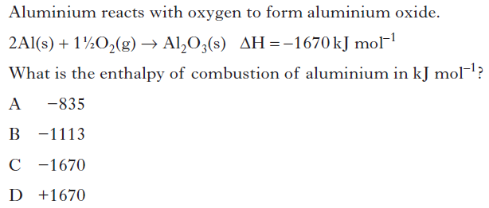

4.

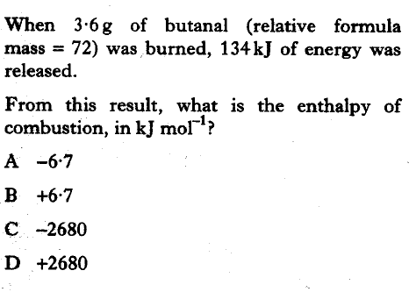

5.

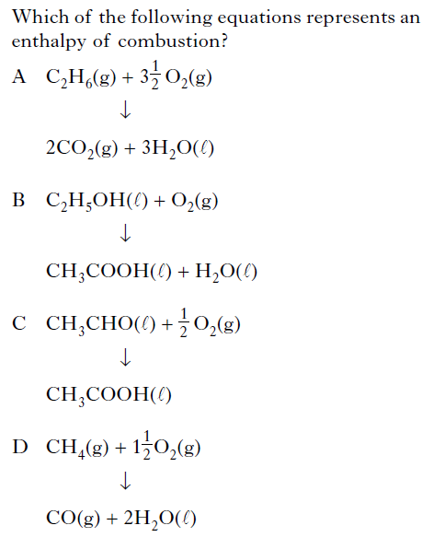

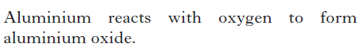6.

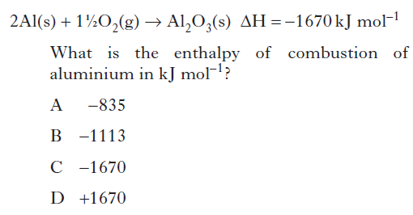

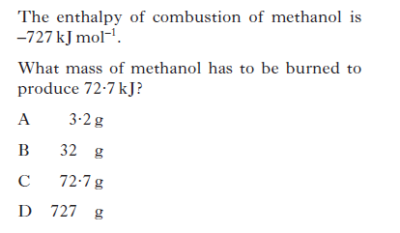7.

8. Write balanced equations to represent:

1. Enthalpy of combustion of ethane.
2. Enthalpy of combustion of carbon monoxide.
3. Enthalpy of combustion of hydrogen.
4. Calculate the heat required to raise (Eh = cmΔt)
5. 100g of water by 12oC.
6. 1 litre of water by 5oC.
7. A cylinder of carbon monoxide is used to heat 500ml of water in a beaker from 20oC to 70oC. The initial weight of the cylinder was 218.26g and the final weight was 207.96g. Calculate the enthalpy of combustion of carbon monoxide.
8. An alcohol burner containing ethanol was used to heat 100ml of water in a beaker. The initial temperature was 17oC and the final temperature was 50oC. The initial weight of the burner was 7.90g and the final weight was 7.44g. Calculate the enthalpy of combustion of ethanol.
9. 5g of sulphur was burned in air and the heat produced used to heat 0.5litres of water from 18oC to 40oC. Calculate the enthalpy of combustion of sulphur.

13.

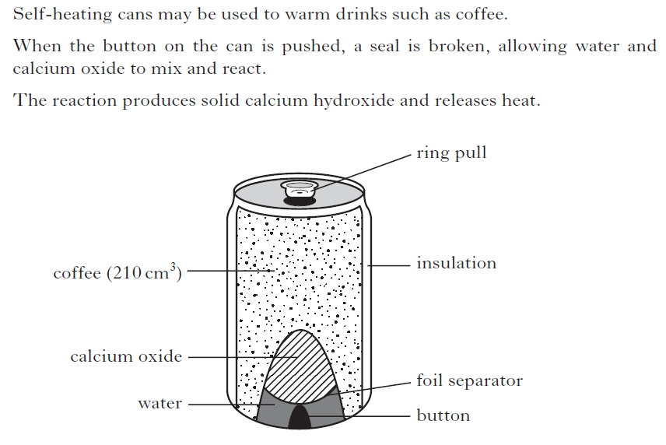

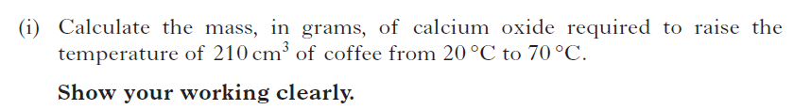

14.

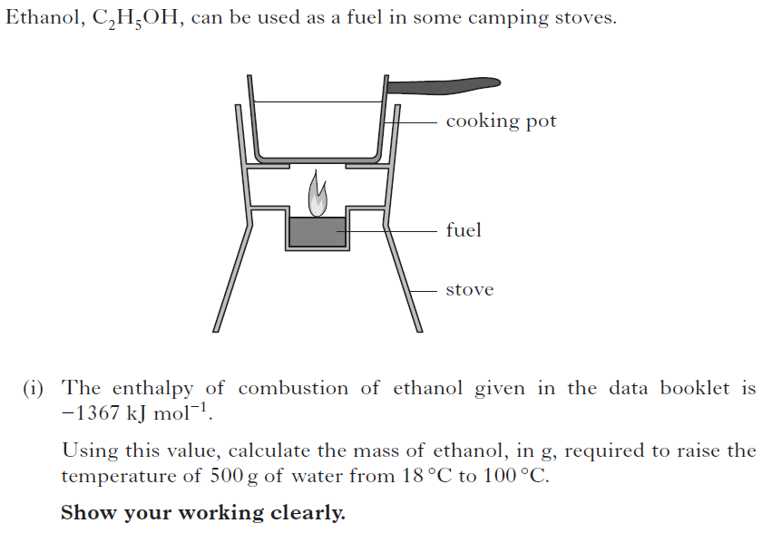

(ii) Suggest 2 reasons why less energy is obtained by burning

ethanol in the camping stove than is predicted from its

enthalpy of combustion.

15.

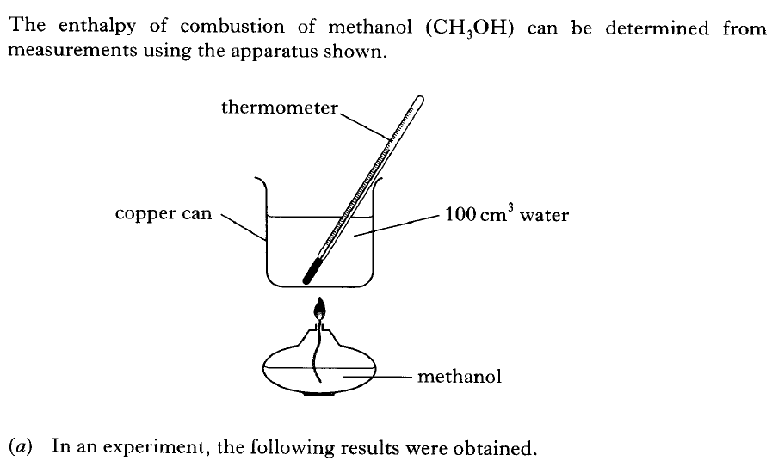

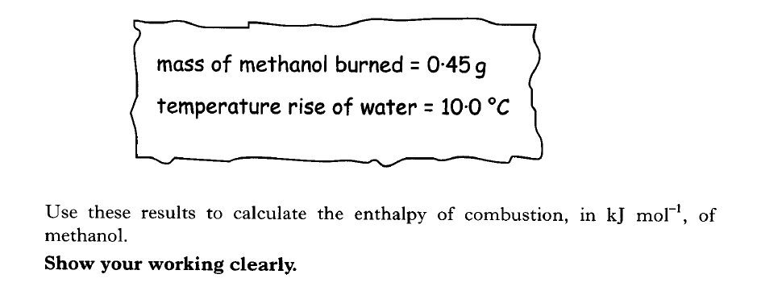16.

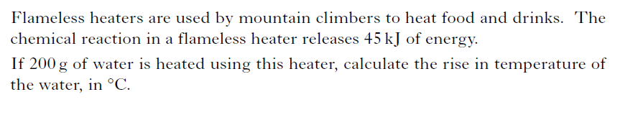

17.

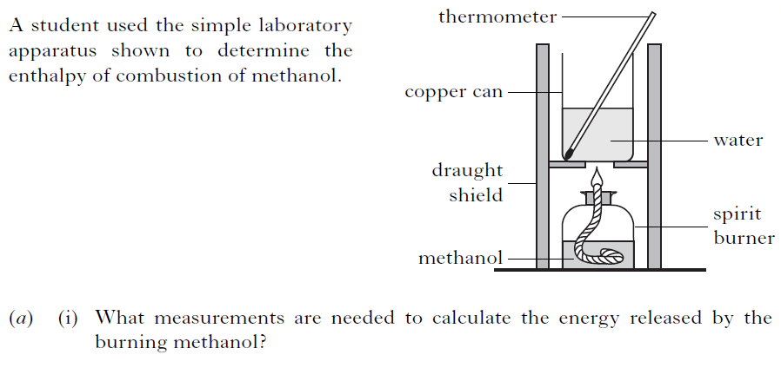

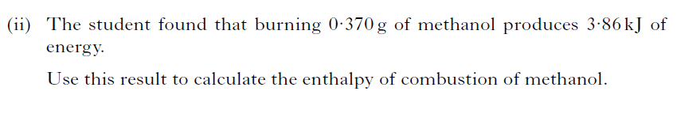

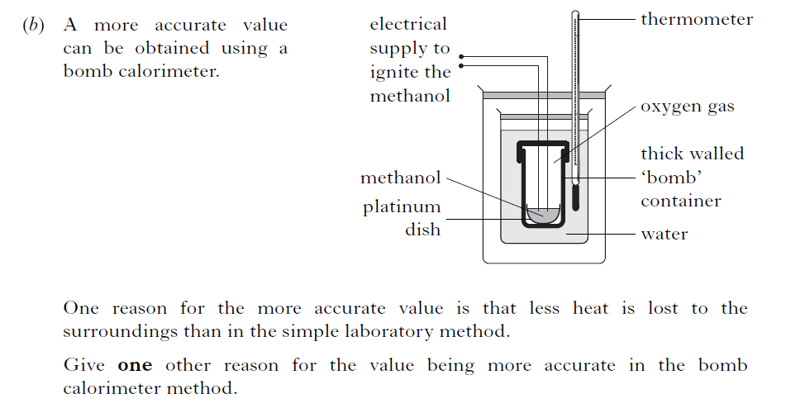

18.

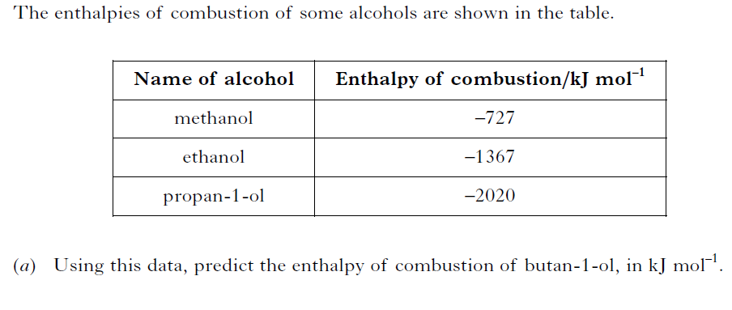

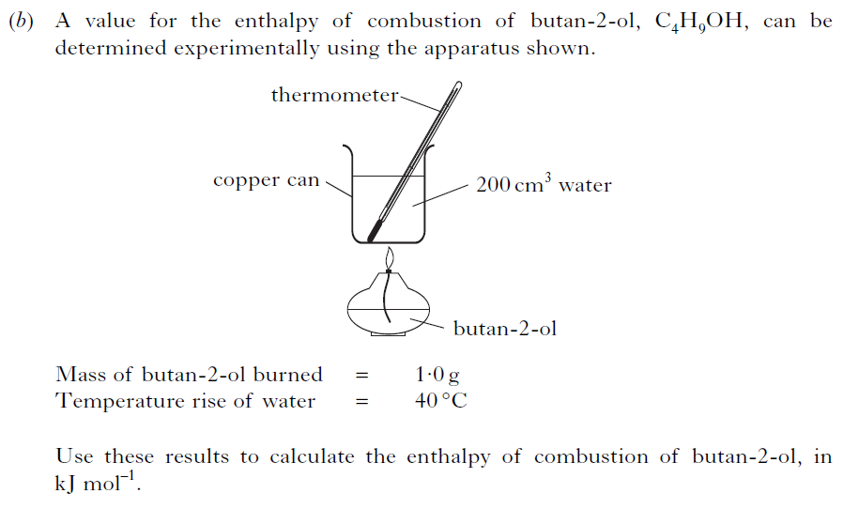

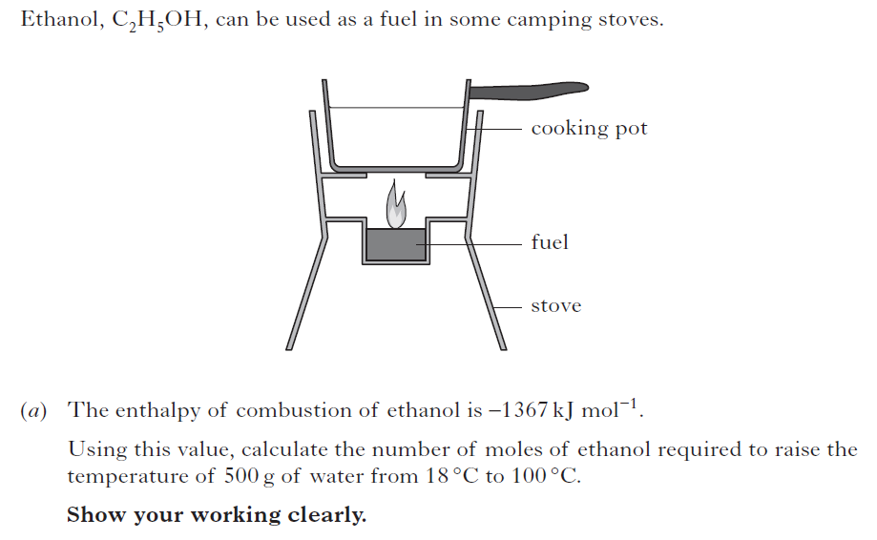19.

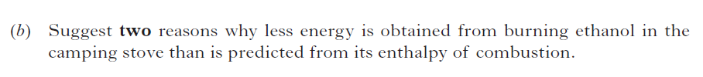

20.

Two litres of water, initially at 250C, were heated using a butane burner.

Using appropriate data from your data booklet, calculate the number of

moles of butane needed to boil this quantity of water.

**HESS’S LAW**

1. Using enthalpies of combustion figures from the Data Book, calculate the enthalpy of formation of:-

(a) methane (b) butane (c) ethene

(d) ethyne (e) methanol (f) propanol

**2**. 2Fe(s) + O2(g) → Fe2O3(s) ΔH = –822kJmol-1

C(s) + O2(g) → CO2(g) ΔH = –394kJmol-1

Which of the following is the standard enthalpy change, in kJmol-1, for the reaction shown below?

Fe2O3(s) + C(s) → 2Fe(s) + CO2(g)

**A** +231

**B** +428

**C** +1216

**D** +1413

1. Consider the reaction pathway shown.

**W** ΔH = –210kJmol-1 **Z**

ΔH = –50kJmol-1

**X** ΔH = –86kJmol-1 **Y**

According to Hess’s Law, the ΔH value, in kJmol-1, for reaction **Z** to **Y** is

**A** +74

**B** -74

**C** +346

**D** -346

1. Consider the reaction pathway shown.

C(s) + O2(g) **X** CO(g) + O2(g)

–393kJmol-1 –283kJmol-1

CO2(g)

According to Hess’s Law, what is the enthalpy change for reaction **X**?

**A** +110kJmol-1

**B** –110kJmol-1

**C** –676kJmol-1

**D** +676kJmol-1

1. The enthalpy of formation of Al2O3 is –1596kJmol-1 and that for

Cr2O3 is –1134kJmol-1.

Calculate the enthalpy of reaction for 2Al + Cr2O3 → Al2O3 + 2Cr

**6.** H2(g) → 2H(g) ΔH = 435kJmol-1

Br2(g) → 2Br(g) ΔH = 192kJmol-1

2HBr(g) → 2H(g)  + 2Br ΔH = 728kJmol-1

Calculate the enthalpy of formation of hydrogen bromide.

7 The equation for the enthalpy of formation of C2H6 is shown below.

C2H4(g) + H2(g) 🡪 C2H6(g)

Determine the heat of reaction for this reaction

Use the following reactions:

C2H4(g) + 3O2(g) 🡪 2CO2(g) + 2H2O(l) ΔH = -1401 kJ

C2H6(g) + 7/2O2(g) 🡪2CO2(g) + 3H2O(l) ΔH = -1550 kJ

H2(g) + 1/2O2(g) 🡪 H2O(l) ΔH = -286 kJ







**REDOX TITRATIONS**

1. The overall equation for the reaction of I2 with SO32- ions is:

I2 + SO32- + H2O → 2I- + SO42- + 2H+

Calculate the volume of iodine solution (concentration 0·5mol 1-1) needed

to completely react with 50cm3 of sodium sulphite solution of

concentration 0·2mol 1-1.

**2.** The overall equation for the reaction of Fe3+ ions with I- ions is:

2Fe3+ + 2I- → I2 + 2Fe2+

Calculate the volume of iodide solution (concentration 0·2mol 1-1) needed

to completely react with 25cm3 of iron (iii) nitrate solution of

concentration 0·1mol 1-1.

**3.** The overall equation for the reaction of sodium sulphite solution with iron(lll) ions is:

2Fe3+ + 2SO32-- + H2O → 2Fe2+ 2SO42- + 2H+

Calculate the concentration of the sodium sulphite solution if 25cm3 of it

is needed to completely react with 50cm3 of iron(lll) nitrate solution of

concentration 0·5mol 1-1.

4. 25cm3 of acidified potassium dichromate solution reacted completely

with 25cm3 of potassium iodide solution (concentration 0·5mol 1-1).

Calculate the concentration of the potassium dichromate solution. The

overall equation for the reaction is:

Cr2O72- + 14H+ + 6I- → 2Cr3+ + 7 H2O + 3I2

5. Hydrogen peroxide is a colourless liquid with the formula H2O2. Its solution

can be used as an antiseptic. A hospital technician was checking the

concentration of a hydrogen peroxide solution. She titrated 25·0cm3

portions of the solution against an acidified potassium permanganate solution.

The reaction taking place during the titrations is:

2MnO4-(aq) + 6H+(aq) + 5H2O2(aq) → 2Mn2+(aq) + 8H2O(*l*) + 5O2(g)

(purple) (colourless)

The technician’s results are shown in the table below.

|  |  |  |  |
| --- | --- | --- | --- |
| Titration | 1 | 2 | 3 |
| Titre volume/cm3 | 16·5 | 15·8 | 15·8 |

* 1. How would the technician know that the end-point of titration had been reached?
  2. Why would the technician ignore the result of the first titration when calculating the mean titre volume?
  3. The concentration of the potassium permanganate solution was 0·101mol 1-1. Use the technician’s results to calculate the concentration of the hydrogen peroxide solution.

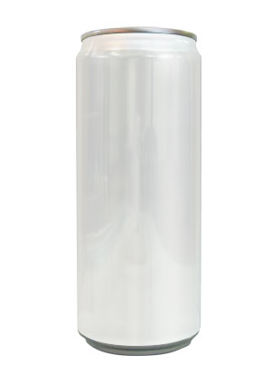

1. Sugars, such as glucose, are often used as sweeteners in soft drinks.

***Hi-Energy***

***Glucose***

***Drink***

***For***

***Athletes***

The glucose content of a soft drink can be estimated by titration

against a standardised solution of Benedict’s solution.

The copper(II) ions in Benedict’s solution react with glucose as shown

C6H12O2(aq) + 2Cu2+(aq) + 2H2O(*l*) → Cu2O(s) + 4H+(aq) + C6H12O7(aq)

1. In one experiment, 25·0cm3 volumes of a soft drink were titrated with Benedict’s solution in which the concentration of copper(II) ions was 0·500mol 1-1. The following results were obtained:

|  |  |
| --- | --- |
| Titration | Volume of Benedict’s solution/cm3 |
| 1 | 18·0 |
| 2 | 17·1 |
| 3 | 17·3 |

Average volume of benedict’s solution used = 17·2cm3

Calculate the concentration of glucose in the soft drink, in mol 1-1.

1. In some soft drinks, sucrose is used instead of glucose. Why can the sucrose concentration of a soft drink **not** be estimated by this method?
2. Cigarette lighter flints are composed principally of an alloy of iron and “misch” metal. One flint has a mass of 0·20g. Its percentage composition by mass is shown in Table 1. Table 2 shows the percentage composition by mass of “misch” metal.

|  |  |  |  |  |
| --- | --- | --- | --- | --- |
| Table 1 | |  | Table 2 | |
| Misch metal | 75·00 |  | Cerium | 44·00 |
| Iron | 19·70 |  | Lanthanum | 35·00 |
| Others | 5·30 |  | Neodymium | 12·50 |
|  |  |  | Praseodymium | 4·75 |
|  |  |  | Others | 3·75 |

1. Calculate the mass of cerium metal in the flint.

(b) A second flint, also with a mass of 0·20g, was dissolved in 30cm3 of dilute sulphuric acid, and heated with a catalyst to produce a solution containing Ce4+(aq) ions. The mass of cerium in this second flint was found by titrating

10cm3 of the Ce4+(aq) solution with iron(II) sulphate solution, using a suitable indicator.

|  |
| --- |
| Equations |
| Fe2+(aq) → Fe3+(aq) + e |
| Ce4+(aq) + e → Ce3+(aq) |

1. 0·76g of solid FeSO4 was required to make 100cm3 of 0·05mol 1-1 iron(II) sulphate solution. Describe fully how you would prepare 100cm3 of 0·05 mol 1-1 iron(II) sulphate solution.
2. It was found that 4·85cm3 of 0·05mol 1-1 iron(II) sulphate solution was required to reduce 10cm3 of the Ce4+(aq) solution.

Calculate the mass of cerium in the flint.

(Take the relative atomic mass of cerium to be 140)